LAB ASSIGNMENT -3

Ethical Challenges and Responsible AI in Cyber Security
Artificial Intelligence (AI) is increasingly used in cyber security to detect malware, identify suspicious network activity, prevent attacks, and monitor users and devices. Although AI can improve security and respond to threats quickly, its use also creates important ethical and societal concerns. The major concerns include bias, privacy, accountability, and transparency.

CODE:
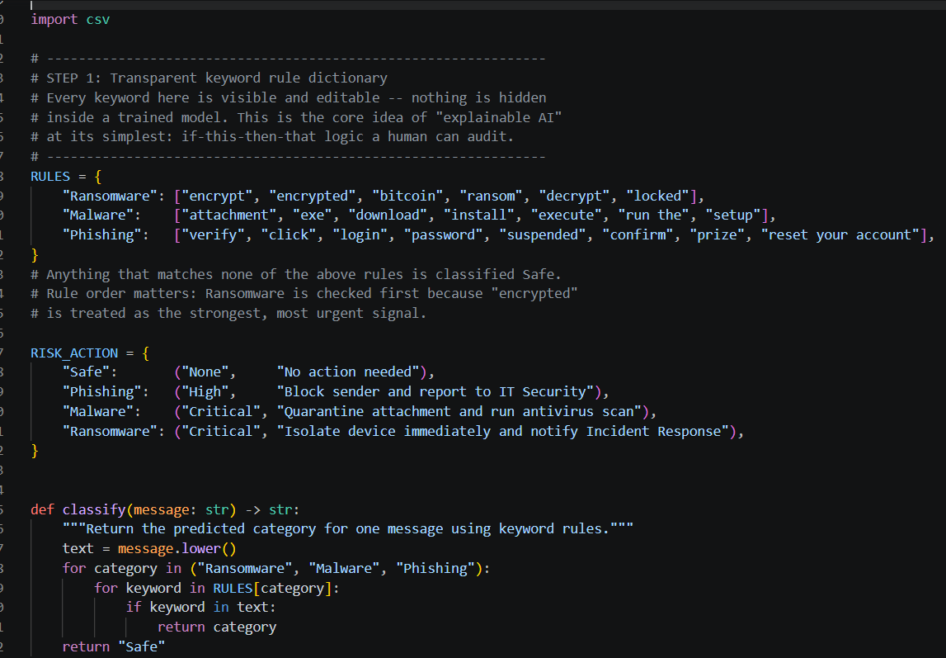
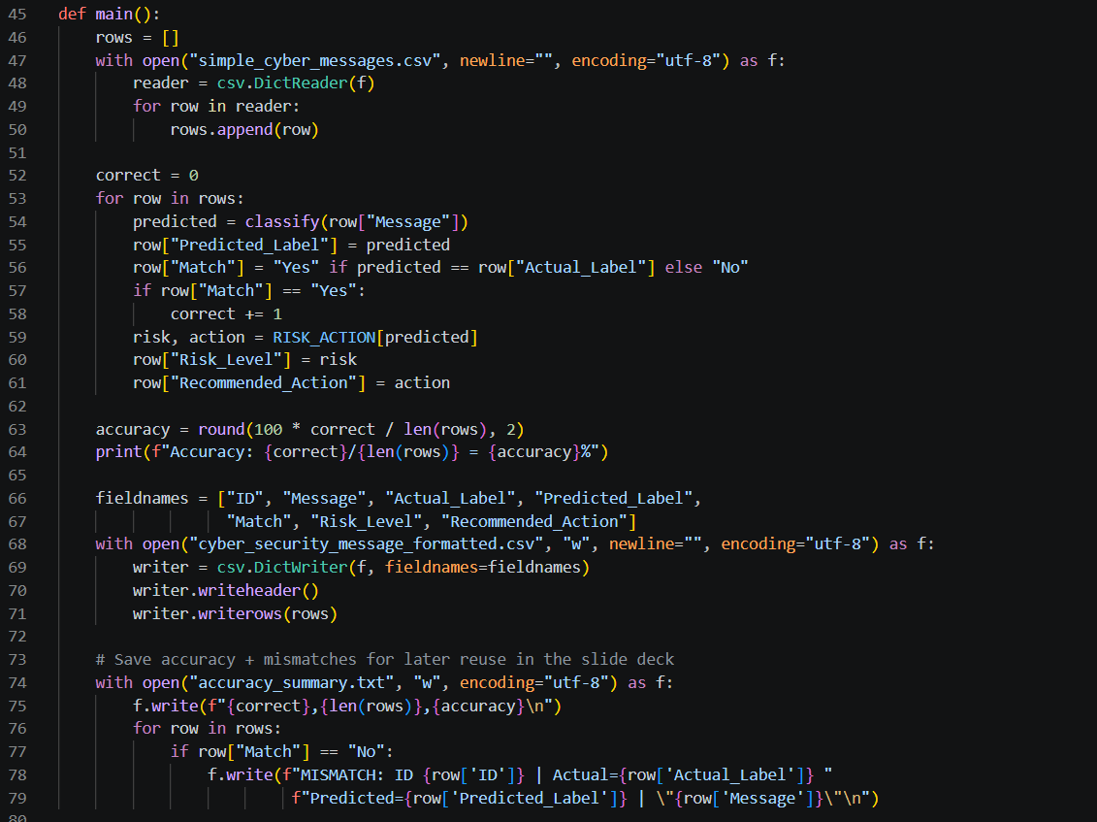

OUTPUT:
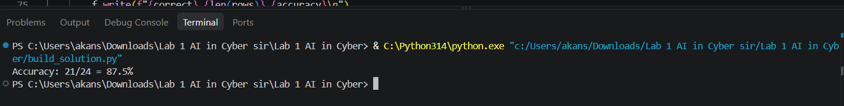

CSV files:
