Lab Task — Multithreading, Synchronization and Deadlock



Operating System Lab

Name: Akansha
Roll no: 2401010195
Course: B-Tech CSE Core
Year: 3rd Year, 5th Semester
Roll No: 2401010195 Submitted To: Ms. Suman Punia

Description
1. Create a single-threaded baseline workload.
2. Divide the workload into independent tasks.
3. Create multiple worker threads using Python.
4. Display thread identifiers and execution progress.
5. Wait for all worker threads to complete.
6. Measure single-threaded and multithreaded execution time.
7. Compare both versions using the same workload.
8. Explain user-level threads, kernel-level threads and common multithreading models.
9. Discuss responsiveness, resource sharing, concurrency, parallelism, race conditions, deadlocks and overhead.

Code:
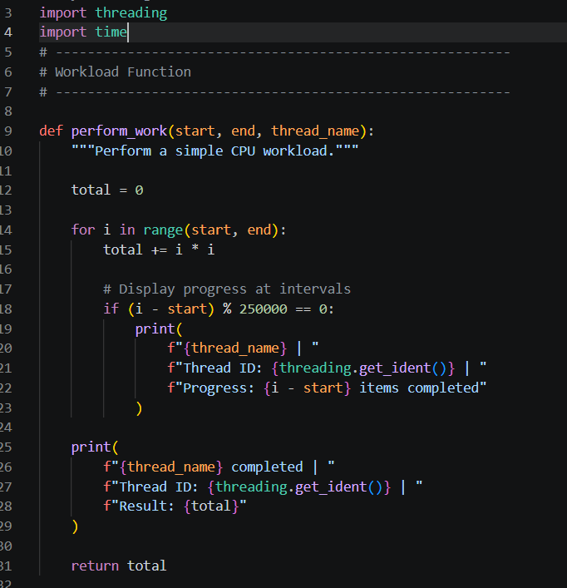
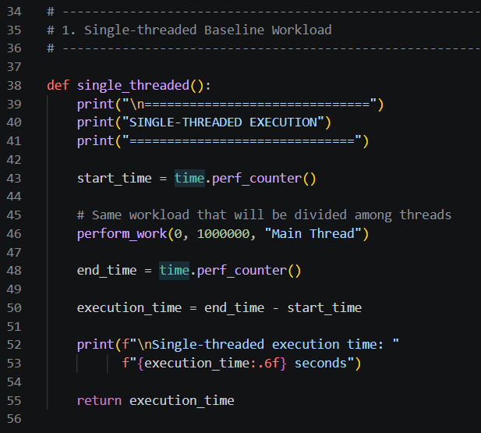
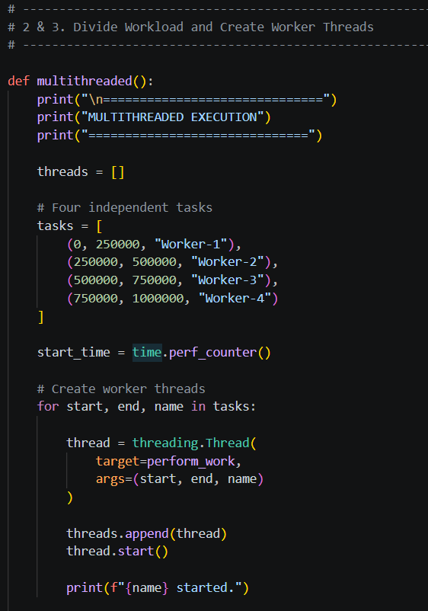
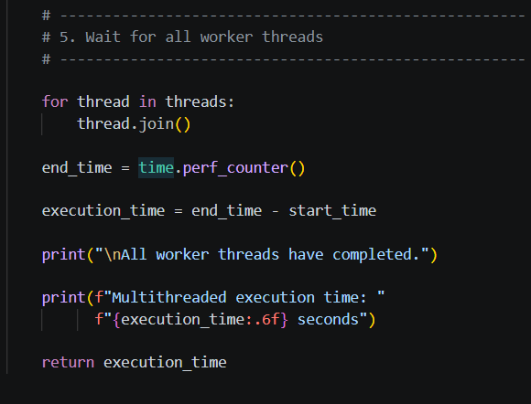
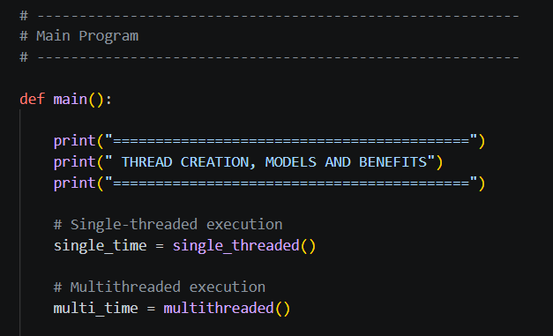
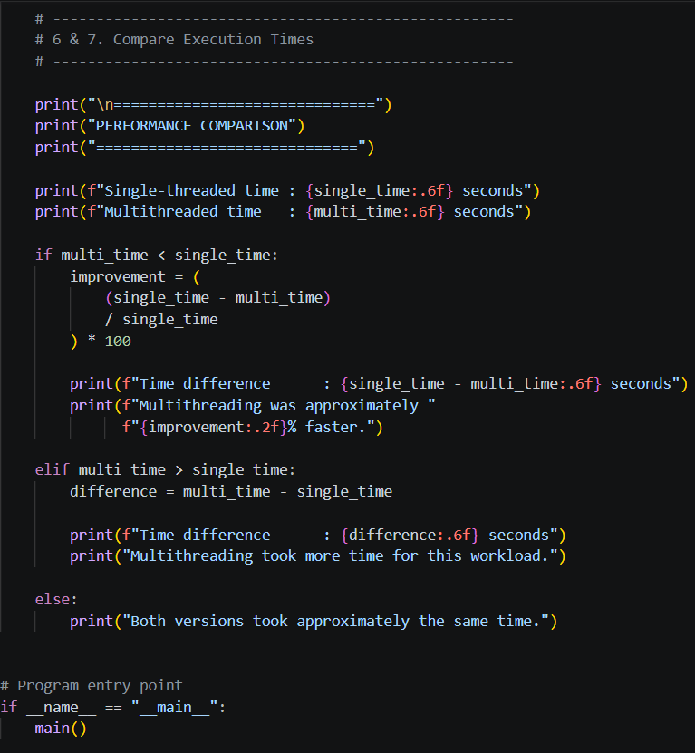

Link of Code: C:\Users\akans\Downloads\Lab 1 AI in Cyber sir\Lab 1 AI in Cyber\OSlab\thread_creation_models_benefits2.py

OUTPUT:
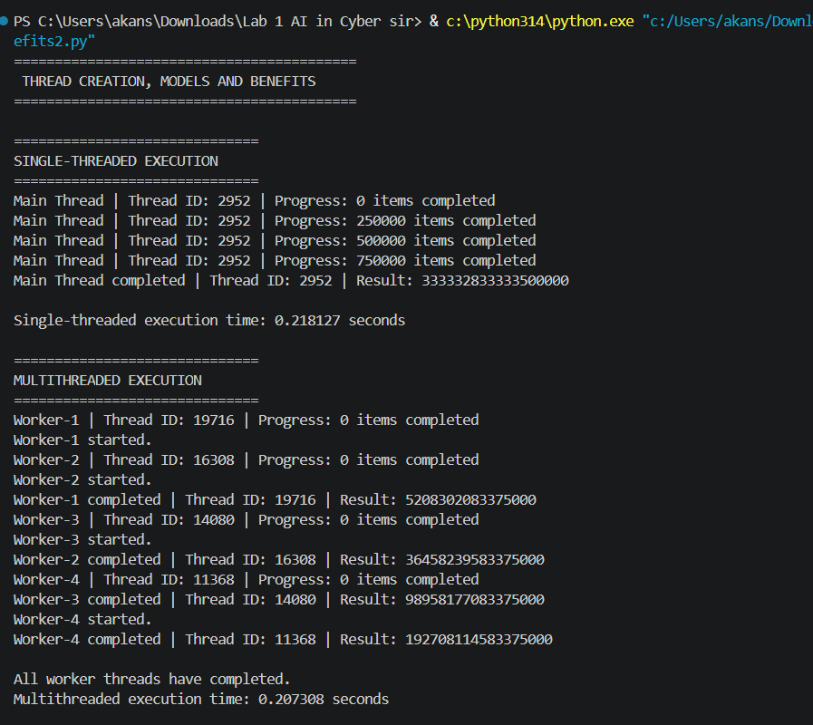
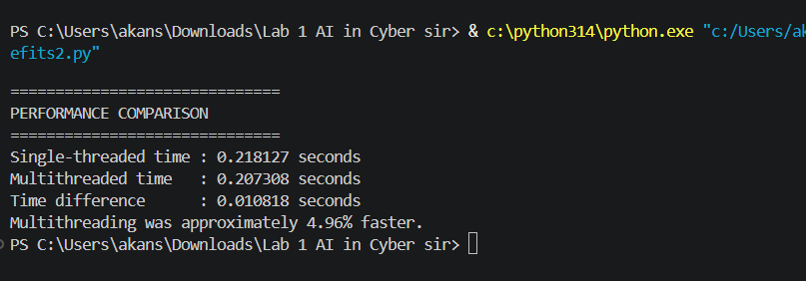

8. Thread Models
User-Level Threads
User-level threads are managed by a user-level thread library rather than directly by the operating system kernel.
Advantages:
- Faster thread creation and switching.
- Kernel does not need to manage every thread.
- Can be implemented without major kernel changes.
Disadvantages:
- If one thread performs a blocking system call, the entire process may be blocked in some models.
- Kernel may not schedule individual user threads independently.

Kernel-Level Threads
Kernel-level threads are directly managed by the operating system.
The operating system knows about the threads and schedules them.
Advantages:
- Threads can be scheduled independently.
- One blocked thread does not necessarily block other threads.
- Can take advantage of multiple CPU cores.
Disadvantages:
- Thread creation and switching can have more overhead.
- Requires operating-system support.

Common Multithreading Models
1. Many-to-One
Many user-level threads are mapped to one kernel thread.
A blocking operation can affect the entire process.
2. One-to-One
Each user thread is mapped to one kernel thread.
User Thread 1 ---> Kernel Thread 1
User Thread 2 ---> Kernel Thread 2
User Thread 3 ---> Kernel Thread 3
This allows better parallelism but can require more system resources.
3. Many-to-Many
Many user threads are mapped to multiple kernel threads.
This provides flexibility between the two approaches.

9. Important Multithreading Concepts
Responsiveness
Multithreading can keep an application responsive while another thread performs a task.
Example: A graphical application can continue accepting user input while another thread performs background work.

Resource Sharing
Threads belonging to the same process share resources such as:
- Memory
- Files
- Global variables
- Other process resources
This makes communication between threads easier.

Concurrency
Concurrency means multiple tasks make progress during overlapping periods.
The tasks do not necessarily execute at exactly the same time.

Parallelism
Parallelism means multiple tasks actually execute at the same time, usually on different CPU cores.
Concurrency and parallelism are related but not identical.

Race Condition
A race condition occurs when multiple threads access shared data and the final result depends on the order in which the threads execute.

Deadlock
A deadlock occurs when two or more threads wait for resources held by each other and none can continue.

Threading Overhead
Creating, scheduling, switching, and synchronizing threads requires resources.
For a small workload, the overhead of creating multiple threads may be greater than the performance benefit.
Therefore, multithreading does not always mean faster execution.

