Lab Task — Multithreading, Synchronization and Deadlock
Race Condition, Lock and Semaphore



Operating System Lab

Name: Akansha
Roll no: 2401010195
Course: B-Tech CSE Core
Year: 3rd Year, 5th Semester
Roll No: 2401010195 Submitted To: Ms. Suman Punia

Description
1. Create shared data or a shared counter.
2. Allow multiple threads to update the shared data without protection.
3. Compare the expected result with the actual result.
4. Repeat execution to demonstrate timing-dependent behaviour.
5. Correct the race condition using a Lock or equivalent mutual-exclusion mechanism.
6. Implement a Semaphore-based version.
7. Use the same workload for the unprotected, Lock-based and Semaphore-based versions.
8. Measure execution time for each version.
9. Compare correctness and synchronization overhead.

CODE:
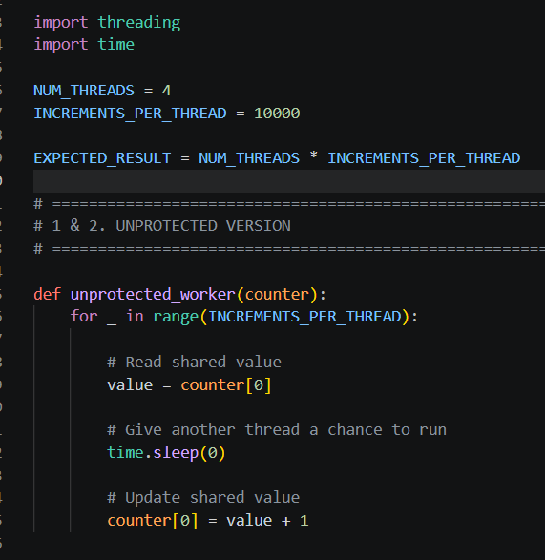
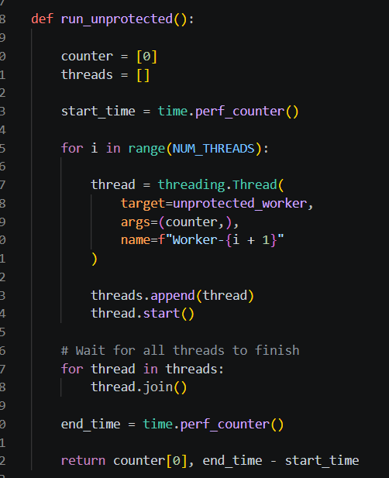
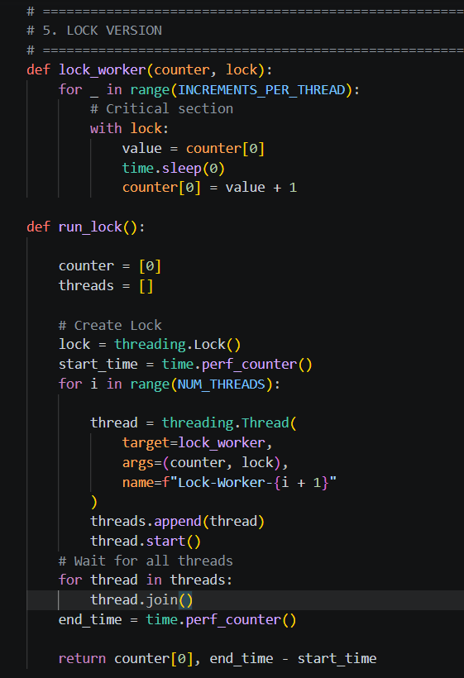
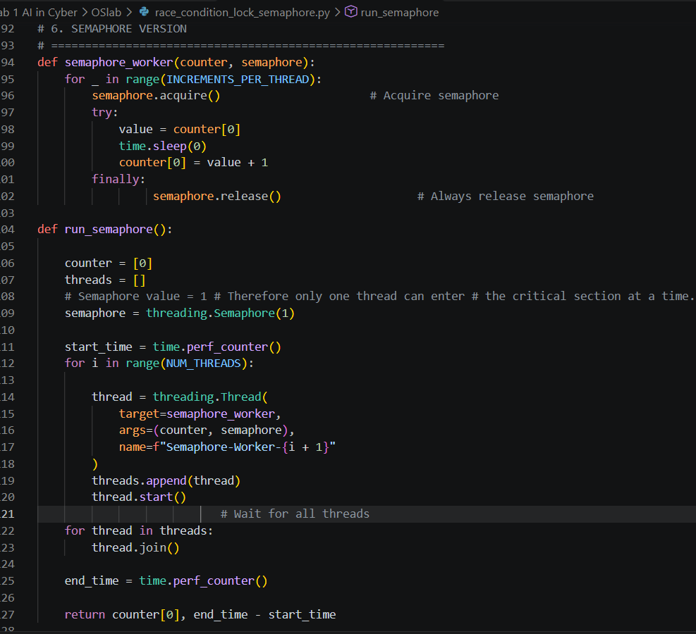
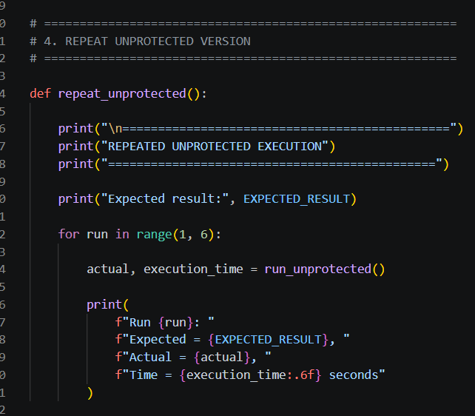
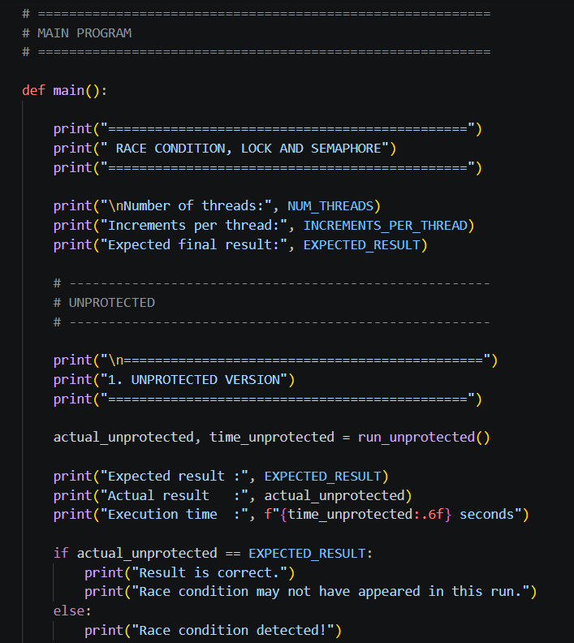
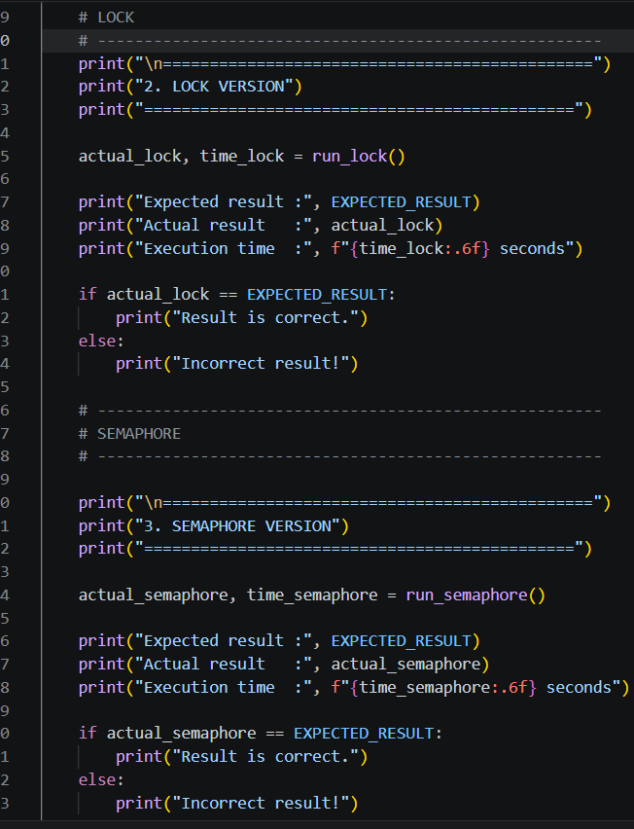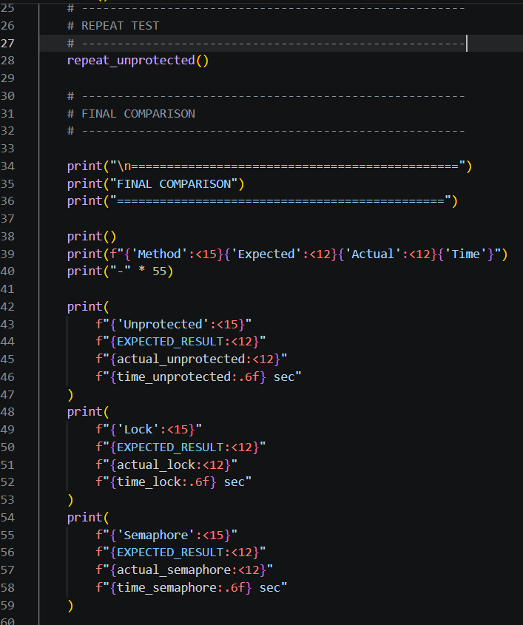
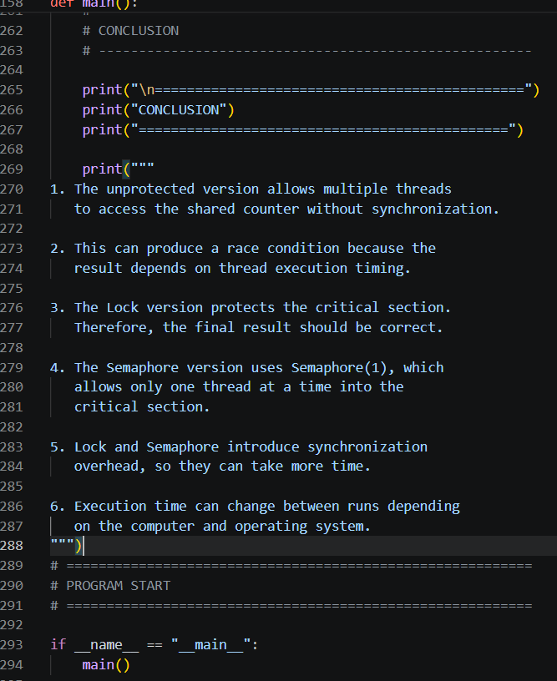

Link of Code: C:\Users\akans\Downloads\Lab 1 AI in Cyber sir\Lab 1 AI in Cyber\OSlab\race_condition_lock_semaphore.py

OUTPUT:
