Lab Task — Multithreading, Synchronization and Deadlock



Operating System Lab

Name: Akansha
Roll no: 2401010195
Course: B-Tech CSE Core
Year: 3rd Year, 5th Semester
Roll No: 2401010195 Submitted To: Ms. Suman Punia

Description
1. Implement the Producer–Consumer problem using a finite circular buffer.
2. Use suitable synchronization mechanisms to control buffer access.
3. Implement the Readers–Writers problem with protected reader count and exclusive writer access.
4. Implement the Dining Philosophers problem using controlled shared-resource access.
5. Prevent permanent deadlock using resource ordering, a waiter mechanism or restricted concurrency.
6. Use finite iterations so that every program terminates normally.
7. Display the state of shared resources and thread operations.
8. Discuss deadlock, starvation, fairness and correctness.

CODE:
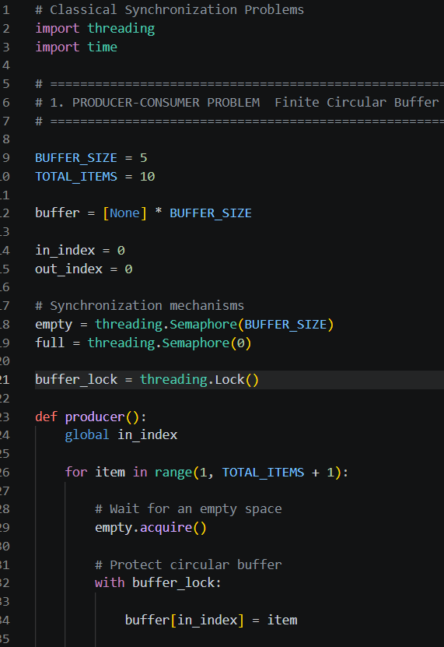
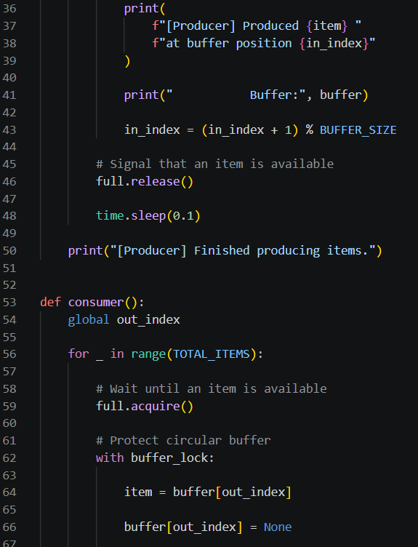
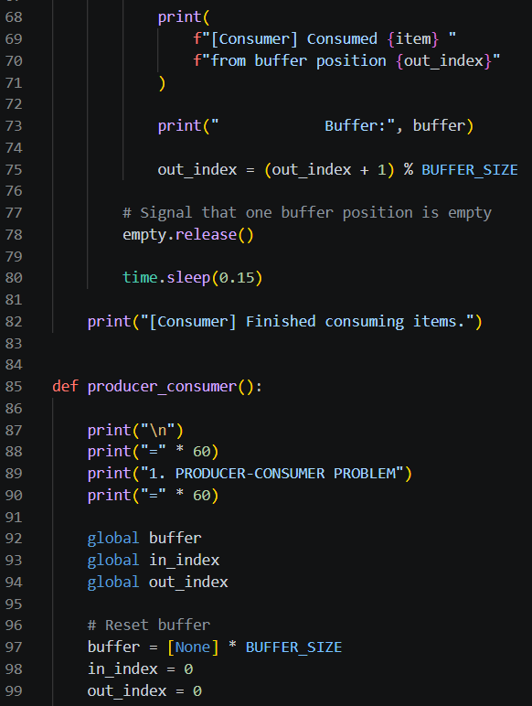
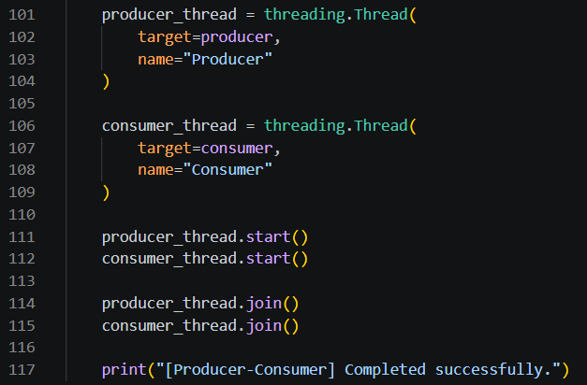
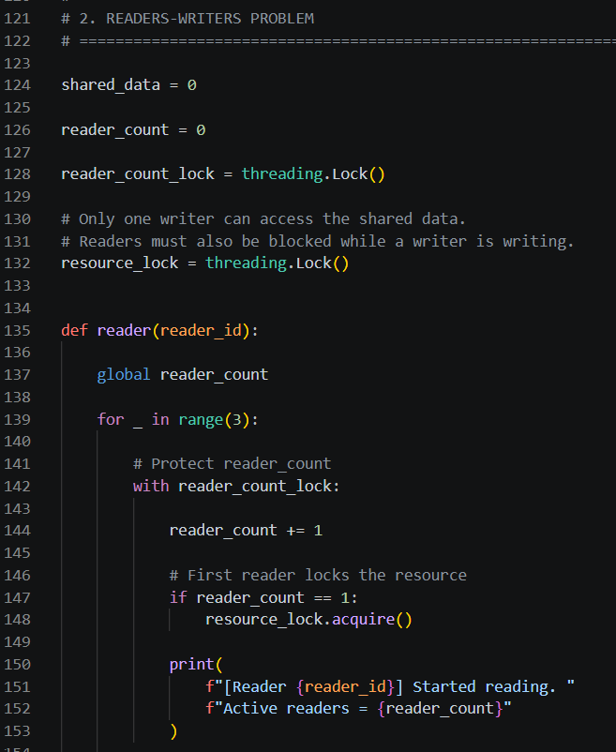

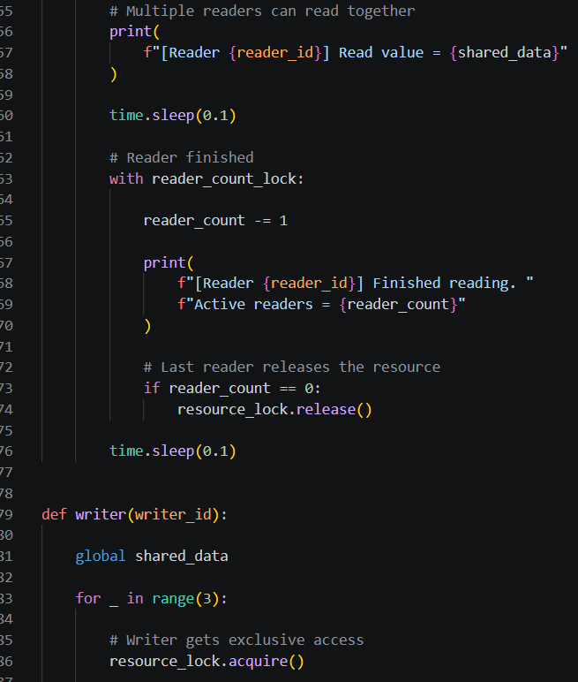
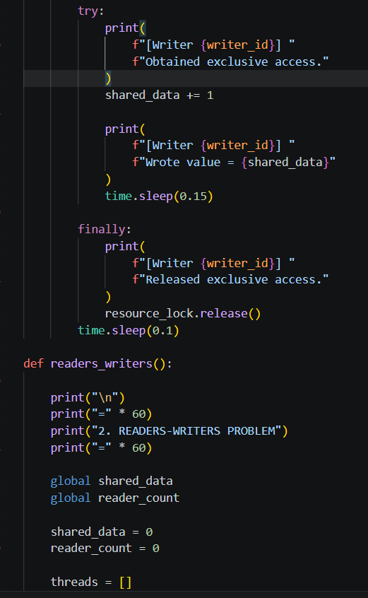

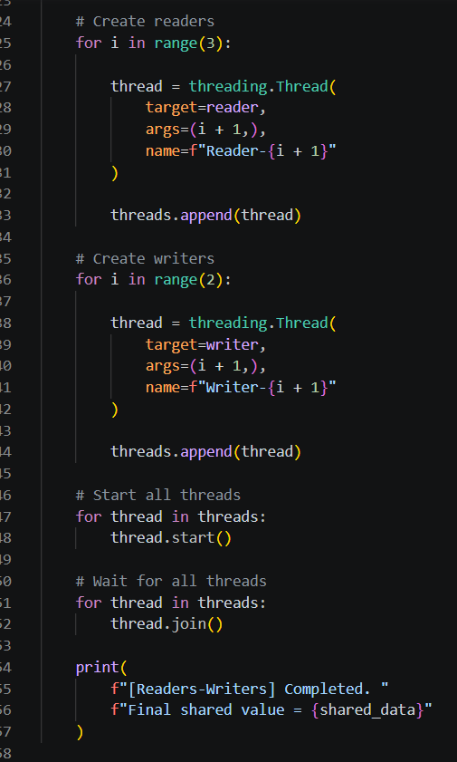
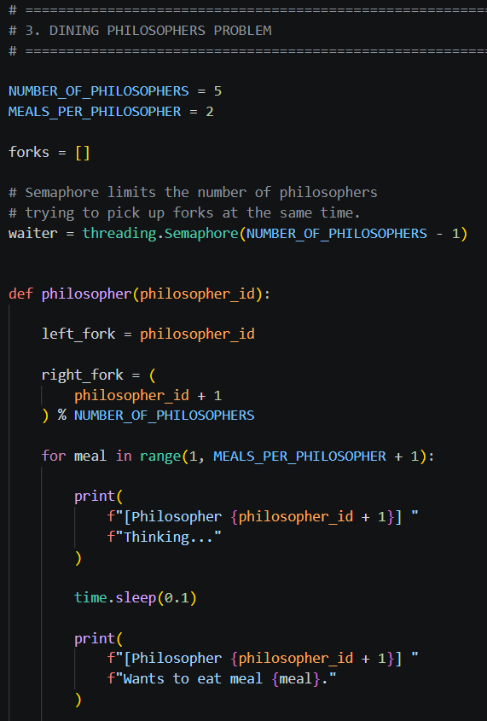
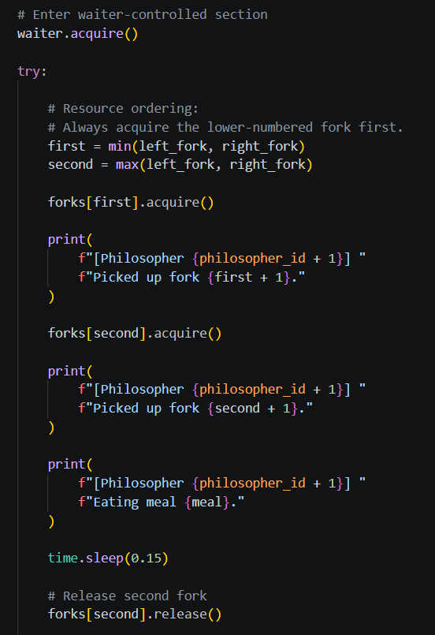
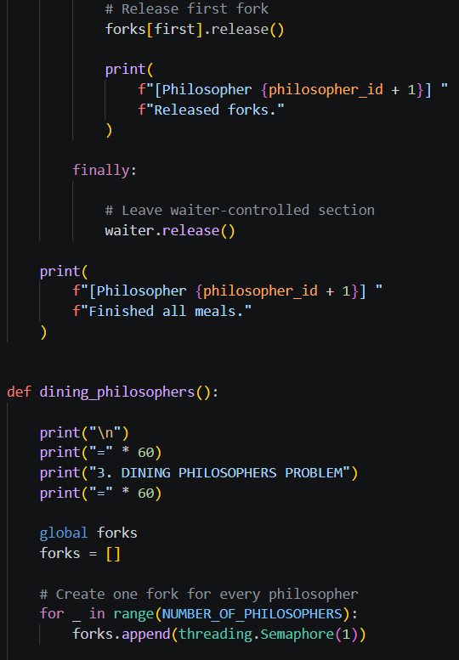
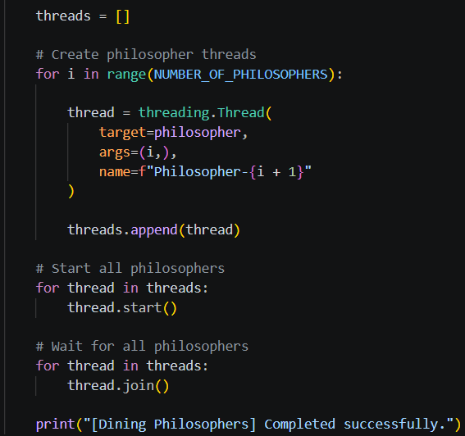
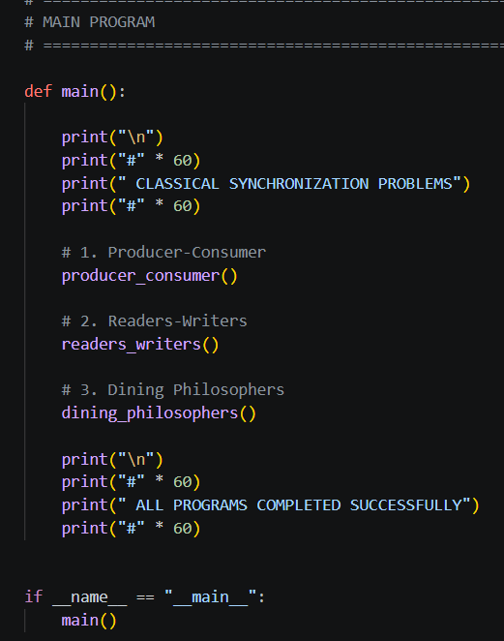

OUTPUT:

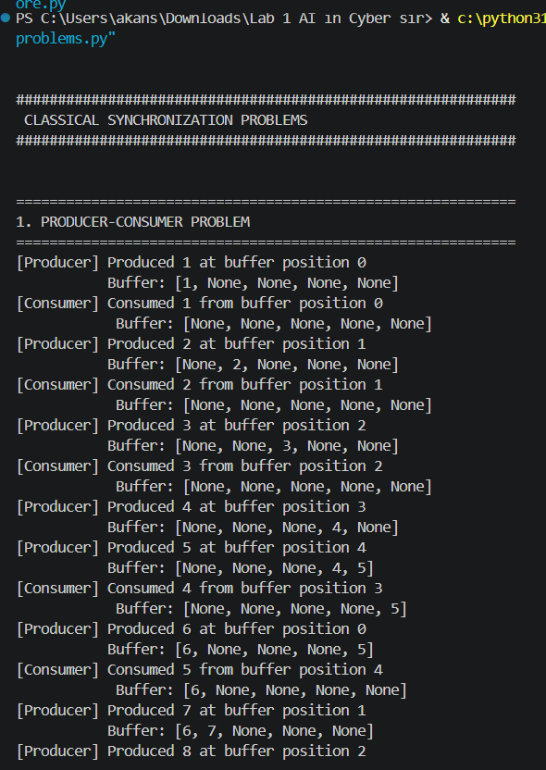
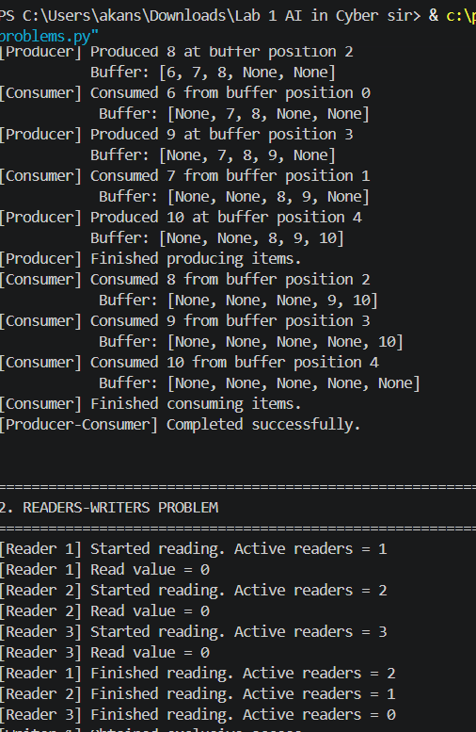
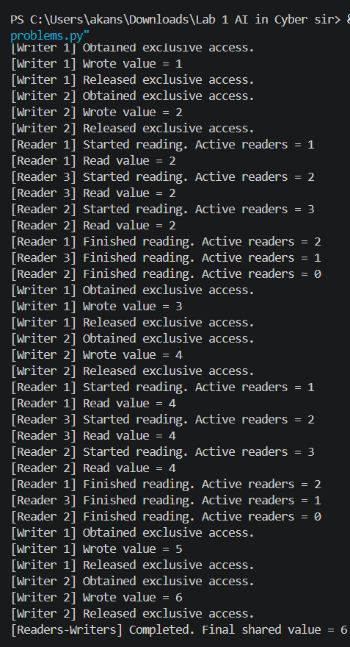
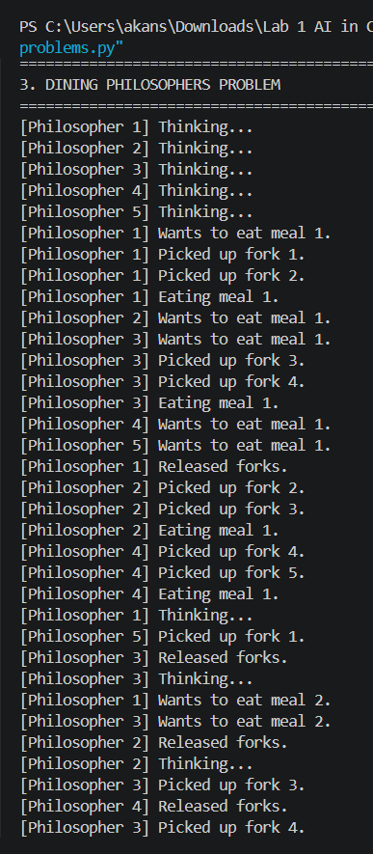
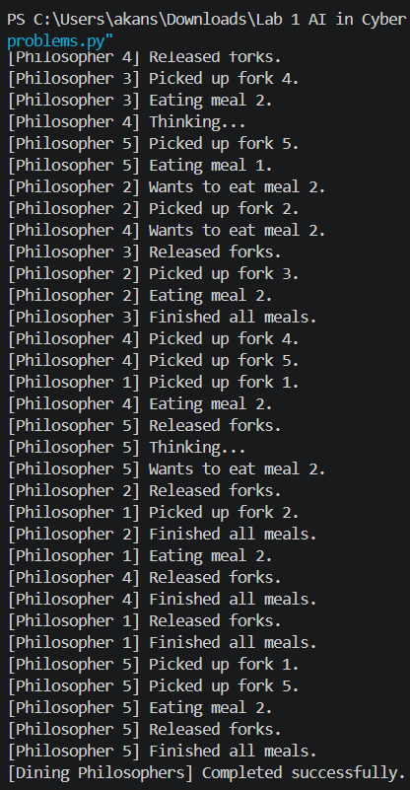

Link of Code: C:\Users\akans\Downloads\Lab 1 AI in Cyber sir\Lab 1 AI in Cyber\OSlab\classical_synchronization_problems.py

Explanation
1. Producer–Consumer
The Producer creates items and puts them into a finite circular buffer.
The Consumer removes items from the buffer.
The buffer has only:
BUFFER_SIZE = 5
So the producer cannot continuously add items when the buffer is full.
Synchronization used
empty = threading.Semaphore(BUFFER_SIZE)
full = threading.Semaphore(0)
buffer_lock = threading.Lock()
- empty counts available empty positions.
- full counts available items.
- buffer_lock protects the actual buffer.
The circular buffer uses:
in_index = (in_index + 1) % BUFFER_SIZE
and:
out_index = (out_index + 1) % BUFFER_SIZE
Therefore, when an index reaches the end, it returns to position 0.

2. Readers–Writers
The Readers–Writers problem involves shared data that can be:
- Read by multiple readers at the same time.
- Written by only one writer at a time.
This prevents a writer from changing the data while readers are accessing it.

3. Dining Philosophers
There are five philosophers and five forks.
Each philosopher needs two forks to eat.
Each fork can therefore be held by only one philosopher at a time.

Deadlock prevention
Two techniques are used.
A. Resource ordering
The philosophers always acquire the lower-numbered fork first:
first = min(left_fork, right_fork)
second = max(left_fork, right_fork)
This prevents circular waiting caused by philosophers acquiring forks in inconsistent orders.
B. Waiter mechanism
The program also uses:
waiter = threading.Semaphore(NUMBER_OF_PHILOSOPHERS - 1)
Only four philosophers can simultaneously enter the fork-acquisition section.
This prevents all five philosophers from holding one fork each and waiting forever for another fork.

Deadlock, Starvation, Fairness and Correctness
Deadlock
Deadlock occurs when threads wait forever for resources held by other threads.
For example:
Thread A → holds Resource 1 → waits for Resource 2

Thread B → holds Resource 2 → waits for Resource 1
The Dining Philosophers implementation prevents this using resource ordering and restricted concurrency.

Starvation
Starvation occurs when a thread waits for a resource for a very long time because other threads repeatedly get access first.
Synchronization mechanisms should therefore be designed carefully so that every thread eventually gets a chance to execute.

Fairness
Fairness means giving competing threads reasonable opportunities to access shared resources.
For example, a synchronization system should avoid allowing one thread to repeatedly obtain a resource while another thread waits indefinitely.
The exact fairness behavior can depend on the operating system and synchronization implementation.

Correctness
Correct synchronization ensures that:
- The producer does not overwrite a full buffer.
- The consumer does not consume from an empty buffer.
- Multiple readers can safely read shared data.
- Writers get exclusive access.
- Philosophers do not permanently deadlock while acquiring forks.
- All threads eventually terminate because the programs use finite iterations.

