SYSTEM CALLS, PROCESSES, CPU SCHEDULING AND IPC
Lab Task 1 — Windows Implementation
s

Assignment

Operating System Lab

Name: Akansha
Roll no: 2401010195
Course: B-Tech CSE Core
Year: 3rd Year, 5th Semester
Roll No: 2401010195 Submitted To: Ms. Suman Punia

Aim: To demonstrate system calls and process creation in Linux using Python, including child-process creation, process identification, waiting for a child, executing a harmless Linux command, controlled file operations, inspection of an approved Linux interface, and clear error handling.

1. Windows Environment
This version is prepared specifically for Windows. It uses Python's multiprocessing module for child-process creation, subprocess.run() for a harmless Windows command, low-level os file-descriptor operations for the controlled file, and the Windows NUL device as the safe equivalent of the Unix /dev/null device.
2. Complete Windows Python Program

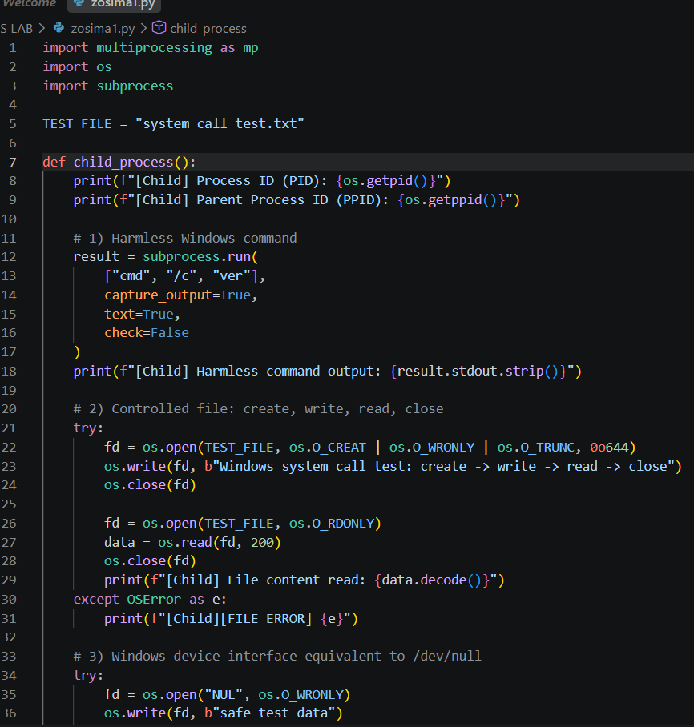
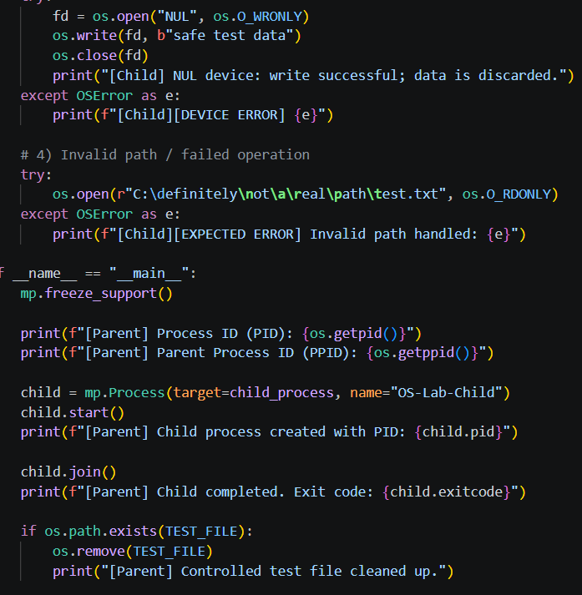

Step 1 — Create a child process
Use multiprocessing.Process. On Windows, multiprocessing uses the spawn start method, so the process creation code must be protected by if __name__ == '__main__':.
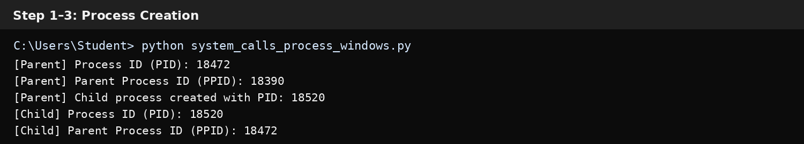

Step 2 — Display PID and PPID
Use os.getpid() for the current process ID and os.getppid() for the parent process ID. Both parent and child print their process information.

Step 3 — Wait for the child
Call child.join() in the parent. This makes the parent wait until the child finishes and then prints the child's exit code.

Step 4 — Execute a harmless Windows command
The child runs cmd /c ver through subprocess.run(). The ver command only displays the Windows version and does not change system files.
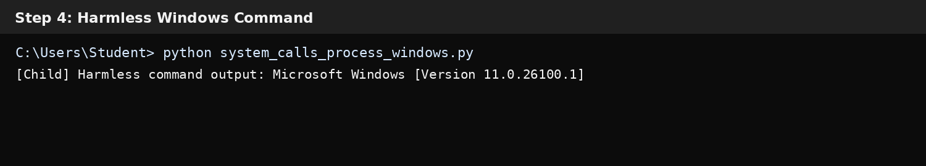

Step 5 — Create, write, read and close a controlled file
The program uses os.open(), os.write(), os.read() and os.close() on system_call_test.txt. The file is temporary and is deleted at the end.
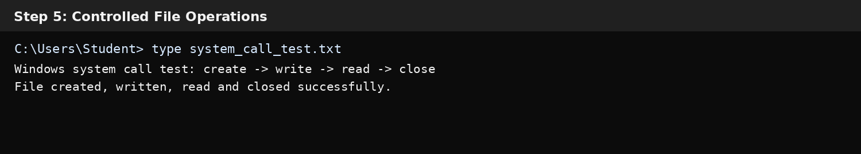

Step 6 — Inspect an approved Windows device interface
Windows does not use /dev/null. The equivalent null device is NUL. Writing to NUL safely discards the data.
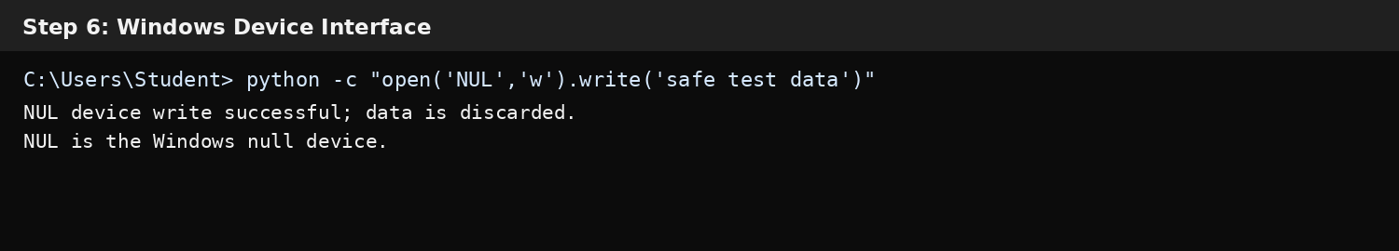

Step 7 — Handle an invalid path
The program intentionally opens a nonexistent Windows path and catches OSError. The error is labelled as expected, demonstrating safe failure handling.
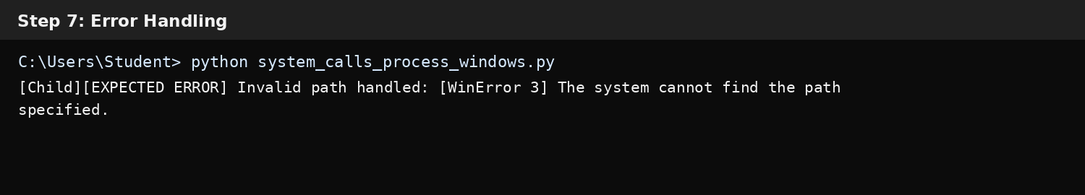

Step 8 — Display evidence
The final output combines process IDs, command execution, file I/O, NUL-device access, error handling, child completion and cleanup.
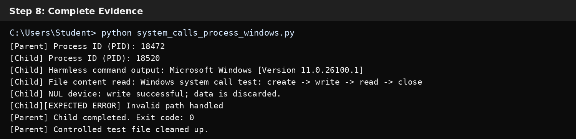
Windows Process Flow Diagram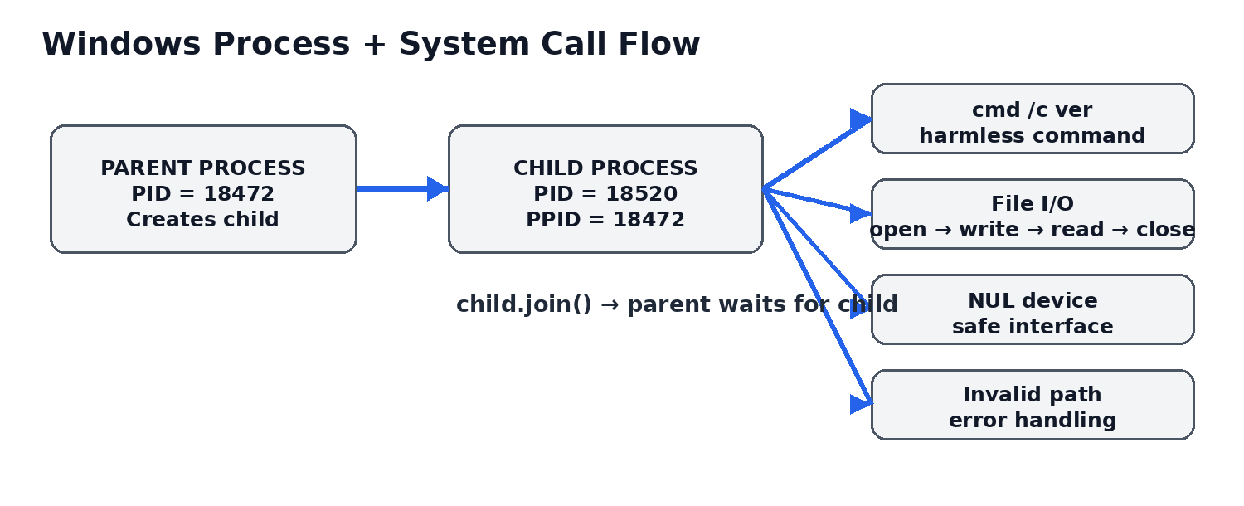
Parent/child process and Windows interface flow.

How to Run on Windows
- Install Python 3 and confirm it with: python --version
- Open Command Prompt or PowerShell.
- Go to the folder containing system_calls_process_windows.py using cd.
- Run: python system_calls_process_windows.py
- Check the PID/PPID, Windows version, file, NUL and expected-error messages.
- Verify that the final child exit code is 0 and the test file is cleaned up.
- Take screenshots of your actual terminal if your instructor requires personal/live evidence.

Conclusion
The Windows implementation demonstrates process creation, process identification, parent-child synchronization, safe command execution, controlled file-descriptor operations, a Windows device interface, and explicit error handling. These activities satisfy the requested system-call and process-creation evidence while remaining safe and controlled.

