
K.R. MANGALAM UNIVERSITY
SOET
(School of Engineering & Technology)
B. TECH CSE (CORE)
AI In Cyber Security Lab
(ENSP355)

Submitted by- Submitted to-
Akansha Mr. Anurag Singh
Roll no – 2401010195

Port Monitoring
- To display all connection and Listening port
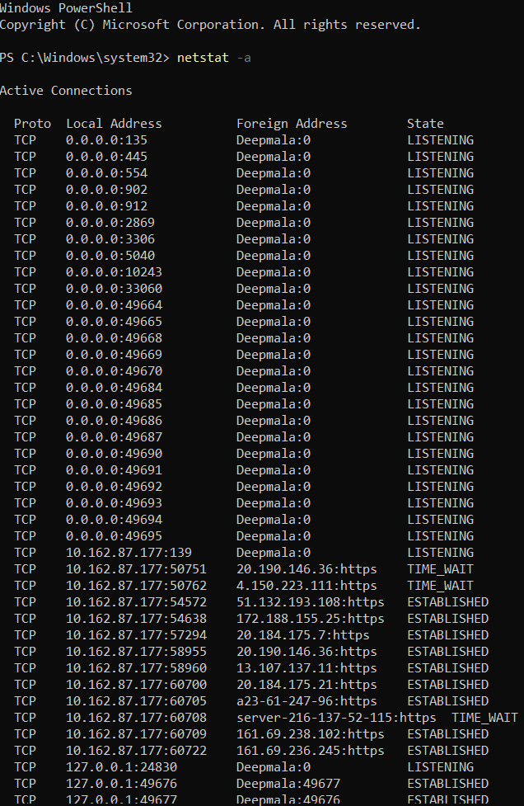
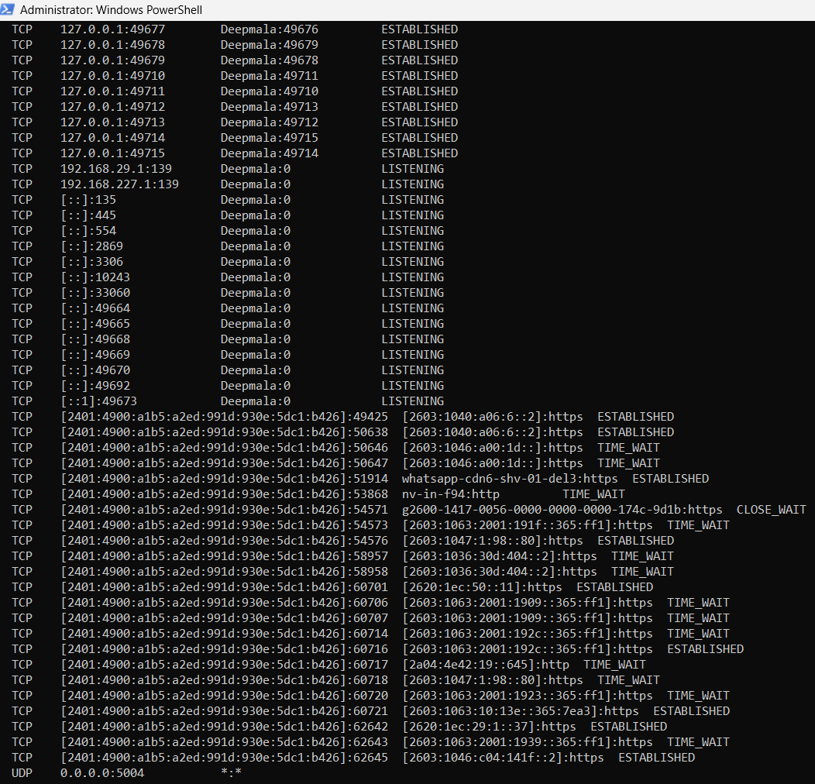

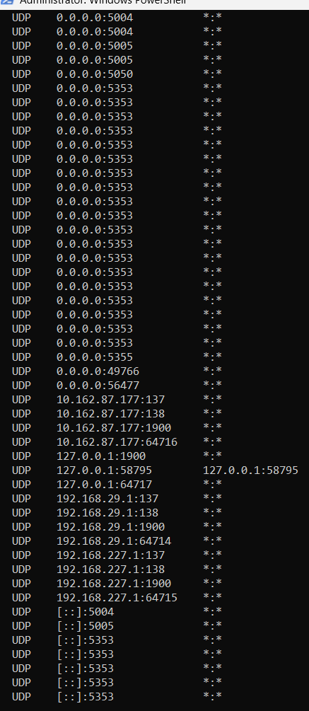
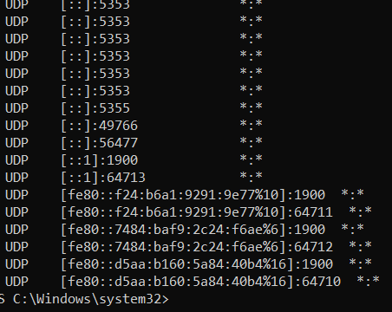

- Displays the executable involved in creating each connection or
listening port.
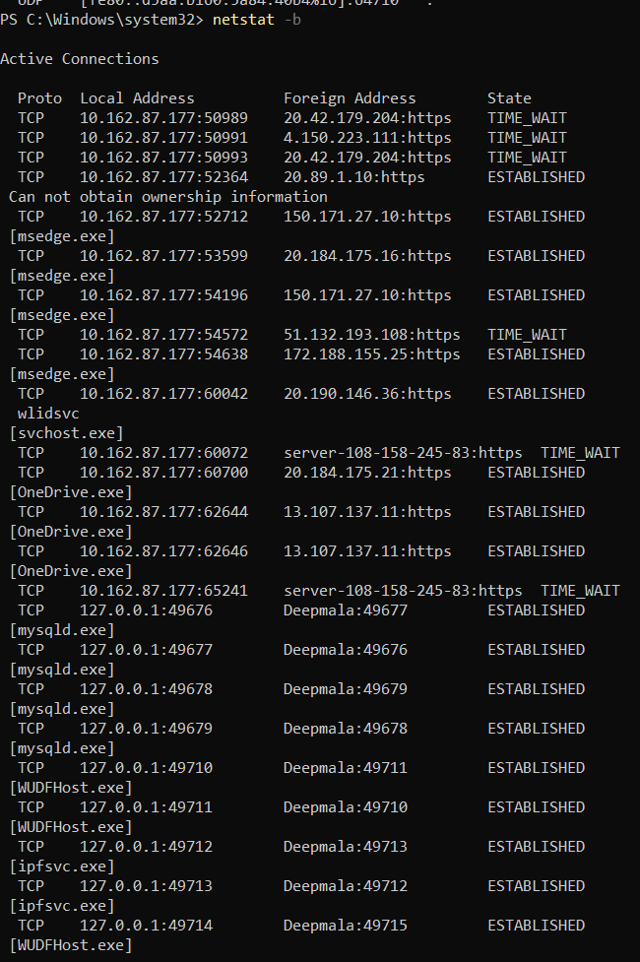
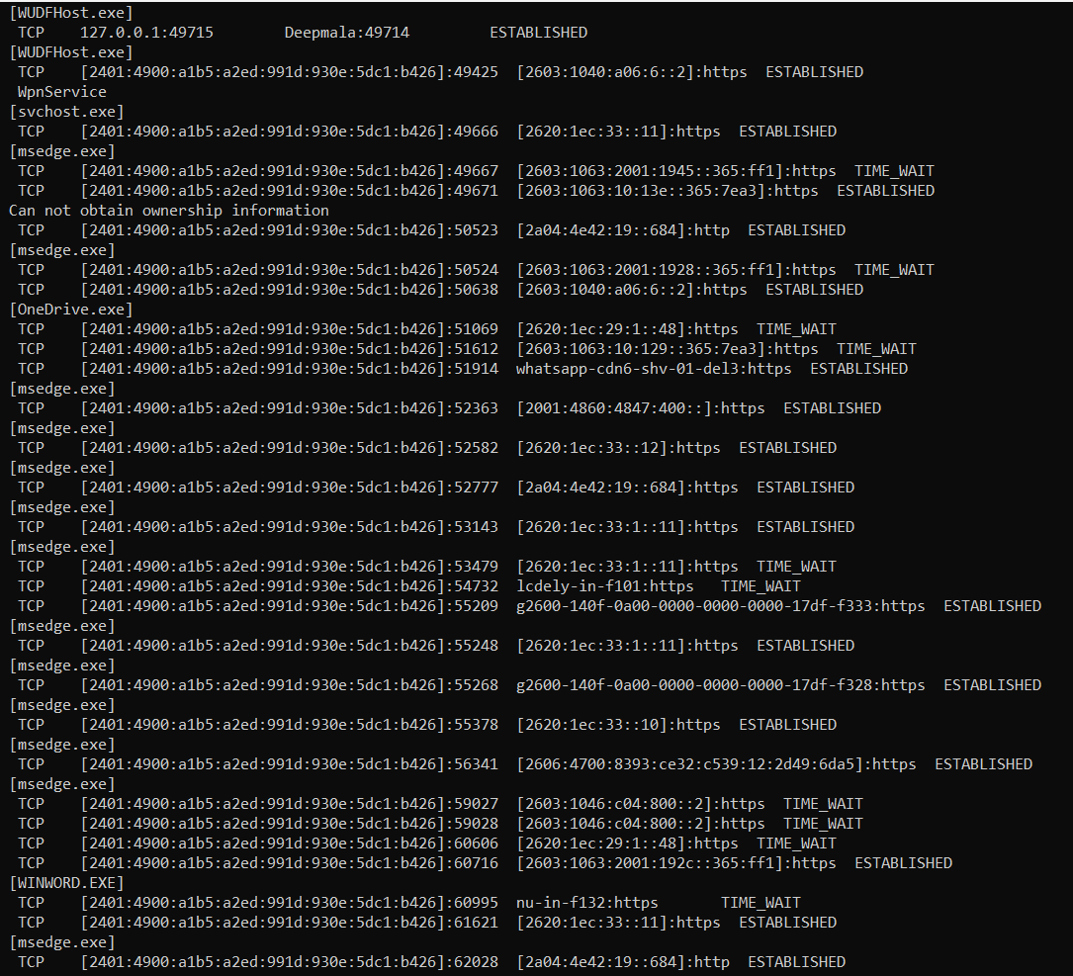
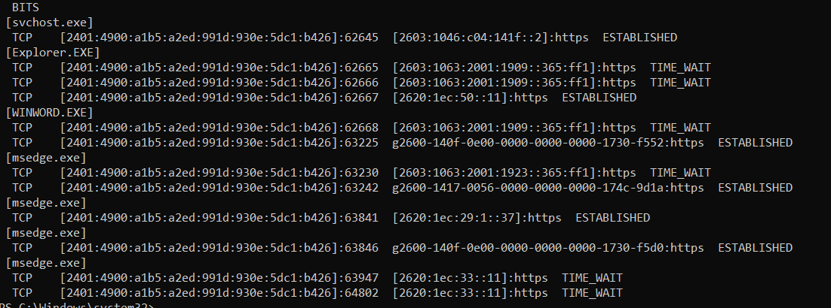

3. Displays a list of processes sorted by the number of TCP or UDP
ports currently consumed.
