
K.R. MANGALAM UNIVERSITY
SOET
(School of Engineering & Technology)
B. TECH CSE (CORE)
AI In Cyber Security Lab
(ENSP355)

Submitted by- Submitted to-
Akansha Mr. Anurag Singh
Roll no – 2401010195

Routing Table
1. To display all connections, port, all executable with process ID
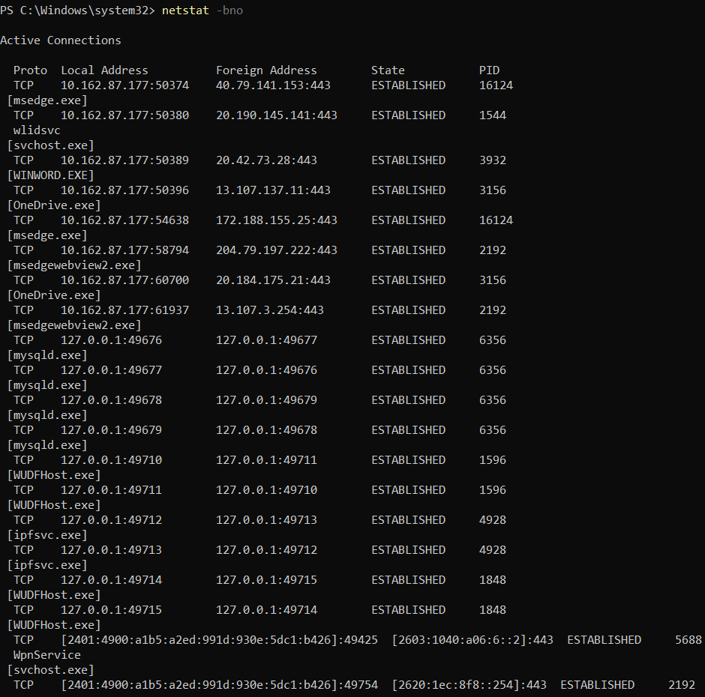
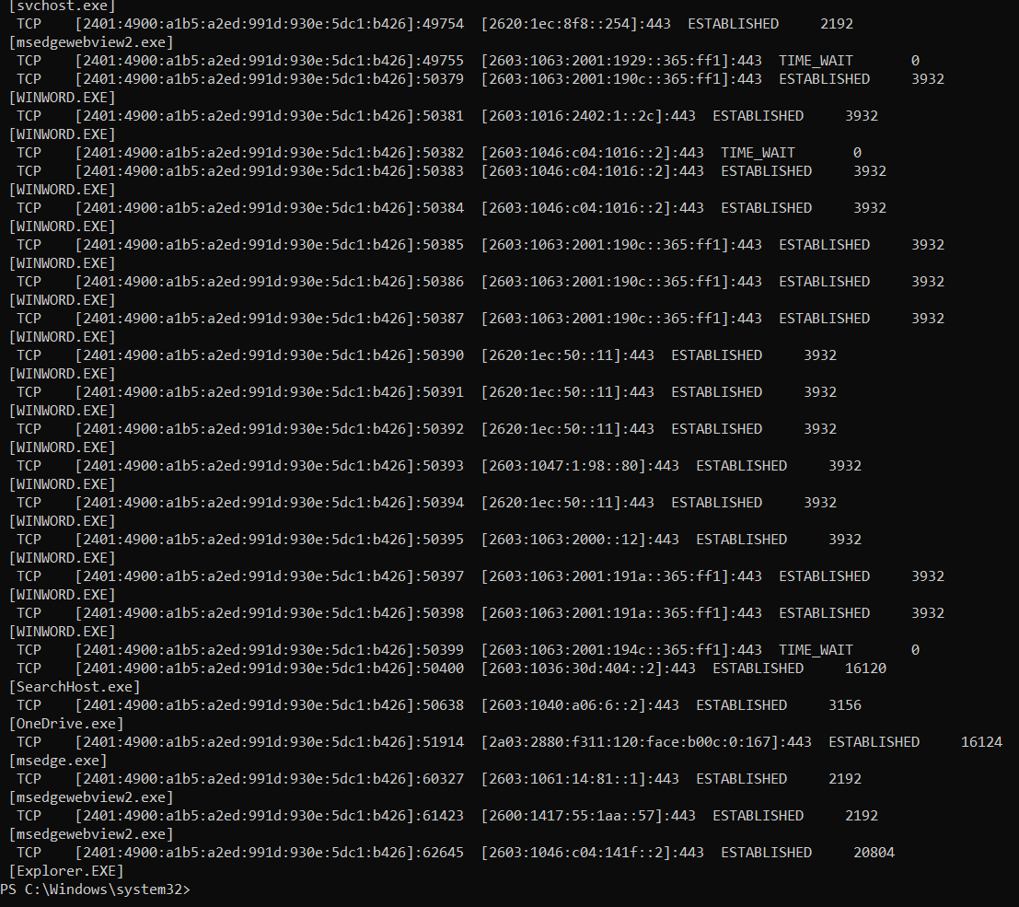

2. To display Routing Table
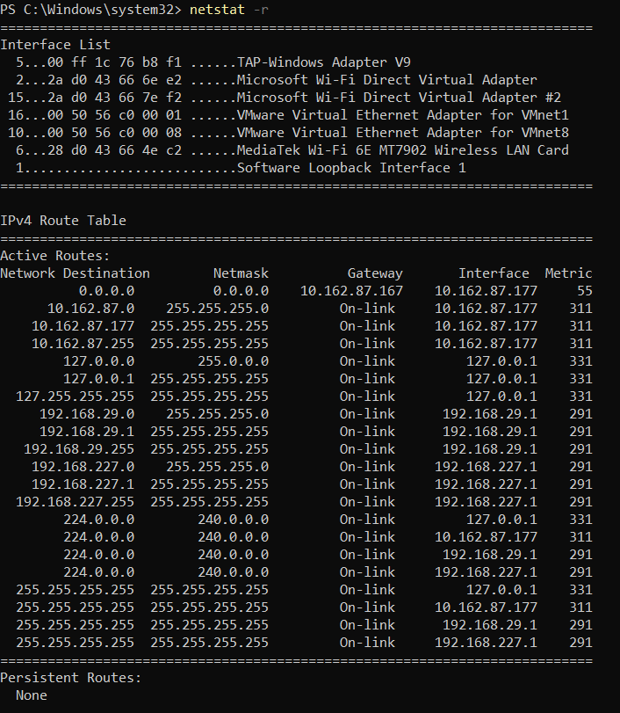
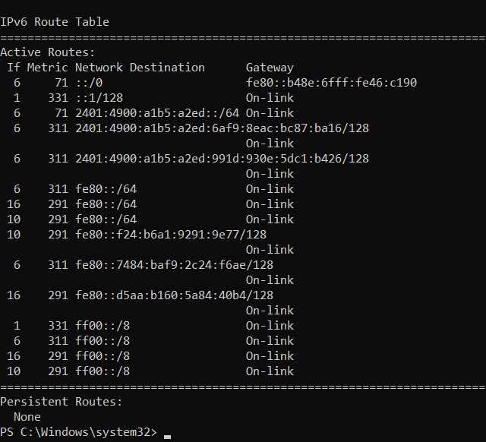

3. To display network packet statistics

