Lab Task — Multithreading, Synchronization and Deadlock


Operating System Lab

Name: Akansha
Roll no: 2401010195
Course: B-Tech CSE Core
Year: 3rd Year, 5th Semester Submitted To: Ms. Suman Punia

Deadlock Handling and Banker’s Algorithm
Description
1. Create a controlled circular-wait scenario.
2. Ensure that the program does not remain permanently blocked.
3. Identify mutual exclusion, hold and wait, no preemption and circular wait.
4. Demonstrate deadlock prevention using resource ordering or another approved method.
5. Accept Allocation, Maximum and Available-resource data.
6. Calculate the Need matrix.
7. Apply the Banker’s safety algorithm.
8. Display the safe sequence or report an unsafe state.
9. Demonstrate deadlock detection.
10. Demonstrate controlled recovery through resource release or process/thread termination.

Link: C:\Users\akans\Downloads\Lab 1 AI in Cyber sir\Lab 1 AI in Cyber\OSlab\deadlock_bankers.py

CODE:
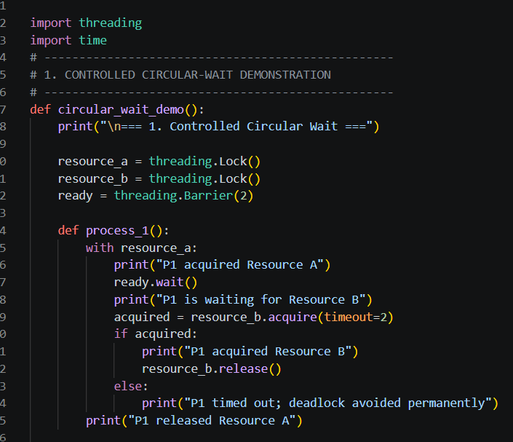
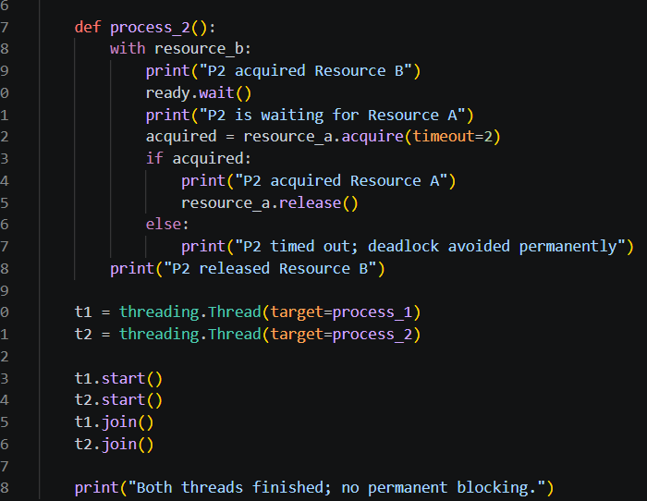
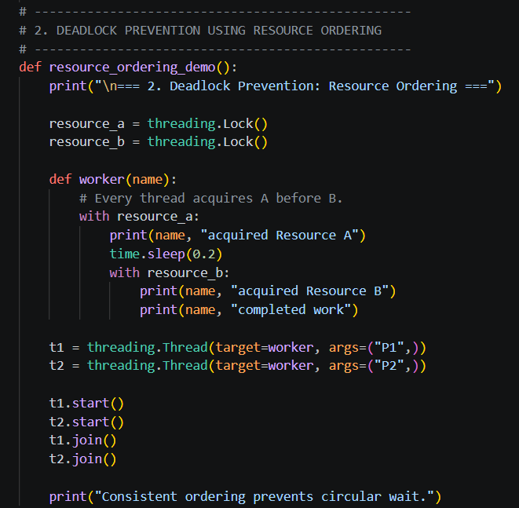
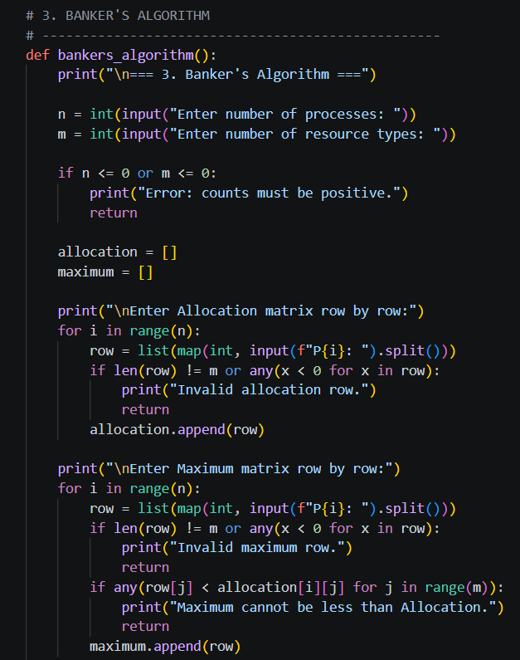

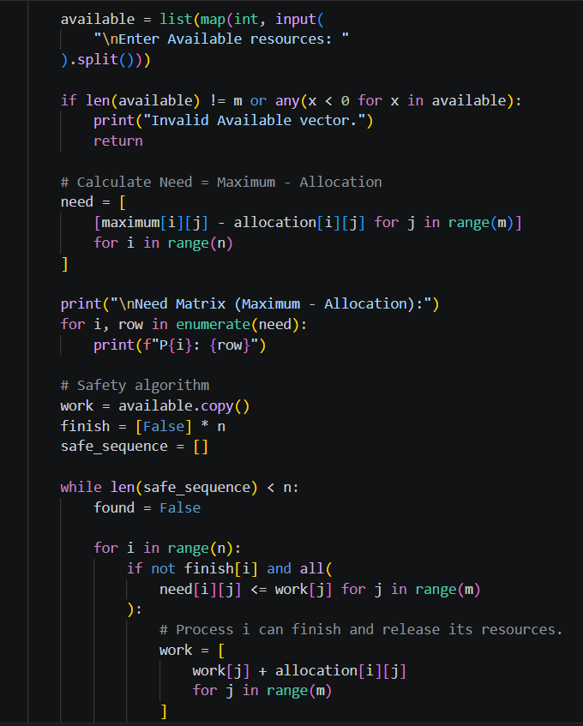
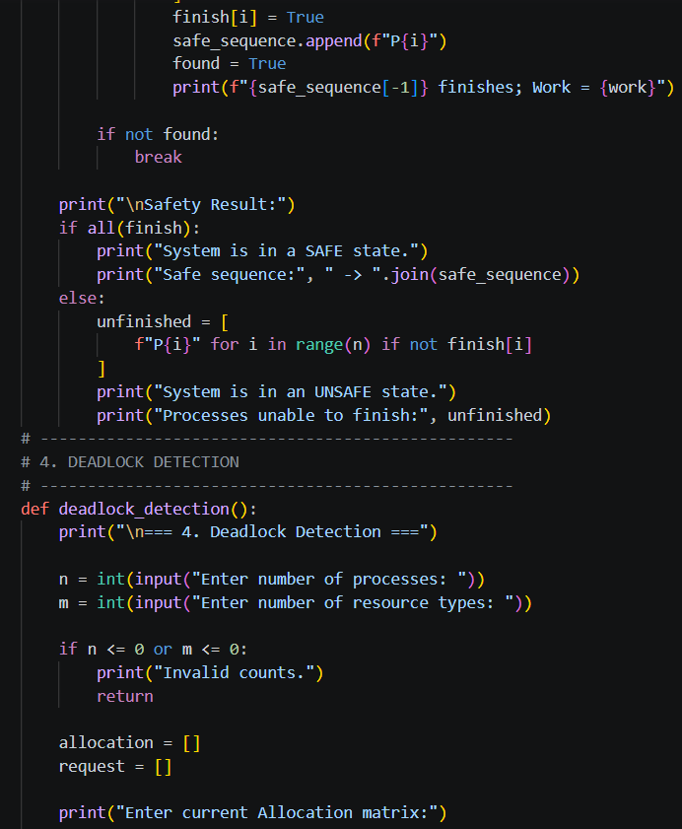

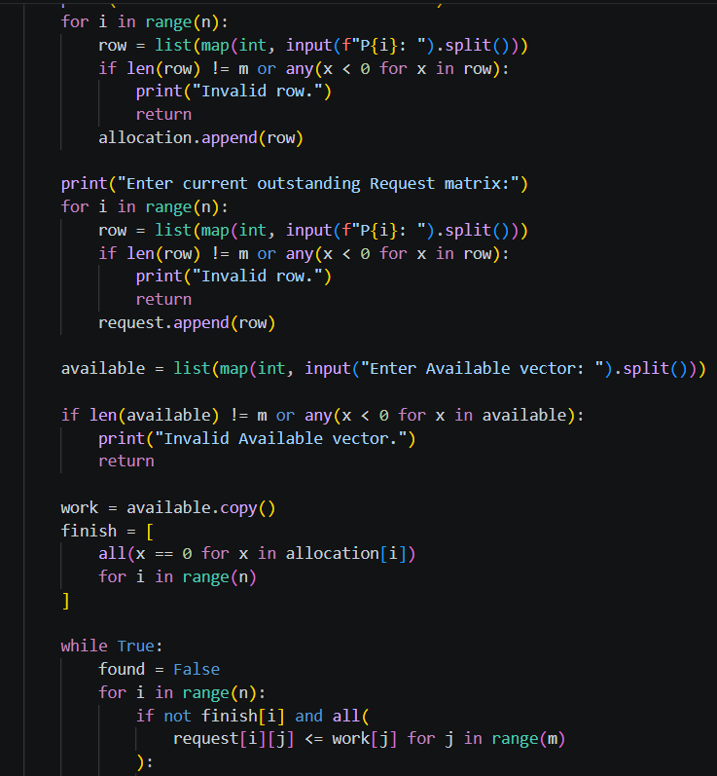
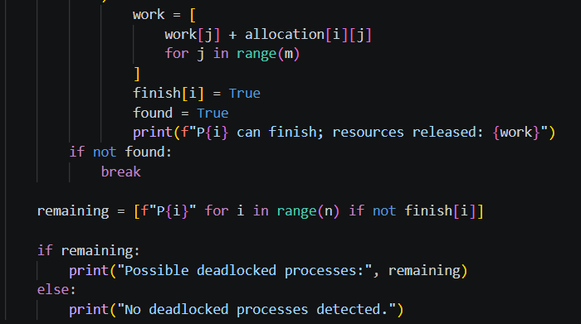
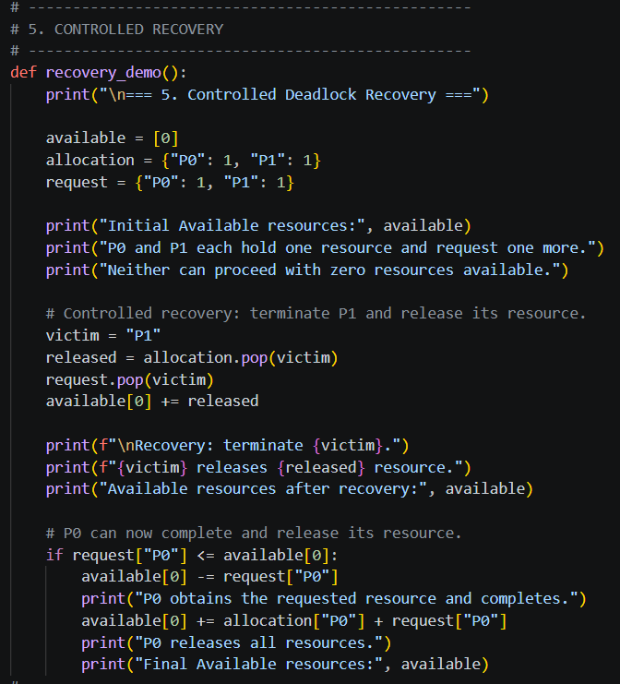
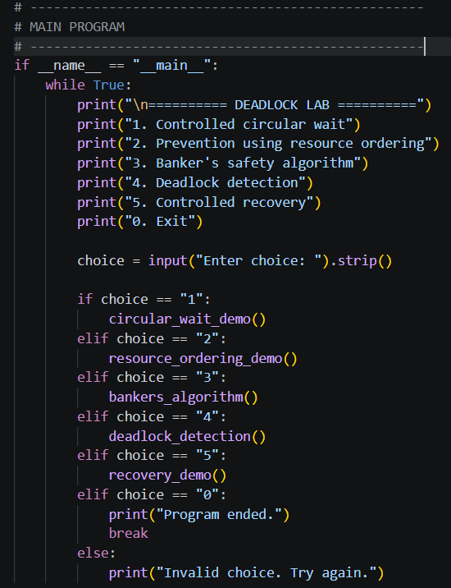
OUTPUT:
