Lab Task — Multithreading, Synchronization and Deadlock



Operating System Lab

Name: Akansha
Roll no: 2401010195
Course: B-Tech CSE Core
Year: 3rd Year, 5th Semester
Roll No: 2401010195 Submitted To: Ms. Suman Punia

Aim: To Create a single-threaded baseline workload, Divide the workload into independent tasks, Create multiple worker threads using Python, Display thread identifiers and execution progress, Wait for all worker threads to complete, Measure single-threaded and multithreaded execution time, Compare both versions using the same workload, Explain user-level threads, kernel-level threads and common multithreading models, Discuss responsiveness, resource sharing, concurrency, parallelism, race conditions, deadlocks and overhead.
CODE:
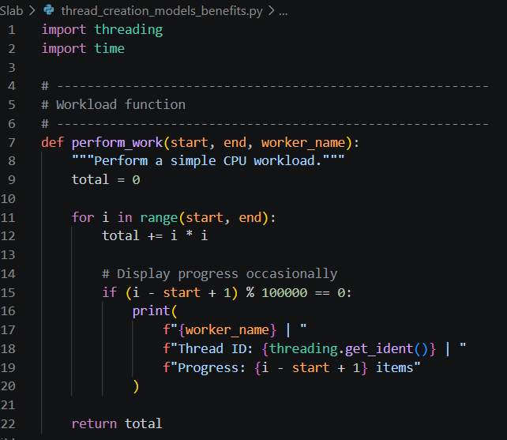
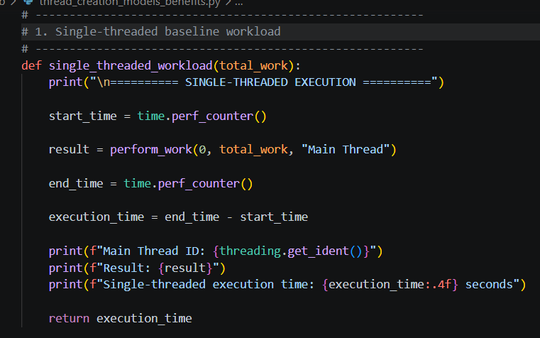
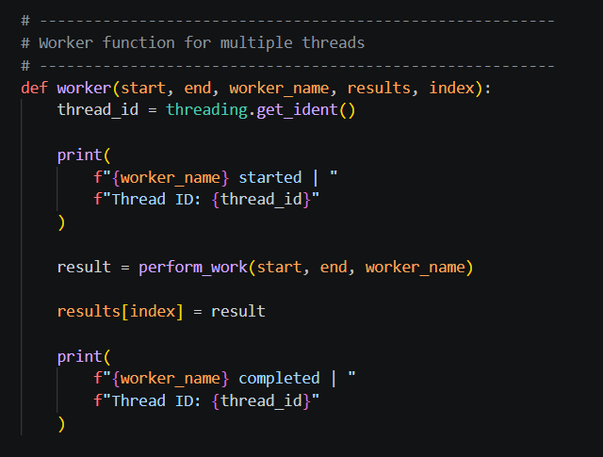
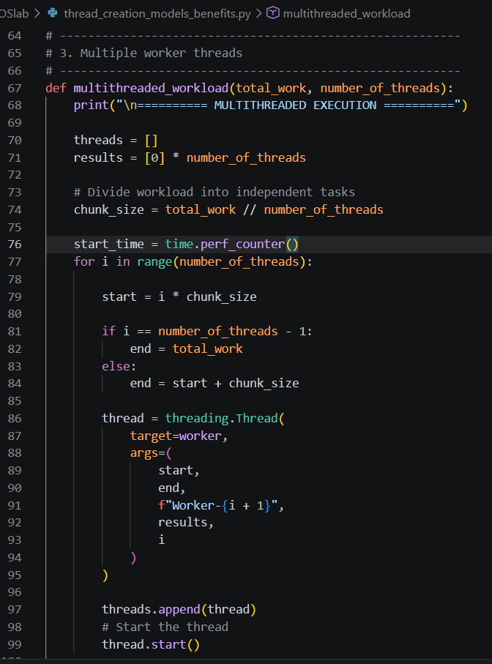
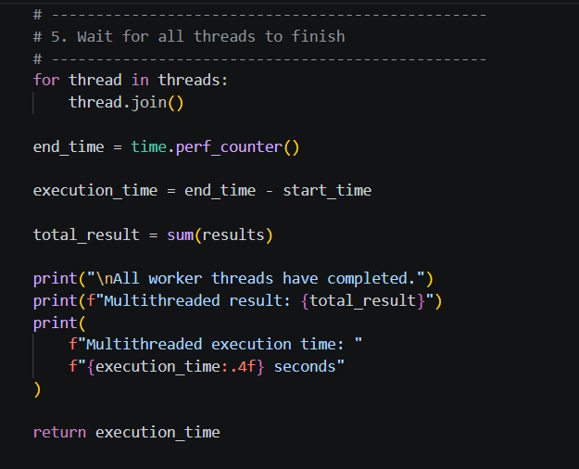
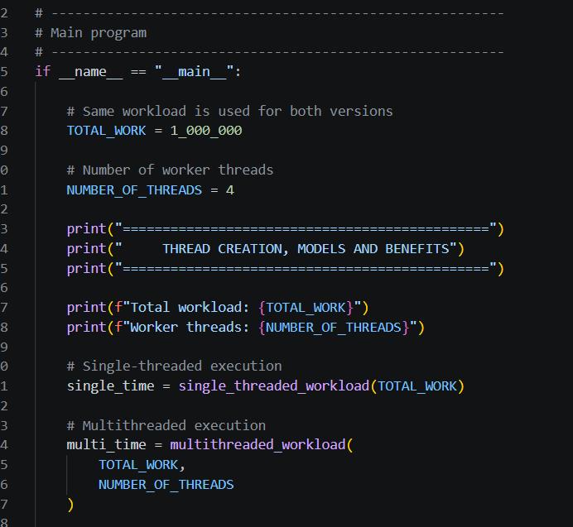
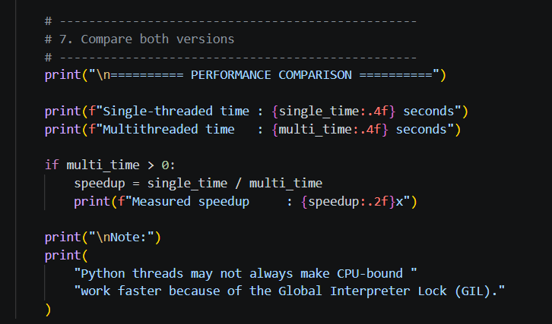

OUTPUT:
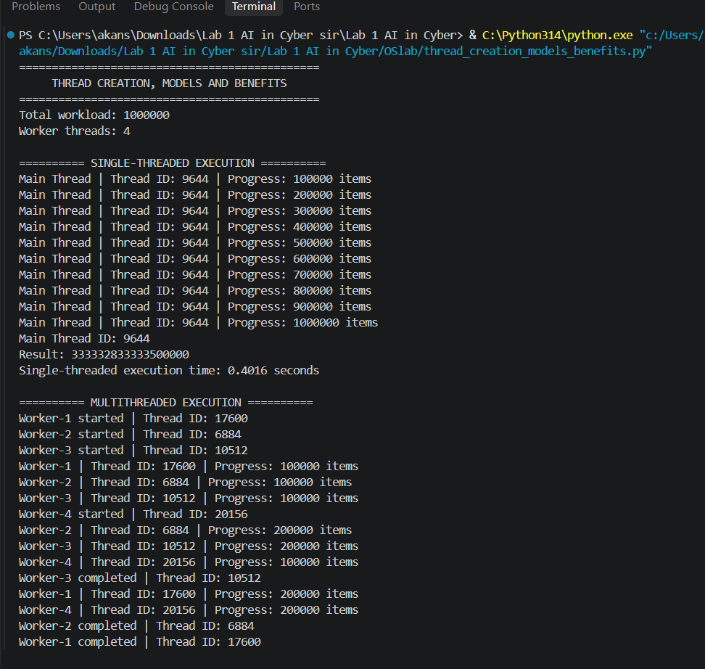
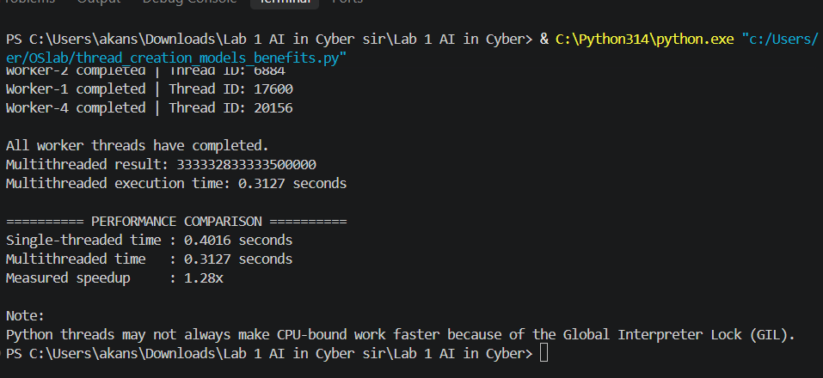
User-level threads
User-level threads are managed by a user-level library/application rather than directly by the operating system kernel.
Advantages:
- Fast to create and manage.
- Less operating-system overhead.
Disadvantage:
- If one thread blocks, depending on the implementation, other threads may also be affected.
Kernel-level threads
Kernel-level threads are managed directly by the operating system kernel.
Advantages:
- The OS can schedule individual threads.
- Threads can run on different CPU cores.
Disadvantages:
- Creating and managing them can have more overhead.
Common multithreading models
- Many-to-One
Many user threads are mapped to one kernel thread.
- One-to-One
Each user thread is mapped to one kernel thread.
- Many-to-Many
Many user threads are mapped to multiple kernel threads.

Responsiveness: Threads allow a program to continue performing other tasks while another task is running. This can make applications more responsive.
Resource sharing: Threads belonging to the same process share resources such as memory and files. This makes communication between threads easier.
Concurrency: Concurrency means multiple tasks make progress during overlapping periods.
Parallelism: Parallelism means multiple tasks actually execute at the same time, usually on multiple CPU cores.
Race condition: A race condition happens when multiple threads access shared data at the same time and the final result depends on the order of execution.
For example:
Thread 1 → changes balance
Thread 2 → changes balance
↓
Unexpected result
Locks can be used to protect shared resources.
Deadlock: A deadlock occurs when threads wait for resources held by each other and none can continue.
Thread overhead: Creating, scheduling and managing threads requires CPU and memory resources. For small workloads, the overhead can sometimes be greater than the performance benefit.

