Lab Task — Multithreading, Synchronization and Deadlock


Operating System Lab

Name: Akansha
Roll no: 2401010195
Course: B-Tech CSE Core
Year: 3rd Year, 5th Semester Submitted To: Ms. Suman Punia

Classical Synchronization Problems
Description
1. Implement the Producer–Consumer problem using a finite circular buffer.
2. Use suitable synchronization mechanisms to control buffer access.
3. Implement the Readers–Writers problem with protected reader count and exclusive writer access.
4. Implement the Dining Philosophers problem using controlled shared-resource access.
5. Prevent permanent deadlock using resource ordering, a waiter mechanism or restricted concurrency.
6. Use finite iterations so that every program terminates normally.
7. Display the state of shared resources and thread operations.
8. Discuss deadlock, starvation, fairness and correctness.

CODE:
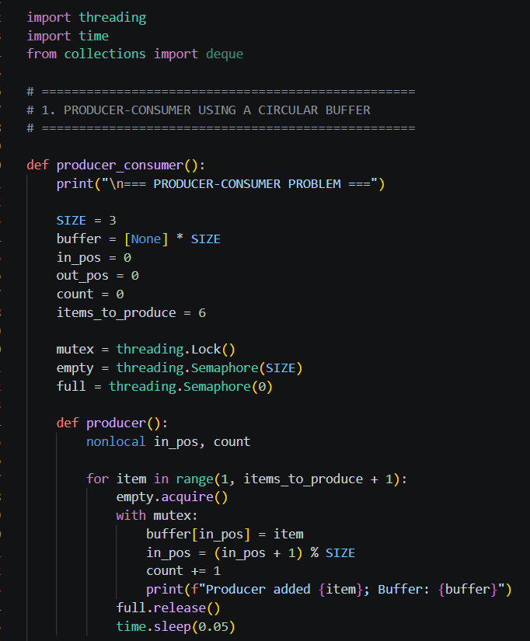
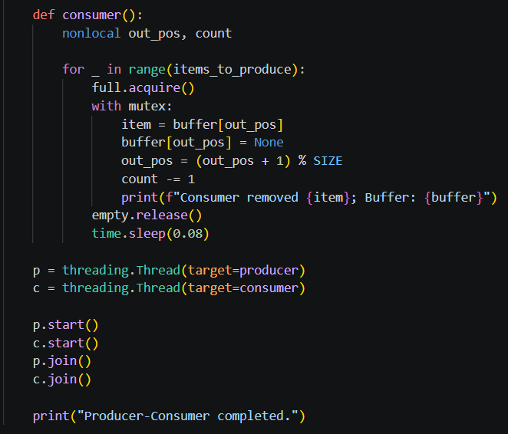
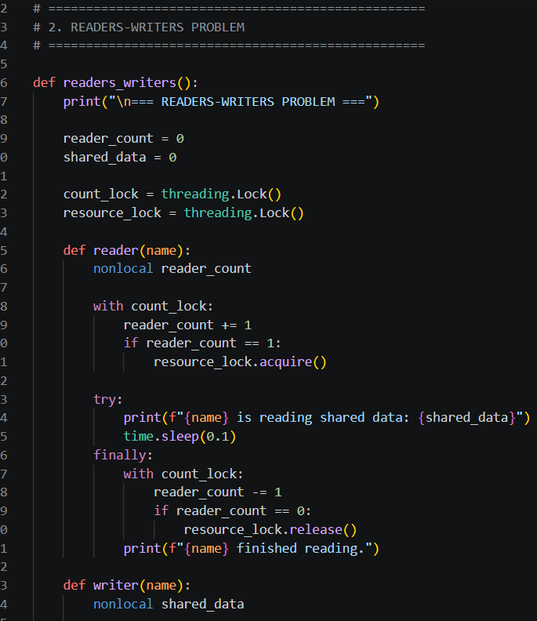
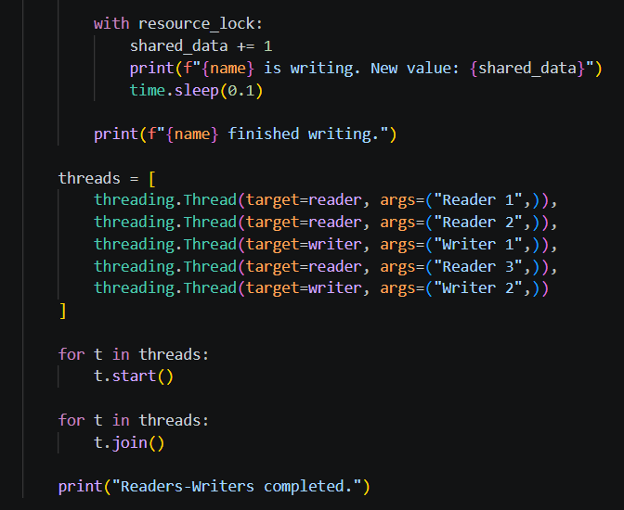
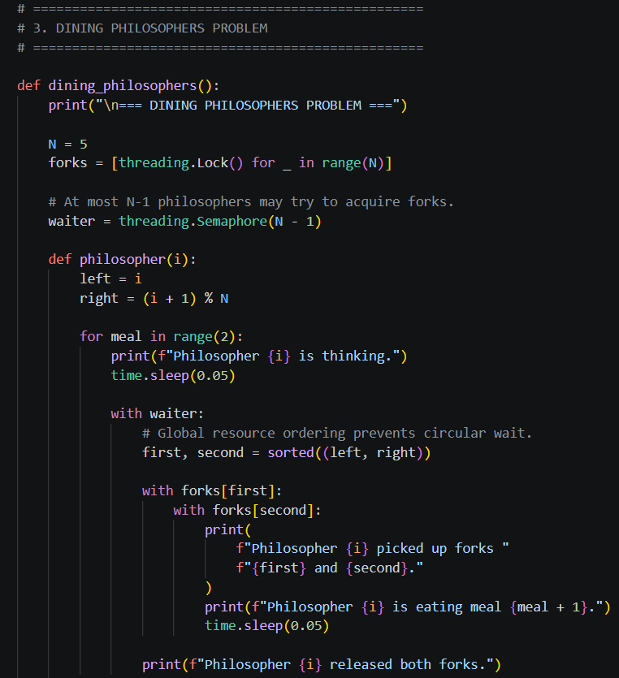
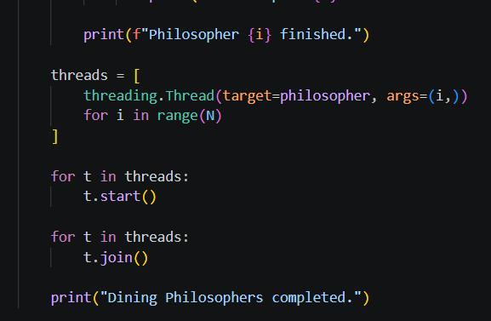
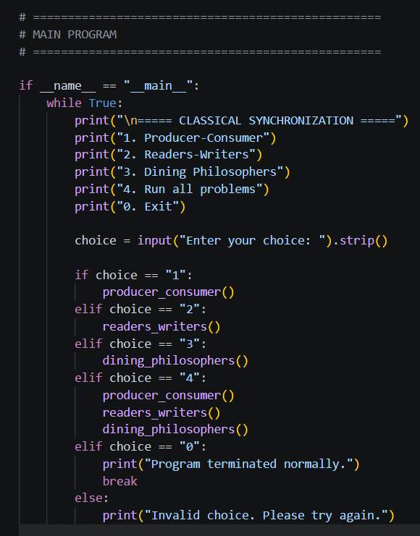

OUTPUT:
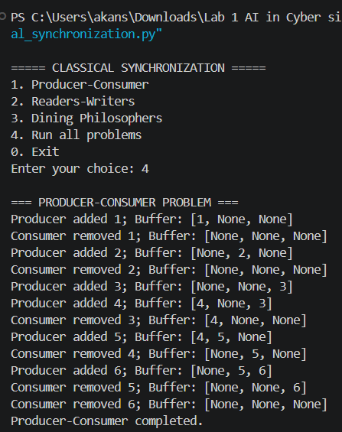

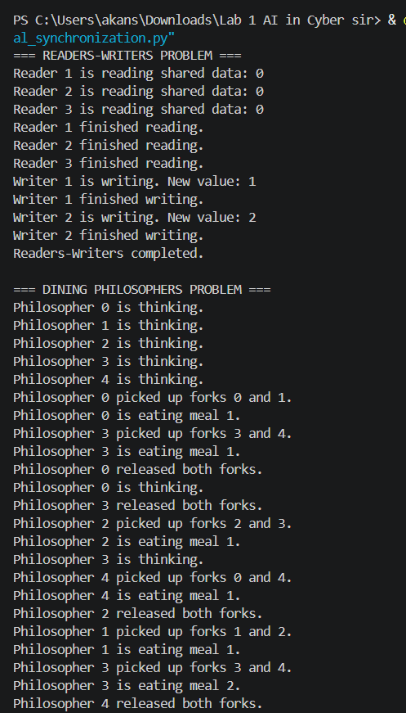
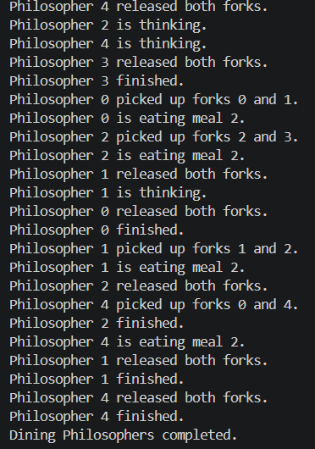

Classical synchronization problems are used in Operating Systems to explain how multiple processes or threads safely share common resources. Synchronization prevents race conditions, where the result depends on the unpredictable order of execution.
The three major classical synchronization problems are:
1. Producer–Consumer Problem: A producer adds items to a shared buffer, while a consumer removes them. A finite circular buffer must not overflow or allow a consumer to remove an item when it is empty. Locks and semaphores can coordinate access.
2. Readers–Writers Problem: Multiple readers can access shared data simultaneously, but a writer must have exclusive access. A lock protects the reader count and prevents simultaneous writing and reading.
3. Dining Philosophers Problem: Several philosophers share forks, and each needs two forks to eat. If everyone holds one fork and waits for another, deadlock can occur. Resource ordering or a waiter mechanism can prevent it.

