**SQL ASSIGNMENT**

1.Write a query to fetch the EmpFname from the EmployeeInfo table in upper case and use the ALIAS name as EmpName.

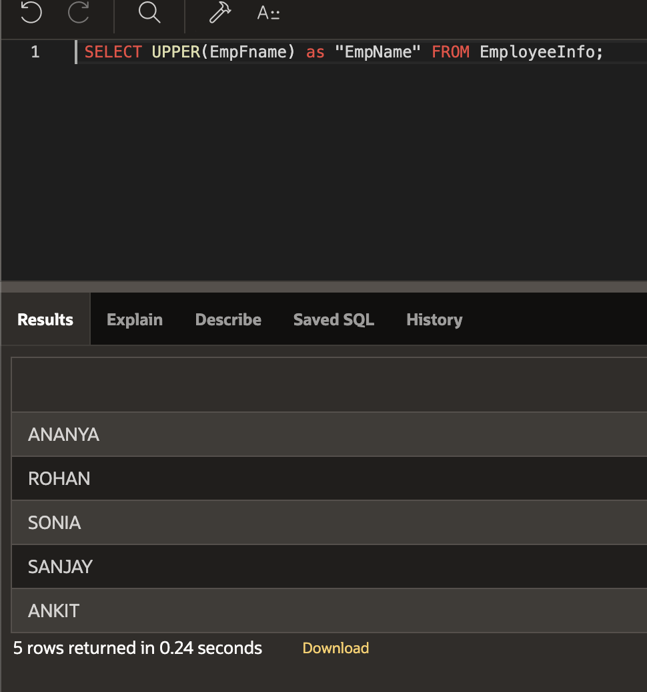

2. Write a query to fetch the number of employees working in the department ‘HR’.

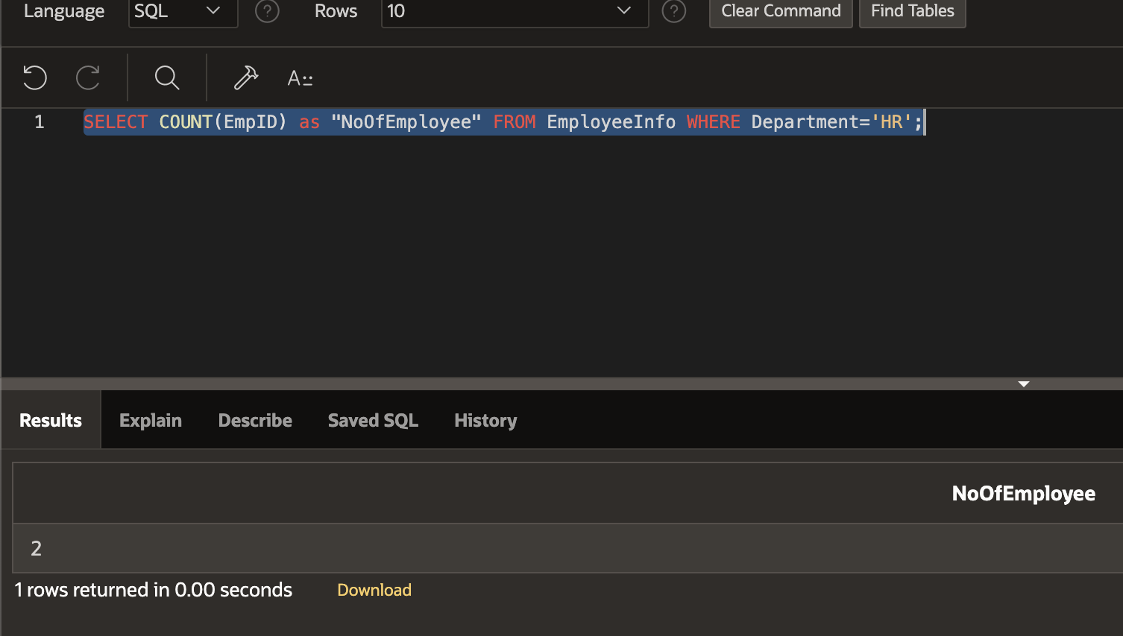

3. Write a query to retrieve the first four characters of  EmpLname from the EmployeeInfo table.

4. Write a query to create a new table which consists of data and structure copied from the other table.

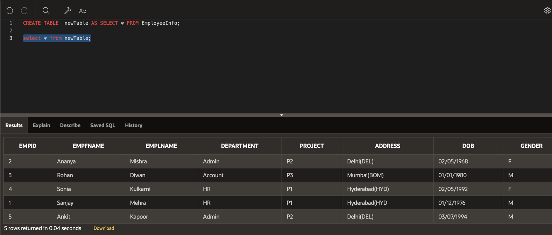

5. Write a query to retrieve the EmpFname and EmpLname in a single column as “FullName”. The first name and the last name must be separated with space.

6. Write a query to retrieve Departments who have less than 2 employees working in it.

7. Write a query to find the third-highest salary from the EmpPosition table.

8. Write a query to find the Nth highest salary from the table without using TOP/limit keyword.

9. Write a query to fetch 50% records from the EmployeeInfo table.

**SELECT** TOP 50 percent * **FROM** EmployeeInfo;

10. Write a query to retrieve duplicate records from a table.

