**Practical No. 2**

**Aim:** To create GIT Repository and execute different git commands.

**Code:**

1. **Creation of branch and merging files:**

**Output:**

Files present in the master branch

code written in add.py file

Master branch

Branch created other than master branch

add.py file in the new branch created with a new code in the file

Shifted to new branch

New branch merged with the master branch

**Merge conflict:**

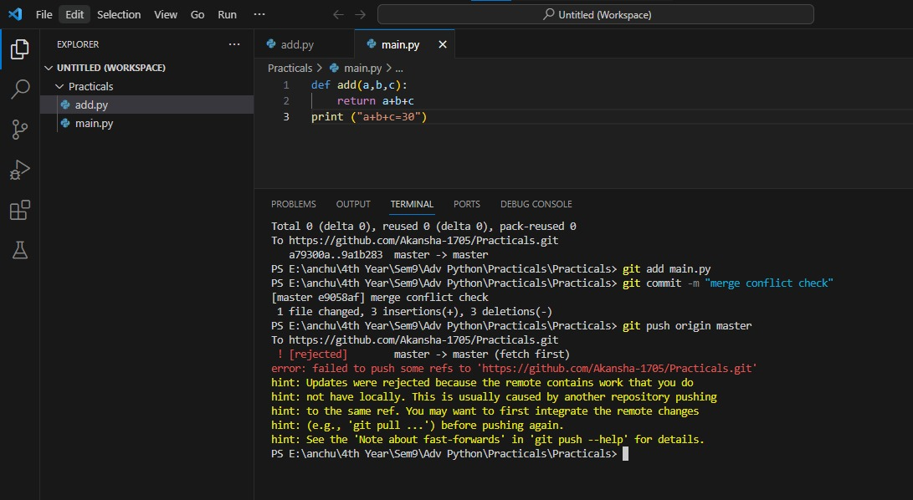

Merge conflict- An error occurs when same positional change is done between two commits

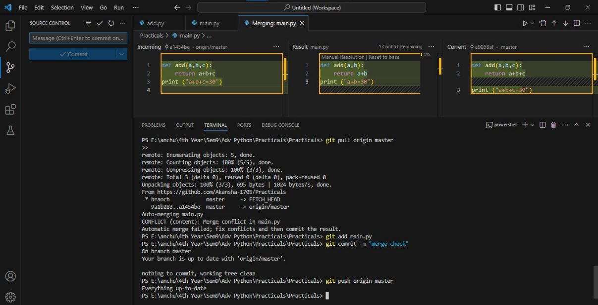

All the changes were accepted that occurred between the two commits

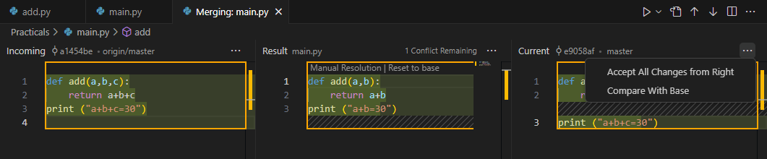

1. **Git log and git diff implementation:**

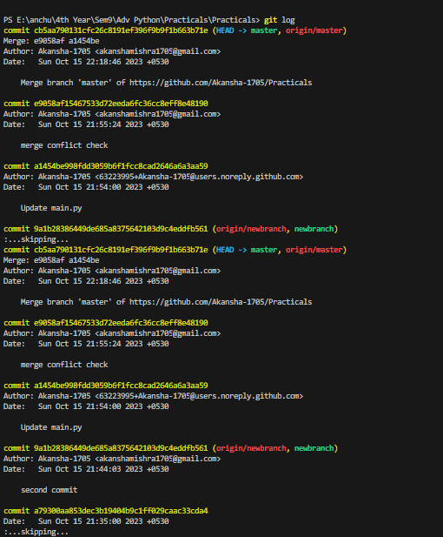

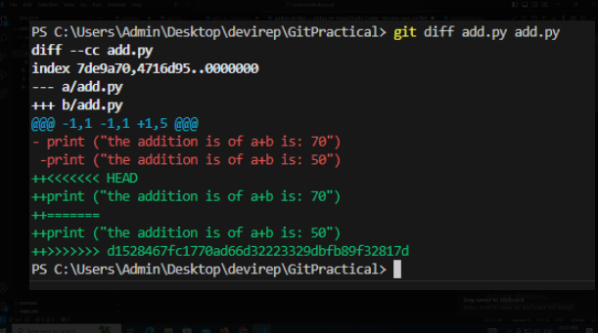

The differences between the two files can be known using the git diff command

1. **Merge conflict between collaborators:**

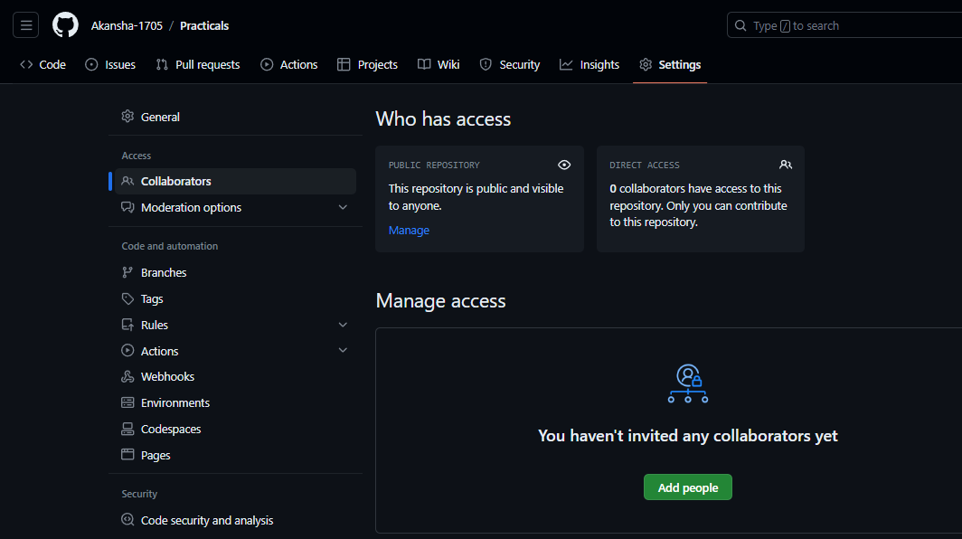

Add people to the workspace for working on the same project

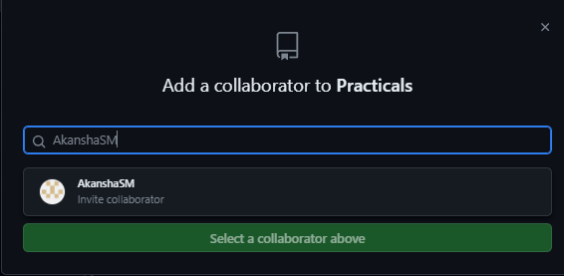

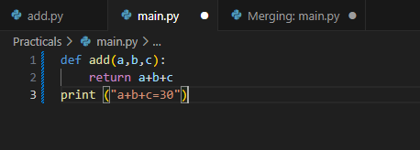

The code in the main file

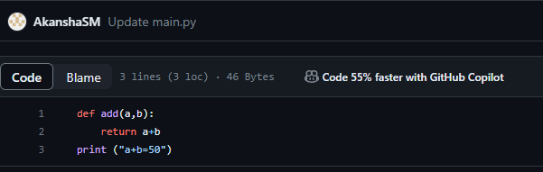

The code changed by the collaborator and committed the changes before the main user

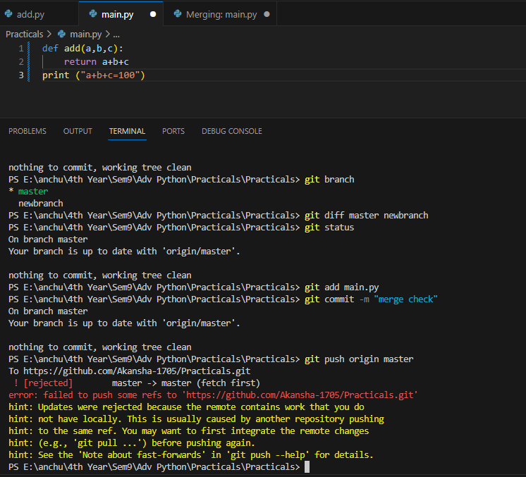

As the changes were committed by the collaborator before the user so, an error occurred

At the same time the code was changed in the main file and committed

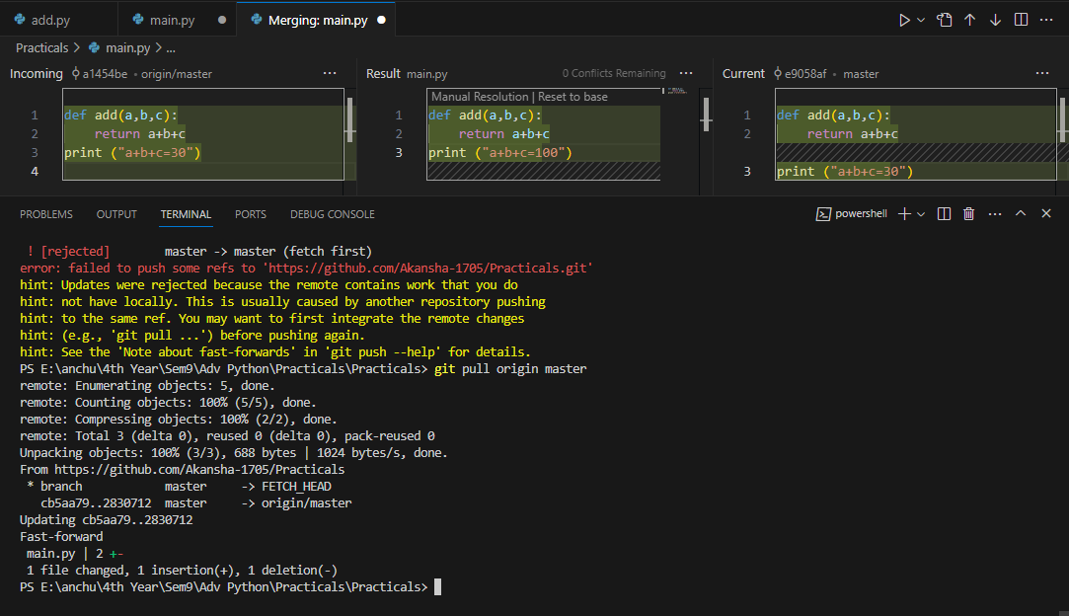

The branch was pulled back and changes are accepted by the user

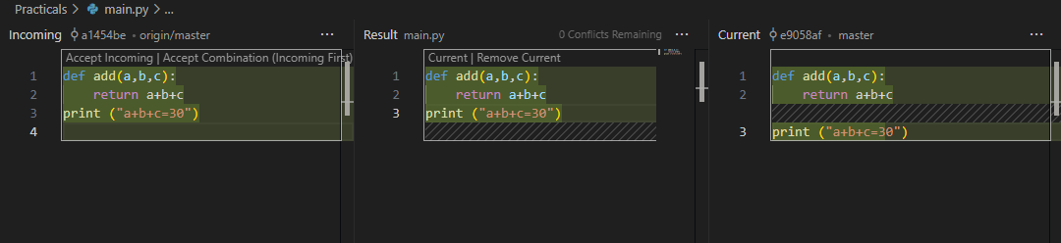

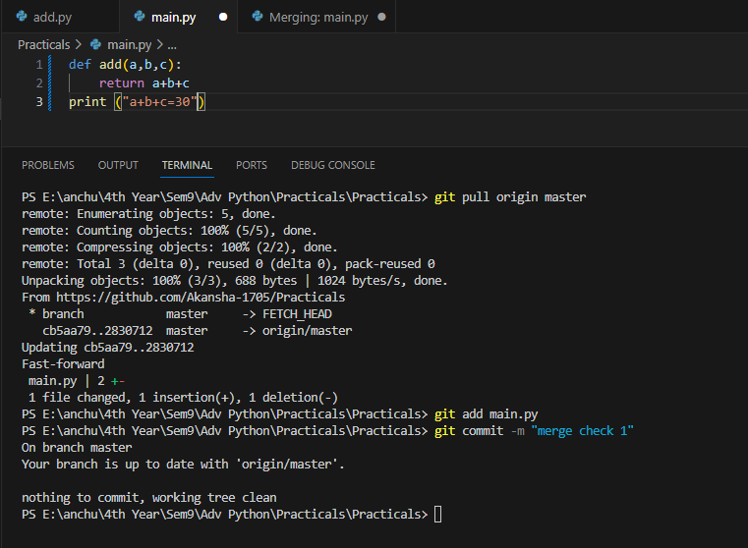

Changes got reflected in the main file after accepting the merge conflict from collaborator