**Practical No. 2**

**Aim:** To create GIT Repository and execute different git commands.

**Code:**

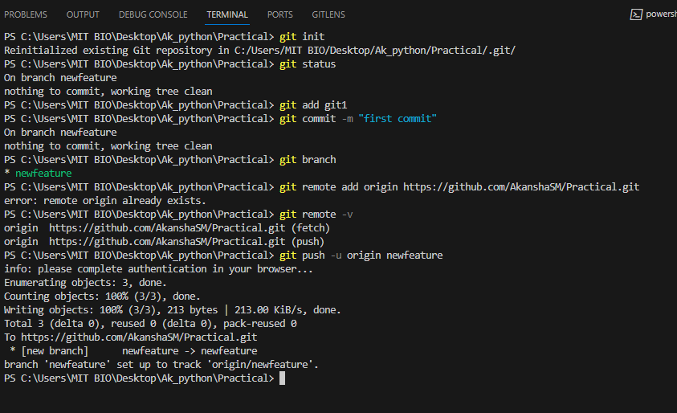

PS C:\Users\Admin\Desktop\Akansha\GitPractical> **git status**

On branch master

No commits yet

Untracked files:

(use "git add <file>..." to include in what will be committed)

add.py

nothing added to commit but untracked files present (use "git add" to track)

PS C:\Users\Admin\Desktop\Akansha\GitPractical> **git add add.py**

PS C:\Users\Admin\Desktop\Akansha\GitPractical> **git commit -m "first commit"**

create mode 100644 add.py

create mode 100644 main.py

PS C:\Users\Admin\Desktop\Akansha\GitPractical> **git branch**

* master

PS C:\Users\Admin\Desktop\Akansha\GitPractical> **git status**

On branch master

nothing to commit, working tree clean

PS C:\Users\Admin\Desktop\Akansha\GitPractical> **git remote add origin** https://github.com/AkanshaSM/GitPractical.git

PS C:\Users\Admin\Desktop\Akansha\GitPractical> **git remote -v**

PS C:\Users\Admin\Desktop\Akansha\GitPractical> **git config --global user.email "mishra.akansha1705@gmail.com"**

PS C:\Users\Admin\Desktop\Akansha\GitPractical> **git config --global user.name "AkanshaSM"**

Enumerating objects: 4, done.

Delta compression using up to 20 threads

Compressing objects: 100% (2/2), done.

To https://github.com/AkanshaSM/GitPractical.git

* [new branch] master -> master

PS C:\Users\Admin\Desktop\Akansha\GitPractical> **git checkout newbr1**

Switched to branch 'newbr1'

PS C:\Users\Admin\Desktop\Akansha\GitPractical> **git status**

On branch newbr1

nothing to commit, working tree clean

PS C:\Users\Admin\Desktop\Akansha\GitPractical> **git add add.py**

PS C:\Users\Admin\Desktop\Akansha\GitPractical> **git commit -m "second commit"**

On branch newbr1

PS C:\Users\Admin\Desktop\Akansha\GitPractical> **git push origin newbr1**

remote: Create a pull request for 'newbr1' on GitHub by visiting:

remote: https://github.com/AkanshaSM/GitPractical/pull/new/newbr1

To https://github.com/AkanshaSM/GitPractical.git

PS C:\Users\Admin\Desktop\Akansha\GitPractical> **git add add.py**

PS C:\Users\Admin\Desktop\Akansha\GitPractical> **git commit -m "third commit"**

On branch newbr1

nothing to commit, working tree clean

PS C:\Users\Admin\Desktop\Akansha\GitPractical> **git status**

On branch newbr1

PS C:\Users\Admin\Desktop\Akansha\GitPractical> **git add add.py**

PS C:\Users\Admin\Desktop\Akansha\GitPractical> **git commit -m "third commit"**

[newbr1 5f2b81f] third commit

PS C:\Users\Admin\Desktop\Akansha\GitPractical> **git push origin newbr1**

Counting objects: 100% (5/5), done.

Compressing objects: 100% (2/2), done.

Total 3 (delta 0), reused 0 (delta 0), pack-reused 0

To https://github.com/AkanshaSM/GitPractical.git

PS C:\Users\Admin\Desktop\Akansha\GitPractical> **git checkout master**

Switched to branch 'master'

PS C:\Users\Admin\Desktop\Akansha\GitPractical> **git commit -m "final commit"**

nothing to commit, working tree clean

PS C:\Users\Admin\Desktop\Akansha\GitPractical> **git push origin master**

Everything up-to-date

PS C:\Users\Admin\Desktop\Akansha\GitPractical> **git merge newbr1**

Updating 5a248a1..5f2b81f

Fast-forward

add.py | 3 +--

1 file changed, 1 insertion(+), 2 deletions(-)

PS C:\Users\Admin\Desktop\Akansha\GitPractical> **git add add.py**

PS C:\Users\Admin\Desktop\Akansha\GitPractical> **git commit -m "final commit"**

On branch master

nothing to commit, working tree clean

PS C:\Users\Admin\Desktop\Akansha\GitPractical> **git push origin master**

Total 0 (delta 0), reused 0 (delta 0), pack-reused 0

To https://github.com/AkanshaSM/GitPractical.git

5a248a1..5f2b81f master -> master

PS C:\Users\Admin\Desktop\Akansha\GitPractical> **git checkout newbr1**

Switched to branch 'newbr1'

PS C:\Users\Admin\Desktop\Akansha\GitPractical> **git checkout master**

Switched to branch 'master'

PS C:\Users\Admin\Desktop\Akansha\GitPractical> **git branch -d newbr1**

Deleted branch newbr1 (was 5f2b81f).

PS C:\Users\Admin\Desktop\Akansha\GitPractical> **git status**

On branch master

nothing to commit, working tree clean

PS C:\Users\Admin\Desktop\Akansha\GitPractical> **git checkout newbr1**

Switched to a new branch 'newbr1'

branch 'newbr1' set up to track 'origin/newbr1'.

PS C:\Users\Admin\Desktop\Akansha\GitPractical> **git checkout master**

Switched to branch 'master'

PS C:\Users\Admin\Desktop\Akansha\GitPractical> **git branch -d newbr1**

Deleted branch newbr1 (was 5f2b81f).

PS C:\Users\Admin\Desktop\Akansha\GitPractical>