**Practical No: 3**

**(Part A)**

**Aim:** To use render template and redirect functions in Flask

**Code:**

1. **Basic Flask:**

from flask import Flask

app=Flask(__name__)

@app.route("/Ak/<name>/<int:password>")

def display(name,password):

return f"<h1>Name: {name}</h1> <h1>Password: {password}</h1>"

if __name__ == "__main__":

app.run()

**Implementation:**

**Terminal Commands:**

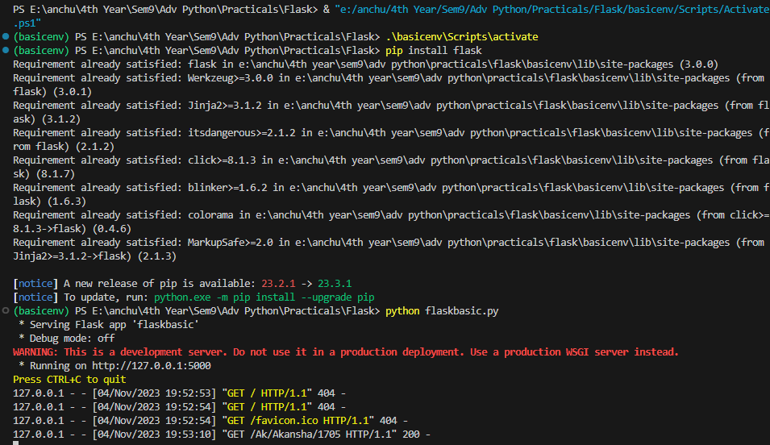

Click on the link to see the output

**Output:**

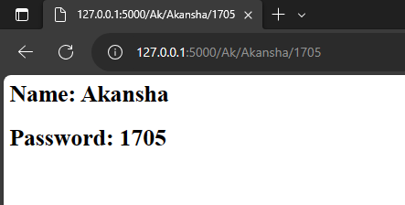

Variables passed in the url

1. **Render template:**

**Python file code:**

from flask import Flask,render_template,url_for,request

app=Flask(__name__)

@app.route('/Ak')

def func1():

return render_template('renderh.html')

if __name__=='__main__':

app.run(debug=True)

**html code:**

<!DOCTYPE html>

<html>

<head>

<title>Login Page</title>

</head>

<body>

<form action="/Ak">

<label for="username">Username:</label>

<input type="text" id="username" name="username" required><br><br>

<label for="password">Password:</label>

<input type="password" id="password" name="password" required><br><br>

<input type="submit" value="Login">

</form>

</body>

</html>

**Implementation:**

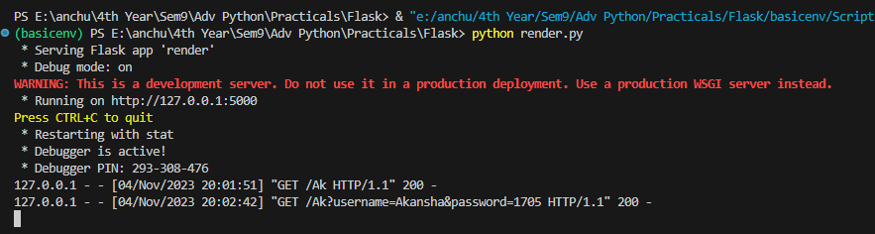

Click on the link to see the output

**Output:**

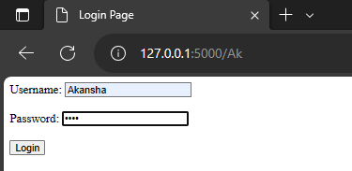

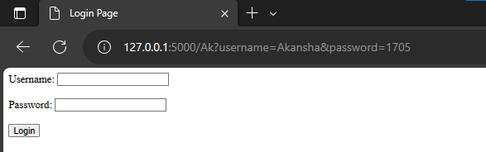

After logging in the name and password can be retrieved in the url

Click on the link to see the output

1. **Redirect:**

**Python file:**

from flask import Flask, redirect, url_for, request, render_template, jsonify

app = Flask(__name__)

@app.route('/Ak')

def func1():

return render_template('redirecth.html')

@app.route('/redirect_check', methods=["POST"])

def validate():

if request.method == 'POST' and request.form['username'] == 'Akansha' and request.form['password'] == '1705':

return jsonify({"message": "Logged in Successfully!"})

else:

return jsonify({"message": "Invalid credentials - login failed!"})

@app.route('/success')

def success():

return "Logged in Successfully!"

@app.route('/invalid')

def invalid():

return "Invalid credentials - login failed!"

if __name__ == '__main__':

app.run(debug=True)

**html code:**

<head>

<title>Login Page</title>

</head>

<body>

<form action="/redirect_check" method="POST">

<label for="username">Username:</label>

<input type="text" id="username" name="username" required><br><br>

<label for="password">Password:</label>

<input type="password" id="password" name="password" required><br><br>

<input type="submit" value="Login">

</form>

</body>

</html>

**Implementation:**

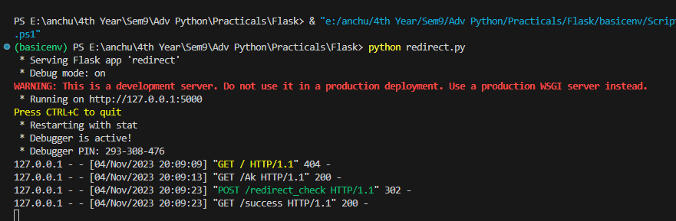

**Output:**

1. Entering correct username and password thus redirected to success url

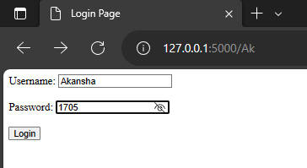

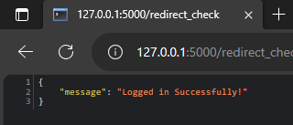

1. Entering wrong password and username thus redirected to invalid url

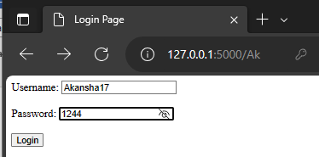

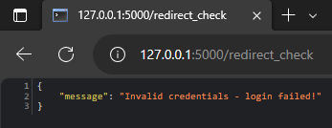

**(Part B)**

**Aim:** To create an application (login page) using a Flask APIwith MySQL connectivity.

**Code:**

1. **Login page html code for the application:**

<!DOCTYPE html>

<html>

<head>

<title>Login Page</title>

<style>

body {

font-family: Arial, sans-serif;

background-color: #f2f2f2;

text-align: center;

}

.container {

background-color: #fff;

max-width: 400px;

margin: 100px auto;

padding: 20px;

border-radius: 5px;

box-shadow: 0 0 5px rgba(0, 0, 0, 0.3);

}

h3 {

font-size: 18px;

color: #007BFF; /* Set text color to dark blue */

}

input {

display: block;

width: 100%;

padding: 6px;

margin: 10px 0;

border: 1px solid #ccc;

border-radius: 3px;

background-color: #f9f9f9; /* Light grey background */

}

input[type="submit"] {

background-color: #007BFF; /* Blue button */

color: #fff;

border: none;

padding: 10px 15px;

cursor: pointer;

}

</style>

</head>

<body>

<div class="container">

<h2>Login Page</h2><br>

<form action="/loginsql" method="POST">

<h3>Username:</h3>

<input type="text" id="username" name="username" required>

<h3>Password:</h3>

<input type="password" id="password" name="password" required>

<br>

<input type="submit" value="Login">

</form>

</div>

</body>

</html>

1. **About Me html code for the application:**

<!DOCTYPE html>

<html>

<head>

<title>About Me</title>

</head>

<body>

<table align="center" width="600">

<tr>

<td align="center">

<h1>About Me</h1>

</td>

</tr>

<tr>

<td align="center">

<p>Hi, thank you for logging in. I am Akansha Mishra, a 5th-year integrated M.Tech Bioengineering student. I love painting and drawing, and here is one of my paintings:)</p>

</td>

</tr>

<tr>

<td align="center">

<img src="{{ url_for('static', filename='Fluid_art.jpg') }}" style="max-width: 100%;">

</td>

</tr>

</table>

</body>

</html>

1. **Python file for the application:**

from flask import Flask, render_template, request, redirect, url_for

from flask_mysqldb import MySQL

app = Flask(__name__)

app.config['MYSQL_HOST'] = 'localhost'

app.config['MYSQL_USER'] = 'root'

app.config['MYSQL_PASSWORD'] = 'root123'

app.config['MYSQL_DB'] = 'flaskdb'

mysql = MySQL(app)

@app.route('/')

def func1():

return render_template('loginsql.html')

@app.route('/loginsql', methods=['POST'])

def login():

if request.method == 'POST' and 'username' in request.form and 'password' in request.form:

username = request.form['username']

password = request.form['password']

cursor = mysql.connection.cursor()

cursor.execute("SELECT * FROM flasktable WHERE user_id=%s AND password_user=%s", (username, password))

account = cursor.fetchone()

if account:

return render_template('aboutme.html')

else:

return redirect(url_for("fail"))

@app.route('/fail')

def fail():

return "Invalid Credentials- Please enter correct username and password!"

if __name__ == '__main__':

app.run(debug=True)

1. **MySQL workbench database creation:**

create database flaskdb;

use flaskdb;

create table flasktable(user_id varchar(30) NOT NULL,password_user varchar(30) NOT NULL);

insert into flasktable(user_id,password_user) values ('akansha01','#ak1705');

SELECT * from flasktable;

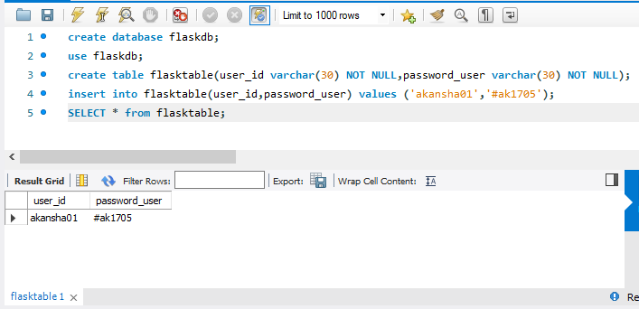

**Implementation:**

1. In the terminal run the following commands
2. Check if the python is already installed ---> python --version
3. E:\anchu\4th Year\Sem9\Adv Python\Practicals\FlaskSql> py -m venv flasksqlenv
4. PS E:\anchu\4th Year\Sem9\Adv Python\Practicals\FlaskSql> .\flasksqlenv\Scripts\activate
5. (flasksqlenv) PS E:\anchu\4th Year\Sem9\Adv Python\Practicals\FlaskSql> pip install flask
6. (flasksqlenv) PS E:\anchu\4th Year\Sem9\Adv Python\Practicals\FlaskSql> pip install flask-mysqldb
7. (flasksqlenv) PS E:\anchu\4th Year\Sem9\Adv Python\Practicals\FlaskSql> python sqlflask.py

**Output:**

1. After successful login:

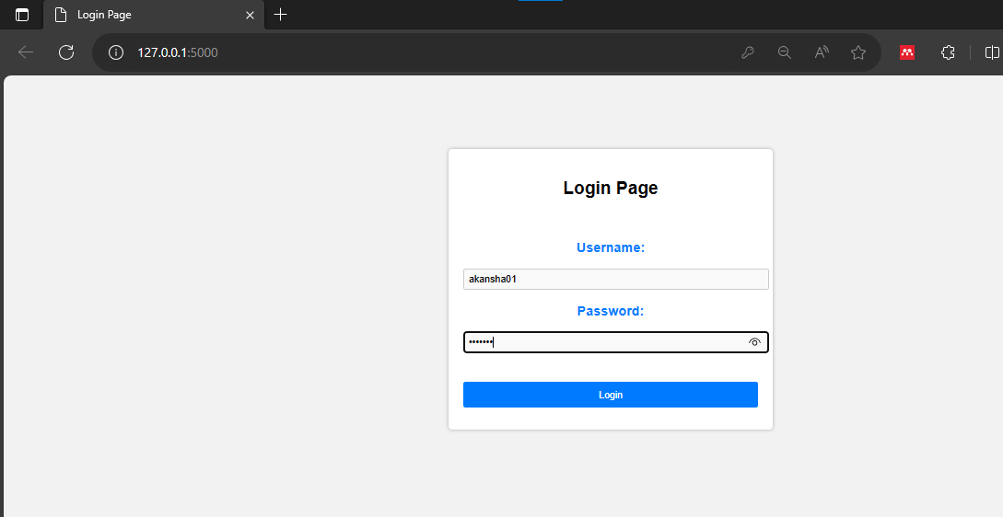

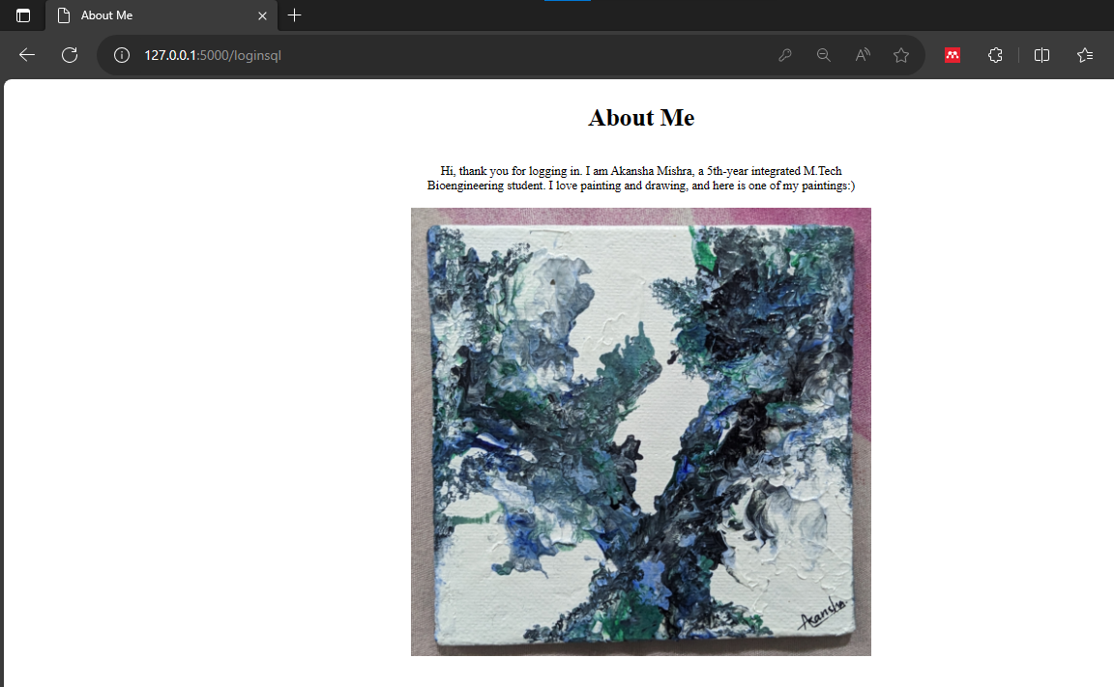

Directed to about me page if the username and password matches with the mysql database

1. Message displayed after unsuccessful login:

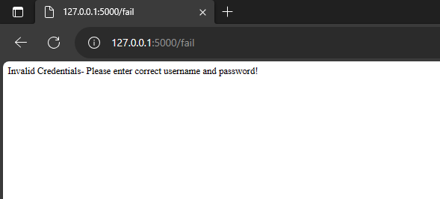

If the username and password doesn’t match with the mysql database entry then it is redirected to the fail url and a message is displayed