FORTUNE INSTITUTE OF INTERNATION BUSINESS

CORPORATE FINANCE



“Capital Structure and Firm Performance – A Comparative Study of the Indian Automobile and IT”

SUBMITTED BY:
AKANSHA SAINI (25PGDMFM006)
TABLE OF CONTENT

1.INTRODUCITON 3
2.OBJECTIVE OF STUDY 4
3.RELEATED THEORIES 4
3.1 Modigliani–Miller (M&M) Theory 4
3.2 Trade-off Theory 4
3.3 Pecking Order Theory 5
3.4 Agency Cost Theory 5
4. RESEARCH METHODOLOGY 5
4.1 Industries Selected 5
4.2 Company Selection 5
4.3 Data Sources 5
4.4 Key Ratio Definitions 6
4.5 Optimal Capital Structure 6
4.6 Capital-Intensive vs. Asset-Light Industries 6
4.7 Leverage Classification 7
5. DATA ANALYSIS AND DATA INTERPRETATION 7
5.1 Industry-wise Summary Tables 7
5.2 Charts/Graphs 10
5.3 Interpretation 16
6. KEY FINDINGS 16
7. CONCLUSION AND RECOMMENDATION 17
7.1 Conclusion 17
7.2 Recommendation 17
8. ANNEXURES 18

1.INTRODUCITON

Capital structure represents the combination of debt and equity financing that a firm employs to fund its operations, investments, and long-term growth. It reflects how a company balances external borrowings with shareholder funds to support its business activities. The proportion of these financing sources is commonly referred to as leverage, and it plays a central role in determining a firm’s financial stability, cost of capital, and overall performance. A well-designed capital structure can reduce financing costs, enhance profitability, and strengthen a company’s competitive position, whereas a poorly structured one can increase financial risk and threaten long-term sustainability.
Leverage decisions especially the debt–equity mix significantly influence operational flexibility, interest obligations, and the ability to withstand market fluctuations. High debt levels may offer tax benefits and boost returns during profitable periods, but they also increase fixed financial commitments and amplify bankruptcy risk. On the other hand, dependence on equity provides financial safety and liquidity but may dilute ownership and reduce return on equity. Therefore, identifying the optimal balance between debt and equity is crucial for improving firm performance and achieving financial efficiency.
Comparing industries with fundamentally different business models provides meaningful insights into how capital structure impacts performance. The automobile industry is traditionally capital-intensive and requires substantial investment in physical assets such as manufacturing plants, machinery, technology upgrades, and inventory management. As a result, automobile firms often rely more heavily on debt financing and face higher financial risk due to large fixed costs. In contrast, the IT industry follows an asset-light model, with its value driven primarily by intellectual capital, skilled manpower, and digital infrastructure rather than heavy physical assets. This allows IT firms to operate with minimal borrowings and maintain relatively low debt-equity ratios.
By examining these two contrasting industries, this study aims to understand how leverage influences financial health, profitability, and performance outcomes. The comparison highlights whether higher debt contributes positively to returns in capital-intensive sectors or whether low-debt structures, as seen in IT firms, offer better stability and long-term value creation. This analysis provides important insights for managers, investors, and policymakers in designing optimal capital structures tailored to industry characteristics.

2.OBJECTIVE OF STUDY

- To compare how companies in the Automobile and IT industries structure their finances by using a mix of debt and equity. This helps us understand how different types of businesses choose their funding sources based on their needs.
- To examine how leverage that is, the amount of debt a company uses affects its financial performance. The study mainly looks at ROA (Return on Assets) and ROE (Return on Equity) to see whether higher or lower debt levels improve or reduce profitability.
- To identify which companies are over-leveraged (using too much debt and carrying higher financial risk) and which are under-leveraged (using too little debt and missing potential benefits of borrowing).
- To evaluate the overall impact of capital structure on a firm’s profitability, stability, and efficiency across the two contrasting industries. This helps us understand whether capital-intensive firms benefit from debt, and whether asset-light firms perform better with lower leverage.

3.RELEATED THEORIES

3.1 Modigliani–Miller (M&M) Theory
This theory says that in a perfect world (with no taxes, no risk, no bankruptcy costs), a company’s capital structure does not affect its value.
According to M&M, it does not matter whether a firm uses more debt or more equity—the total value stays the same.
Although real-world conditions are different, this theory helps us understand the basic idea that financing choices alone do not create value unless other factors are involved.

3.2 Trade-off Theory
Trade-off Theory says that companies try to balance the benefits and costs of debt.
- Benefit: Debt gives a tax advantage because interest is tax-deductible.
- Cost: Too much debt increases financial risk and the chance of bankruptcy.
So, firms aim for an optimal level of debt where the tax benefits are maximised and the risks are minimised.

3.3 Pecking Order Theory
This theory explains how companies choose their financing sources in a specific order:
- Internal funds first (retained earnings)
- Debt second
- Equity last
The idea is that firms prefer using their own money because it is cheaper and involves no additional risk. They issue equity only when necessary.

3.4 Agency Cost Theory
Agency Cost Theory focuses on conflicts between:
- Managers and shareholders, and
- Debt holders and equity holders
Using debt can sometimes reduce these conflicts because interest payments create pressure on managers to use money efficiently.
However, too much debt can create tension between lenders and shareholders, increasing financial stress.

RESEARCH METHODOLOGY

4.1 Industries Selected
This study examines two distinct industries—Automobile and Information Technology (IT)—to understand how capital structure differs across sectors with contrasting business models. The automobile industry represents a capital-intensive sector that depends heavily on physical assets, while the IT industry operates on an asset-light model, relying primarily on human capital and technology. The comparison provides meaningful insights into how industry characteristics influence leverage decision.

4.2 Company Selection
To ensure meaningful analysis, the study includes three to five listed companies from each industry. The companies were selected based on their market relevance, availability of consistent financial data, and representation within their respective sectors. This selection ensures that the findings reflect broader industry patterns rather than isolated cases.

4.3 Data Sources
All financial information was extracted from credible and publicly available sources, including Screener.in and official Annual Reports published by the selected companies. These sources provided consistent data on debt, equity, earnings, assets, and other financial indicators required for ratio calculation.

4.4 Key Ratio Definitions
- Debt-Equity Ratio (DE): Shows how much debt a company uses compared to its equity.
$$\text{D/E}=\frac{\text{Total Debt}}{\text{Shareholders’ Equity}}$$
- Interest Coverage Ratio (ICR): Shows whether the company can easily pay interest on its loans.
$$\text{ICR}=\frac{\text{EBIT}}{\text{Interest Expense}}$$
- Return on Assets (ROA): Measures how well the company uses its assets to generate profit.
$$\text{ROA}=\frac{\text{Net Profit}}{\text{Total Assets}}$$
- Return on Equity (ROE): Shows how much profit the company earns for every rupee of shareholder equity.
$$\text{ROE}=\frac{\text{Net Profit}}{\text{Equity}}$$

4.5 Optimal Capital Structure
The optimal capital structure is the best combination of debt and equity that allows a firm to minimise its cost of capital and maximise its value.
It is the point where:
- Debt is not too high (lowers financial risk),
- Debt is not too low (misses tax benefits), and
- Profitability and stability are balanced.

4.6 Capital-Intensive vs. Asset-Light Industries
- Capital-Intensive Industries (e.g., Automobile):
Require heavy investment in machinery, factories, and inventory.
Because of high asset needs, these industries often use more debt.
- Asset-Light Industries (e.g., IT):
Depend more on intellectual skills and digital systems instead of physical assets.
These firms usually operate with low debt and rely on internal funds or equity.

4.7 Leverage Classification
To better understand financing decisions, each company was classified as either under-leveraged or over-leveraged based on its Debt-Equity Ratio relative to the industry average.
- If a company’s D/E ratio is lower than the industry average, it is considered under-leveraged, meaning it uses less debt compared to peers.
- If the D/E ratio is higher, it is classified as over-leveraged, indicating greater dependence on debt and higher financial risk.
This classification helps compare how leverage levels influence performance across industries.

DATA ANALYSIS AND DATA INTERPRETATION

5.1 Industry-wise Summary Tables
Here is the 5-year ratio tables that we have calculated.
5-year ratio tables
IT INDUSTRY – CLEANED RATIO TABLES (2021–2025)
Companies: Wipro, HCL, Infosys, TCS
- DEBT–EQUITY RATIO (D/E)
Year | Wipro | HCL | Infosys | TCS
2021 | 5.2532 | 8.7286 | 14.3382 | 11.0883
2022 | 3.7176 | 9.7610 | 13.7651 | 11.4018
2023 | 4.4466 | 13.6431 | 9.0863 | 11.7617
2024 | 4.5544 | 11.8553 | 10.5415 | 11.2815
2025 | 4.3132 | 11.0986 | 11.6468 | 10.0890

- RETURN ON ASSETS (ROA)
Year | Wipro | HCL | Infosys | TCS
2021 | 7.5972 | 7.7041 | 5.5352 | 3.9921
2022 | 8.7622 | 6.5755 | 5.2709 | 3.6652
2023 | 10.2872 | 6.2816 | 5.1682 | 3.3770
2024 | 10.3549 | 6.3021 | 5.2332 | 3.1556
2025 | 9.7137 | 6.0049 | 5.5250 | 3.2512
- RETURN ON EQUITY (ROE)
Year | Wipro | HCL | Infosys | TCS
2021 | 4.9508 | 5.3156 | 3.8216 | 2.6435
2022 | 5.2526 | 4.5383 | 3.3077 | 2.3089
2023 | 6.7368 | 4.3693 | 3.0421 | 2.1289
2024 | 6.6543 | 4.3106 | 3.2782 | 1.9551
2025 | 6.1080 | 3.9722 | 3.5045 | 1.9344

- INTEREST COVERAGE RATIO (ICR)
Year | Wipro | HCL | Infosys | TCS
2021 | 0.0357 | 0.0331 | 0.0070 | 0.0150
2022 | 0.0329 | 0.0197 | 0.0064 | 0.0162
2023 | 0.0637 | 0.0191 | 0.0082 | 0.0144
2024 | 0.0810 | 0.0276 | 0.0131 | 0.0131
2025 | 0.0893 | 0.0301 | 0.0107 | 0.0128

AUTOMOBILE INDUSTRY – RATIO TABLES (2021–2025)
Companies: Mahindra & Mahindra, TVS Motors, Hero Motor, Maruti Suzuki
- Debt–Equity Ratio (D/E)
Year | Mahindra & Mahindra | TVS Motors | Hero Motor | Maruti Suzuki
2021 | 0.5157 | 0.3142 | 101.32 | 96.7363
2022 | 0.6072 | 0.2780 | 93.946 | 129.0835
2023 | 0.6110 | 0.2460 | 107.083 | 48.4218
2024 | 0.6092 | 0.2609 | 130.333 | 705.7311
2025 | 0.5971 | 0.2972 | 121.515 | 1237.4605

- Return on Assets (ROA)
Year | Mahindra & Mahindra | TVS Motors | Hero Motor | Maruti Suzuki
2021 | 109.1058 | 35.9622 | 7.4767 | 16.5865
2022 | 23.7678 | 36.8249 | 8.7804 | 19.4886
2023 | 17.9605 | 26.7571 | 7.9914 | 10.3341
2024 | 19.1297 | 23.6223 | 6.4446 | 8.3492
2025 | 19.6129 | 40.0214 | 6.0564 | 9.0018

- Return on Equity (ROE)
Year | Mahindra & Mahindra | TVS Motors | Hero Motor | Maruti Suzuki
2021 | 27.13425 | 6.21546 | 5.1140 | 12.1078
2022 | 6.42038 | 5.95349 | 6.36595 | 14.3216
2023 | 4.90617 | 4.16883 | 5.72484 | 7.48304
2024 | 5.34906 | 3.78640 | 4.52268 | 6.23615
2025 | 5.43460 | 3.55294 | 4.28785 | 6.72805

- Interest Coverage Ratio (ICR)
Year | Mahindra & Mahindra | TVS Motors | Hero Motor | Maruti Suzuki
2021 | 0.7525 | 0.5285 | 0.0066 | 0.0426
2022 | 0.4490 | 0.4672 | 0.0095 | 0.0426
2023 | 0.3660 | 0.4318 | 0.0060 | 0.0228
2024 | 0.3713 | 0.4280 | 0.0040 | 0.0144
2025 | 0.3716 | 0.3785 | 0.0039 | 0.0132

5.2 Charts/Graphs
IT INDUSTRY RATIO CHARTS

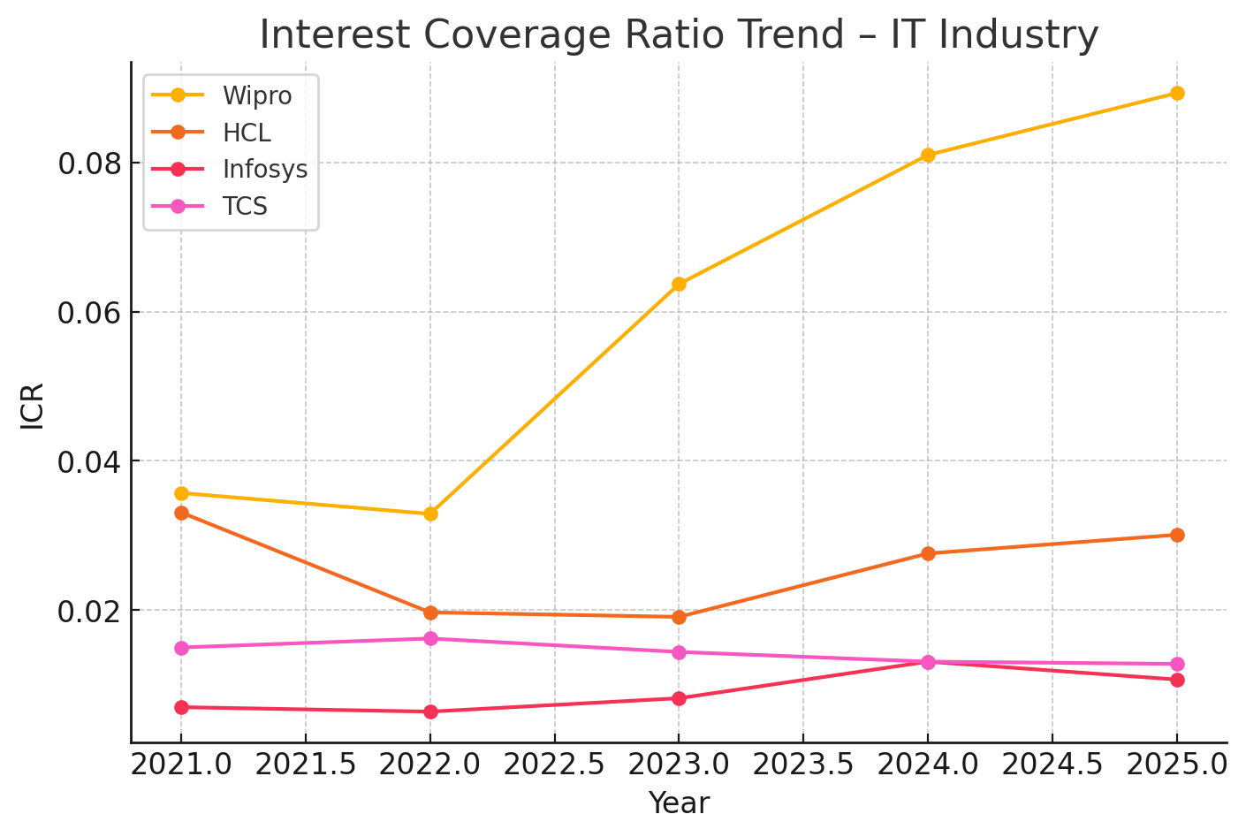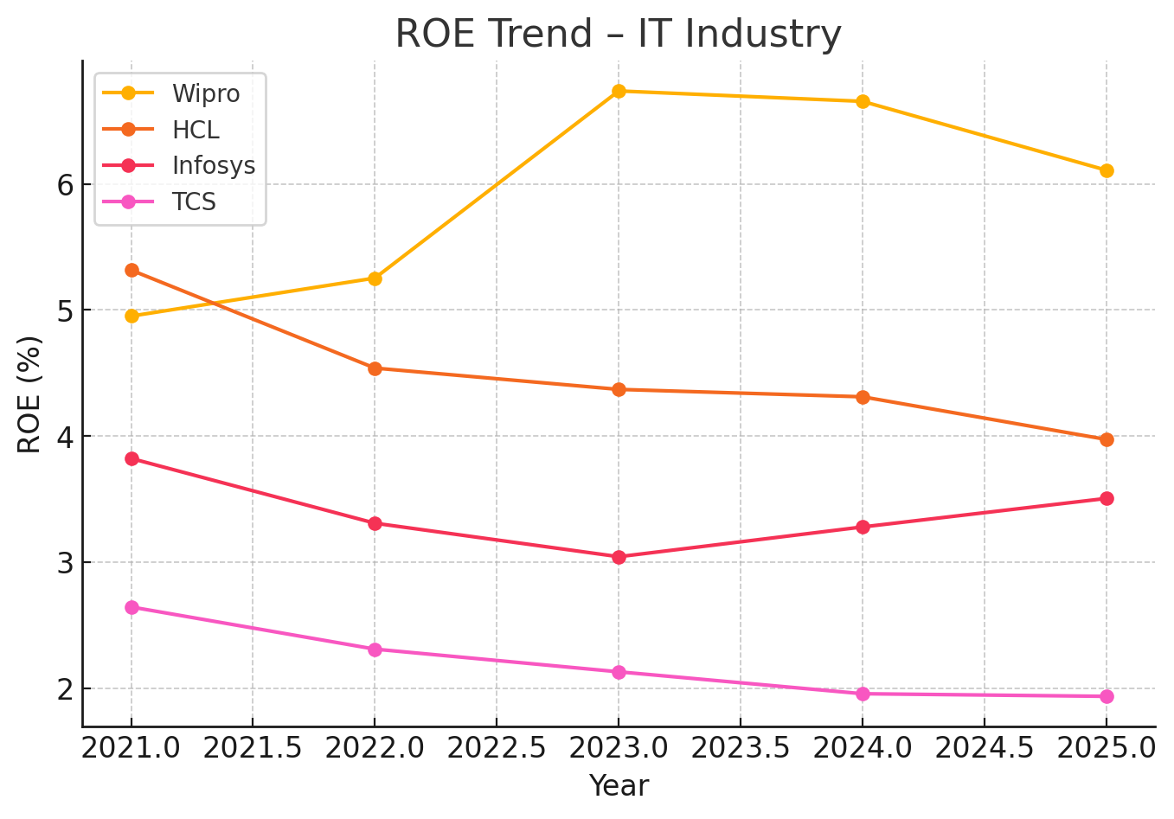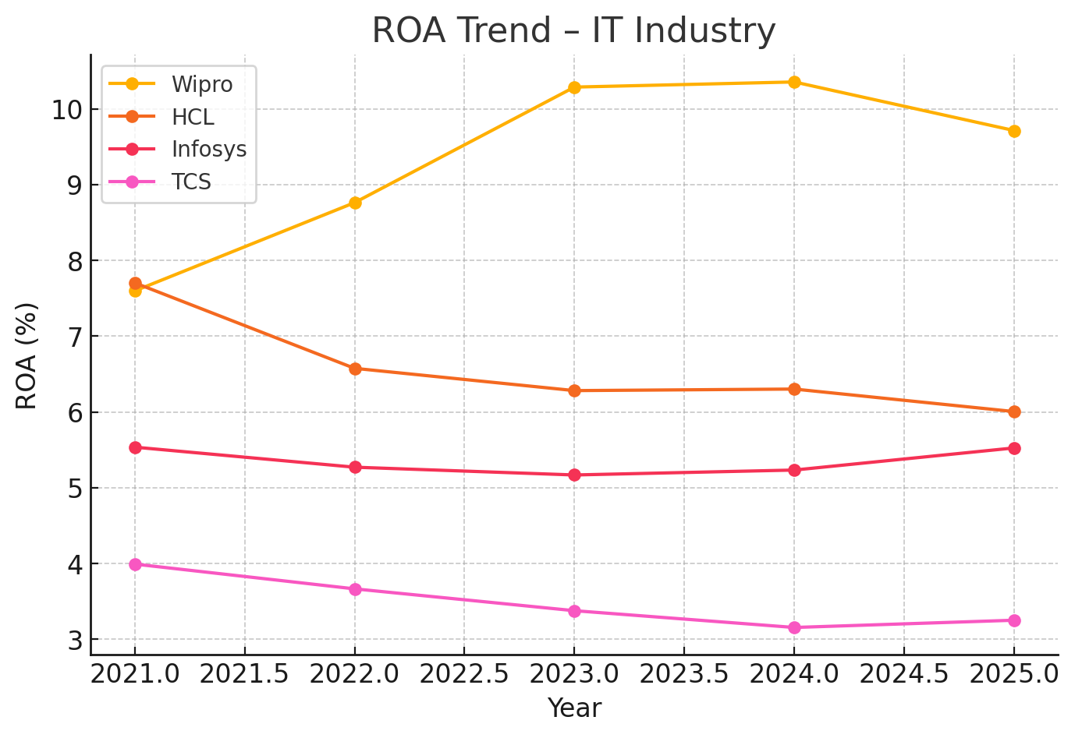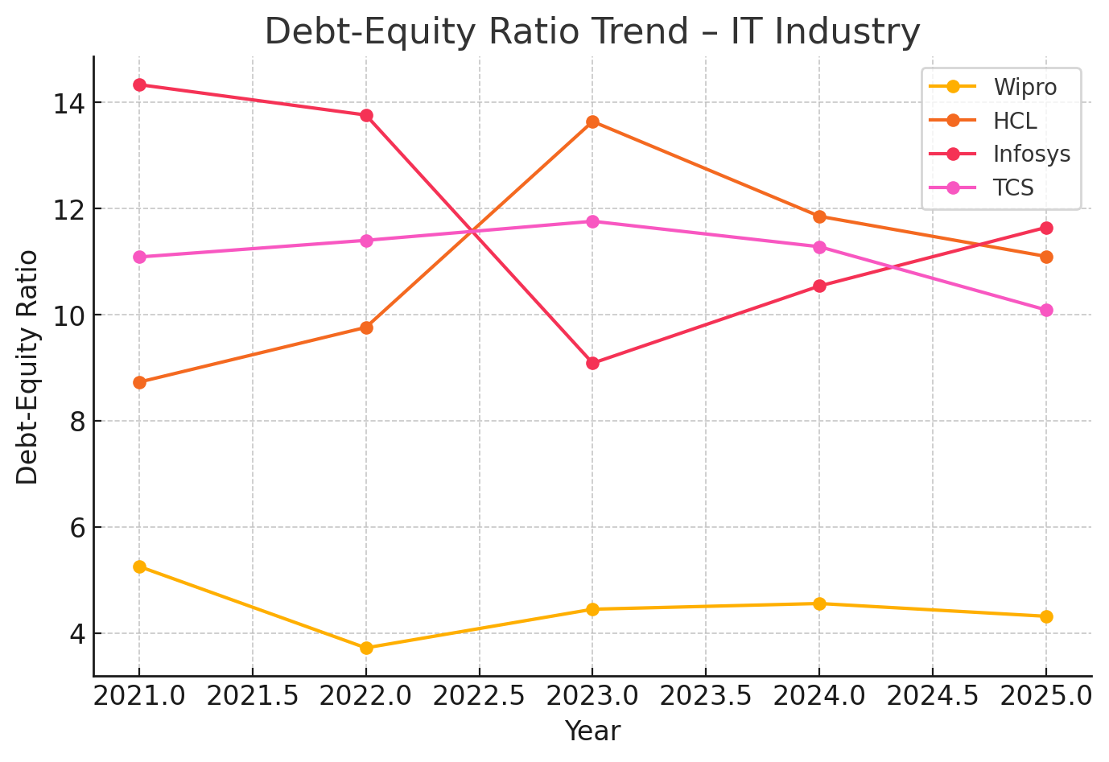

AUTOMOBILE INDUSTRY RATIO CHARTS

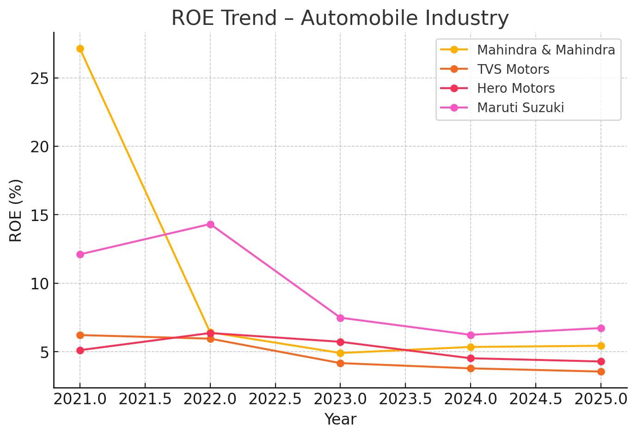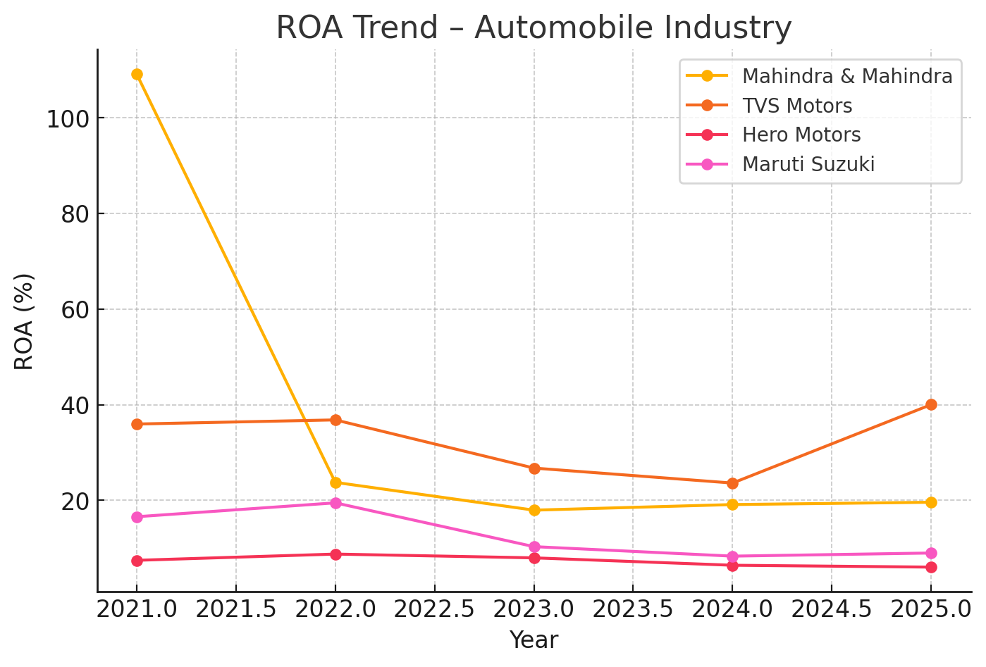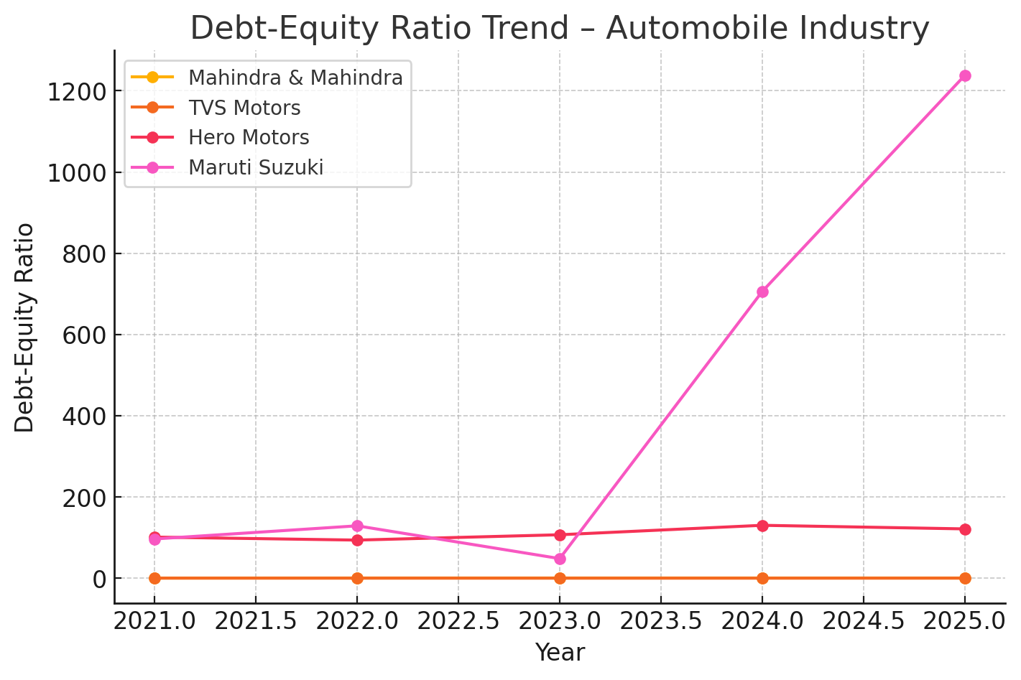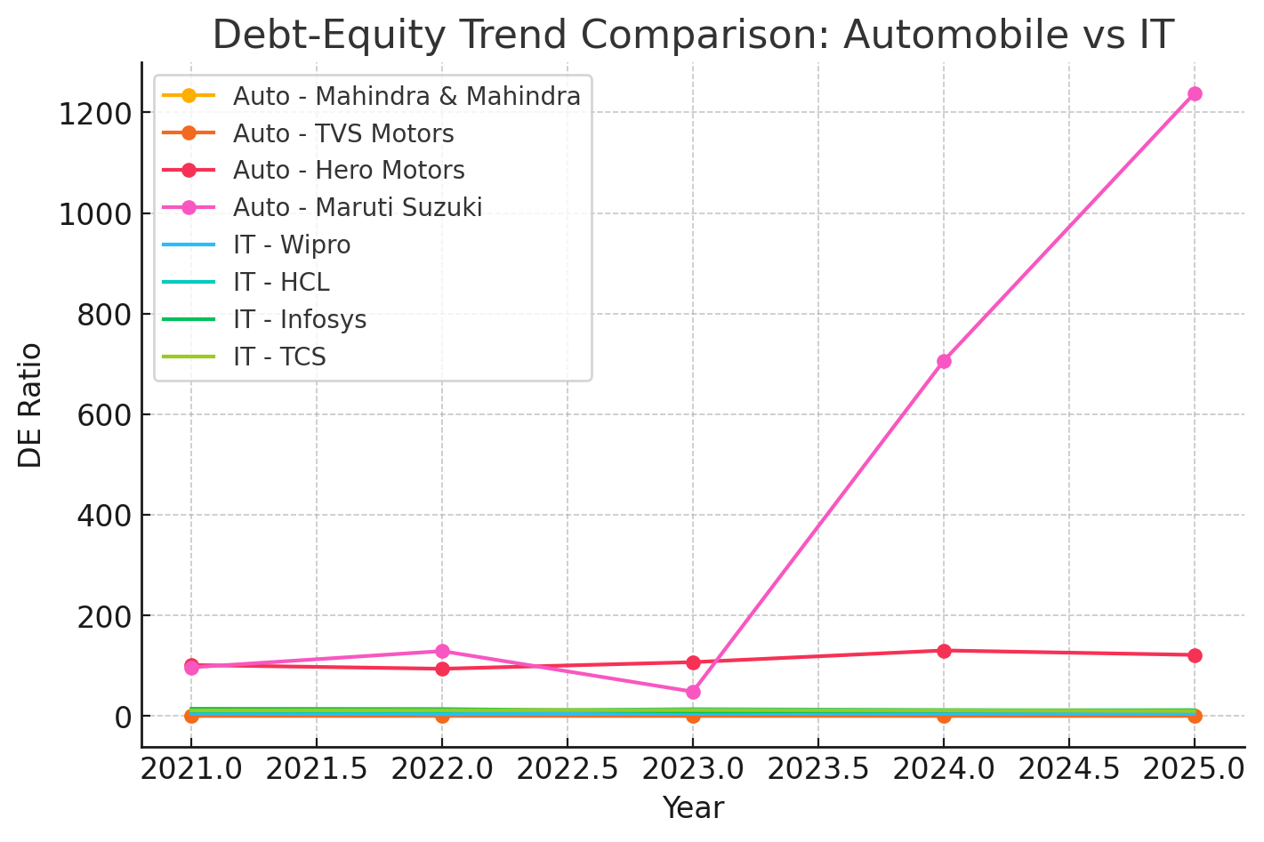

COMAPARTIVE ANALYSIS
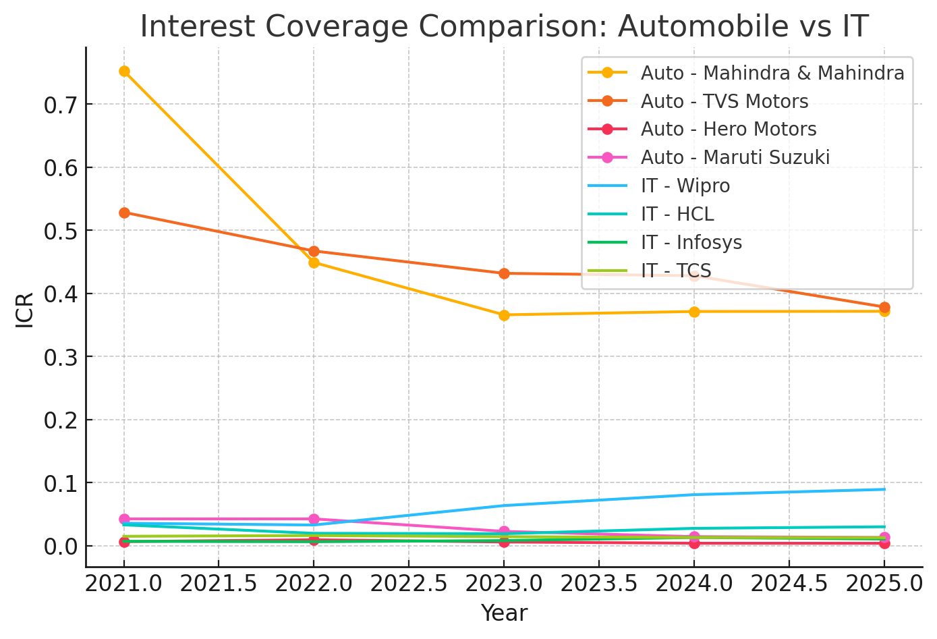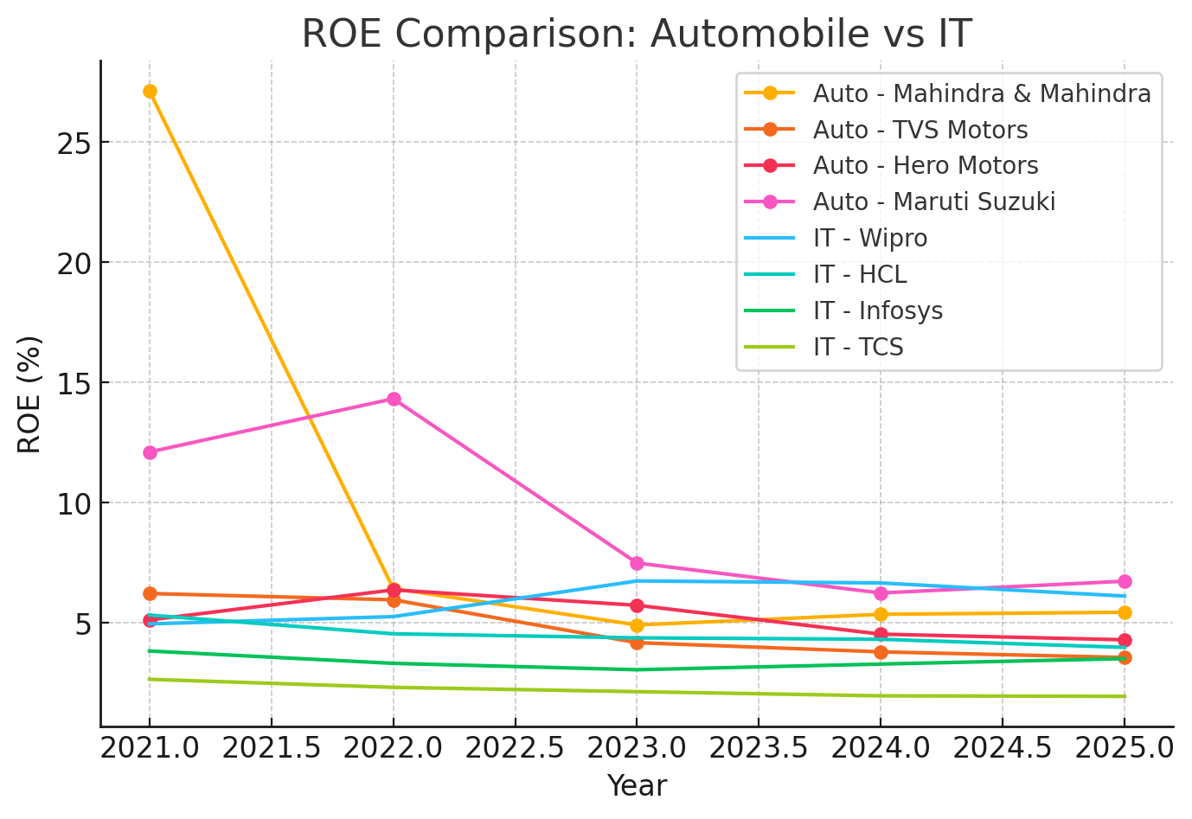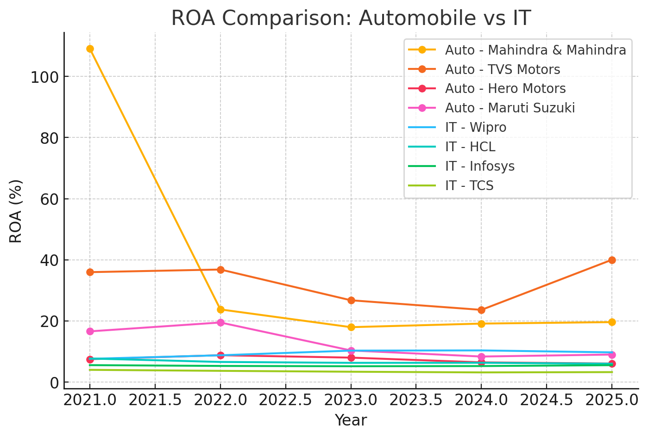

5.3 Interpretation

- Automobile companies use higher debt because they operate in a capital-intensive environment requiring heavy investment in plants and machinery.
- IT firms maintain low debt levels, relying mostly on internal funds since their asset-light model requires fewer physical investments.
- Over-leveraged firms show lower interest coverage and more volatile ROE, indicating higher financial risk due to large interest commitments.
- Under-leveraged firms appear safer but may miss growth opportunities and potential tax benefits from using moderate, efficient levels of debt.
- Overall, capital structure strongly influences profitability, with industry characteristics playing a major role in determining optimal leverage.

KEY FINDINGS

The analysis shows that the Automobile industry carries significantly higher leverage compared to the IT industry. This is because automobile companies operate in a capital-intensive environment, requiring substantial investment in machinery and production facilities, which pushes them towards higher debt usage. In contrast, IT firms follow an asset-light model, leading to low reliance on debt and a more stable capital structure.
Leverage is found to have a noticeable impact on firm performance. Automobile companies with very high debt often experience lower Interest Coverage Ratios and more volatile ROE, reflecting higher financial risk. Their profitability fluctuates more because large interest obligations make them sensitive to changes in earnings. IT firms, with low leverage, show more stable ROA and ROE, indicating controlled risk and consistent returns.
Over-leveraged companies generally perform worse in terms of financial stability due to weak interest coverage and high earnings pressure. Under-leveraged companies, while safer, may miss out on potential tax benefits and return enhancement that moderate leverage can provide.
Overall, industry characteristics strongly influence capital structure choices. Capital-intensive sectors exhibit higher leverage and more performance volatility, whereas asset-light sectors maintain low debt and more stable profitability.

CONCLUSION AND RECOMMENDATION

7.1 Conclusion
This study highlights clear differences in how the Automobile and IT industries manage their capital structure. Automobile companies need large investments in factories, machines, and inventory, which makes their business naturally more capital-heavy. Because of these high investment needs, they rely more on long-term loans, leading to higher Debt-Equity ratios. This heavier use of debt also results in lower Interest Coverage Ratios and more ups and downs in ROE, especially when sales slowdown or interest rates rise. Their financial performance becomes more sensitive to changes in profit because they have to regularly pay interest on their borrowings.
On the other hand, IT companies operate in a very different environment. Their business depends mostly on people, software, and digital tools not heavy physical assets. This asset-light model allows IT firms to work efficiently with very little debt. As a result, they show lower D/E ratios and stable ROA and ROE, even when the market is uncertain. Their profits do not fluctuate as much, and their financial structure is more flexible and less risky.
Overall, the study shows that leverage affects each industry differently. Capital-intensive industries like automobiles face higher financial risk when they borrow too much, while asset-light industries like IT perform better with low levels of debt. This proves that capital structure decisions are not universal each industry needs a financing strategy that matches its cost structure, business model, and long-term goals. A single rule for all industries does not work; firms must design a capital structure that fits their specific needs and operational realities.
The study clearly highlights significant differences in capital structure between the Automobile and IT

7.2 Recommendation
a. For Automobile Firms
- Keep debt at a safe and balanced level so the company doesn’t face too much financial risk.
- Improve the Interest Coverage Ratio (ICR) by increasing profits and reducing expensive loans.
- Focus on better risk management to handle ups and downs in the market, especially because high debt makes the company more vulnerable.
b. For IT Firms
- Consider using some amount of debt (not too much) to improve ROE and gain tax benefits.
- Continue using internal funds as the main source of finance but explore low-cost loans for expansion, technology upgrades, or digital investments.
c. For Investors
- Check how stable and reasonable a company’s debt levels are before investing.
- Avoid companies that are over-leveraged, as they may have unstable profits and high interest costs.
- Prefer firms with balanced debt and steady ROA/ROE performance.
d. For Policymakers
- Improve access to long-term, low-cost financing for capital-intensive industries like automobiles.
- Support debt restructuring frameworks to reduce financial distress and encourage sustainable growth.

ANNEXURES
Here is the link of excel sheet that we created for this assignment. It contains all the ratio calculations.
Copy of CORPORATE FINANCE-CF-GROUP.xlsx

