

A CASE STUDY (IEEE Format)

Software Requirements Specification Document

***Remote Health Connect***

***Submitted By:***

***Akanshal 102103324***

***Jalaj Singh 102103330***

***Akshit Garg 102103334***

***Akshat K Bansal 102103320***

**TABLE OF CONTENTS**



# Chapter No. Topic Page No.

|  |  |  |  |  |
| --- | --- | --- | --- | --- |
| 1. |  |  | Introduction | 3 |
|  | 1.1 |  | Purpose of this Document | 3 |
|  | 1.2 |  | Scope of the Development Project | 3 |
|  | 1.3 |  | Definitions, abbreviations and acronyms | 5 |
|  | 1.4 |  | References | 7 |
|  | 1.5 |  | Overview | 7 |
| 2. |  |  | Overall Description | 8 |
|  | 2.1 |  | Product Perspective | 8 |
|  | 2.2 |  | Product functions | 11 |
|  | 2.3 |  | User Characteristics | 12 |
|  | 2.4 |  | General Constraints, Assumptions and Dependencies | 13 |
|  | 2.5 |  | Apportioning of the requirements | 14 |
| 3. |  |  | Specific Requirements | 15 |
|  | 3.1 |  | External Interface Requirements | 15 |
|  | 3.2 |  | Detailed Description of Functional Requirements | 15 |
|  | 3.3 |  | Performance Requirements | 16 |
|  | 3.4 |  | Logical database requirements | 18 |
|  | 3.5 |  | Quality attributes | 19 |
|  | 3.6 |  | Other requirements | 19 |

1. Change History 19
2. Document Approvers 20

# Introduction



## Purpose of this Document

The purpose of this SRS document is to provide a detailed insight into remote health connect software project. This comprehensive document will delineate the project's key parameters and objectives, elucidate its intended audience, and outline the essential facets of its user interface. Additionally, it will expound upon the necessary hardware and software prerequisites for the system's successful implementation. Furthermore, the SRS will serve as a roadmap that helps everyone, including our client, the development team, and the people who will use the software, understand what the project is supposed to do.

* 1. **Scope of the Development Project**

The scope of the Remote Health Connect project is to develop a comprehensive healthcare management software system. This system will serve as a secure, user-friendly platform for healthcare providers and patients, facilitating remote healthcare interactions and data management.

The software must be able to perform the following operations:

1. **Telehealth Services:** The project will include the implementation of robust telehealth services, enabling users to engage in virtual healthcare consultations. Patients will be able to schedule appointments, communicate with healthcare professionals, and receive medical advice through video conferencing and secure messaging features.
2. **Electronic Health Records (EHR):** The system will support the creation and maintenance of electronic health records (EHR) for patients. This includes storing medical histories, prescriptions, test results, and treatment plans in a secure and easily accessible digital format.
3. **Appointment Management:** Patients will have the ability to schedule, reschedule, and cancel appointments with healthcare providers. Automated reminders and notifications will help patients stay on top of their healthcare appointments and commitments.



1. **Regulatory Compliance:** The system will adhere to healthcare regulations and standards, ensuring data privacy and security in accordance with relevant laws.
2. **Maintenance and Updates:** Regular maintenance and updates will be an integral part of the project to address software enhancements, security patches, and bug fixes, ensuring the long-term reliability and performance of the platform.

**Initial Implementation and Expansion Strategy**

Initially, our focus for the Remote Health Connect project will be on a controlled rollout, beginning with a Pilot Phase. During this initial phase, we will implement the system to cater to the needs of a specific healthcare unit or department, serving as a testing ground for the platform's functionalities and performance.

**1. Pilot Phase**

* Targeted Units: The Pilot Phase will concentrate on serving the healthcare needs of students .In the context of Remote Health Connect, this might involve specific medical health centre, hostels, or departments.
* Intended Audience: The intended audience for the Pilot Phase will encompass approximately 40 individuals, including 4-5 staff members and the remaining as patients. This phase will be instrumental in evaluating the platform's usability and effectiveness among healthcare professionals and patients.

The scope of this system is not just limited to the university campus only as the same mechanism can be reused in for health monitoring anywhere. As the project progresses, we will strategically assess its performance and usability at each phase, ensuring that it aligns with our objectives of enhancing healthcare services, data security, and user satisfaction. This phased approach allows us to refine the system, gather user feedback, and make necessary adaptations before expanding its reach to a broader audience and integrating it with other institution-wide applications.



## 1.3 Definitions, abbreviations and acronyms

**Definitions**

Table 1 gives explanation of the most commonly used terms in this SRS document.

**Table 1: Definitions for most commonly used terms**

|  |  |  |
| --- | --- | --- |
| **S.No.** | **Term** | **Definition** |
| 1 | Health Portal | A web-based platform that provides users with access to health-related information, services, and tools. |
| 2 | EHR (Electronic Health Record) | A digital version of a patient's medical history, including diagnoses, treatments, medications, and test results. |
| 3 | Telemedicine | The remote provision of healthcare services using telecommunications technology. |
| 4 | HIPAA | U.S. legislation that regulates the privacy and security of patient health information. |
| 5 | Prescription Management | A tool that enables users to request prescription refills, view medication history, and receive electronic prescriptions from doctors. |
| 6 | HL 7 | A set of international standards for the exchange of healthcare information between systems, ensuring interoperability in healthcare IT. |



**Abbreviations**

Table 2 gives the full form of most commonly used mnemonics in this SRS document.

**Table 2: Full form for most commonly used mnemonics**

|  |  |  |
| --- | --- | --- |
| **S.No.** | **Mnemonic** | **Full Form** |
| 1 | EMR | Electronic Medical Record |
| 2 | HIT | Health Information Technology |
| 3 | CMS | Centers for Medicare & Medicaid Services |
| 4 | HIPAA | Health Insurance Portability and Accountability Act |
| 5 | HL7 | Health Level 7 (standard for exchanging healthcare information) |
| 6 | GDPR | General Data Protection Regulation |

## 1.4 References

[1]. Health Portal Link:https://en.wikipedia.org/wiki/Patient_portal

[2]. Remote health Link: https://onlinelibrary.wiley.com

[3]. HIPAA Definition. Link: https://www.sciencedirect.com/

[4]. Studied About the idea Of Remote Health Link: <https://link.springer.com/>

[5]. https://app.diagrams.net/#G1mCgudE3SMrwKaBWM1cJdvrwAY50qz4as

[6]. <https://www.edrawmax.com/templates/1029416/>

[7]. https://www.virtusa.com/solutions/healthconnect

[8]. https://healthscholar.com/c/8c357334-76cd-4003-97fc-6157c786b6dc



## 1.5 Overview



Chapterization

The following sections of this document will delve into the detailed aspects of the Remote Health Connect project, providing comprehensive information about the project's users, hardware requirements, and the functional and data requirements of the software. In this section 2, we will provide a broader overview of the project, detailing the characteristics of the users who will interact with the Remote Health Connect platform. We will also explore the necessary hardware infrastructure required for its successful operation.

# 2. Overall Description

# 

## Product Perspective

The Remote Health Connect product is designed to operate as a web-based platform accessible through standard web browsers, ensuring flexibility and ease of use for both doctors and students. Instead of relying on specialized hardware components like smart card readers, the system leverages a user-friendly digital interface.

Upon logging into the platform, doctors and students are directed to the main web portal. Here, doctors have access to a range of functionalities, including the ability to manage appointment requests, view patient information and medical records, and conduct secure video conferencing consultations with patients. This streamlined process empowers healthcare professionals to efficiently provide care and medical guidance remotely.

For students, the platform offers a user-friendly interface to schedule appointments with healthcare providers. They can easily book an appointment, discuss health concerns, and engage in secure video conferences with doctors. This ensures that students receive timely medical advice and support, all from the convenience of their devices, eliminating the need for complex hardware such as smart card readers.

The product's focus on a web-based interface enhances accessibility, making healthcare interactions more efficient and user-centric. It fosters seamless communication between doctors and patients, ultimately improving the quality and accessibility of healthcare services in a digital age.



**1. User-Centric Interface:**

* Remote Health Connect offers a web-based portal accessible from various devices and web browsers.
* Users, including doctors and students, log in to the platform and are directed to a user-friendly main page.

**2. Doctor Functionality:**

* Doctors can efficiently manage appointment requests, review patient profiles, and access medical records.
* Secure video conferencing capabilities enable doctors to conduct remote consultations effectively.

**3. Student Engagement:**

* Students have a simplified interface for scheduling appointments, discussing health concerns, and booking video conferences with healthcare providers.
* This accessible system ensures that students can easily seek medical advice and support.

**4. Elimination of Hardware Constraints:**

* Unlike systems relying on smart card readers, Remote Health Connect operates solely through a digital interface.
* This eliminates the need for specialized hardware components, enhancing accessibility and usability.



Functional Requirements



## Product Functions

Functional requirements for the Remote Health Connect project outline the specific features and capabilities that the software must possess to meet the needs of healthcare providers and patients. Here are the key functional requirements:

1. Users (doctors and students) must be able to register for accounts.The system should authenticate users securely, verifying their identities.

2. Users can create and update their profiles, providing essential personal and medical information.Patients can maintain a health record accessible to healthcare providers.

3. Users can view the availability of healthcare providers and schedule appointments based on their preferences.The system should provide a calendar view for easy scheduling.

4. Doctors can approve or reject appointment requests.Users receive notifications and reminders about upcoming appointments.

5. Users can exchange secure text messages with healthcare providers.Messages should be organized for easy tracking and retrieval.

6. Users can initiate and join secure video conferences for remote consultations.The system should support real-time video and audio communication.

7. Regular data backups are performed to prevent data loss.The system supports data recovery in case of unexpected events.

## User Characteristics

The goal is to design software for a Remote health monitoring system in the college campus for different users. The main users are listed below as follows:

**1.** **PATIENT (Students & Staff )**

Patients can choose the best preferred appointments from the options provided and

can also change the appointment schedule or cancel it. After appt. is confirmed by the respective doctor they can pay their consultant fee online. Patients have access to only their records.

Key functions:

• Make appointment.



• Cancel appointment.

• Update Details.

•View Payment History.

**2.** **DOCTOR**

Doctors can view the patient appointment list and provide the confirmation or make

changes in the appointment list if required. Doctors have access to only records of those

patients whom they are treating.

Key functions:

• Confirmation of appointment.

• Cancellation of appointment.

• Modification of appointment list.

• Add Prescription.

Our objective is to create user-friendly software that caters to all user types, including healthcare professionals. Therefore, during the software design process, we can make the following assumptions about the characteristics of each user:

* Users will be comfortable with using computers and navigating digital interfaces.
* Users are capable of using the software to access health information and perform tasks without advanced technical knowledge.

While users are not expected to be familiar with the intricate workings of healthcare monitoring devices, they should have a basic understanding of how to use these devices effectively when interacting with the software.

## 2.4 General Constraints, Assumptions and Dependencies

The following list presents the constraints, assumptions, dependencies or guidelines that are imposed upon implementation of the Remote health connect software are as follows:

* **Integration with Existing Healthcare Infrastructure:** The software must seamlessly integrate with existing healthcare systems, including electronic health record (EHR) systems, to ensure consistent and accurate patient data sharing.
* **Minimal Resource Requirements:** To accommodate users with varying hardware capabilities, the software should have minimal memory and processing requirements.



* **User-Friendly Interface:** The product should feature an intuitive and user-friendly interface to ensure ease of use for healthcare providers and patients of all technical backgrounds.
* **Video Conferencing Integration:**We assume that the integration of video conferencing into the project may pose certain technical challenges or dependencies. Therefore, we include it as an assumption in the project, acknowledging that seamless video conferencing functionality may require dedicated resources, external API integration, or specialized expertise. While the intention is to provide this feature, the assumption recognizes the potential complexities involved in its successful implementation within project constraints.
* **Regular Database Maintenance:** The central and backup database servers must undergo regular updates and maintenance to ensure data integrity and security, even though this may introduce temporary latency



Progression of the Project and Implementation of the requirements

## 2.5 Apportioning of requirements

In the context of the Remote Health Connect project, apportioning of requirements plays a pivotal role in orchestrating the development and deployment of this multifaceted healthcare management system. This process involves the careful allocation of project requirements to specific modules, functionalities, and teams, ensuring that each aspect of the project is addressed efficiently and cohesively.

By apportioning requirements, we can designate specific components for user authentication, appointment scheduling, electronic health records, video conferencing, and more. This delineation of responsibilities allows for focused development efforts, efficient testing, and systematic integration, resulting in a well-structured and comprehensive healthcare platform.

Moreover, apportioning can in future help in tracking the progress of individual components, identifying dependencies between different modules, and facilitating collaboration among teams responsible for various aspects of the project. It ensures that the project objectives, such as providing secure and accessible remote healthcare services, are met while maintaining transparency and accountability throughout the project's lifecycle.



In essence, apportioning of requirements in the Remote Health Connect project is a strategic approach that enables the effective allocation of resources and efforts, ultimately contributing to the successful delivery of a user-friendly and feature-rich healthcare management system.

# 3. Specific Requirements

### 3.1 External Interface Requirements:



External Interface Requirements for the Remote Health Connect Project are designed with simplicity and minimal hardware usage in mind:

**User Interface:** The product should have a straightforward user interface optimized for small screens with a maximum resolution of 320 x 240 pixels. It should rely on text-based or minimal graphic elements to ensure usability on devices with limited display capabilities.

**Input Method:** The user input should be accommodated through a simple keypad or an equivalent user-friendly input method to facilitate interaction, appointment scheduling, and data entry.

**Sound and Animation:** The initial version of the system does not require sound or animation. However, future iterations may consider incorporating sound features, such as personalized greetings upon card swiping, keeping in mind the potential for enhanced user engagement.

These external interface requirements emphasize simplicity and usability for a wide range of devices, ensuring that the software remains accessible and functional even on systems with limited graphical and audio capabilities.

**3.2 Detailed Description of Functional Requirements**



Table 3 shows a template that I’ll be using to describe functional requirements for three types of users: student, staff, student cum staff as one can easily deduce the functional requirements for other user types with this template.

**Table 3: Template for describing functional requirements**

|  |  |
| --- | --- |
| **Purpose** | A description of the functional requirements and its reasons |
| **Inputs** | What are the inputs; in what form will they arrive; from what sources  can the inputs come; what are the legal domains of each input. |
| **Processing** | Describes the outcome rather than the implementation; includes any  validity checks on the data, exact timing of operation (if needed), how to handle unexpected or abnormal situations |
| **Outputs** | The form, shape, destination and volume of output; output timing; range of parameters in the output; unit of measure of the output; process by which output is stored or destroyed; process for handling  error message produced as output. |

**Functional Requirements for Student Home Screen**

|  |  |
| --- | --- |
| **Purpose** | The student home screen serves as the central hub for students using the Remote Health Connect platform. Its functional requirements are defined to ensure that students can efficiently access and manage their healthcare-related tasks, such as scheduling appointments, accessing medical records, and initiating video conferencing sessions with healthcare providers. |
| **Inputs** | Inputs to the student home screen primarily come from students themselves, including login credentials, appointment requests, and personal health information. These inputs must comply with healthcare data privacy regulations to safeguard sensitive information. |
| **Processing** | The processing on the student home screen involves user authentication, appointment scheduling, and navigation to other sections of the platform. Timing of operations must meet real-time requirements, particularly when scheduling appointments or initiating video conferencing sessions. |
| **Outputs** | The outputs from the student home screen take various forms, including appointment confirmations, access to electronic health records, notifications for scheduled video conferencing sessions, and secure messaging capabilities. |

**Functional Requirements for Doctor Home Screen**



|  |  |
| --- | --- |
| **Purpose** | The doctor home screen serves as the primary interface for healthcare professionals using the Remote Health Connect platform. Its functional requirements are designed to enable doctors to efficiently manage patient appointments, access electronic health records, initiate video conferencing sessions, and provide medical guidance through secure messaging. |
| **Inputs** | Inputs to the doctor home screen originate from various sources, primarily from doctors themselves and their patients. These inputs include login credentials, appointment requests, patient medical records, and messages. |
| **Processing** | The processing on the doctor home screen encompasses user authentication, patient management, appointment scheduling, video conferencing initiation, and secure messaging. The system performs validity checks to ensure data accuracy and completeness. |
| **Outputs** | Outputs from the doctor home screen take various forms, such as appointment confirmations, access to patient electronic health records, notifications for scheduled video conferencing sessions, and secure messaging capabilities. |

**3.3 Performance Requirements**

* The system should respond to user interactions, such as appointment scheduling, messaging, and video conferencing, with minimal latency, aiming for response times of under one second for routine tasks.
* During video conferencing sessions, the system should ensure high-quality audio and video transmission with minimal lag or buffering to facilitate clear communication between doctors and patients.
* Implementing load balancing mechanisms to distribute user requests evenly across multiple servers or instances to prevent overloading and ensure consistent performance.
* Establishing robust backup and recovery procedures to safeguard against data loss and system failures, enabling quick restoration in case of unforeseen events.
* Deploying the system on cloud infrastructure to leverage scalability, redundancy, and disaster recovery features provided by cloud service providers. This allows for flexibility and cost-effectiveness in managing resources.

## 3.4 Logical Database Requirements

**Figure** shows the E-R diagram for the entire system.



## 3.5 Quality Attributes

The Remote Health Connect product places a strong emphasis on key quality attributes to cater to its diverse user base, including students and doctors . First and foremost, the product is designed with responsiveness in mind, ensuring quick loading times and efficient performance on a wide range of devices and terminals. Additionally, the system's robustness is a critical aspect, capable of gracefully handling a variety of user inputs, including incorrect responses or unexpected keystrokes, without compromising the overall user experience. These quality attributes collectively contribute to a user-friendly and reliable healthcare platform that can adapt to the needs and behaviors of its diverse user community, ultimately enhancing the accessibility and usability of remote healthcare services.

## 3.6 Other Requirements

None at this time

# 4. Change History



Version 1.0 – Initial Release

200209

## 5. Document Approvers

SRS for Remote Health Connect (An Online Healthcare Portal) Project approved by:



**(name) Designation: Date:**

**Diagrams**



**DFD Level 0:**

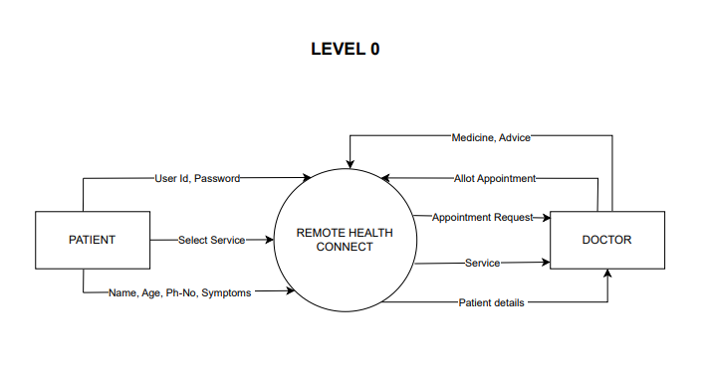

**DFD Level 1:**

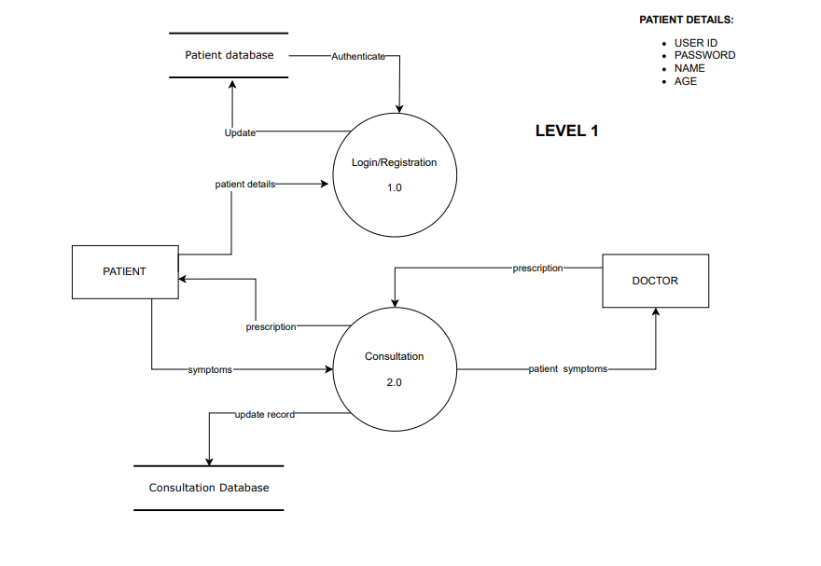

**DFD Level 2:**



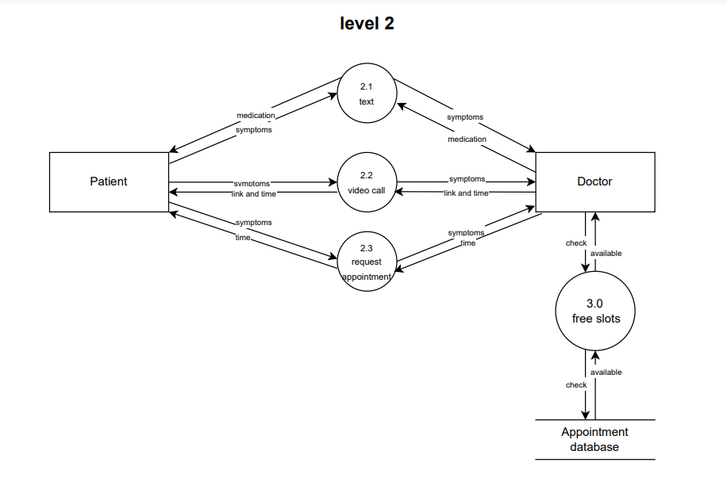

**Use Case Diagram**



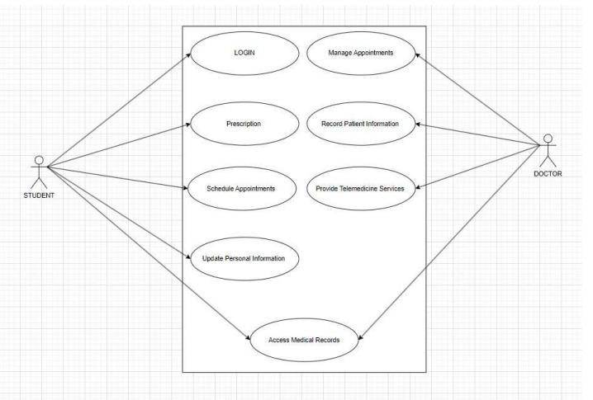

**Use Case Scenario:**

**Actors:**

•Student: A Thapar University student seeking medical assistance.

•Healthcare Professional(Doctor): A healthcare staff member at Thapar University responsible for providing medical services.

**Preconditions:**

•The student has a registered account on the Thapar University Online Health System.

•The healthcare professional is logged into the system and available for consultations.

**Main Flow:**

1.The student logs into the Thapar University Online Health System using their university credentials.

2.The system displays the student's dashboard, showing their upcoming appointments, medical

history, and options for booking a new appointment or joining an online consultaƟon.

3.The student selects the option to "Book an Online Consultation."

4.The system presents available time slots for online consultations with healthcare professionals.

5.The student selects a suitable time slot and confirms the appointment request.



6.The system sends a confirmation notification to the student's email and updates their dashboard

with the upcoming appointment.

7.Meanwhile, the healthcare professional receives a notification of the new appointment request

and reviews the student's medical history and previous records through the system.

8.At the scheduled time, both the student and healthcare professional log into the Online Health System.

9.The online consultation begins with a video call or chat interface, allowing the student and

healthcare professional to communicate and discuss the student's health concerns.

10.During the consultation, the healthcare professional may ask questions, provide advice, prescribe medication, or recommend further tests.

11.The healthcare professional updates the student's medical records and treatment plan within the system in real-time.

12.After the consultation, the student receives a summary of the discussion, including any

prescriptions or recommendations, through the Online Health System.

**Postconditions:**

• The student has a record of the online consultation in their medical history.

• The healthcare professional has updated the student's medical records.

• If necessary, the student can follow up with additional appointments or actions based on the healthcare professional's recommendations.

**Alternative Flow:**

• If the student or healthcare professional encounters technical issues during the online

consultation, they can contact technical support for assistance or reschedule the appointment.

This use case scenario demonstrates how the Thapar University Online Health System facilitates online healthcare consultaƟons, allowing students to access medical services conveniently and healthcare professionals to provide care remotely while maintaining accurate medical records. The system enhances accessibility and efficiency in healthcare delivery within the university community.

**Login Swimlane Diagram**

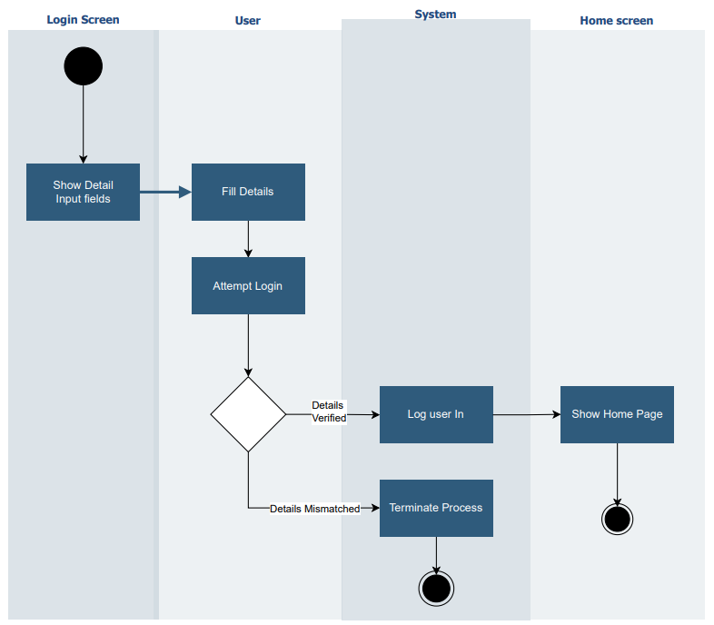



**Consultation Activity Diagram**



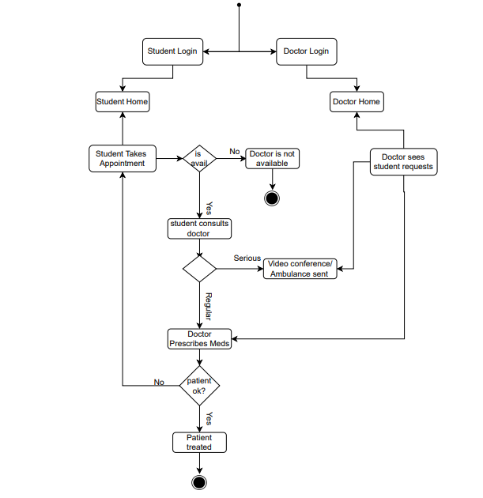



**Class Diagram**

