Home Page (fragment)
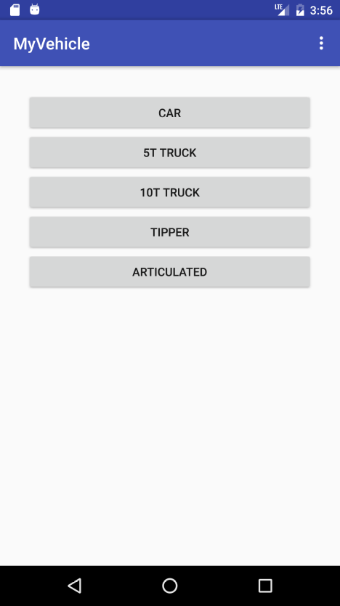
Single activity with multiple fragments
Different vehicle pages
These pages all have a similar appearance and so only the appearance for Car page will be shown, as in the figures below. The page has the large text for the vehicles' name, Car, at the top of the view area. On the following lines the data that is to be logged and saved is shown in the figures below.
The line immediately below the title line has the text "Driver: " with a text entry field beside it with a text hint Drivers' name. Below this the text "Rego #: ", followed by an EditText field with the hint xxx-xxx.
This is followed by a Button with the text Start time: followed by an empty Text. Following this are two other hidden Button's. The first has the text First break: followed by an empty Text field. Below this is the Second break: button with an empty Text field. Finally an End time: button is followed by a final empty Text field, as shown in figure 2.
When an entry is made by pressing a button the button should no longer be visible on the page, but the current time should appear in the empty text field adjacent to the button that was pressed. The following button is then showed and can be clicked to add the current time to the adjacent text field. This continues until the End time: button is pressed and the final time is shown.
The Save Log Entry is used is used to add the time values to an internal data object that saves all values.
The Show Log Entries button is used to present all the time entries in a list format as shown in the next section. If a Text field does not have a value then a Toast message is displayed and an error message appears as shown in the figure on the right.
The Previous button will take you to the preceding vehicle's data entry page, the Next button will take you to the next vehicles data entry page. The Home button will take you to the Startup (Home) page.

Show Log Entry Page (Fragments)
This fragment contains a list view with the driver id, vehicle rego number on one line followed by the vehicle date-time information values separated on separate lines as shown. Every saved entry for that car is displayed in the list like this. A driver may drive more than one car during the week so multiple entries can appear in the list, as shown in the figure on the right below. At the bottom of the page is a button that returns the user to the car data entry page. Note this buttons' text is customized with the name Car.
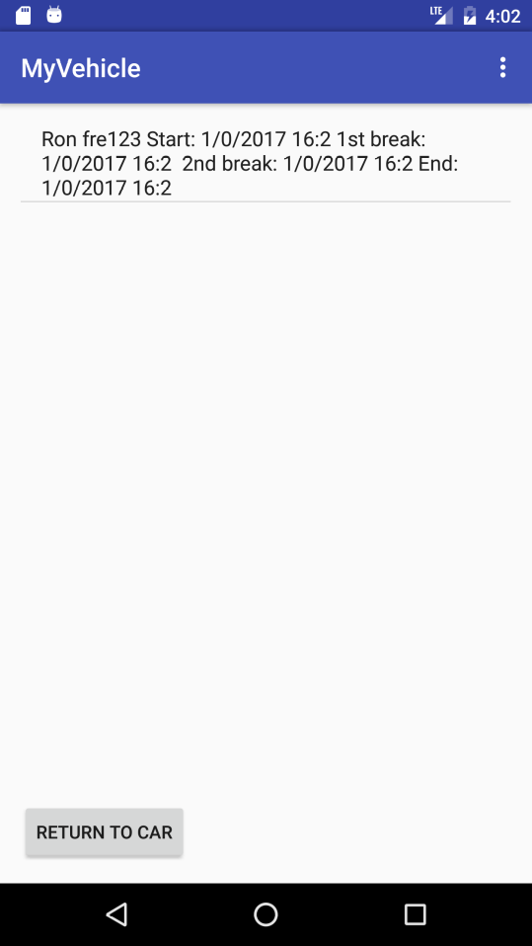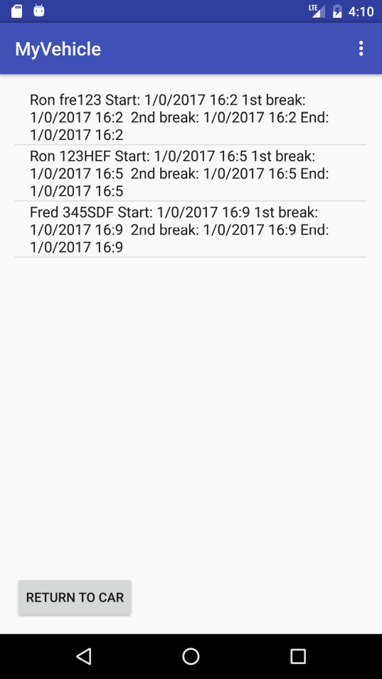

Options Menu pages
A number of menu options should be shown, if the user presses the console Menu button, as shown in Fig. 4.
If the user taps the Save entries Menu then all data in the lists for the 5 vehicle types should be saved to a SQLite database on the mobile device. Typically this is done when the driver finishes driver the vehicle, and before driving a new vehicle. When the application is opened this database is used to initialize previously saved vehicles' vehicle logger entries to that given in the database. Subsequently new values are added to the app as the user enters new data.
The Send all entries will be used for other purposes in the next assignment, but for now we will use it to clear the current database of all entries. The Profile menu option is covered in the next section.

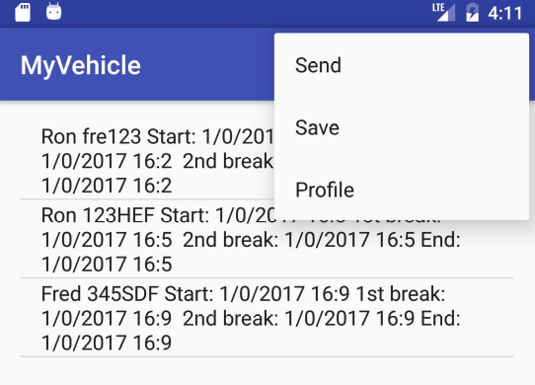

Profile page
The Profile fragment UI is shown in the Fig. 5. A Logger username edit text field is supplied for the drive to enter their username. Two text fields are also supplied so that the user can enter their associated password for this username. When the Save profile button is pressed this data is to be saved in local variables (for use in the next assignment) and the Home page (fragment) is shown. If the Cancel profile button is pressed the Home page is returned to. The intention of this is to allow for authentication to a company database at a later stage of development of this app.
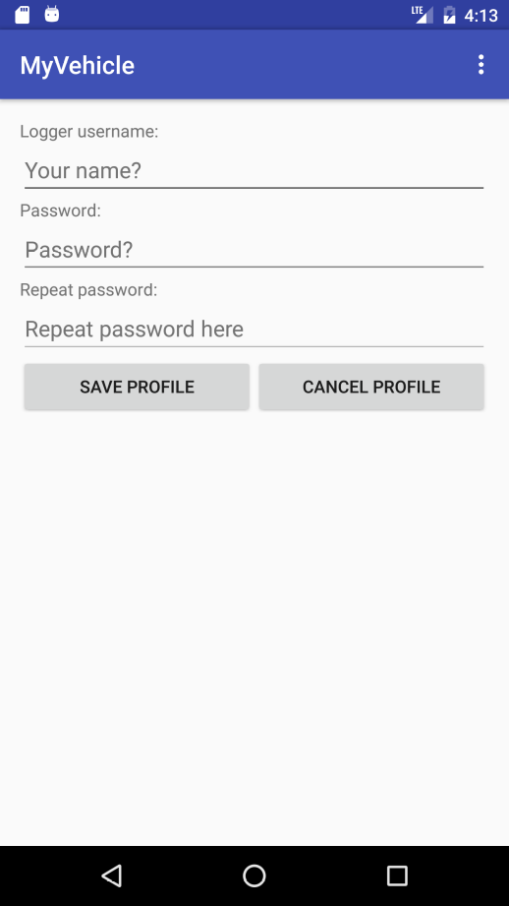
Other Features
When the Send all entries menu option is chosen the dialog shown on the left of the Fig. 6 is shown. If the "OK" button is selected then the existing SQLite database is cleared of all entries along with the local objects used to save the vehicles Vehicle logger entries. As a result subsequently showing the list for any vehicle will present an empty list.
When the Android BackButton is pressed on the Android device the dialog on the right of the figure below is presented. If the user taps the "Yes" button then the local Vehicle logger logs will be written to the SQLite database before quitting the application. If the "No" button is tapped then the application exits without saving any changes to the SQLite database. The intent is that when the user sends the data to home base the database is cleared.
