

សាកលវិទ្យាល័យ សៅស៍អ៊ីសថ៍អេយសៀ

**UNIVERSITY OF SOUTH-EAST ASIA**

3

កិច្ចការស្រាវជ្រាវ

សម្រាប់បំពេញលក្ខខណ្ឌសិក្សាស្រាវជ្រាវមុខវិជ្ជា៖ Network

ប្រធានបទ

គ្រប់គ្រងFileដោយប្រើDomain Controller

សាស្រ្ដាចារ្យ ៖ ​​​Dieb Taohou  
 ស្រាវជ្រាវដោយ ៖

និស្សិត ៖

ជំនាញ ឧត្ដមភាព និងសង្គម

ឆ្នាំសិក្សា ២០23.........-២០24..........

+ទី១Client ជាប្រភេទWindows (win-7, Z://Data)

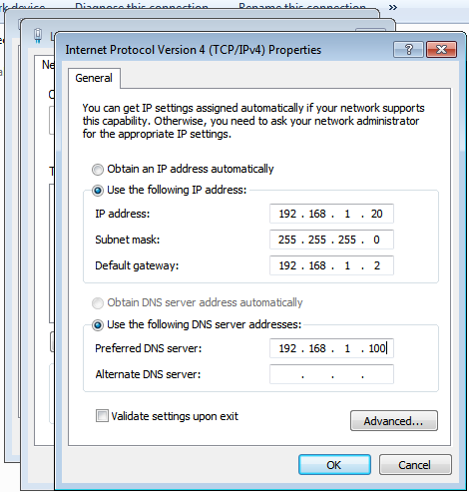-Step1: set ip to your computer and DNS (ip server)

-Step2: right click on your computer and click properties

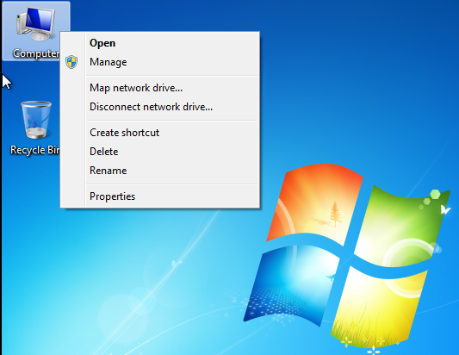

-Step3: click on Change setting

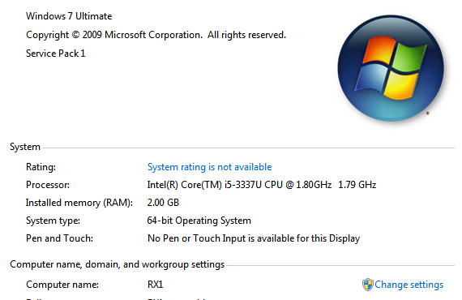

-Step4: click on Change….

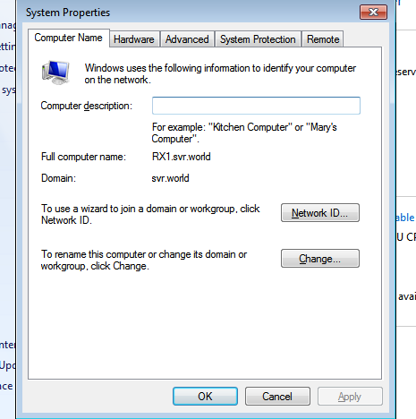

-Step5: click on Domain

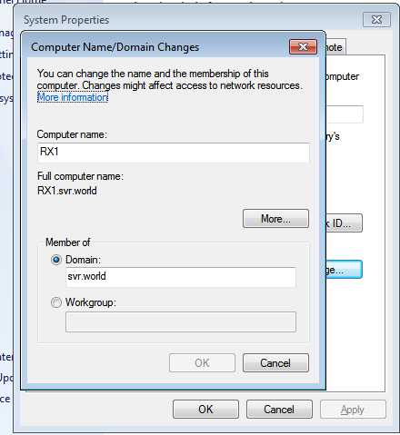

-Step6: server admin and password

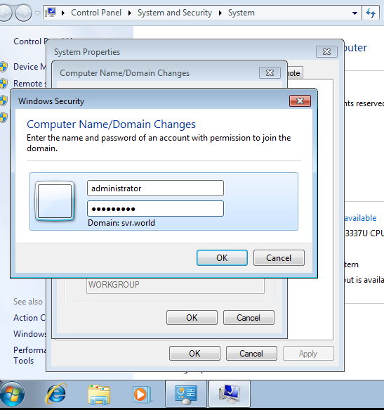

-Step7: click Restart Now

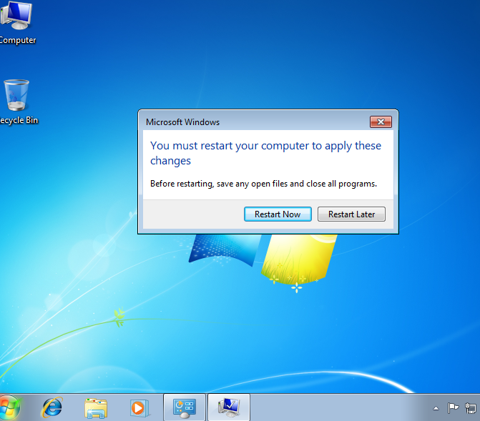

+កំណត់ អោយUser ពេល loginចូលមាន drive ប្រើដោយស្វ័យប្រវត្តិ

+Step1: Add disk (z) and create folder for user(it001)

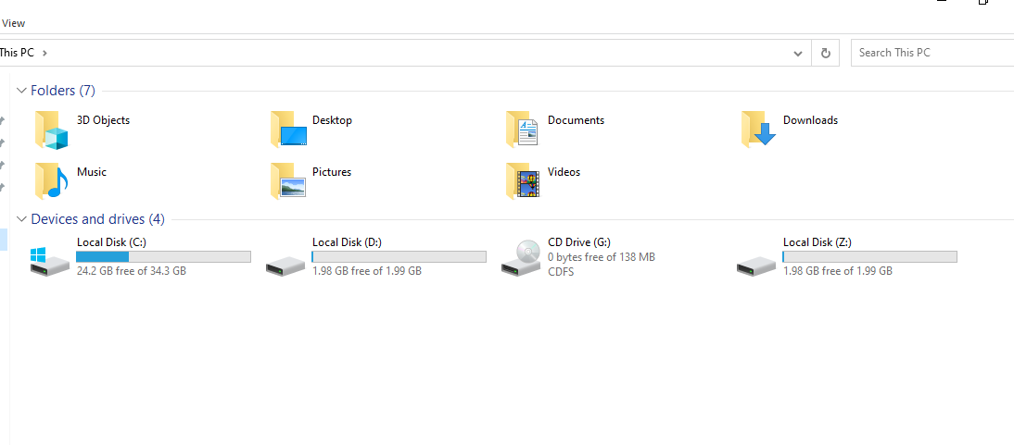

+Step2: right click on folder (it001) and click properties

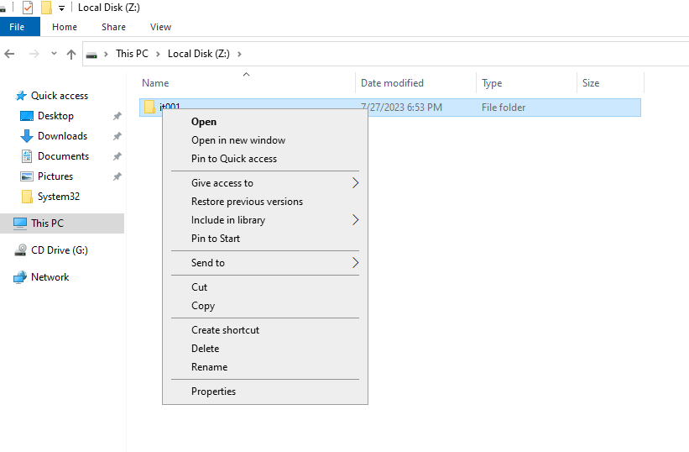

+Step3: click on sharing and share…

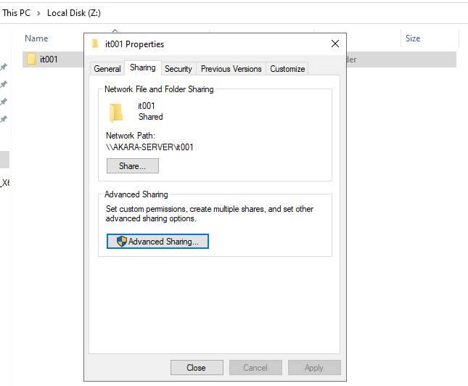

+Step4: Select Everyone and click on Add

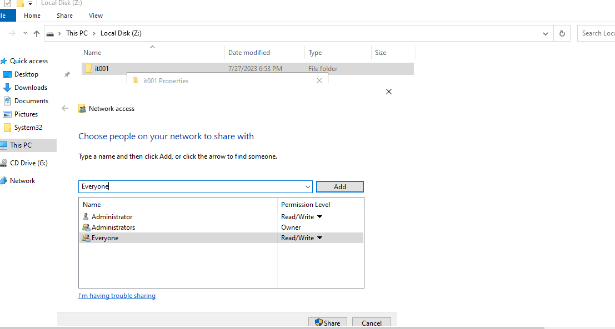

+Step5: click on Tools and select Active Directory Uders and Computers

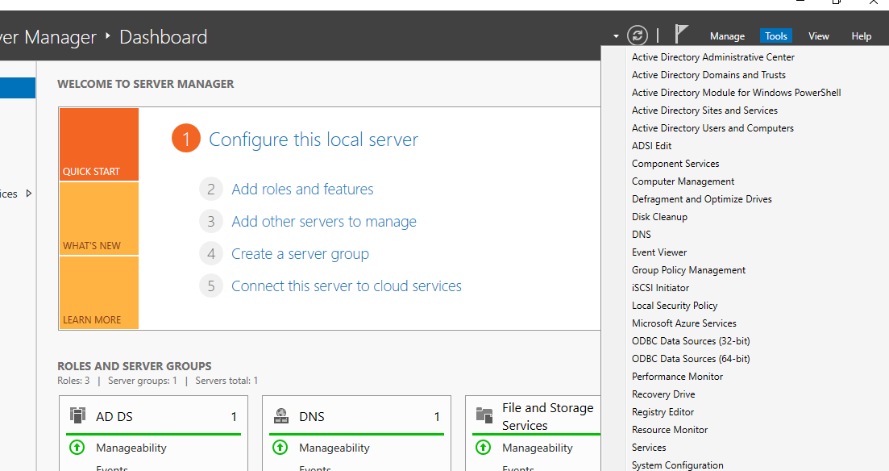

+Step6: select Users and click on user we created

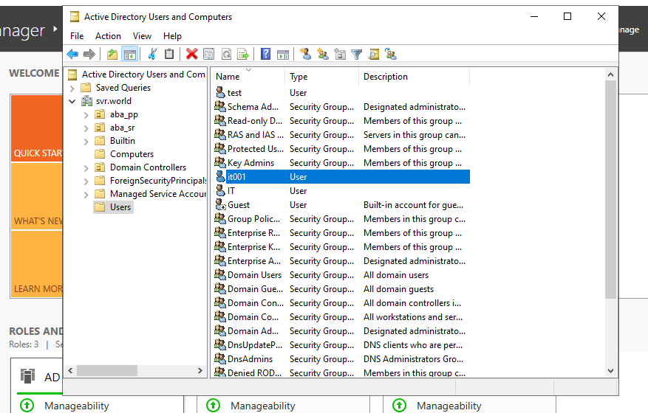

+Step7: double click on user (it001) click on Profile and Past Network Path

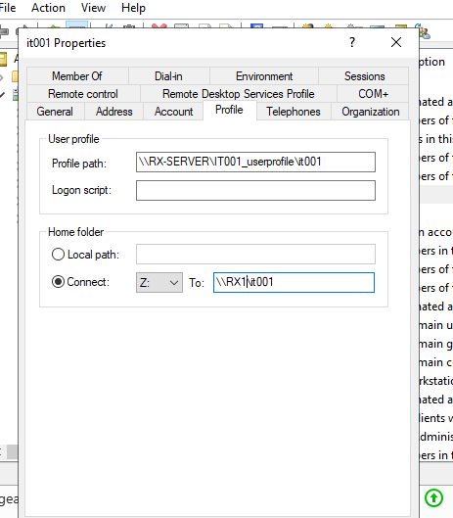

+កំណត់ អោយ User និមួយៗមិនអាចsave File ប្រភេទ .Exe, .ism, .ini បានទេក្នុងFolder

+Step1: select Add roles and features

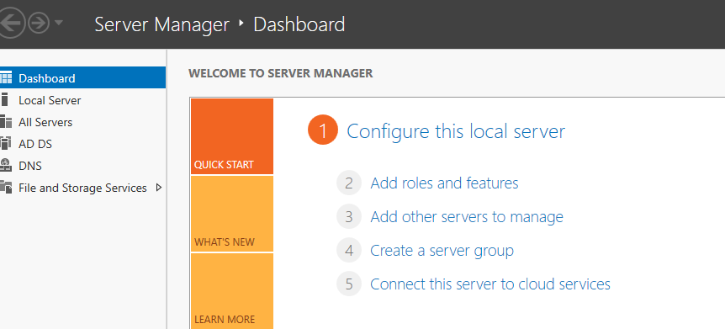

+Step2: click on Next

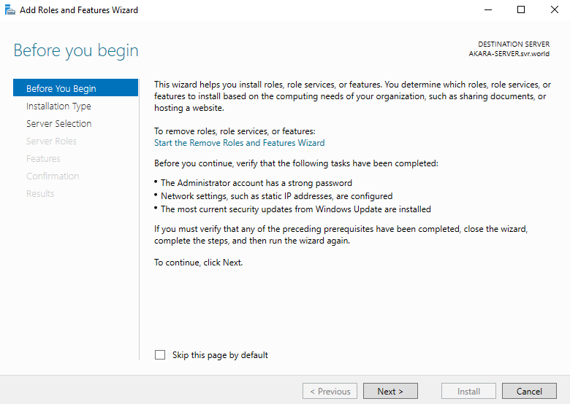

+Step3: click on Next

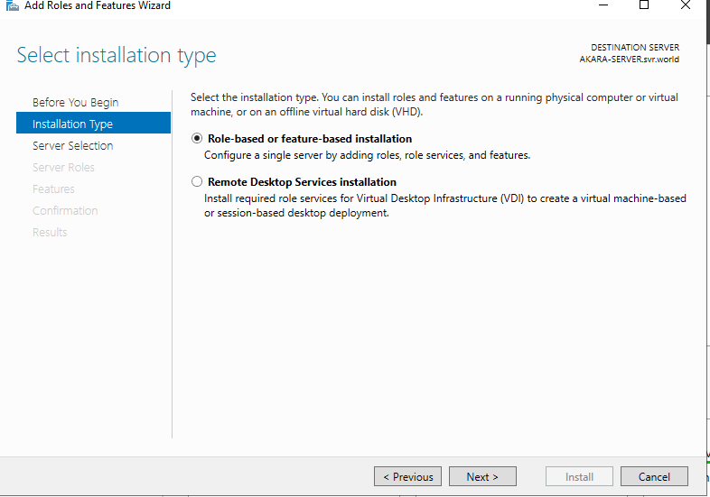

+Step4: click on Next

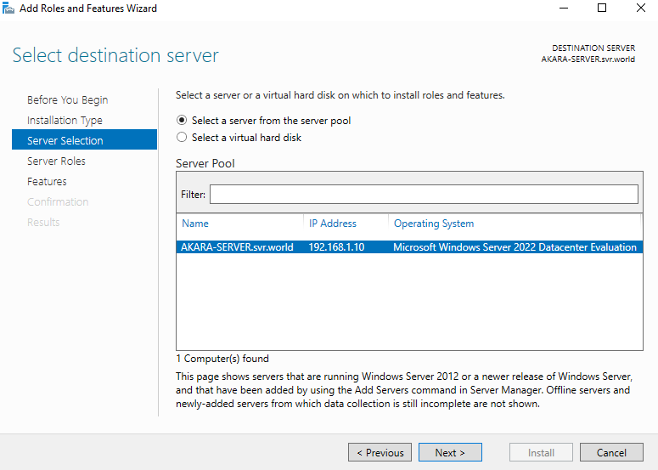

+Step5: click on this

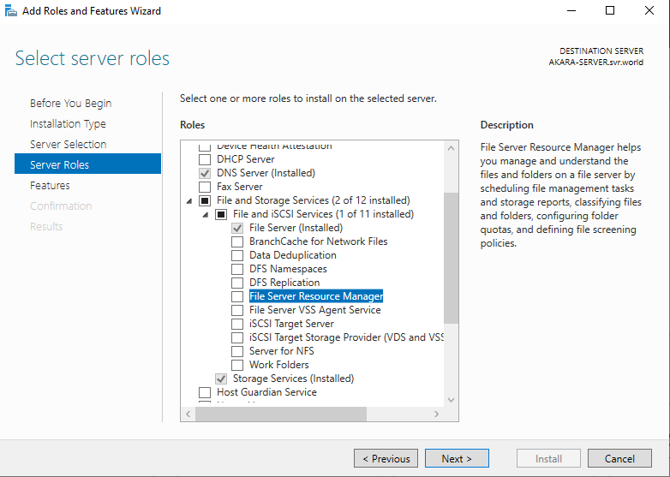

+Step6: click on Add Features

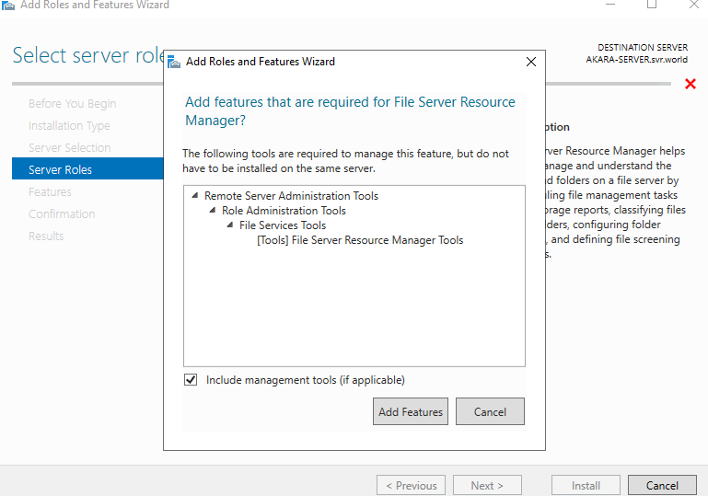

+Step7: click on Next

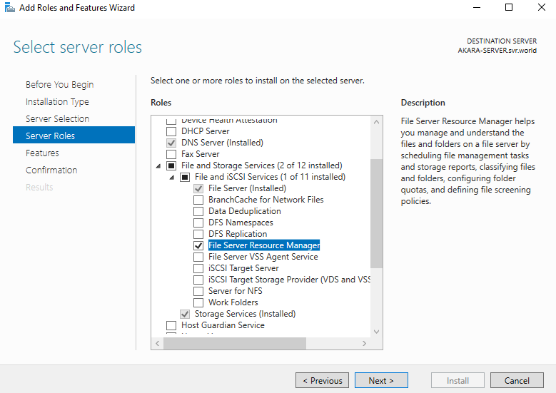

+Step8: click on Install

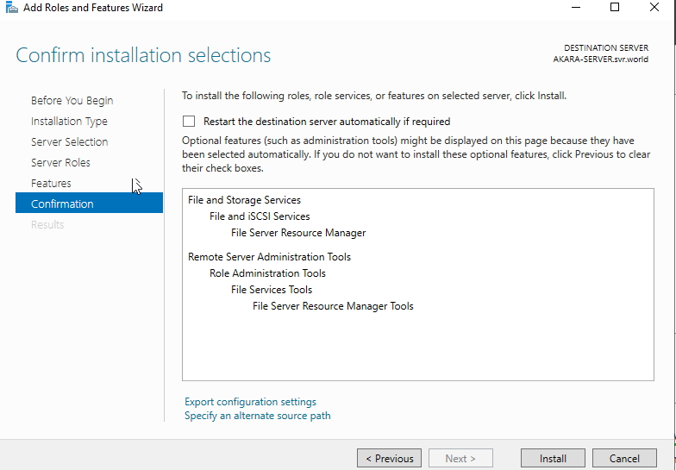

+Step8: click on Tools and select File Server Resources Manager

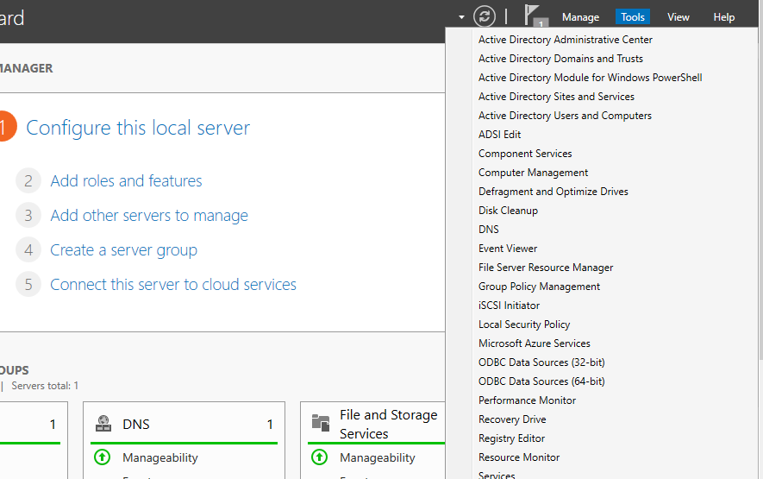

+Step9: click on File Groups and then right click on Create File Groups

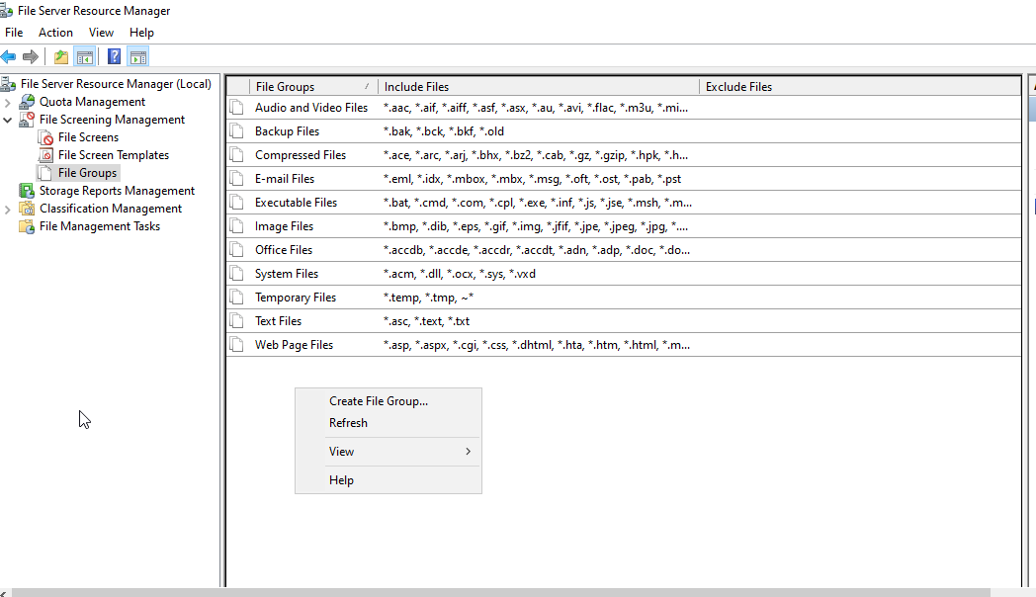

+Step10: set file group name and include to file you want to blocks

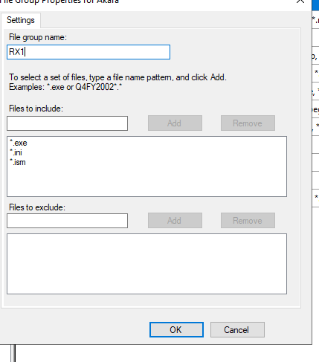

+Step11: click on File Screen Templates and double click on Block Executable Files

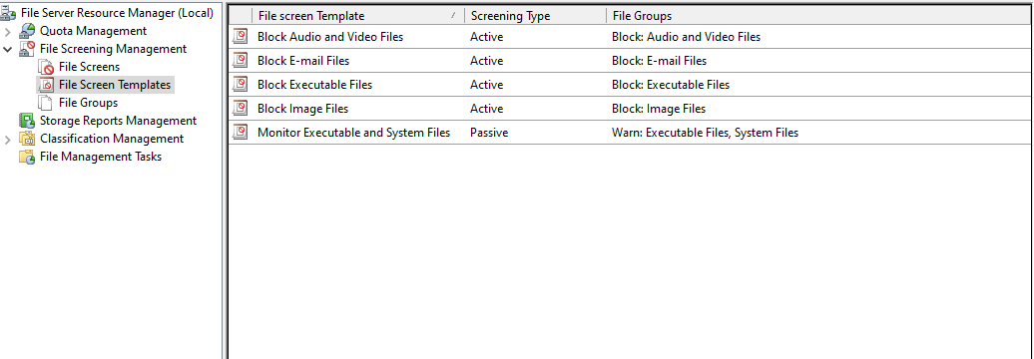

+Step12: select file group to block

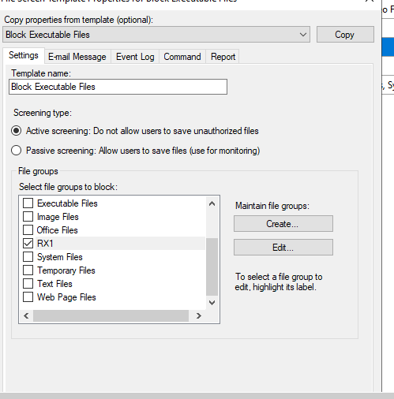

+Step13: click on File Screens and then right click on Create File Screens

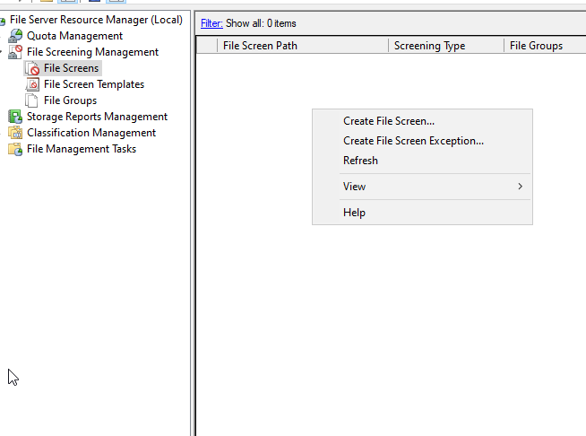

+Step14: click on Browser and select folder

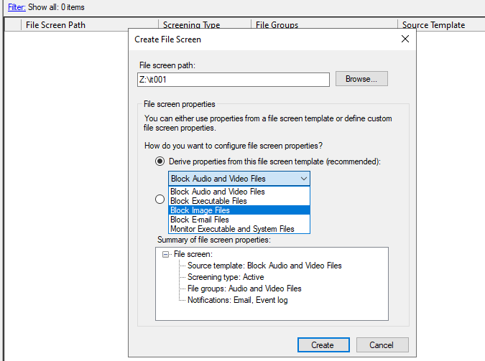

+កំណត់ទីតាំង Save Roaming User ទាំងពីចួលក្នុង Drive D របស់ Server

+Step1: add disk for Userprofile



+Step2: create folder for Userprofile (IT001_userprofile) and sharing

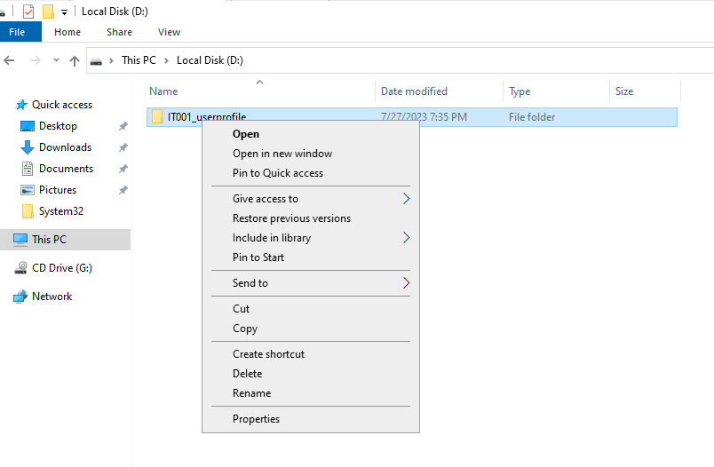

+Step3: click on Sharing and Share…..

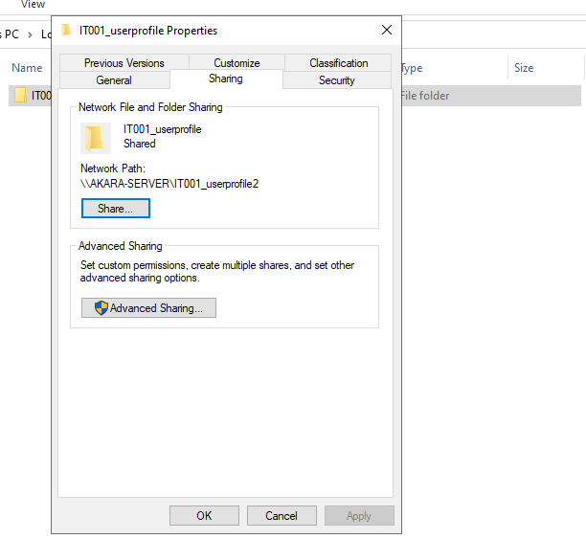

+Step4: Select Everyone and click Add

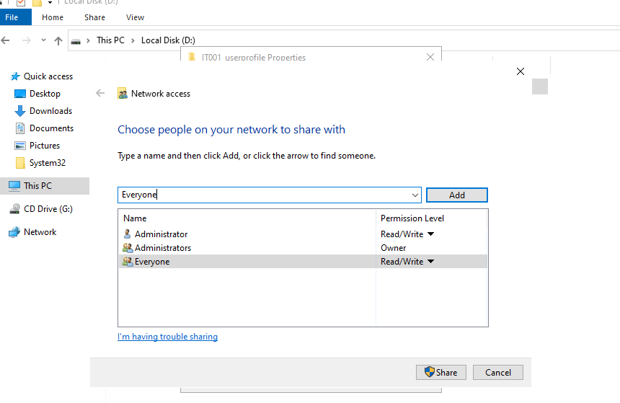

+Step6: Past Network Path to profile path



