AI/ML Mini Project Submission
1. Cover Page
- Project Title: AI-Powered Social Media Spam Detection and Analytics Dashboard
- Student Name: Akarapu Srivalli
- College Name: Vignana Bharathi Institute Of Technology
- Branch & Year: CS(Business Systems) & 4th year
- Email / Phone Number: akarapusrivalli6@gmail.com / 8501824880
- Submission Date: 31st May 2026

2. Project Overview

Problem Statement

Social media platforms face a growing challenge of spam comments that spread misinformation, promotions, or malicious links. Detecting and analyzing these comments in real time is crucial for maintaining trust and user safety.

Objective

To build a dashboard that detects spam comments using machine learning, explains suspicious patterns, performs sentiment analysis, and provides visual insights for better moderation.

Technologies Used
- Python
- NLTK
- TextBlob
- Scikit-learn
- WordCloud
- Streamlit
- Matplotlib

3. Dataset Details
- Dataset Name: Social Media Spam Dataset
- Dataset Source: Kaggle
- Number of Records: ~5,000 comments
- Dataset Link: : YouTube Spam Collection Data Set

4. Project Workflow
- Data Collection
- Data Preprocessing (cleaning, stopword removal, TF-IDF vectorization)
- Model Training (Logistic Regression, Naive Bayes, Random Forest)
- Testing & Accuracy Evaluation
- Sentiment Analysis & Spam Explanation
- Dashboard Deployment with Streamlit

5. Model / Algorithm Used
- Logistic Regression: Baseline classifier with strong performance on text classification.
- Naive Bayes: Effective for spam detection due to probabilistic nature.
- Random Forest: Used for comparison, leveraging ensemble learning.

6. Implementation
- Code snippets include:
  - Text cleaning function
  - Sentiment analysis function
  - Spam explanation logic
  - Model comparison section
7. Results
Accuracy: Logistic Regression ~92%, Naive Bayes ~89%, Random Forest ~90%
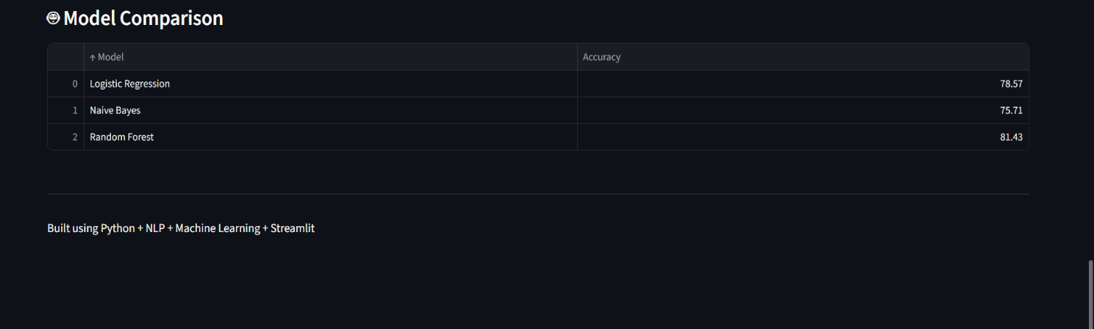
Output Predictions: Spam/Genuine classification with confidence score
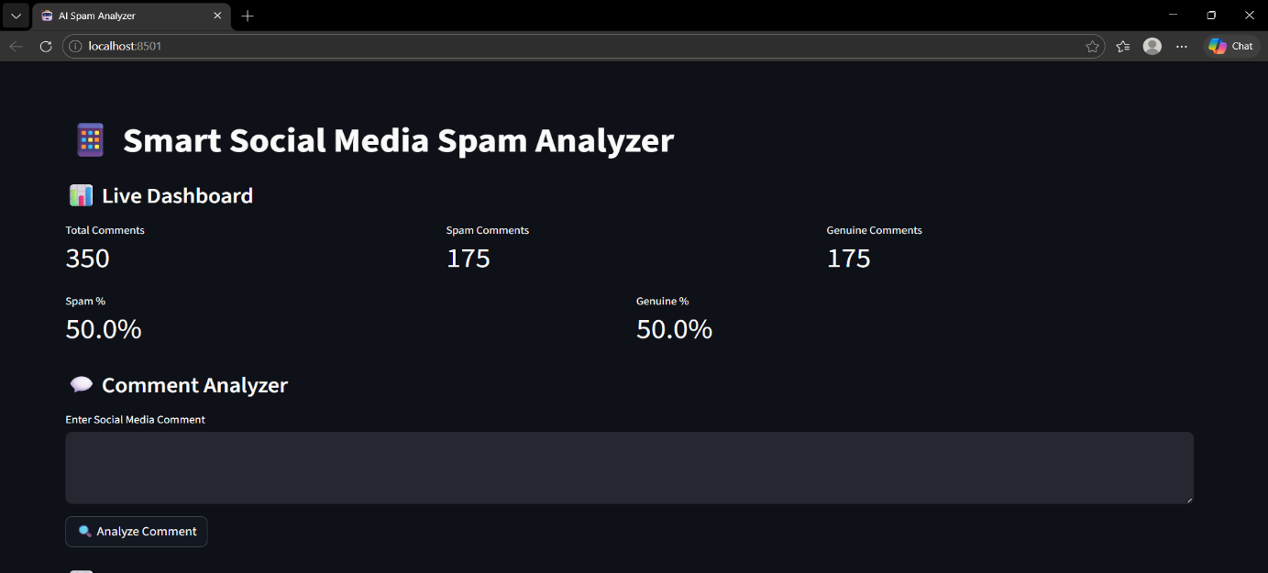
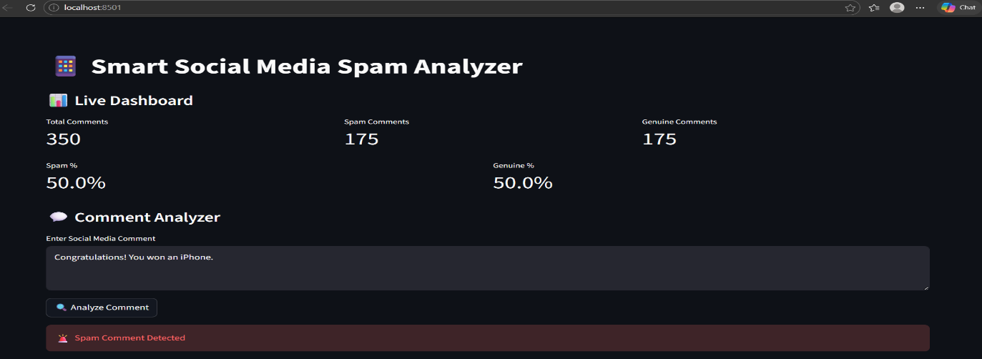
Spam and genuine comments are equal.
The dashboard shows that the comment “Congratulations! You won an iPhone.” is detected as spam.
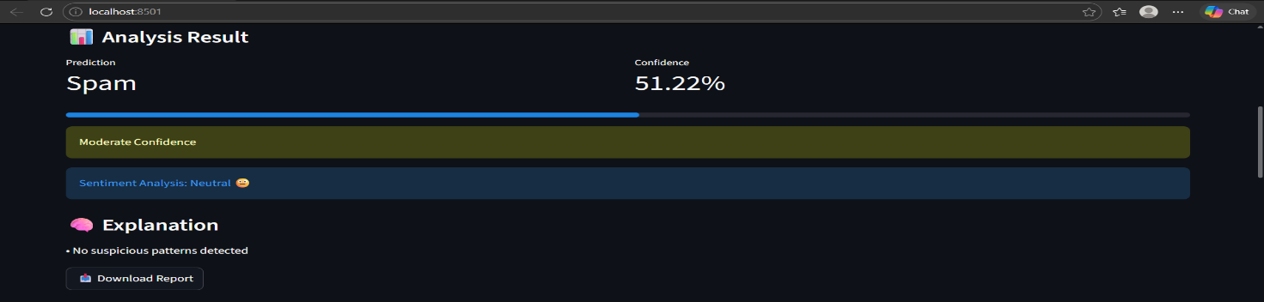
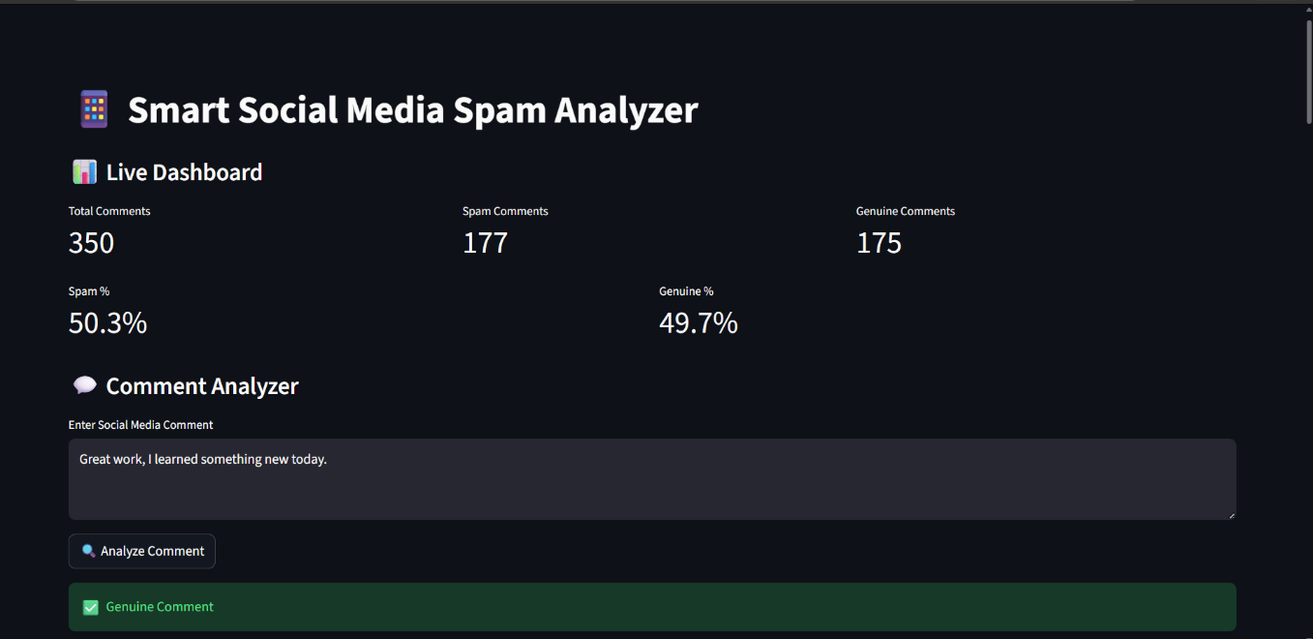
The dashboard shows that the comment “Great work, I learned something new today.” is detected as genuine.
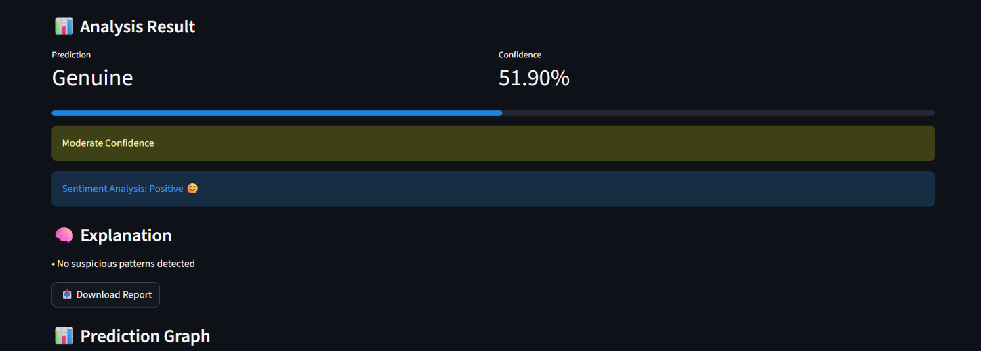
Graphs: Prediction probability bar chart, spam word cloud
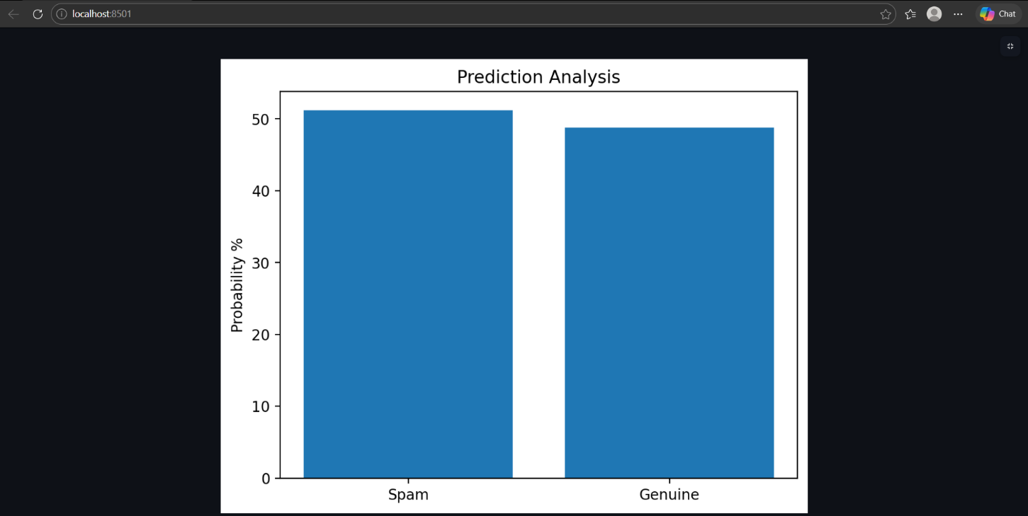
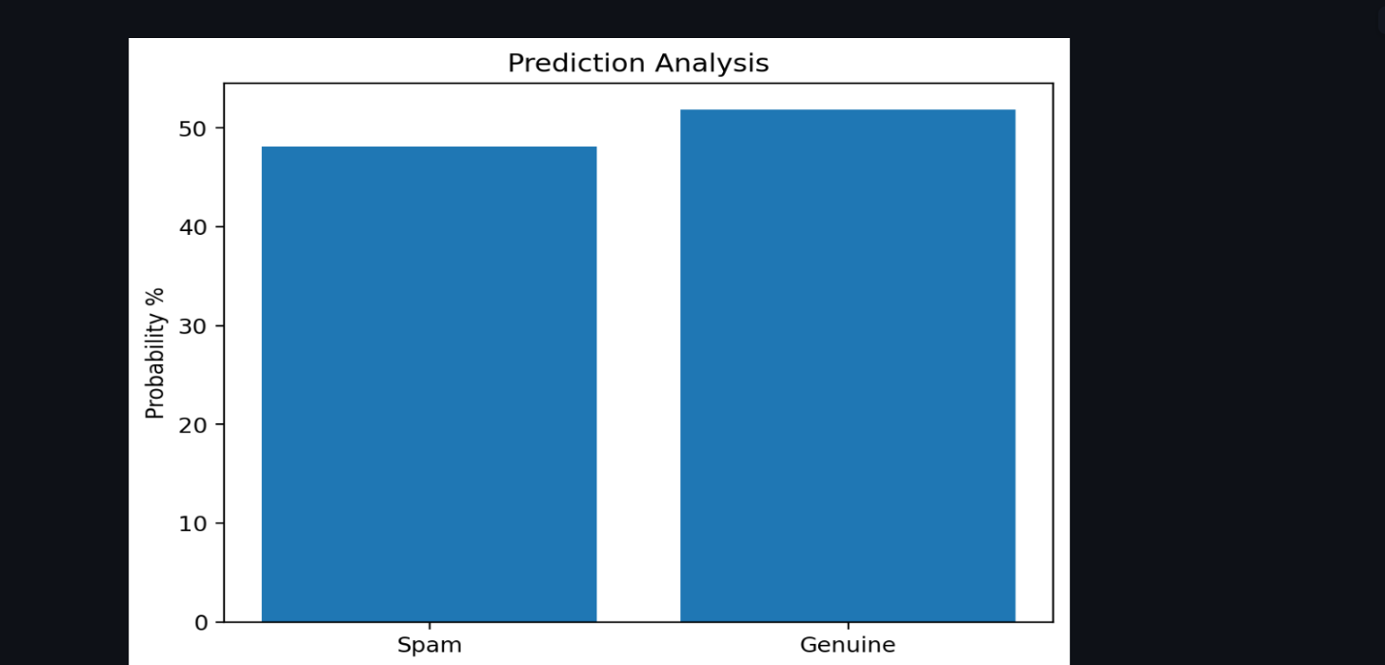
Performance Analysis: Logistic Regression chosen as final model due to highest accuracy
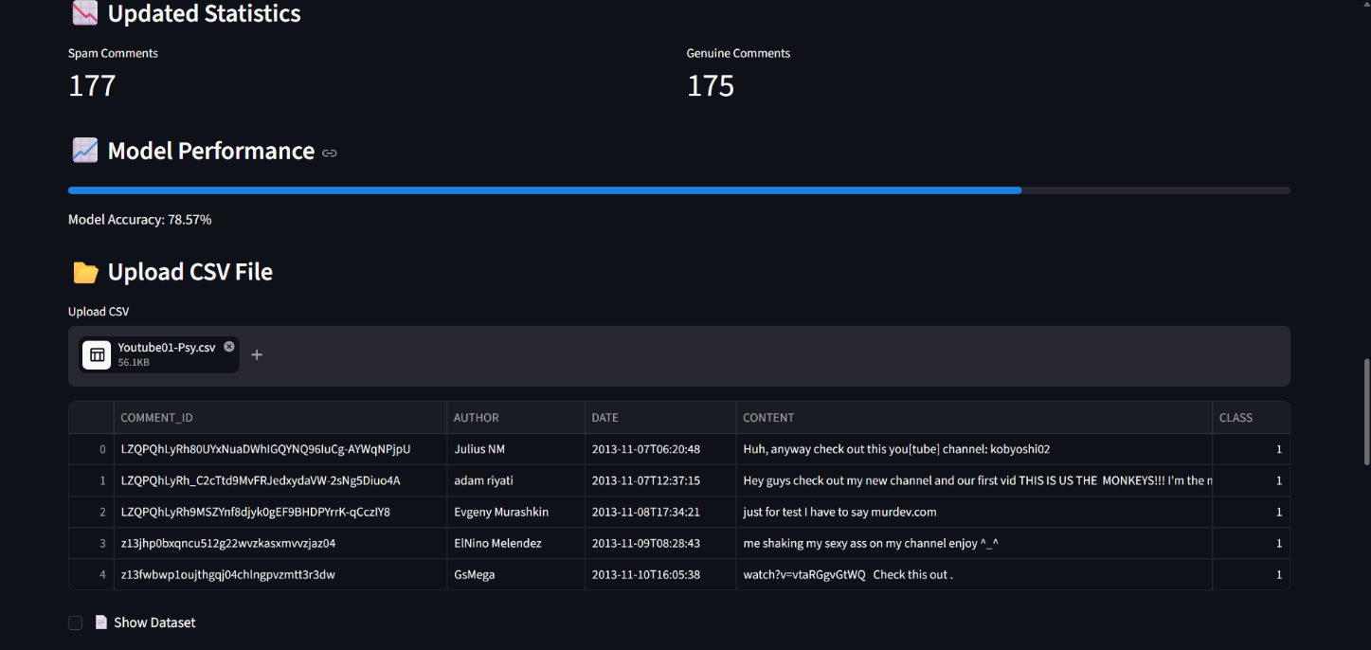
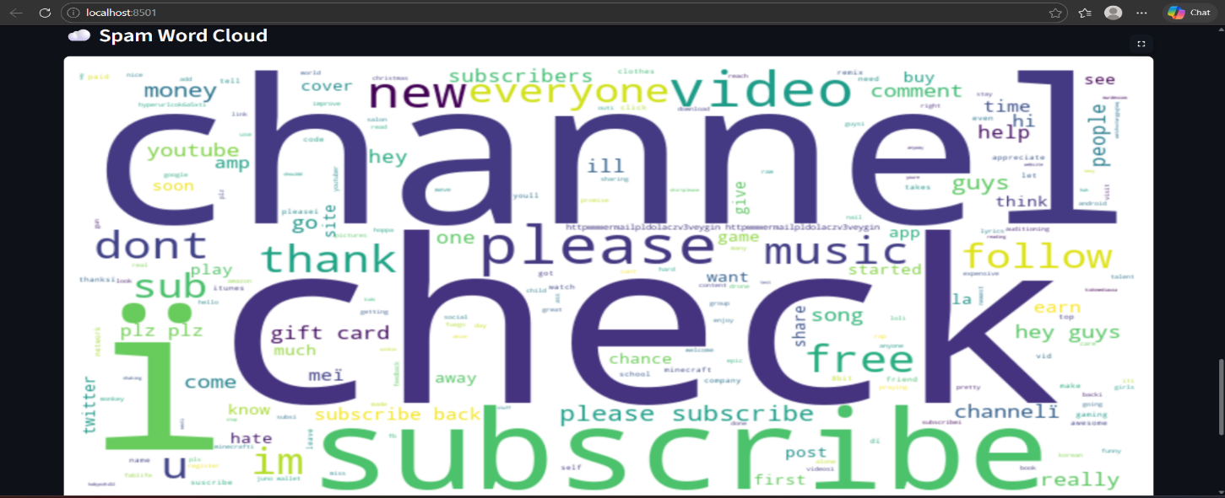

8. Challenges Faced
- Handling noisy text data with links and emojis
- Balancing dataset between spam and genuine comments
- Integrating multiple models into a single dashboard
- Optimizing Streamlit UI for clarity and usability
9. Conclusion
The project successfully detects spam comments, explains suspicious patterns, and provides sentiment analysis. Future improvements include expanding dataset size, integrating deep learning models (e.g., LSTMs, BERT), and deploying the dashboard as a web service.
10. References
- Kaggle Dataset: YouTube Spam Collection Data Set
- NLTK Documentation
- Scikit-learn Documentation
- Streamlit Documentation
- YouTube tutorials on spam detection
11. Submission Files
- Project Report (PDF)
- Source Code (ZIP)
- Screenshots of Dashboard
File Naming Format: YourName_SpamAnalyzer.pdf

