NEARBY
Brand, Icon & PWA Manifest Guide

Version 1.0
Companion to NEARBY Master Build Document v2.6.2
Deployment target: free Netlify subdomain (e.g. nearby-app.netlify.app)
All decisions below are final defaults chosen for this build. Anything the pilot wants to override is called out explicitly.

0. Decisions at a Glance
Everything in this section is a final, ready-to-implement default. Each is expanded with full rationale and specs in the sections that follow.
- App name: NEARBY (unchanged — already established in the Master Build Document).
- Tagline: “Ask around. Instantly.” — used in the manifest name, App Store–style listings, and marketing surfaces.
- Mark: a location pin with three broadcast arcs, symbolizing a request radiating out to nearby shops.
- Primary color: NEARBY Orange #FF5A36 — shared across all three surfaces; Ink Navy and Signal Teal differentiate Admin and Shop surfaces respectively (Section 3.3).
- Typeface: Inter (free, open-source, variable font) with a system-font fallback stack for zero-cost, zero-latency PWA loading.
- Icon set: 11 PNGs (48–512px, incl. two maskable sizes) + favicon.ico + apple-touch-icon, all generated from two source SVGs — delivered alongside this document (Section 7).
- Manifest: complete manifest.json delivered as a standalone file, referenced field-by-field in Section 5.

1. Brand Identity

1.1 — Name
NEARBY is kept as-is from the Master Build Document — it already does the job a name needs to do here: it states the product's core mechanic (proximity) in one plain word, reads clearly at every icon size down to 48px, and has no trademark collision risk in the local-commerce/hyperlocal-search category as of this writing.

1.2 — Tagline
Primary: “Ask around. Instantly.” — captures both halves of the product in four words: the broadcast-a-question mechanic (“ask around”, the way you'd ask a neighbor) and the real-time response window (“instantly”).
Alternate (shorter, for tight spaces like the browser tab or app-switcher card): “Nearby. Right now.”

1.3 — Positioning statement
For a customer standing in front of an empty shelf, NEARBY is the fastest way to find out who nearby actually has what they need — without calling shop after shop or guessing from an out-of-date listing. Unlike general marketplaces, NEARBY doesn't sell anything or take a cut; it just connects a real-time question to the shops close enough to answer it.

1.4 — Voice & tone
- Direct and local — short sentences, plain words, no marketplace jargon (“shops” and “requests,” never “vendors” or “tickets”).
- Calm under real-time pressure — countdown and live-count UI copy stays neutral (“3 shops have answered”), never manufactures urgency.
- Respectful of shopkeepers' time — shop-facing copy is the shortest and most action-oriented of the three surfaces, since FR requirements assume low technical proficiency (Section 2, Master Build Doc).

2. Logomark & Icon System

2.1 — Concept
The mark is a location pin with three concentric arcs fanning above it — the pin is the shop being found; the arcs are the broadcast radiating outward to reach it. It reads at a glance as both “place” and “signal,” the two halves of what the app does, and it survives reduction to a 16px favicon because it's built from two shapes, not fine detail.

2.2 — Construction
- Canvas: 512×512 SVG, exported to every PNG size the manifest and platform targets require (Section 5.2).
- Two source files: nearby-mark.svg (rounded-square background, for app icons/App Store–style listings) and nearby-mark-maskable.svg (full-bleed background, glyph confined to the inner 80% safe circle Android/adaptive icons require).
- Clear space: keep at least 10% of the icon's width as empty margin on every side when placing the mark next to other logos or text.

2.3 — Don'ts
- Don't recolor the glyph off-white or the background off-brand-orange for the primary mark — use the monochrome favicon variant instead if a flat single-color mark is needed.
- Don't stretch or skew — scale uniformly only.
- Don't add a drop shadow or outer glow — the OS/browser chrome already adds its own icon treatment (rounded corners on iOS, circular mask on some Android launchers).

2.4 — The icon system
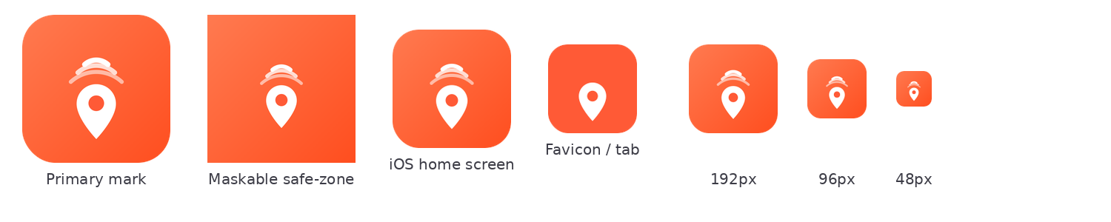
Primary mark, maskable safe-zone variant, iOS/favicon renders, and the size ladder — all generated from the two source SVGs.

3. Color System

3.1 — Palette
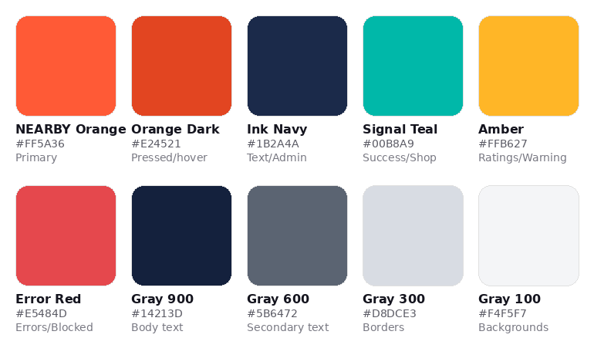
Full palette with hex values and intended usage.

3.2 — Semantic usage
Token | Usage | Maps to
Primary | Primary buttons, active nav, broadcast CTA, links | #FF5A36
Primary-pressed | Hover/active/pressed state of primary elements | #E24521
Success | ‘Yes’ responses, shop open, request:ready state | #00B8A9
Warning | Star ratings, pending/awaiting_selection state | #FFB627
Danger | Errors, rejected/blocked shop states, cancel actions | #E5484D
Text primary | Body copy on light backgrounds | #14213D (Gray 900)
Text secondary | Captions, timestamps, helper text | #5B6472 (Gray 600)
Border | Dividers, input borders, card outlines | #D8DCE3 (Gray 300)
Surface | Page/card background | #F4F5F7 (Gray 100) / #FFFFFF

3.3 — Per-surface accent mapping
All three surfaces share the same palette (one design system, per Section 6.1 of the Master Build Document) but each leads with a different accent so a screenshot alone tells you which surface you're looking at:
- Customer app (/app/*): Orange-forward — primary color drives every CTA (broadcast, select, submit feedback).
- Shop dashboard (/shop/*): Teal-forward — Signal Teal replaces orange as the dominant accent on nav/active states, keeping orange reserved for the Yes/No response buttons only, so the one action that matters is never visually competing with chrome.
- Admin console (/admin/*): Navy-forward — Ink Navy leads (nav, headers), orange is used sparingly for destructive/attention actions (block, suspend, reject) so it reads as a deliberate warning color in this surface rather than a routine CTA color.

3.4 — Accessibility
NEARBY Orange (#FF5A36) on white passes WCAG AA for large text/UI components (3:1) but not for small body text (4.5:1) — use Gray 900 for body copy and reserve orange for buttons, icons, and large headings. White text on Orange, Navy, and Teal backgrounds all pass AA for normal text.

4. Typography

4.1 — Typeface
Inter — free, open-source (SIL OFL), variable font, designed specifically for UI legibility at small sizes on screens. It covers the Latin character set needed for the pilot locality and adds zero licensing cost, consistent with the rest of the stack.
font-family: "Inter", -apple-system, BlinkMacSystemFont, "Segoe UI", Roboto, sans-serif;
The system-font fallback chain means text renders correctly and instantly even before the Inter font file finishes loading over Render/Netlify's free-tier CDN — no invisible-text flash.

4.2 — Scale
Role | Size / line-height | Weight | Used for
Display | 32px / 40px | 700 Bold | Screen titles (rare — mobile-first layout)
H1 | 24px / 32px | 600 SemiBold | Page/section headers
H2 | 18px / 26px | 600 SemiBold | Card headers, shop names
Body | 15px / 22px | 400 Regular | Default copy
Caption | 13px / 18px | 400 Regular | Timestamps, helper text, distances
Button | 15px / 20px | 600 SemiBold | All button labels

5. PWA Manifest

5.1 — manifest.json
Delivered as a standalone file (manifest.json, Section 7). Field-by-field:
Field | Value / rationale
name | “NEARBY — Ask Around, Instantly” — shown on the install prompt and app-switcher on larger screens
short_name | “NEARBY” — shown under the home-screen icon, where space is tight
start_url | “/?source=pwa” — lets analytics distinguish installed-app opens from browser visits at no extra cost
display | “standalone” — hides the browser chrome for an app-like feel on all three surfaces
theme_color | #FF5A36 — colors the OS status bar / task switcher strip
background_color | #FFFFFF — shown briefly on cold start before CSS loads
icons | 11 entries spanning 48–512px, including dedicated 192/512 maskable entries (Section 5.2)
shortcuts | Long-press/right-click app icon shortcuts to “Broadcast a search” and “Shop dashboard” — zero-cost engagement win once installed

5.2 — Icon size checklist
File | Size | Purpose | Required?
icon-512.png | 512×512 | any — install prompt, splash generation | Yes
icon-384.png | 384×384 | any | Recommended
icon-192.png | 192×192 | any — Android home screen | Yes
icon-maskable-512.png | 512×512 | maskable — adaptive icon safe zone | Yes
icon-maskable-192.png | 192×192 | maskable | Yes
icon-152 / 144 / 128 / 96 / 72 / 48.png | various | any — legacy Android/Chrome densities | Nice-to-have
apple-touch-icon-180.png | 180×180 | iOS home screen (iOS ignores the manifest icons) | Yes
favicon.ico | 16/32/48 multi-res | Browser tab | Yes

6. HTML Head Implementation
Add to the SPA's index.html (all paths assume icons are copied to /public/icons/ so Vite serves them at the site root — Section 7.1):
<link rel="manifest" href="/manifest.json">
<link rel="icon" href="/icons/favicon.ico" sizes="any">
<link rel="icon" type="image/png" sizes="32x32" href="/icons/favicon-32.png">
<link rel="apple-touch-icon" href="/icons/apple-touch-icon-180.png">
<meta name="theme-color" content="#FF5A36">
<meta name="apple-mobile-web-app-capable" content="yes">
<meta name="apple-mobile-web-app-status-bar-style" content="black-translucent">
No native splash-screen image set is included in v1 — iOS/Android both auto-generate a splash from theme_color/background_color + the 512px icon, which is sufficient for the pilot and keeps the asset list at zero extra cost.

7. Asset Delivery

7.1 — What's included in this package
- NEARBY-Brand-PWA-Guide.docx — this document
- manifest.json — ready to drop into the SPA's /public/ folder
- nearby-mark.svg / nearby-mark-maskable.svg / nearby-favicon.svg — editable source files
- icons/ — all 14 exported PNGs + favicon.ico listed in Section 5.2, pre-named to match the manifest.json paths exactly

7.2 — Where they go in the repo
public/
manifest.json
icons/
icon-48.png ... icon-512.png
icon-maskable-192.png, icon-maskable-512.png
apple-touch-icon-180.png
favicon.ico, favicon-16.png, favicon-32.png
Vite serves everything under /public/ at the site root unchanged, so the manifest's absolute paths (“/icons/icon-512.png”, etc.) resolve correctly with no build-step configuration — this was chosen specifically to add no Sprint 1 setup work.

8. Hosting Note (Free Netlify Subdomain)
Since the pilot is launching on a free *.netlify.app subdomain rather than a custom domain, two small things follow directly from that choice:
- theme_color and the maskable icon matter more than usual — a netlify.app URL in the address bar is the only “brand” a first-time visitor sees before they install the PWA, so the icon and status-bar color are doing extra trust-building work.
- Pick the subdomain once and treat it as fixed for the pilot — changing it later changes the PWA's origin, which invalidates existing installs (users would need to reinstall). “nearby-app.netlify.app” (already used as the example throughout the Master Build Document, Section 3.9) is a fine, available-pattern choice — confirm availability at netlify.com when the site is created and lock it in before any installs happen.

9. Motion & Interaction
NEARBY's UI is driven by real-time events (Section 3.1 of the Master Build Document) — a live response count, a closing window, a shortlist appearing — so motion isn't decoration here, it's how the state machine in Section 6.3 reads as alive rather than static. Every pattern below is deliberately lightweight: CSS transforms/transitions first, Framer Motion only where React state genuinely needs it, nothing that adds meaningful bundle weight or GPU cost. This keeps faith with the zero-latency-loading decisions made elsewhere in this guide (Section 4.1's font fallback stack, Section 6's no-splash-image default) and with the brand's calm-under-pressure voice (Section 1.4) — motion here should never manufacture urgency the way a marketing-site showcase animation would.

9.1 — Motion tokens
Named constants, not per-component guesswork — keeps every surface consistent and makes prefers-reduced-motion (Section 9.5) a single override point.
Token | Value | Used for
duration-instant | 100ms | Tap/press feedback (9.3)
duration-quick | 180ms | Toasts, skeleton-to-content swap (9.3, 9.4)
duration-standard | 240ms | Card reveal, screen transitions (9.2, 9.3)
ease-standard | cubic-bezier(0.4, 0, 0.2, 1) | Default easing — fast in, gentle stop
ease-out-soft | cubic-bezier(0, 0, 0.2, 1) | Elements entering the screen (reveals, toasts)
stagger-step | 40ms | Delay between successive shortlist cards (9.2)

9.2 — Real-time state animations
Tied directly to the Socket.IO events in Section 5's "Real-time events" table and the client state machine in Section 6.3 of the Master Build Document:
- Broadcast pulse — while a request is status: 'open', the logomark's three arcs (Section 2.1) animate outward as looping, staggered expanding rings (CSS @keyframes, ~1.6s loop, opacity fade). Shown on the customer's own request-detail screen to signal "still broadcasting" without a spinner.
- Live count-up — response:update's count doesn't jump; it eases from the old value to the new one over duration-quick. Never animates past the true number (no bouncy overshoot) — matches the "neutral, never manufactures urgency" voice rule (Section 1.4).
- Shortlist reveal — on request:ready, shop cards fade in + translateY(10px→0) over duration-standard/ease-out-soft, each card offset by stagger-step so the list builds top-to-bottom instead of popping in at once.
- Selection confirmation — request:selected crossfades the shortlist view into the single confirmed-shop card (duration-standard) rather than a hard route change, so the customer doesn't lose their place.
- Expired / cancelled states — no motion beyond the standard screen-transition fade (9.3); these are end states and shouldn't draw extra attention per the calm-tone rule.

9.3 — Core interaction patterns
- Tap/press feedback — buttons and shop cards scale to 0.97 on :active/touchstart over duration-instant, scale back on release. Cheapest signal that the app feels installed/native rather than a browser tab.
- Screen transitions — a single fade + 12px translateY over duration-standard between route changes. No slide-in-from-3D, no shared-element morphing — keeps first paint fast on a Render free-tier cold start (Section 8.4, Master Build Document).
- Toast / snackbar — slides up from the bottom edge + fades in over duration-quick for background socket events (request:selected while elsewhere in the app, request:cancelled). Auto-dismisses; never blocks input.
- Pull-to-refresh / manual reload — a simple rotating-arrow spinner, not a custom illustration; reserved for the REST-fallback polling case in Section 6.3 so the shop dashboard's 5s poll (Master Build Document, Section 6.3) has a visible manual trigger too.

9.4 — Loading & empty states
- Skeleton loaders — shop dashboard cards and the shortlist show gray placeholder blocks (Gray 100/Gray 300, Section 3.1) with a slow left-to-right shimmer, swapped for real content over duration-quick once data arrives. Used instead of a centered spinner anywhere a list is the eventual content.
- Empty states — "no shops in range yet," "no requests waiting" — get a single static instance of the logomark's pin (no looping animation; a looping empty state reads as the app being stuck, not as the app working) plus one line of the direct, plain-word copy defined in Section 1.4.

9.5 — Accessibility: reduced motion
A single `@media (prefers-reduced-motion: reduce)` block disables the broadcast pulse loop, shortlist stagger, and skeleton shimmer app-wide, falling back to instant state changes with no transition. This is one media query against the tokens in Section 9.1 — not a per-component decision — so it can't be missed component-by-component as the app grows.

9.6 — Deliberately out of scope for v1
Named explicitly so it's a documented deferral, not an oversight, consistent with how the Master Build Document handles scope cuts (e.g. Section 3.11):
- 3D/WebGL effects (globe carousels, 3D card flips, parallax scenes) — real GPU/bundle cost for a mobile-first utility app on a free-tier CDN, and off-tone for the "calm, respectful of shopkeepers' time" voice (Section 1.4).
- Sound and haptics — no audio cues or vibration patterns in v1; nothing in the FRs (Master Build Document, Section 2) calls for them and they'd need their own on/off setting.
- Custom page-transition libraries beyond Framer Motion — the fade/translateY pattern in 9.3 covers every transition in the three surfaces; a heavier routing-transition library isn't justified at this scope.
If a future marketing/pre-install landing page is built (separate from the installed PWA, per Section 8's hosting note), heavier showcase-style motion (feature carousels, illustrated hero animation) is reasonable there, since it's a one-time page a visitor loads before installing rather than the installed app itself.

10. Appendix: File Index
File | Purpose
manifest.json | Web app manifest — Section 5
nearby-mark.svg | Primary icon source (rounded-square background)
nearby-mark-maskable.svg | Maskable icon source (full-bleed, safe-zone glyph)
nearby-favicon.svg | Simplified flat mark, source for favicon renders
icons/*.png, favicon.ico | All exported raster sizes — Section 5.2 checklist
This document and its assets are internally consistent with the NEARBY Master Build Document v2.6.2 — no naming, color, or path here contradicts anything specified there.

