INF1103: Lab 1
Foundations of Programming and Dev Ops

1. Introduction
Welcome to your first lab session for INF1103! In this lab, we will calibrate and establish the essential workspace toolkit needed to kickstart your journey into modern software engineering. This session acts as the absolute baseline for all subsequent lab activities, so it is highly important that you not only complete it but thoroughly understand every system metaphor presented here.
Remember, the focus of this module is all about bridging logical programming constructs with modern, automated operational practices. We will systematically evolve our applications week by week, refactoring and packaging our code to fit enterprise-grade deployment standards.
True engineering mastery comes from hands-on problem-solving. Ensure you work through and complete each step of this lab by yourself. While your peers are excellent resources for discussing conceptual architectures, they must not write code for you or share their files with you!
It is highly critical that you have watched and engaged with the Week 1 lecture lessons before attempting this lab. Do not hesitate to ask plenty of questions to your professor and teaching assistants when you hit an infrastructure error. We are here to support you. Good luck!

2. Objectives
In this lab, you will set up Visual Studio Code and write your first python programs. After every feature enhancement, you will commit your work using Git to simulate an industry workflow.

1. Set Up a Development Environment
- Install and configure Visual Studio Code, Python, and Git.
- Verify that all development tools are functioning correctly.

2. Understand Version Control Fundamentals
- Initialize and configure a Git repository.
- Track file changes using Git status and diff commands.
- Stage and commit code changes using meaningful commit messages.

3. Create and Execute Python Programs
- Write, save, and run Python scripts using Visual Studio Code.
- Understand the program execution workflow.

3. Setting Up a Development Environment

- Install Visual Studio Code (VS Code)
VS Code is a lightweight, powerful code editor used by professional software engineers worldwide.
    - Go to the official download page: code.visualstudio.com.
    - Download the installer matching your operating system (Windows, macOS, or Linux).
    - Run the installer and accept all default options.

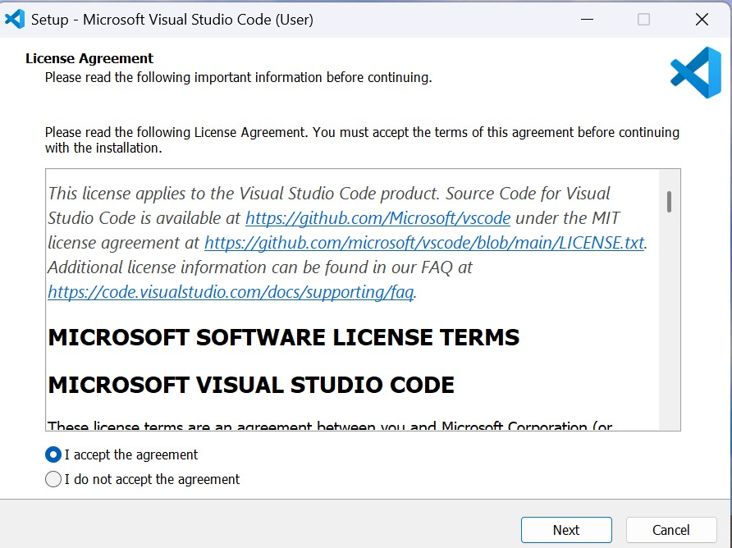

      - Windows Users: Ensure you check the box that says “Add to PATH (requires shell restart)” during setup.

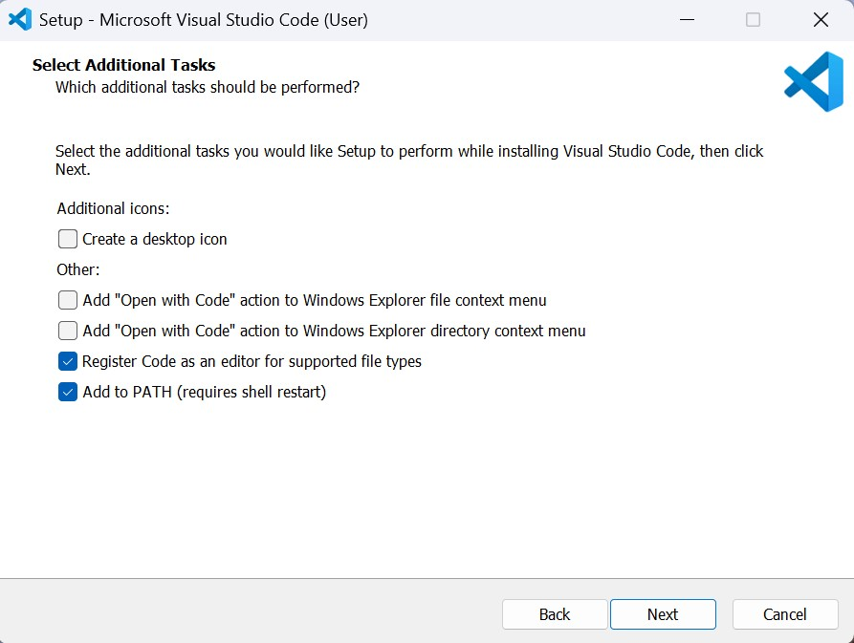

      - Then Next to Install

- Install Python
  - Go to official page: https://www.python.org/downloads/
  - Download Python Install Manager
  - Install the latest Python version.
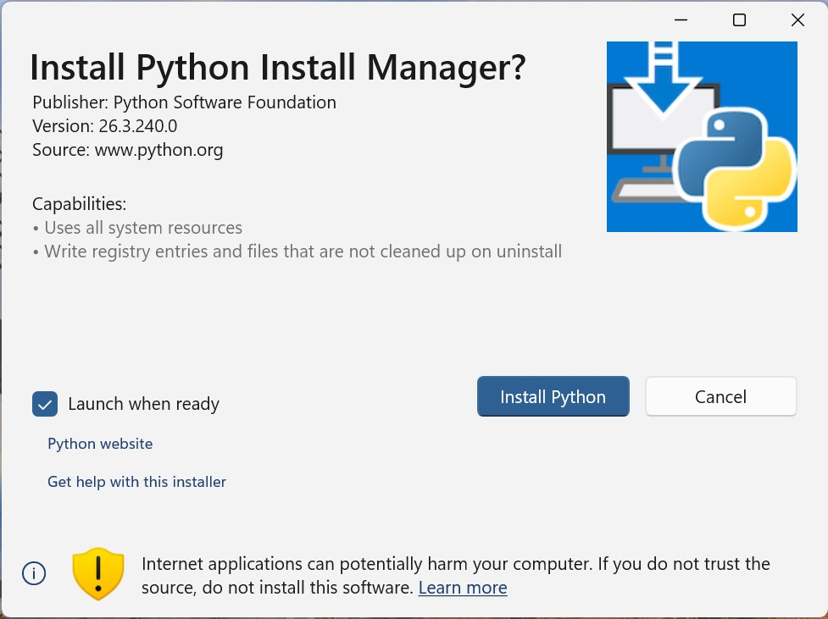
  - Windows users should enable “Add Python to PATH” during installation.

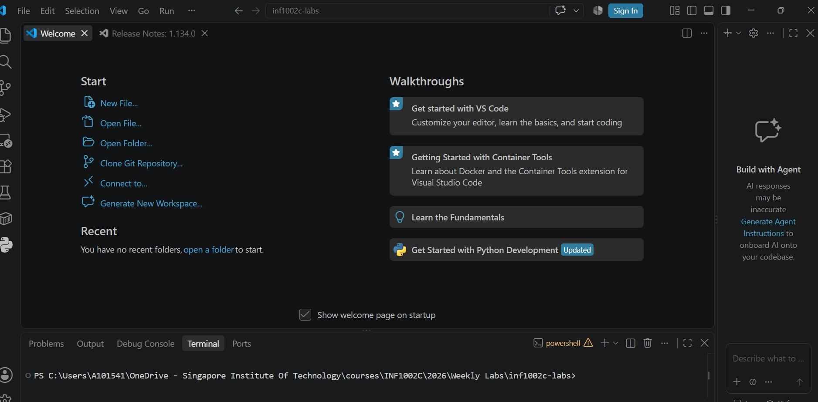
3
.
Link Python is VS Code
a.
Open VS Code

Extensions
Tool Bar
Explorer

Terminal

b. Go to File-> Preferences-> Extensions or the Extension Toolbar. Type python in the Search Bar
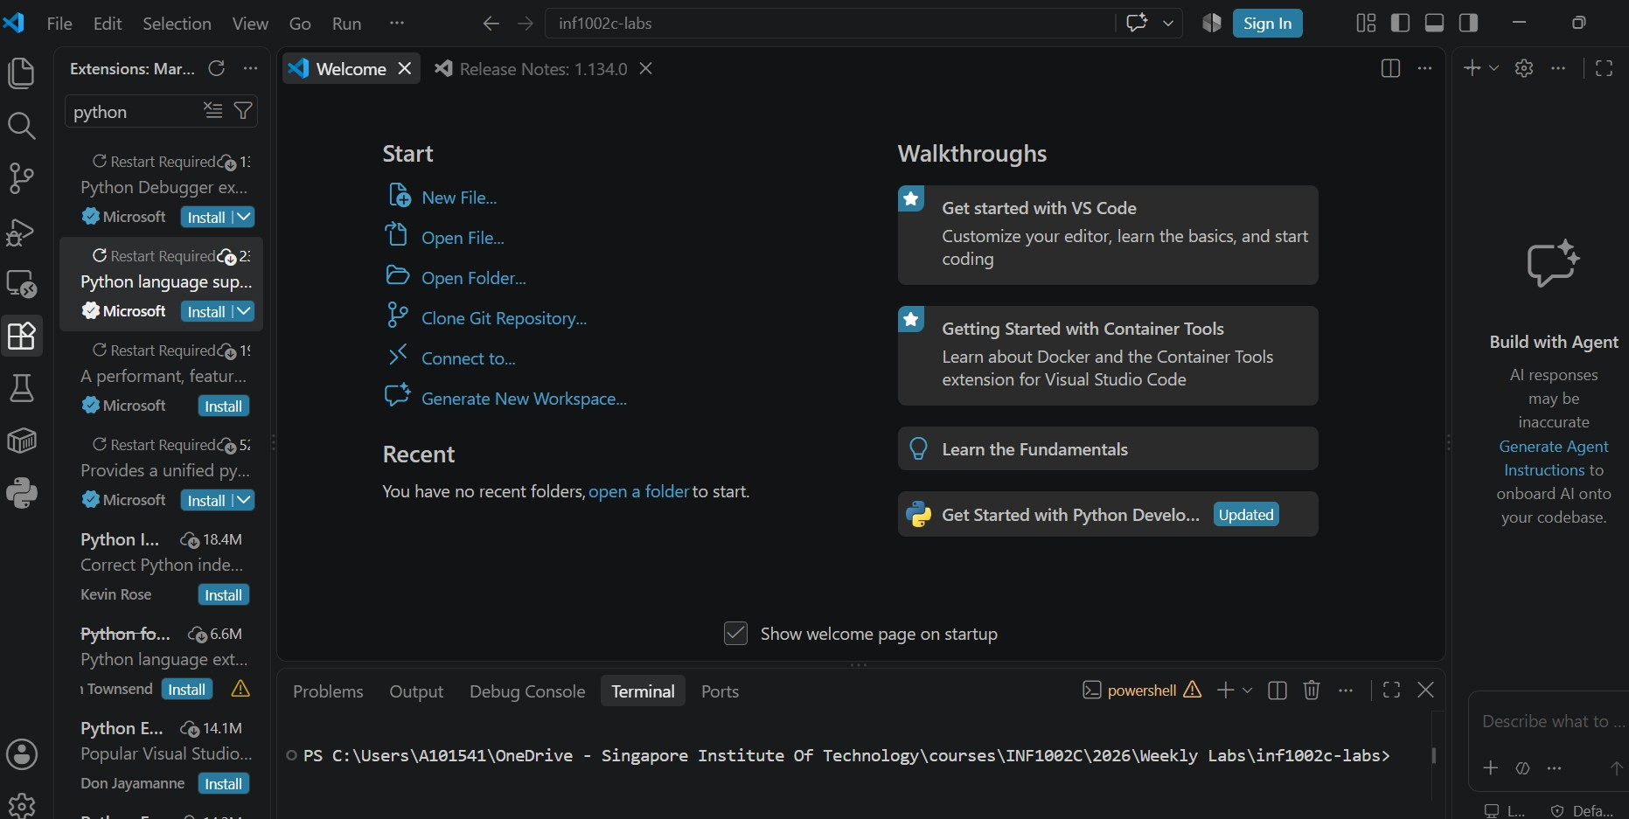

Install
Python
Debugger
and
Python

- Install Git
  - Go to the official Git website: https://git-scm.com/install/
  - Download the installer and run
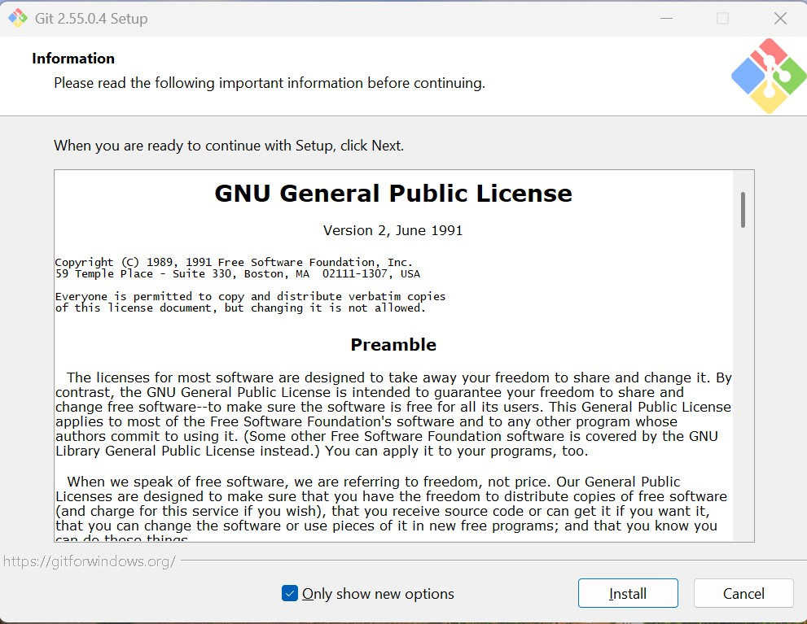

- Check Python and Git versions
  - Open VSCode
  - In Terminal:
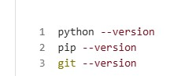
  - The output will be the respective versions

4. Understanding Version Control

Create your Development Workspace:

a. Click Explorer
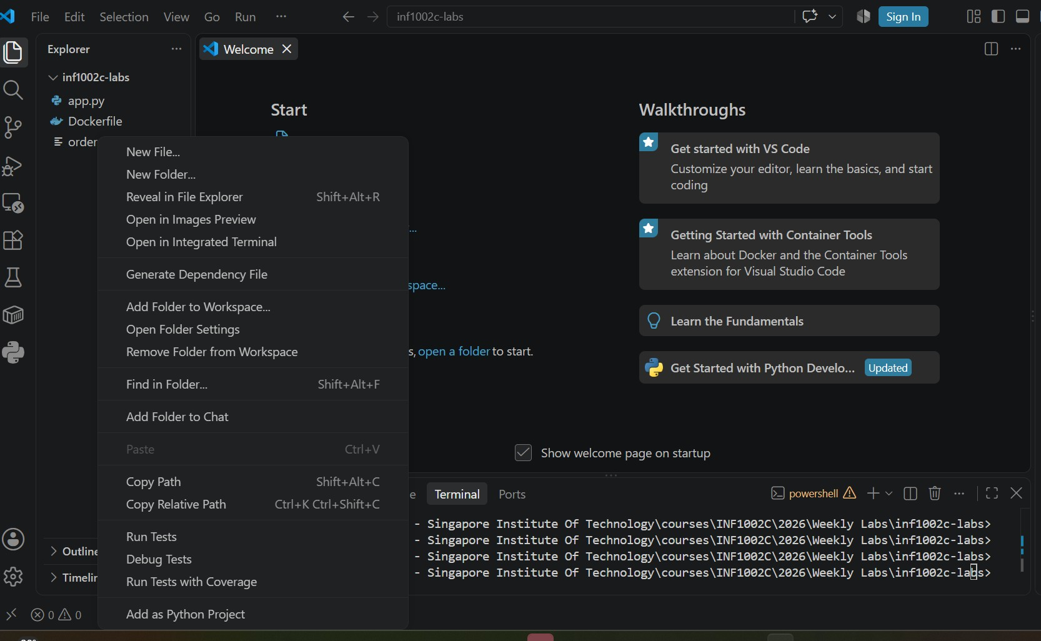
b.
Right click and choose New folder.

- Create INF1103-Labs folder in VS Code.
- Navigate to your project folder cd INF1103-Labs
- Configure Git for the First Time
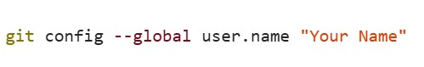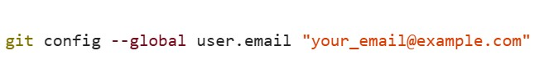 f. Initialize your git repository
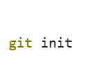
You will get an output message saying:
Initialized empty Git repository in yourFolder/.git/
g. You can check the repo status using:
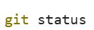
The expected output is:
On branch master
No commits yet
nothing to commit

5. Python Programming

Activity 1: Create your First Python Program and add it to the repository

- Right Click on INF1103-labs folder and click New File hello.py

- Write your first python lines. A welcome message:

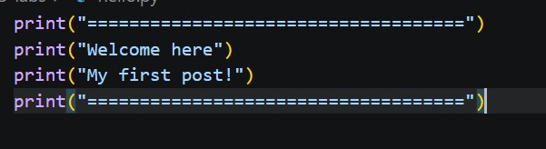
- Go to Run Tab and run your code, what do you observe?
  - Does the program display messages exactly as written?
yes
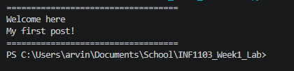
  - What is the order of execution of the statements? top to bottom or bottom to top?
top to bottom
  - Where does the output appear?
terminal

- Add hello.py to your repository, In the VS Code terminal type:
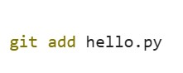
- Check the status of your repo (1.g), the expected output:

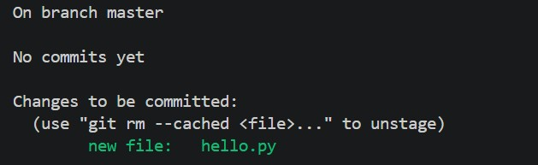
- Create your first commit:

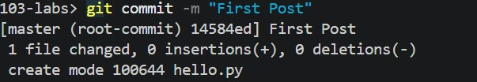
- View the git history by:
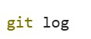

Activity 2: Update your Profile and add it to the repository

- Let’s assume you are creating an Instagram Profile and the first program was a welcome message on your page. Make the following changes to your file:
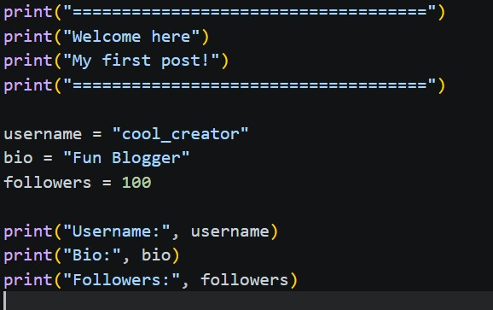
- Run the code and observe:
  - What is the use of the variables “username”, “bio” and “followers”?
the variables username, bio, and followers store profile information so that the data can be referenced and displayed dynamically in the program.
  - What if you change these values, does the output change?
yes, changing these values will change the output. The print() statements dynamically output whatever values are assigned to those variables, so updated values will immediately reflect in the printed terminal output.
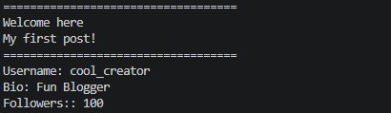
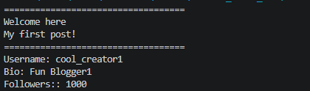
- You can check the difference in the repository files by typing:
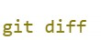
- Add and commit the changes to your repository. The message in the commit helps you later understand what were the changes made to the files.

Activity 3: Follower Growth tracker

- Variables act as containers that store data and changing the value of a variable changes the output. Append the following code to your python file:
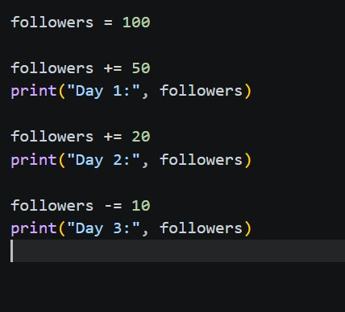

- Run and observe:
  - Do we manually have to reassign the follower value?
no, we do not have to manually reassign the follower value using followers = followers + .... The combined assignment operators update the variable directly.
  - Does each operation affect the first value (100) or the existing value of followers?
each operation affects the existing value of followers. Day 1 updates 100 to 150, Day 2 adds 20 to 150 (becoming 170), and Day 3 subtracts 10 from 170 (becoming 160).
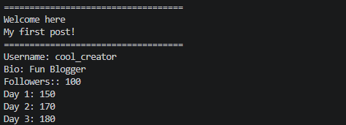
  - What is the use of += or -= operators?
the += and -= operators are augmented assignment operators used to add or subtract a value from a variable and reassign the updated result back to that variable in a single step (followers += 50 is shorthand for followers = followers + 50).
- Commit the changes to your repository

Activity 4: Interactive profile creator
- Currently your program displays hard coded values. Let’s try to make it more interactive and personalized:

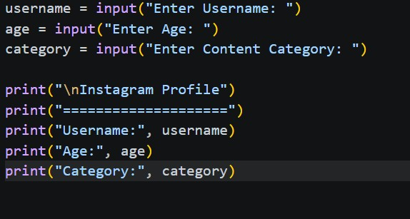

- Run the code and observe:
  - How does input() captures user’s input
the input() function prompts the user to type text into the terminal, pauses program execution until they press Enter, and then returns the typed user input as a string.
  - Is the program dynamic now or still hard coded?
the program is now dynamic because the output values are determined by user input at runtime rather than being hardcoded into the Python script.
  - Try to run multiple types with different inputs
running the code with different inputs changes the output dynamically each time based on whatever text is entered at the prompts.
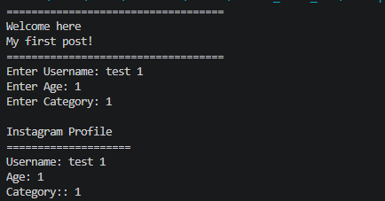
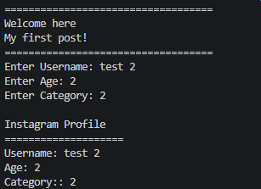
- Commit the change to your repository

Activity 5: Something fun to think about. More on this next week:

- Try this code:
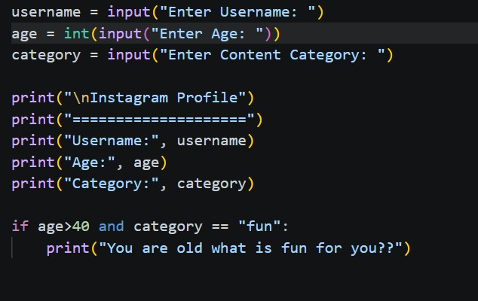

- The output:
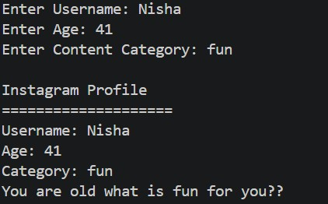

- What do you observe, apart from the fact that I am old:
  - What is the return type for input()
the default return type of input() is a string (str). This is why int() is used to explicitly convert the age input into an integer for numerical comparisons.
  - How are different conditions being checked?
conditions are checked using an if statement combined with the logical operator and “and” comparison operators (> and ==). Both conditions must be true—age > 40 and category == "fun"—for the conditional print statement to execute.
- Commit changes to your repository

What you need to submit?

1. Your python file (with all the 5 activities) 2. Your git log. Store it in a text file.
git log >log.txt
Your log file will have commits to every activity. It will look something like this:
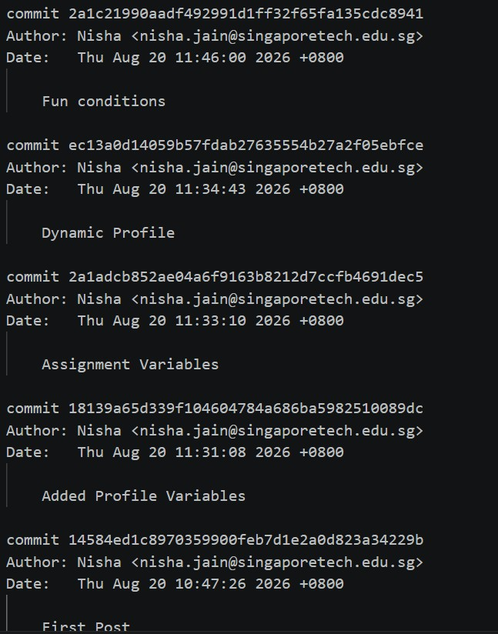

3. Put the python file and log file in a folder. Zip it and upload to xSite

