SIT-INF1103-Labs / Week2_Lab
3. https://github.com/Akari-light/SIT-INF1103-Labs/commits/main/
4. Mount and Run
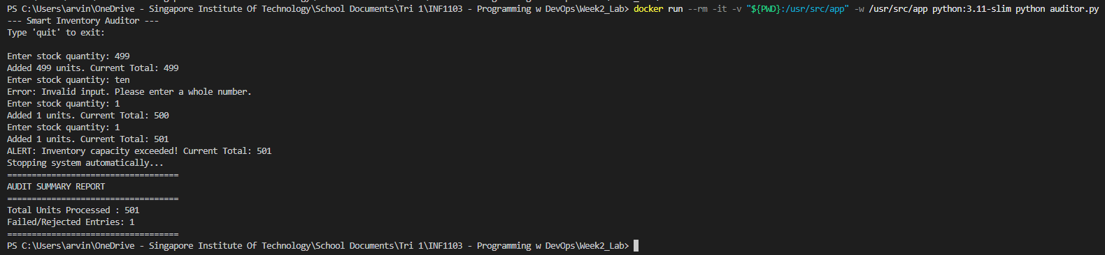
5. Building Custom Image
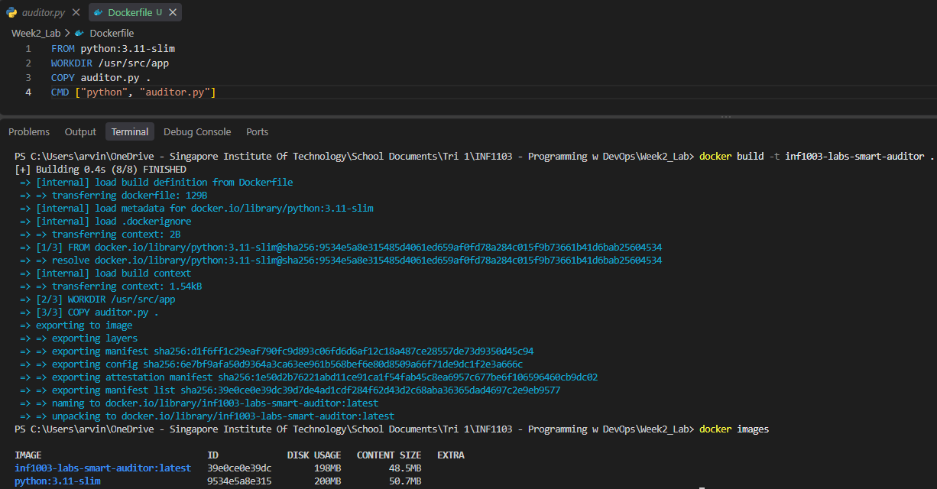
6. Run Custom Container
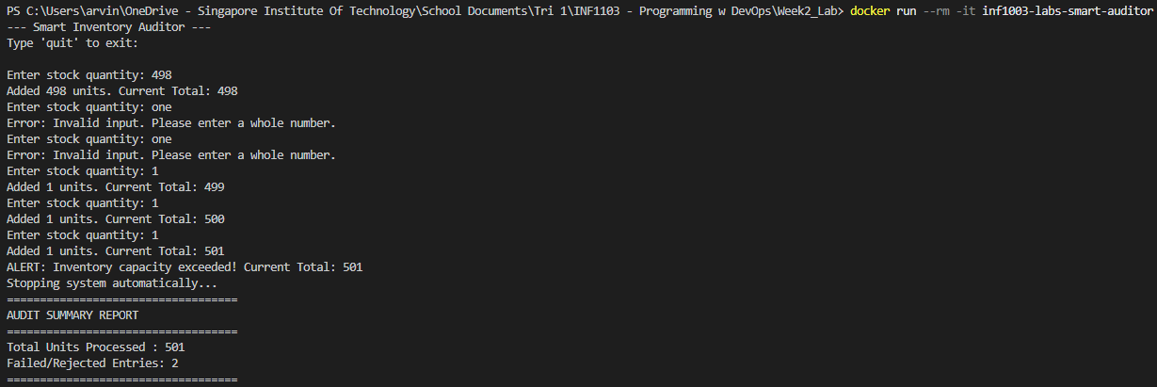

7. Self-Reflection Task
to persist data beyond the lifecycle of a singly container, we can use docker volumes or bind mount.
- docker volumes manage docker directly on the host filesystem which allows persistent storage that can be reattached across multiple container restarts or updates.
- bind mounts mount a specific folder from the local host machine directly inbto the container path so any files written by the app inside the container is saved directly onto the host pc hard drive.

