SIT-INF1103-Labs / Week5_Lab
4. Mount and Run
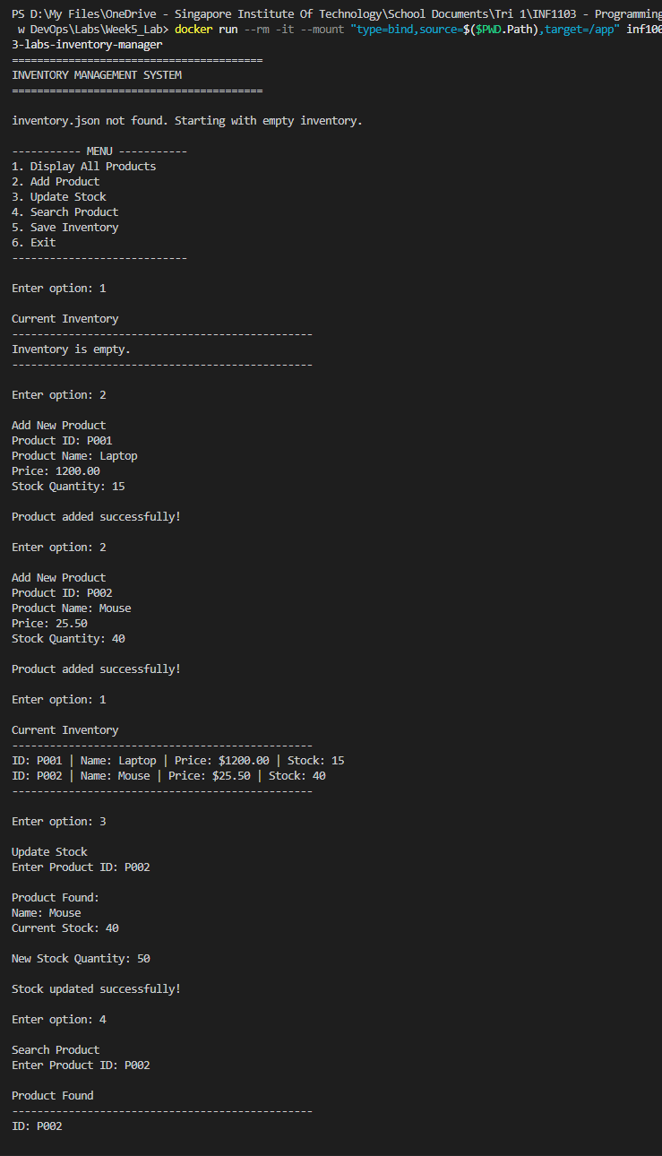
5. Evidence of successful build
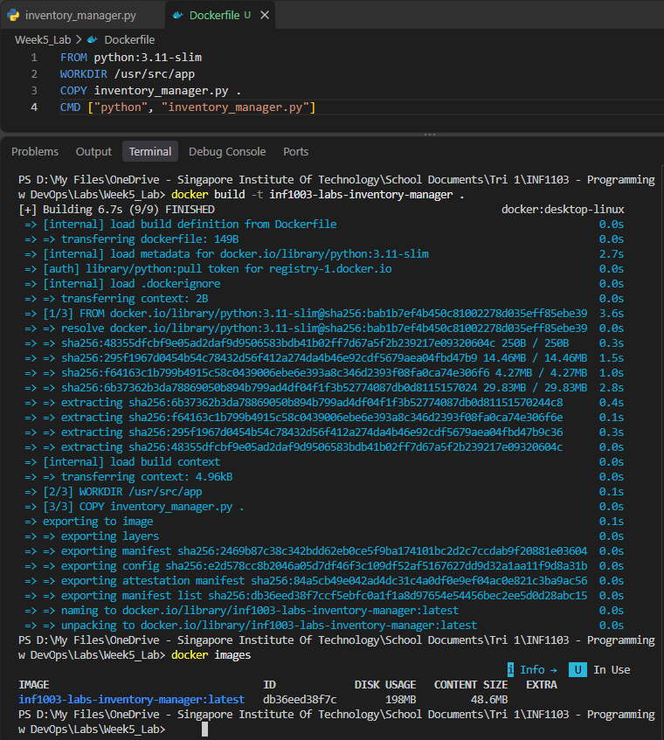
6. Run Custom Container
