SIT-INF1103-Labs / Week3_Lab
3. Mount and Run
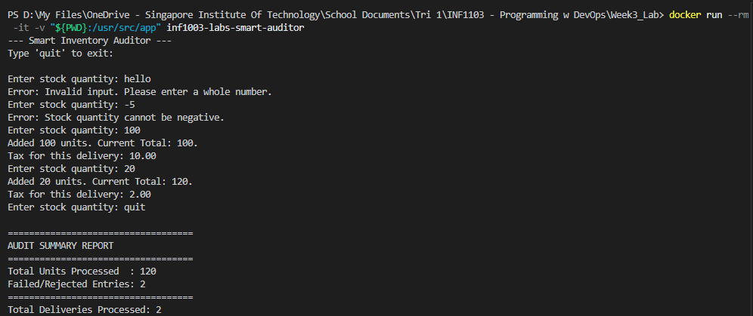
4. Evidence of successful build
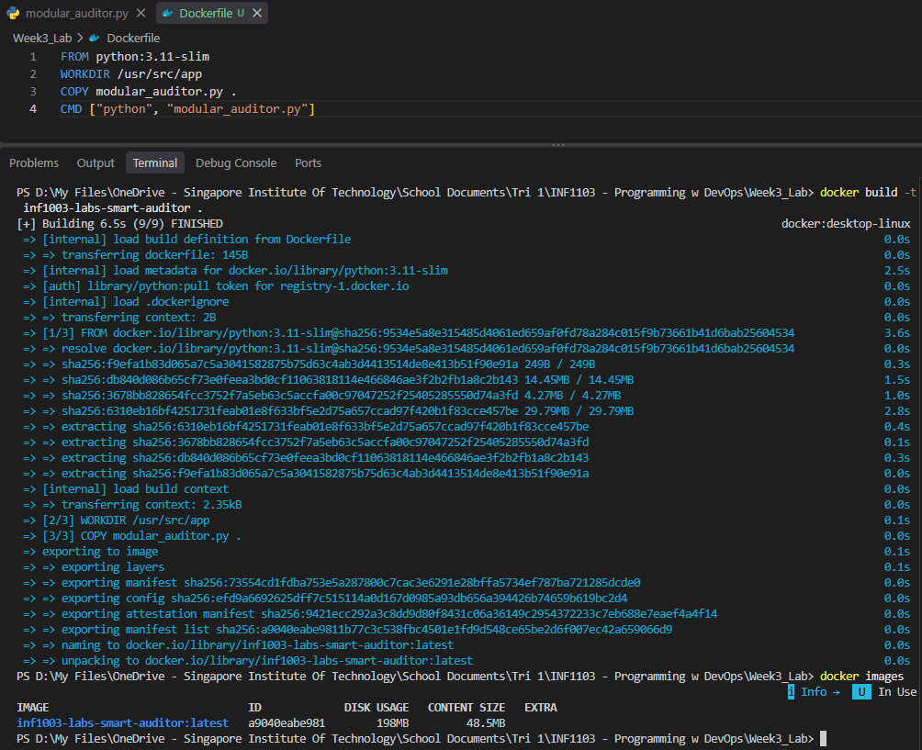
5. Run Custom Container
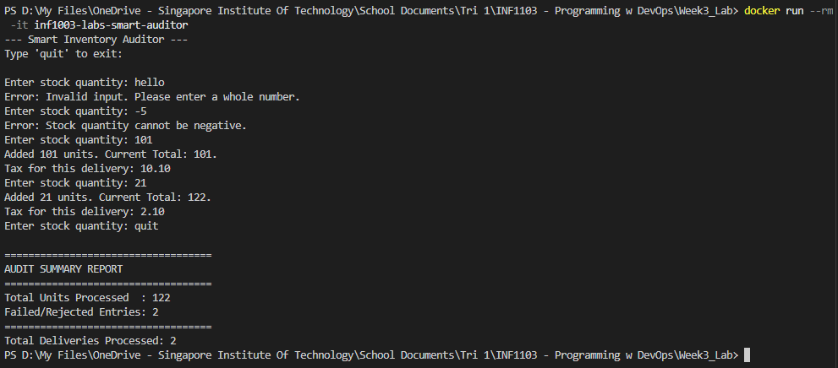

Self-Reflection Task
personally I feel that a function should be coded to focus on its intended responsibility. Since calculate_tax() is meant to calculate tax, it should just return the result and let the caller of the function handle the output. separating these responsibilities makes debugging easier as the program grows and if the manager wants the tax saved to a file instead of printed, I can simply change how the function is being used; from print() to .write()

