
Program and Branch Name:
[B.Tech CSE-A]
PBL Progress Report – I
Field | Details
Course Name | Artificial Intelligence
Course Code | CCSAI0301
Faculty Name | Dr. Mohd. Nazim
Assignment Type | Group Assignment
Student(s) Name | Adityaraj Singh, Akarsh Singh, Afjal Ansari, Aditya Singh, Abhishek Pratap Singh
ERP ID (I Year) / Roll No. (II Year onwards) | 2501330100039, 2501330100045, 2501330100042, 2501330100037, 2501330100025
Team/Group No. (Group/Capstone only) | Group No. 06
Problem Statement / Project Title | Intelligent Medical Inventory Management
SDG(s) | SDG 3 – Good Health and Well-Being
Reporting Month | Month 1
Date of Submission | 12/09/2026

Student Declaration
I certify that this assignment is my own work, with all sources appropriately acknowledged. I understand that a 0% mark and further academic penalties may apply if the content is found to be plagiarised or inappropriately AI-generated.
Student Name & Signature: Adityaraj Singh , Akarsh Singh , Afjal Ansari , Aditya Singh, Abhishek Pratap Singh
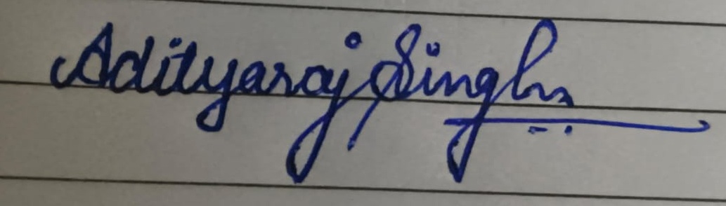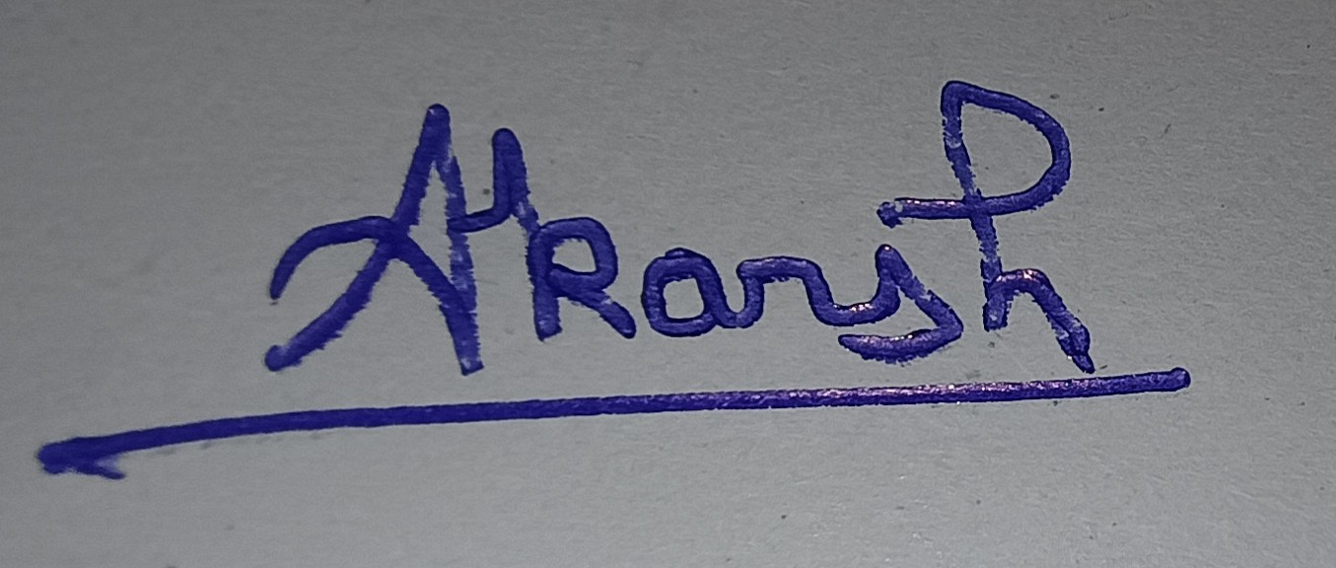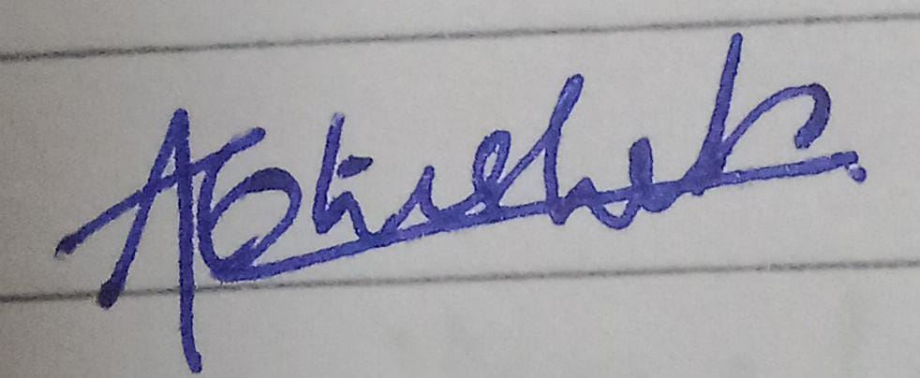
Date: 12/09/26

PBL Progress Report – I
Review 1: Problem Understanding & Initial Progress
Review Coverage: Group Assignment: Unit/Module 1 (Problem Solving Methodologies) and Unit/Module 2 (Adversarial Search)
Field | Details
1. Problem Statement / Assignment or Project Title | Intelligent Medical Inventory Management  Our project is about managing medicines and medical supplies in a better way. The system will help keep track of available medicines, identify medicines that are running low, understand their demand and reduce wastage due to expired medicines. We will study how AI concepts from Unit 1 and Unit 2 can be used in this project.
2. Problem Context & Background | Hospitals and pharmacies need to keep enough medicines available for patients. Sometimes medicines may run out, while sometimes too many medicines are stored and later expire.  Managing a large number of medicines manually can be difficult and time-consuming. Our project aims to study how AI can help in checking inventory, finding suitable options and making better decisions about medicines.
3. Problem Identification / Understanding | From our initial study, we understood that:  - Managing a large number of medicines manually can be difficult.  - Hospitals and pharmacies need regular information about their stock.  - Important information includes medicine name, quantity, demand, expiry date and supplier.  - The system should help find medicines that are running low.  - It should help decide which medicines need attention first.  - AI can help search and choose suitable options.
4. Objectives | 4. Objectives  - To understand the problem of medical inventory management.  - To identify problems in manual inventory management.  - To study AI concepts from Unit 1 and Unit 2.  - To understand how search techniques can help in inventory management.  - To study how AI can help in making inventory decisions.  - To identify the AI concepts that can be used in our project.  - To prepare a basic plan for developing the project.
5. Target Users / Stakeholders | - Hospitals: To keep track of available medicines.  - Pharmacies: To manage medicine stock and restocking.  - Doctors and healthcare staff: To ensure required medicines are available.  - Suppliers: To know which medicines are needed.  - Hospital administrators: To help in better inventory planning.
6. Research / Literature Review Completed | 1. LSTM Drug Demand Forecasting with Adjustment Strategies Paper Link Uses LSTM and adjustment methods to forecast drug demand and reduce inventory costs.  2. Study on Demand Forecasting Techniques for Drugs with Sporadic Demand Paper Link | Compares forecasting methods for irregular drug demand to reduce shortages and excess stock.  3. Management of Drug Supply Chain Information using AI + VMI Paper Link Shows how AI-based inventory and supply-chain management can improve stock control and efficiency.  4. Predicting Drug Shortages Using Pharmacy Data and Machine Learning Paper Link Uses machine learning to predict drug shortages in advance and support better inventory decisions.

Field | Details
7. Unit/Module Concepts Identified for Application | Unit 1 – Problem Solving Methodologies  BFS / DFS: Can help search for suitable medicine or supply options.  Iterative Deepening: Can help search step by step.  Bidirectional Search: Can help search from both the hospital and supplier  sides.  Heuristic: Can help decide which medicine or option is more important.  Greedy Best First Search: Can help select a good option quickly.  A* Search Can help find a suitable and efficient supply option.  AO* Search: Can help when there are different possible choices.  CSP: Can help manage medicines while considering conditions like stock and  demand.  Unit 2 – Adversarial Search  Minimax: We will study whether it can be used for any suitable decision-  making situation.  Alpha-Beta Pruning: Can be used with Minimax to make the search faster if  required.  Github Repository
8. Work Completed During Month 1 | - Finalized the project topic.  - Understood the basic problem of medical inventory management.  - Discussed problems such as low stock, extra stock and expired medicines.  - Decided the main objectives of the project.  - Identified the users of the system.  - Studied AI Unit 1 and Unit 2.  - Discussed how AI concepts can be used in our project.  - Prepared the basic plan for the next stage.
9. Evidence / Supporting Material | Our team studied the AI Unit 1 and Unit 2 course material provided for the subject.
10. Challenges Faced | - Understanding how AI concepts can be used in our project.  - Deciding which AI topics are useful for the project.  - Understanding how search techniques can help manage inventory.  - Deciding what information about medicines should be included.  - Understanding how to use AI without making the project too complicated.  - Planning the project as a team.
11. Individual / Team Contribution | Adityaraj Singh – Problem statement, objectives and project background  Akarsh Singh – Problem identification and AI concept mapping  Afjal Ansari – Literature/course-material study  Aditya Singh – Search algorithm analysis  Abhishek Pratap Singh – CSP and project planning
12. Overall Progress (%) | 20%  This progress includes understanding the problem, deciding the basic requirements, studying Unit 1 and Unit 2 and planning how AI can be used in the project. The actual development and testing will be done in the next reviews.
13. Plan for Next Review | - Finalize the project requirements.  - Select the AI concepts to be used.  - Prepare the basic system design.  - Start initial implementation.  - Test the basic working and record results.
Faculty Evaluation:
To be completed by Faculty in Moodle

