**Development of Virtual lab :Round 3 -Lab Manual - Template (Worksheet)**

|  |
| --- |
| **Name of Faculty:** Mr. Kamlesh Gautam  **Institute: Rajkiya Engineering College,Banda**  **Email ID** (as submitted in the registration form)**: gautam.kamlesh@gmail.com**  **Discipline to which the Lab belongs: Physics**  **Name of the Lab: Optics**  **Name of experiment: To find the image distance for varying object distances and show the nature of image using concave and convex lens.**  (only one Experiment per worksheet)**:**  **Kindly Refer these documents before filling the worksheet**   1. **Coursework (MOOC ) on Pedagogy , Storyboard , Lab Manual :** [**http://bit.ly/Vlabs-MOOC**](http://bit.ly/Vlabs-MOOC) 2. **Additional Documentation booklet for reference.** [**http://vlabs.iitb.ac.in/vlabs-dev/document.php**](http://vlabs.iitb.ac.in/vlabs-dev/document.php) 3. **Sample Git Repository. : https://github.com/Akarsh12345/Optics_sample.git** |

ROUND 2

**1. Aim and Objective**

**To find the image distance for varrying object distances and show the nature of image using concave and convex lens.**

**2. Theory**

Lens:-

The lens is a combination of two or more simple glasses that converges or diverges the ray of light.Two main types of lenses are:-

(i) **Convex lens**

**(ii) Concave lens**

1. Convex lens-

It converges the ray of light so it is also called converging lens.These lenses are thicker at middle and thinner at the edges.

(ii) Concave lens-

It diverges the ray of light so it is also called diverging lens. These are thnner at middle and thicker at the edges.

LENS FORMULA :-

**(1÷v)-(1÷u)=1÷f**

**(1÷v)=(1÷u)+(1÷f)**

**(1÷v)=(u+f)÷(uf)**

**v=(u*f)÷(u+f)**

**3.PROCEDURE**

step 1 : First of all go to the start.html("also allow blocked content if you are using Internet Explorer")

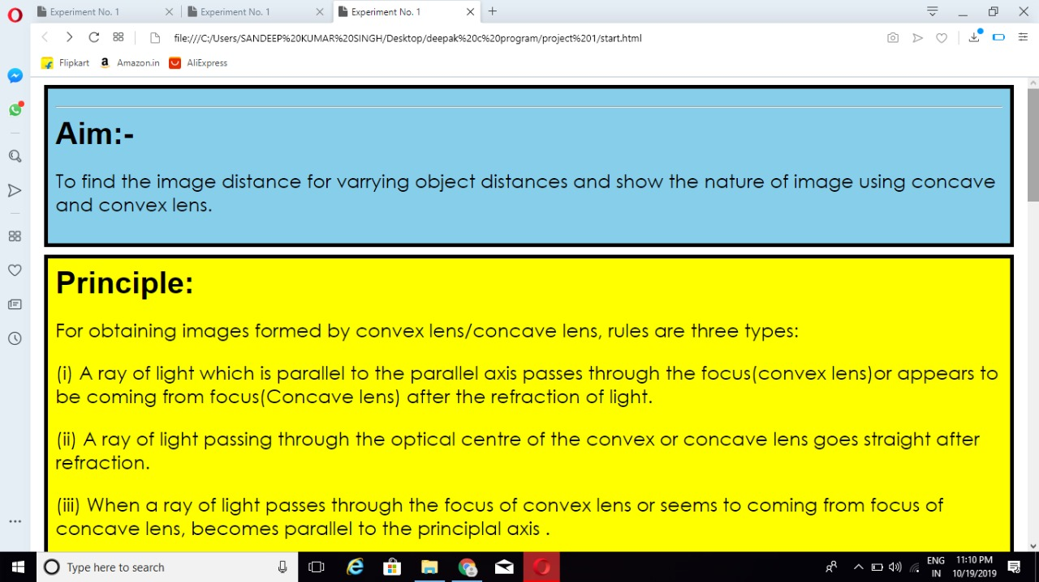

step 2 : At the end of webpage there is button who redirect to the prequestion.html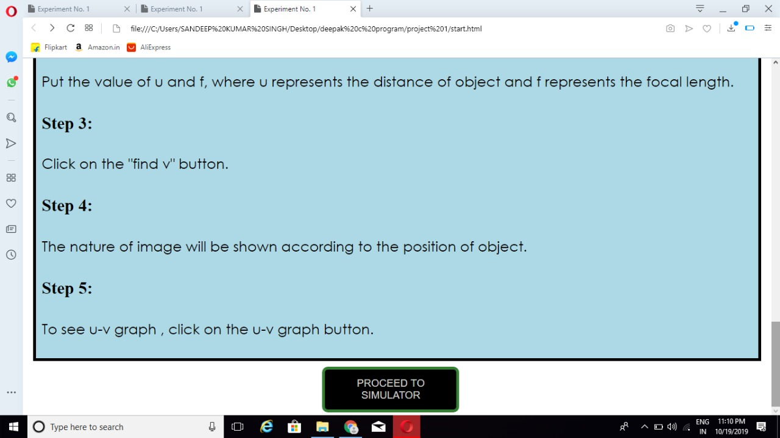

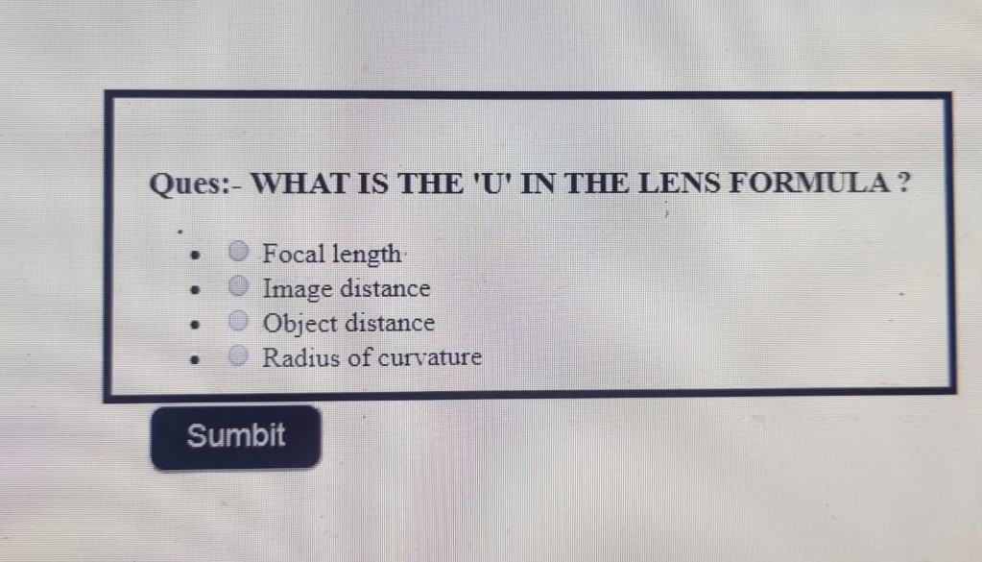

step 3 : a.If you give the wrong answer you go to the start.html



b. If you give the right answer it direct to the simulator.html

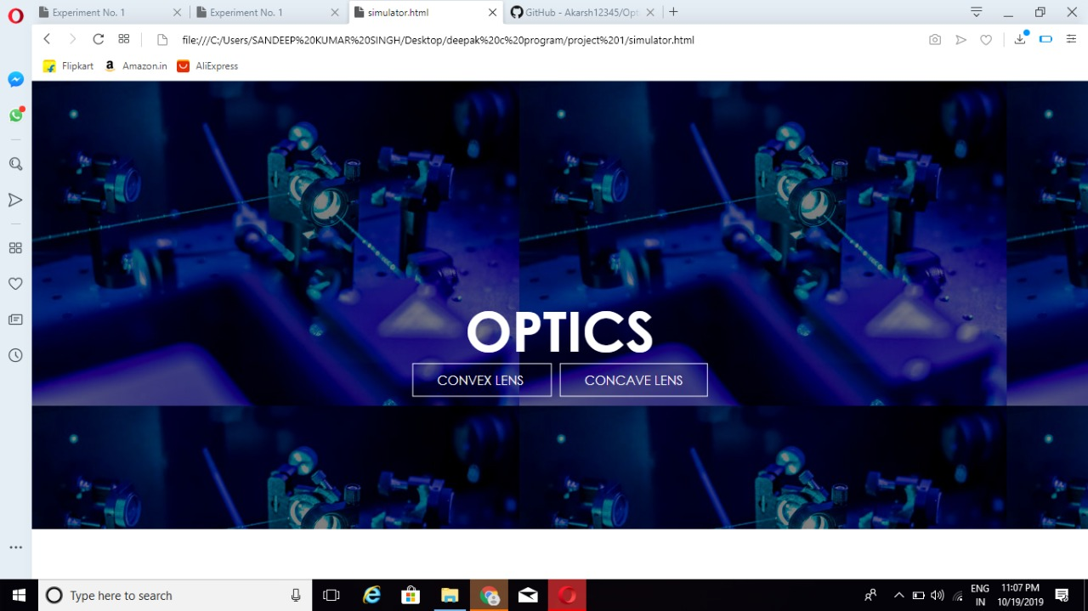

step 4 : So simulator work is written in the procedure of home page.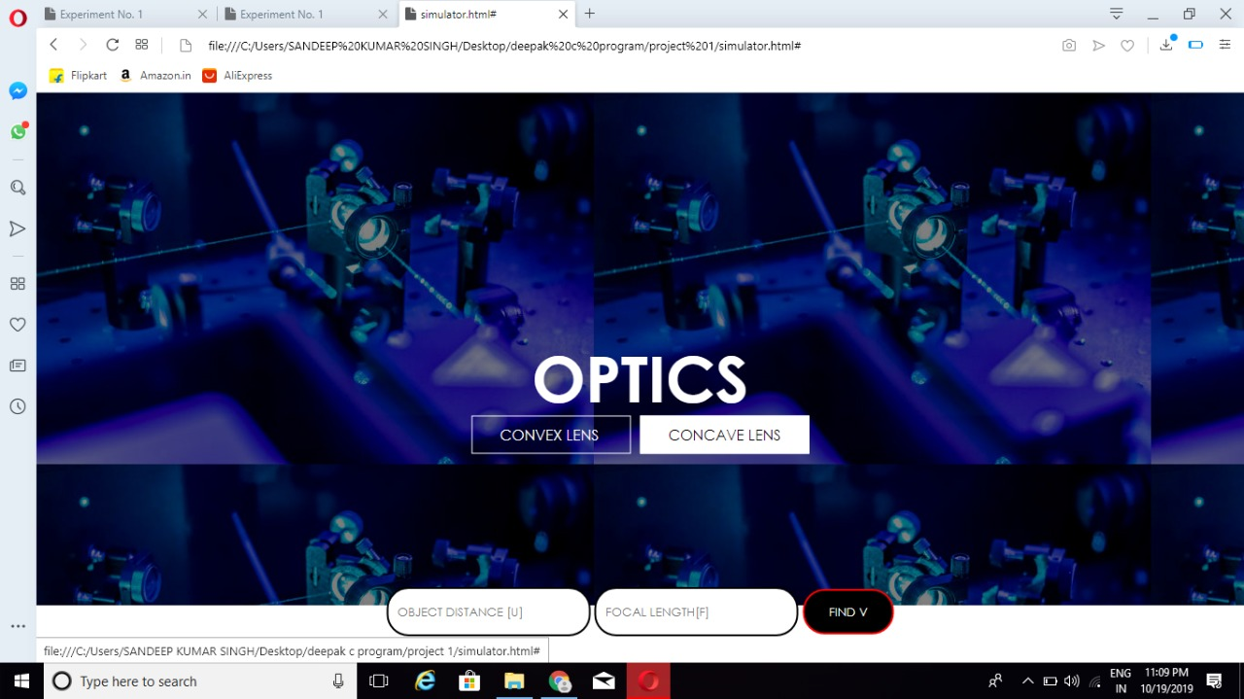

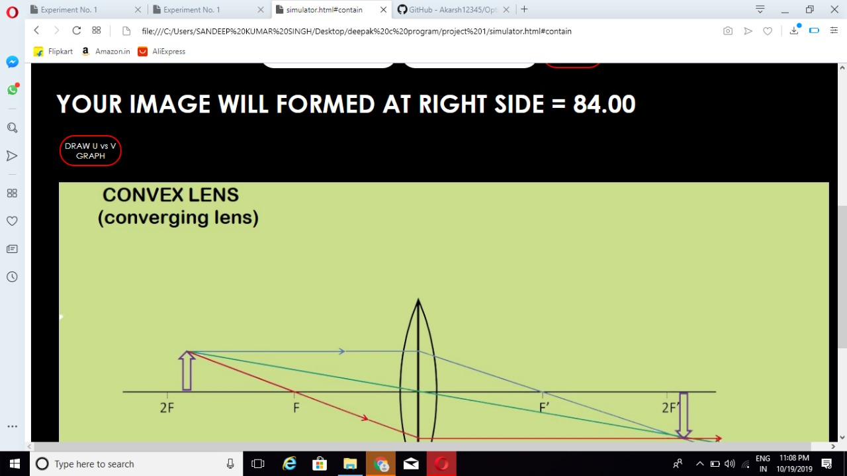

step 5 : At the end when the graph is showing so after some point there is button "READY FOR QUIZ"

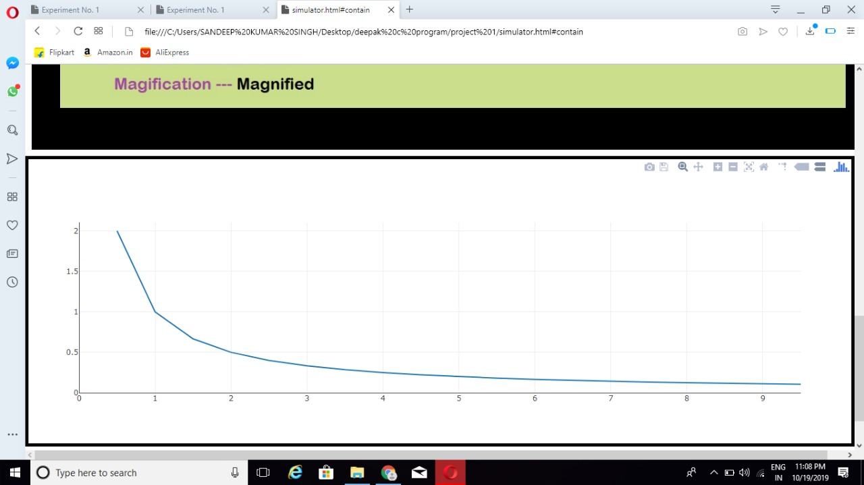

step 6 : Your experiment completed.

**4.Pre test Assessments**

1. **Ques**:- WHAT IS THE 'U' IN THE LENS FORMULA ?
   1. Focal length
   2. Image distance
   3. **Object distance (Correct answer )**
   4. Radius of curvature

**5.Post test Assessments**

Question 1:-**What is the Focal length of convex lens ?**

option1: **Positive**

option2:-Negative

option3:-Zero

option4:-None of the above.

Question 2**:-What is the Focal length of concave lens ?**

option1: Positive

option2:**Negative**

option3:Zero

option4:None of the above".

Question 3:**What is the Nature of concave lens ?**

option1: Converging

option2:**Diverging.**

option3:Don't know

option4:-None of the above.

Question 4:**What is the Nature of convex lens ?**

option1: **Converging**

option2:Diverging.

option3:Don't know

option4:-None of the above