Assignment 5
Loops In JAVA

Name: Akarsh Anand
Section: 2CSE14
Roll No.: 25SCS1003000760

Objective
The objective of this set of programs is to practice fundamental Java concepts such as loops (for, while), conditional statements (if-else), and basic arithmetic operations by solving simple number-based problems.

1. Find the Sum of Numbers from 1 to N
This program reads a value N from the user and calculates the sum of all natural numbers from 1 to N using a for loop.

Java Program
import java.util.Scanner;

public class SumOfNumbers {
public static void main(String[] args) {
Scanner sc = new Scanner(System.in);

System.out.print("Enter the value of N: ");
int n = sc.nextInt();

int sum = 0;
for (int i = 1; i <= n; i++) {
sum = sum + i;
}

System.out.println("Sum of numbers from 1 to " + n + " = " + sum);

sc.close();
}
}

Output
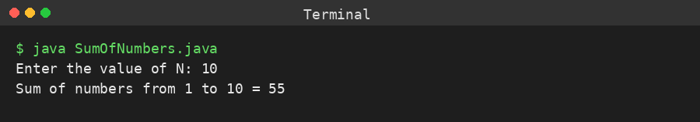

2. Print Multiples of 5 from 1 to 100
This program iterates through numbers from 1 to 100 and prints only those numbers that are exactly divisible by 5.

Java Program
public class MultiplesOfFive {
public static void main(String[] args) {
System.out.println("Multiples of 5 from 1 to 100:");

for (int i = 1; i <= 100; i++) {
if (i % 5 == 0) {
System.out.print(i + " ");
}
}
System.out.println();
}
}

Output
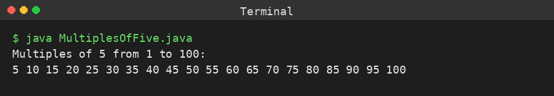

3. Count How Many Numbers Are Divisible by 3 Between 1 and N
This program reads a value N from the user and counts how many numbers between 1 and N are exactly divisible by 3.

Java Program
import java.util.Scanner;

public class CountDivisibleByThree {
public static void main(String[] args) {
Scanner sc = new Scanner(System.in);

System.out.print("Enter the value of N: ");
int n = sc.nextInt();

int count = 0;
for (int i = 1; i <= n; i++) {
if (i % 3 == 0) {
count++;
}
}

System.out.println("Count of numbers divisible by 3 between 1 and " + n + " = " + count);

sc.close();
}
}

Output
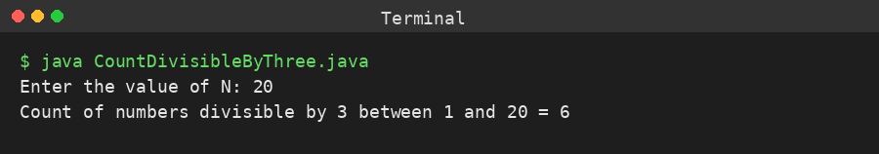

4. Check Whether a Number Is Prime or Not
This program reads a number from the user and checks whether it is a prime number by testing divisibility from 2 up to the square root of the number.

Java Program
import java.util.Scanner;

public class PrimeCheck {
public static void main(String[] args) {
Scanner sc = new Scanner(System.in);

System.out.print("Enter a number: ");
int num = sc.nextInt();

boolean isPrime = true;

if (num <= 1) {
isPrime = false;
} else {
for (int i = 2; i <= Math.sqrt(num); i++) {
if (num % i == 0) {
isPrime = false;
break;
}
}
}

if (isPrime) {
System.out.println(num + " is a Prime Number");
} else {
System.out.println(num + " is Not a Prime Number");
}

sc.close();
}
}

Output
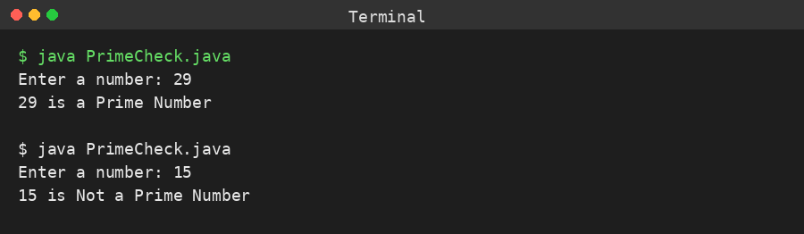

5. Reverse of a Given Number
This program reads a number from the user and reverses its digits using the modulus and division operators inside a while loop.

Java Program
import java.util.Scanner;

public class ReverseNumber {
public static void main(String[] args) {
Scanner sc = new Scanner(System.in);

System.out.print("Enter a number: ");
int num = sc.nextInt();

int original = num;
int reversed = 0;

while (num != 0) {
int digit = num % 10;
reversed = reversed * 10 + digit;
num = num / 10;
}

System.out.println("Reverse of " + original + " is " + reversed);

sc.close();
}
}

Output
