Assignment 8
Polymorphism in Java: Concepts, Types, and Implementation

Name: Akarsh Anand
Section: 2CSE14
Roll No.: 25SCS1003000760

Objective
The objective of this assignment is to understand the concept of Polymorphism, its different types, and the implementation of Method Overloading through practical Java programs.

Part A: Understanding of Theory Concept

1. Explain Polymorphism in Java
Definition: Polymorphism is one of the four fundamental principles of Object-Oriented Programming (OOP), derived from the Greek words “poly” (many) and “morphs” (forms).

Why Polymorphism is important in OOP
- Code Reusability
- Flexibility and Extensibility
- Simplifies Code Maintenance
- Supports Dynamic Behavior
- Enables Loose Coupling

2. Explain the Types of Polymorphism
Polymorphism in Java is broadly divided into two types:

(a) Compile-Time Polymorphism (Static Polymorphism)
Compile-time polymorphism is also known as static polymorphism because the method that needs to be executed is decided at compile time itself, based on the method signature (name, number, and type of parameters).

(b) Run-Time Polymorphism (Dynamic Polymorphism)
Run-time polymorphism is also known as dynamic polymorphism because the decision about which method to execute is made at run time, not compile time.
class Animal {
void sound() { System.out.println("Animal makes a sound"); }
}
class Dog extends Animal {
@Override
void sound() { System.out.println("Dog barks"); }
}

// At run time:
Animal a = new Dog();
a.sound(); // Output: Dog barks

3. Explain Method Overloading

Definition
Method Overloading is a feature in Java that allows a class to have more than one method with the same name, provided that their parameter lists (number of parameters, type of parameters, or order of parameters) are different.

Rules of Method Overloading
- The method name must be the same.
- The parameter list must differ in at least one of the following ways: number of parameters, data type of parameters, or order/sequence of parameters.
- Overloaded methods can have different access modifiers.
- Overloaded methods can have different throws clauses.

Different Ways to Overload a Method
- By changing the number of parameters: add(int a, int b) and add(int a, int b, int c)
- By changing the data type of parameters: add(int a, int b) and add(double a, double b)
- By changing the order of parameters: show(String name, int age) and show(int age, String name)

Why Changing Only the Return Type Is Not Method Overloading
In Java, method calls are resolved by the compiler using the method's name and parameter list (its signature); the return type is not part of the method signature.

Difference between Method Overloading and Method Overriding
Basis | Method Overloading | Method Overriding
Definition | Same method name with different parameter lists in the same class | Subclass provides a specific implementation of a method already defined in its parent class
Polymorphism Type | Compile-time (static) polymorphism | Run-time (dynamic) polymorphism
Class Involved | Occurs within the same class | Occurs between parent and child classes (inheritance)
Parameters | Must be different (number/type/order) | Must be exactly the same
Return Type | Can be same or different | Must be same or a covariant type
Binding | Resolved at compile time (early binding) | Resolved at run time (late binding)
Purpose | Increases readability and code reusability | Achieves run-time behavior specific to subclass

Part B: Programming Questions

1. Calculator Addition
A class Calculator is created with the add() method overloaded three times: to add two integers, to add three integers, and to add two decimal numbers. An object of the class is created and all overloaded methods are called.
public class Calculator {

// Overloaded method to add two integers
int add(int a, int b) {
return a + b;
}

// Overloaded method to add three integers
int add(int a, int b, int c) {
return a + b + c;
}

// Overloaded method to add two decimal numbers
double add(double a, double b) {
return a + b;
}

public static void main(String[] args) {
Calculator calc = new Calculator();

System.out.println("Sum of two integers (5, 10): " + calc.add(5, 10));
System.out.println("Sum of three integers (5, 10, 15): " + calc.add(5, 10, 15));
System.out.println("Sum of two decimals (5.5, 10.2): " + calc.add(5.5, 10.2));
}
}

Output:
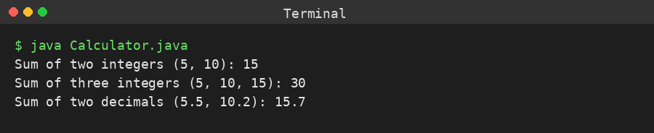

2. Display Method
A class Display is created with the show() method overloaded three times: to display only the student's name, to display the name and age, and to display the name, age, and marks.
public class Display {

// Overloaded method to display only student's name
void show(String name) {
System.out.println("Student Name: " + name);
}

// Overloaded method to display student's name and age
void show(String name, int age) {
System.out.println("Student Name: " + name + ", Age: " + age);
}

// Overloaded method to display student's name, age, and marks
void show(String name, int age, double marks) {
System.out.println("Student Name: " + name + ", Age: " + age + ", Marks: " + marks);
}

public static void main(String[] args) {
Display d = new Display();

d.show("Akarsh Anand");
d.show("Akarsh Anand", 20);
d.show("Akarsh Anand", 20, 89.5);
}
}

Output:
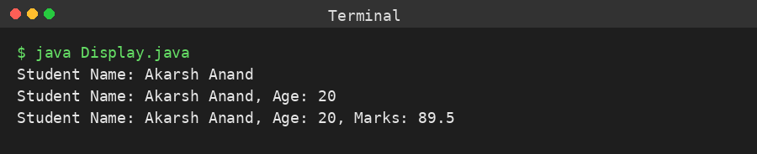

3. Find Maximum
A class FindMaximum is created with the max() method overloaded three times: to find the maximum between two integers, three integers, and two decimal numbers.
public class FindMaximum {

// Overloaded method to find maximum of two integers
int max(int a, int b) {
return (a > b) ? a : b;
}

// Overloaded method to find maximum of three integers
int max(int a, int b, int c) {
int m = (a > b) ? a : b;
return (m > c) ? m : c;
}

// Overloaded method to find maximum of two decimal numbers
double max(double a, double b) {
return (a > b) ? a : b;
}

public static void main(String[] args) {
FindMaximum fm = new FindMaximum();

System.out.println("Maximum of two integers (12, 25): " + fm.max(12, 25));
System.out.println("Maximum of three integers (12, 25, 18): " + fm.max(12, 25, 18));
System.out.println("Maximum of two decimals (12.5, 9.8): " + fm.max(12.5, 9.8));
}
}

Output:
