**Name-Akarsh Jain**

**Unique Id- 2005685**

Problem 6: (30 points) For the FIR filter with function below determine the direct form realization. 𝐇(𝐳) = 𝟏 + 𝟐𝐳 −𝟏 − 𝟑𝐳 −𝟐 − 𝟒𝐳 −𝟑 + 𝟓𝐳 −𝟒 Build this filter using basic building blocks in Simulink. Make this a reference model.

MODEL:  
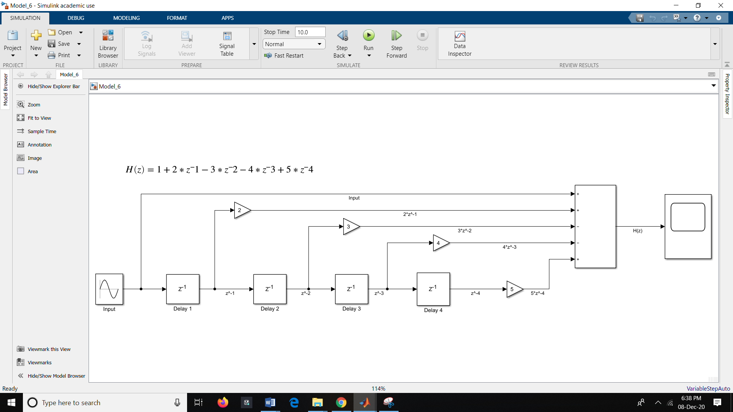

OUTPUT:

