**Name-Akarsh Jain**

**Unique Id- 2005685**

Problem 5: (30 points) For the circuit shown in Figure 3, the equation is 𝑅 𝑑𝑄 𝑑𝑡 + 1 𝐶 𝑄 = 𝐸(𝑡) Simulate this equation for 10 seconds for 5 different initial conditions and inputs E(t)

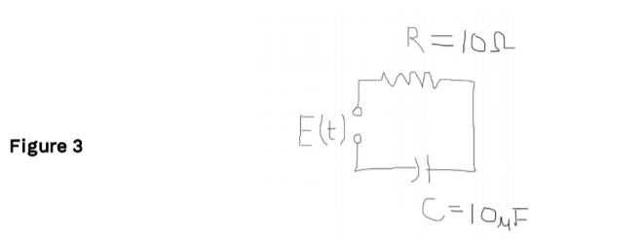

MODEL

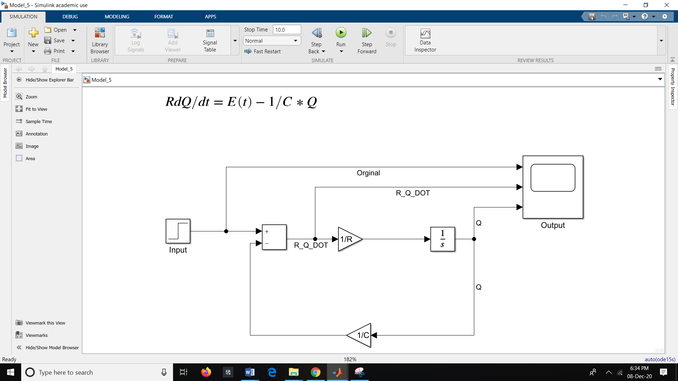

OUTPUT

