**Name-Akarsh Jain**

**Unique Id- 2005685**

Problem 10: (40 points) Build a diode model using Lookup table. Simulate it with an appropriate input signal.

Link- https://www.gopracticals.com/electronics/basic-electronics/to-obtain-v-i-zener-diode/

MODEL

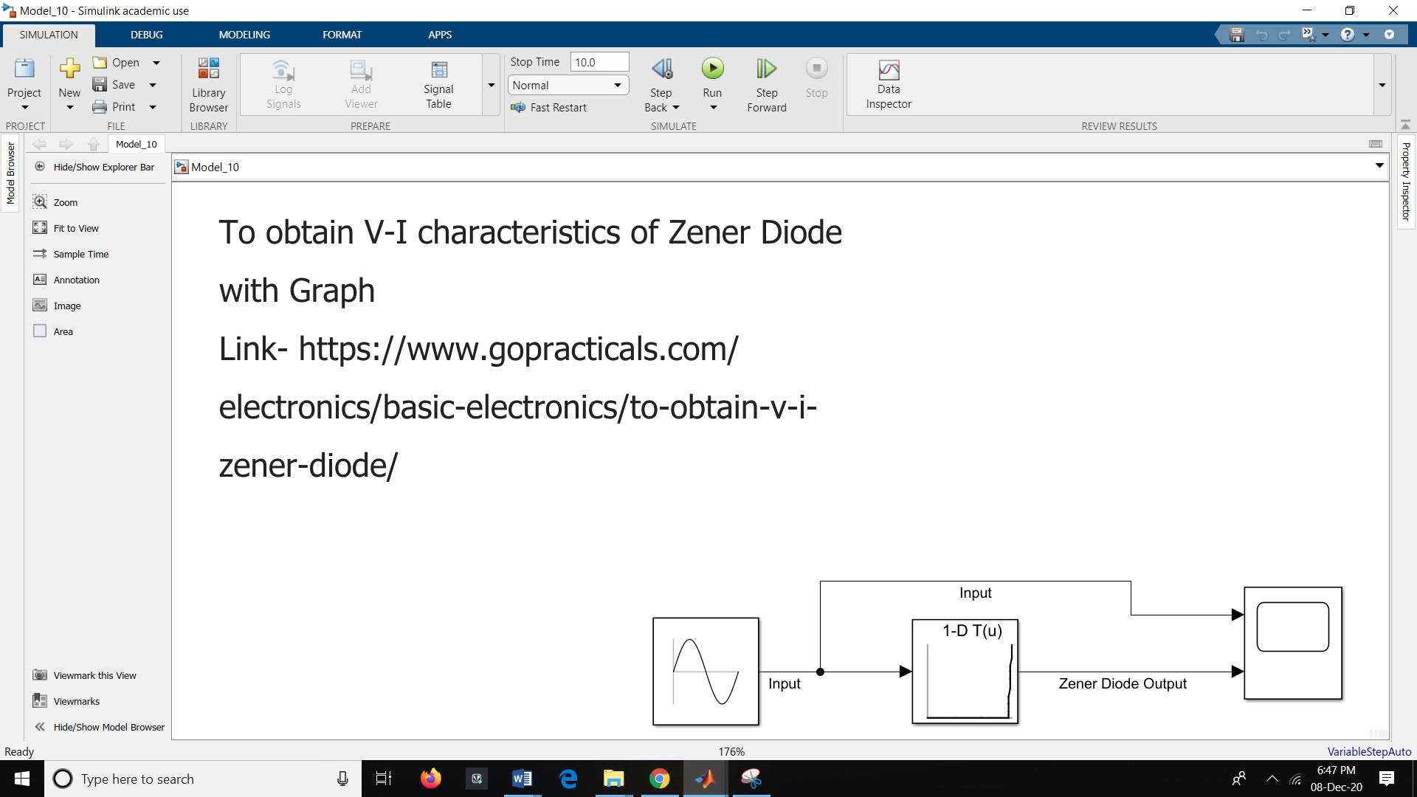

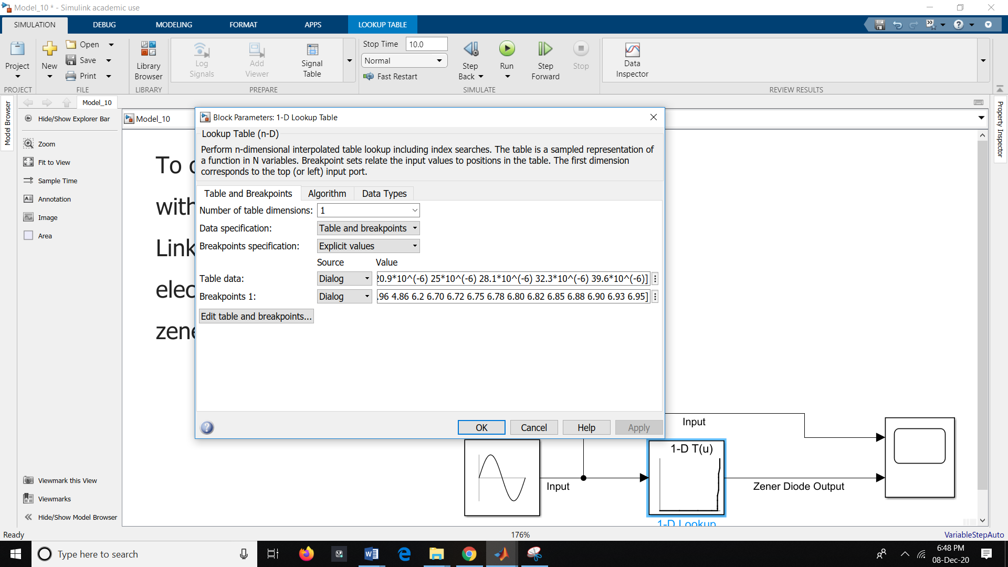

OUTPUT:

