**Name-Akarsh Jain**

**Unique Id- 2005685**

Problem 4: (20 points) Realize the filter described by difference equation 𝐲(𝐧) = 𝟎.𝟓 ∗ 𝐲(𝐧 − 𝟏) − 𝟎.𝟐𝟓 ∗ 𝐲(𝐧 − 𝟐) + 𝐱(𝐧) + 𝟎.𝟒 ∗ 𝐱(𝐧 − 𝟏)

MODEL

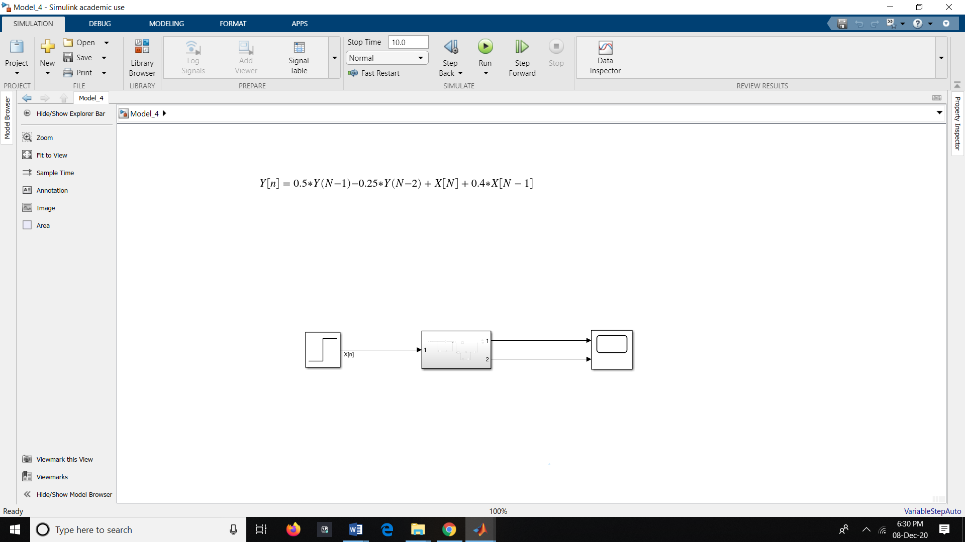

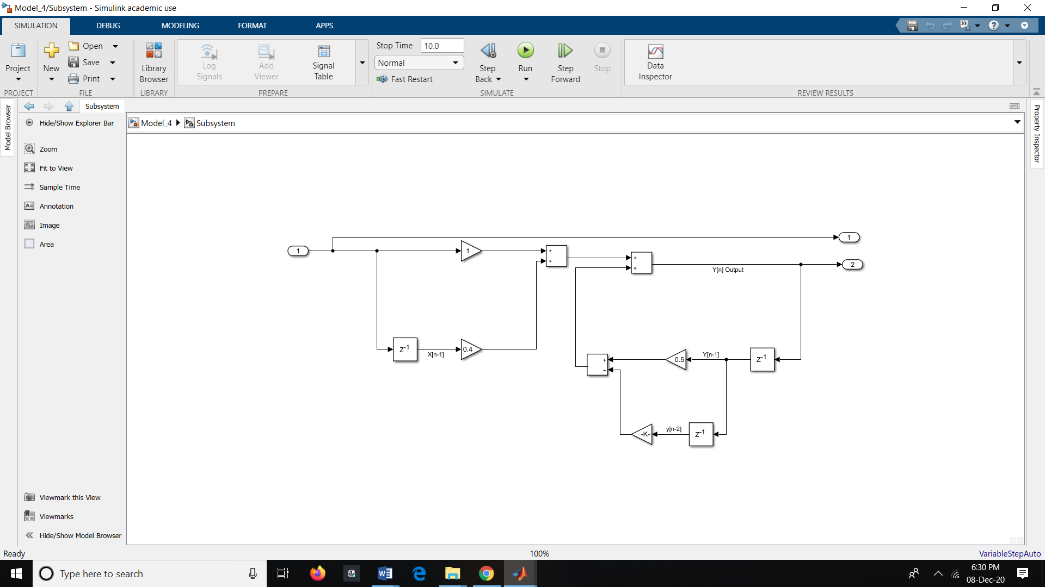

OUTPUT:

