Name-Akarsh Jain

Unique ID-2005685

BLDC MOTOR

Model:

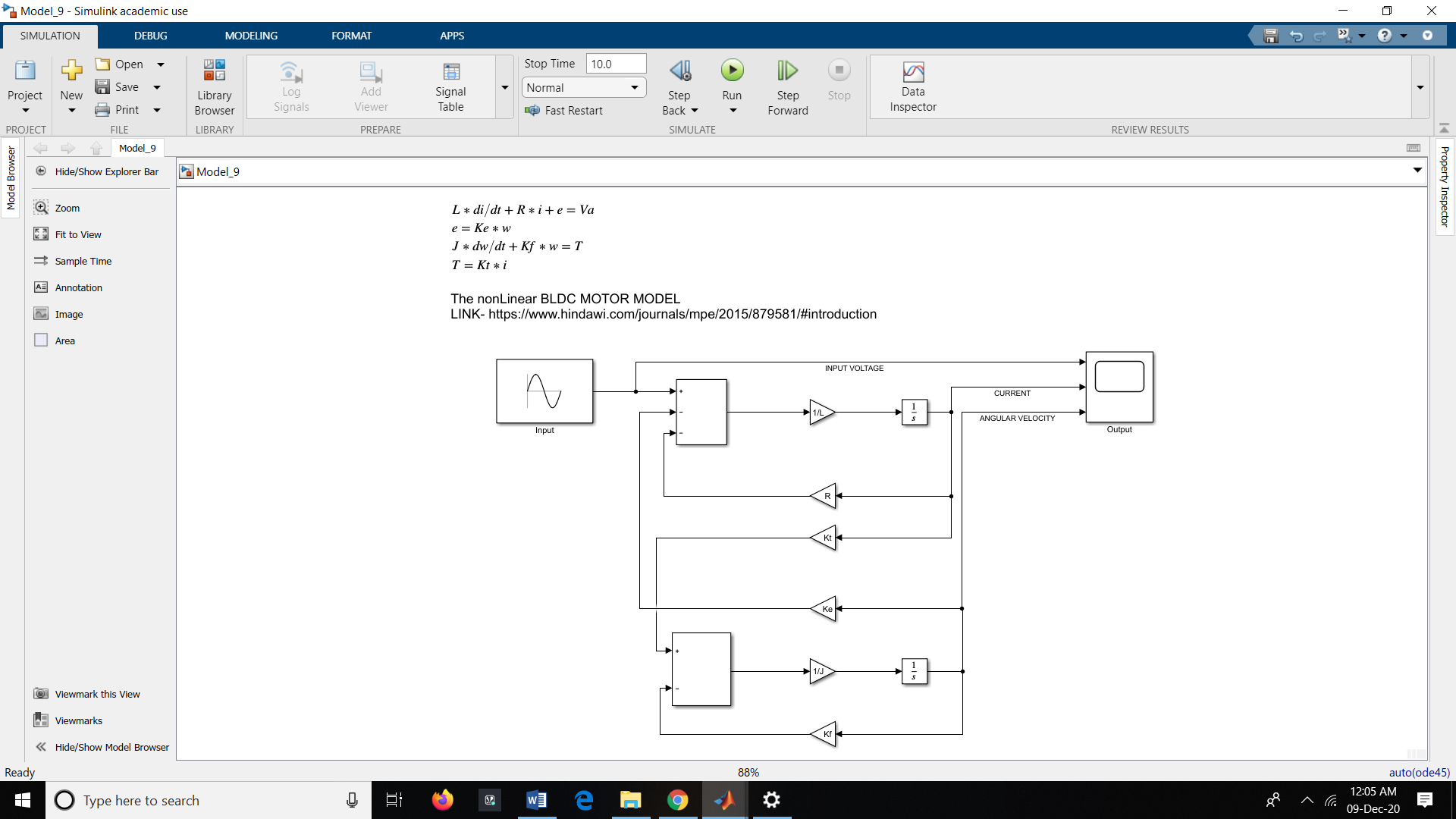

Output:

