**Name-Akarsh Jain**

**Unique ID-2005685**

Problem 1: (100 points) Build a 3-digit Mod 5 counter using Stateflow

Model:  
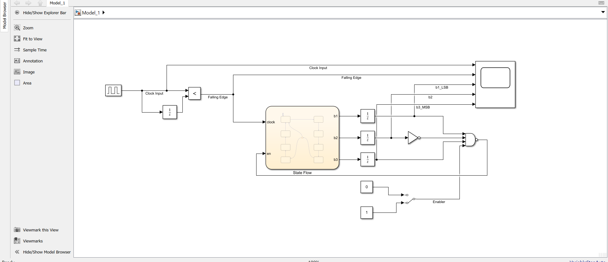

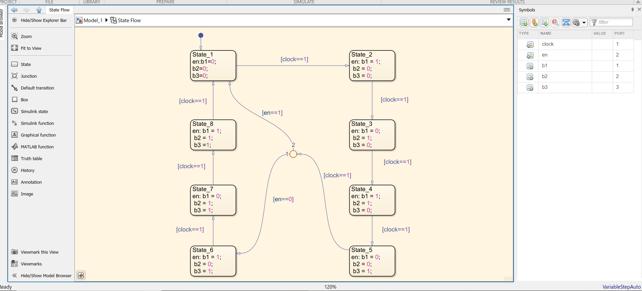

OUTPUT:

