**Name-Akarsh Jain**

**Unique ID-2005685**

Problem 3: (100 points) Consider the Cruise Control Model from the following link https://ctms.engin.umich.edu/CTMS/index.php?example=CruiseControl&section=Simu linkModeling Build this system in Simulink. Design a controller (P, PI, PD or PID) to achieve following goals with basic building bocks • Rise time < 5 s • Overshoot < 10% • Steady-state error < 2% Build a reference model to use the PID along with this system. Use Data Dictionary.

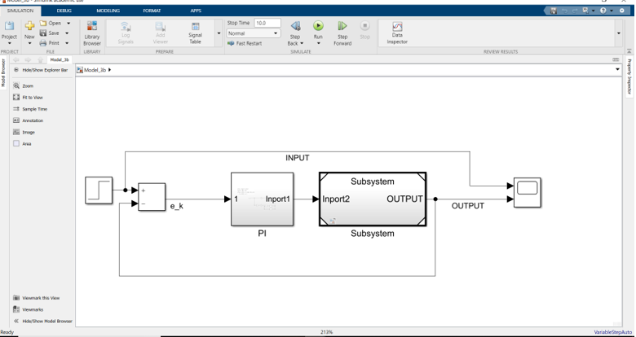

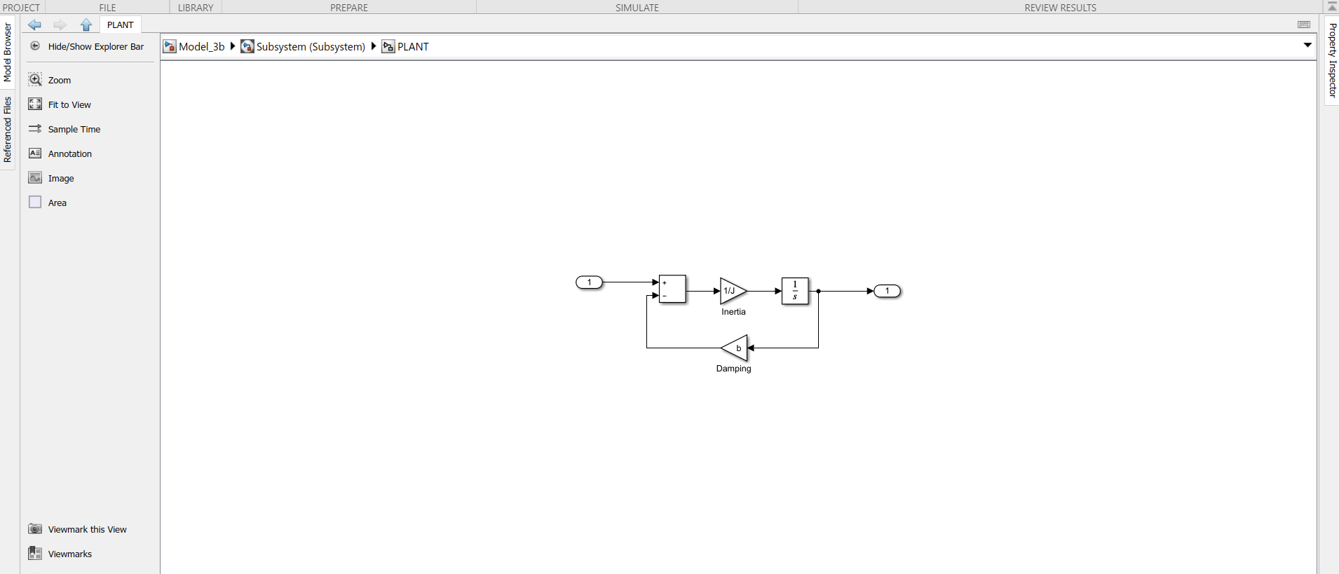

Output:

The values of PID are tuned in accordance with rise time, overshoot, steady state error.

The value of Ki= 44

The value of Kp=336

