Name-Akarsh Jain

Unique ID-2005685

Problem 4: (100 points) Consider the Motor Position Control Model from the following link https://ctms.engin.umich.edu/CTMS/index.php?example=MotorPosition&section=Simu linkModeling Build this system in Simulink. Design a PID controller to achieve following goals using basic building blocks For a 1-radian step reference, the design criteria are given are the following. • Settling time less than 0.040 seconds • Overshoot less than 16% • No steady-state error, even in the presence of a step disturbance input Build a reference model to use the PID along with this system. Use Data Dictionary

Model:  
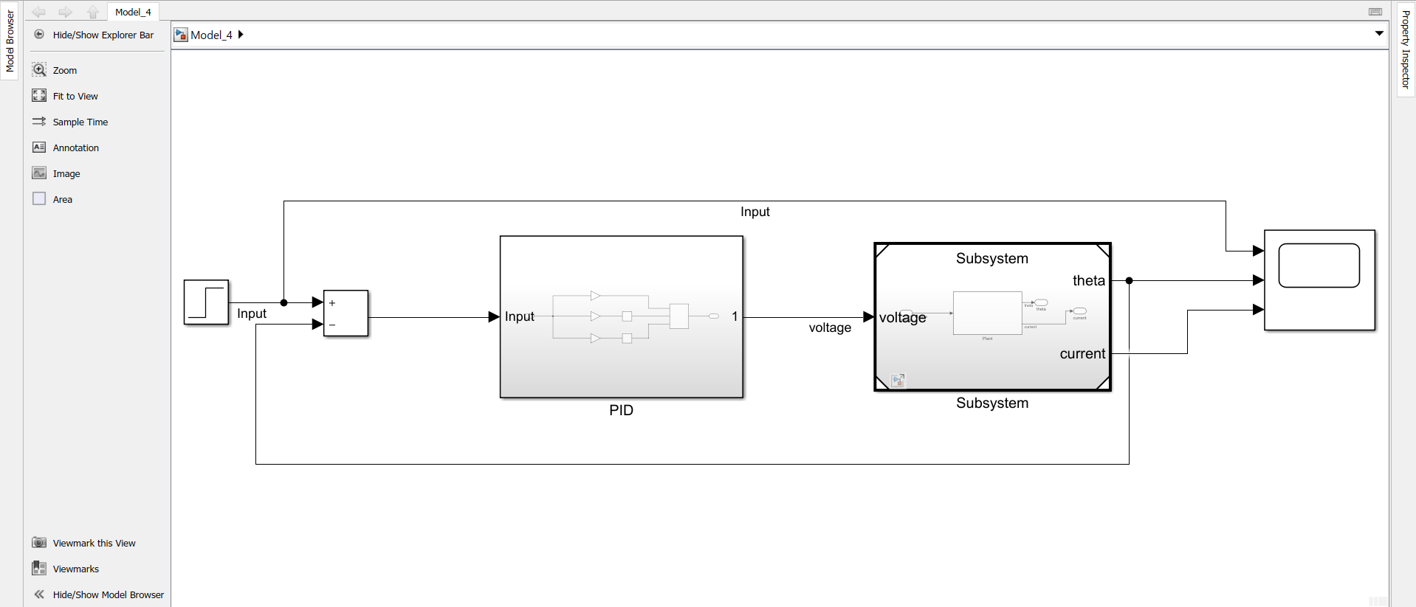

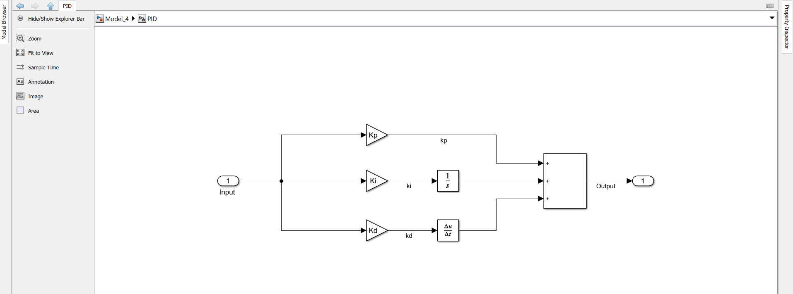

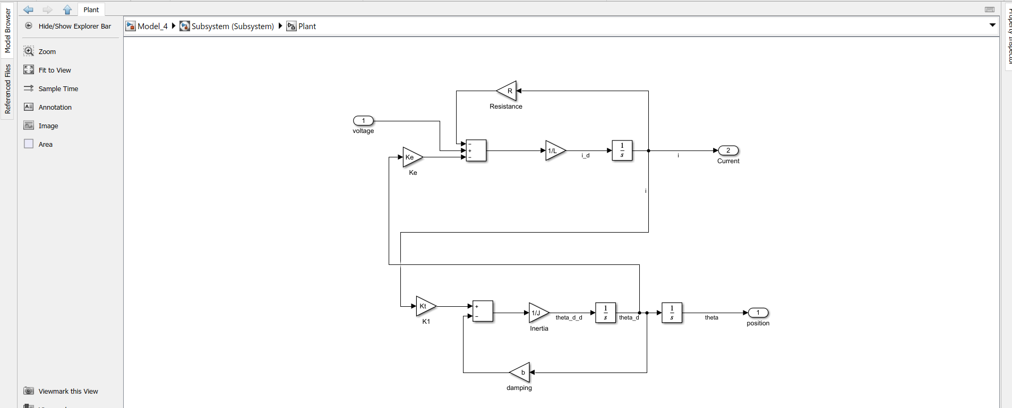

Output:  
The values of PID are tuned and thus

Kp=612

Ki=0.18

Kd=23

