**Name- Akarsh Jain**

**Unique Id: 2005685**

**Problem 1 (100 points)**

In State flow design a vending machine using Mealy semantics

Model:  
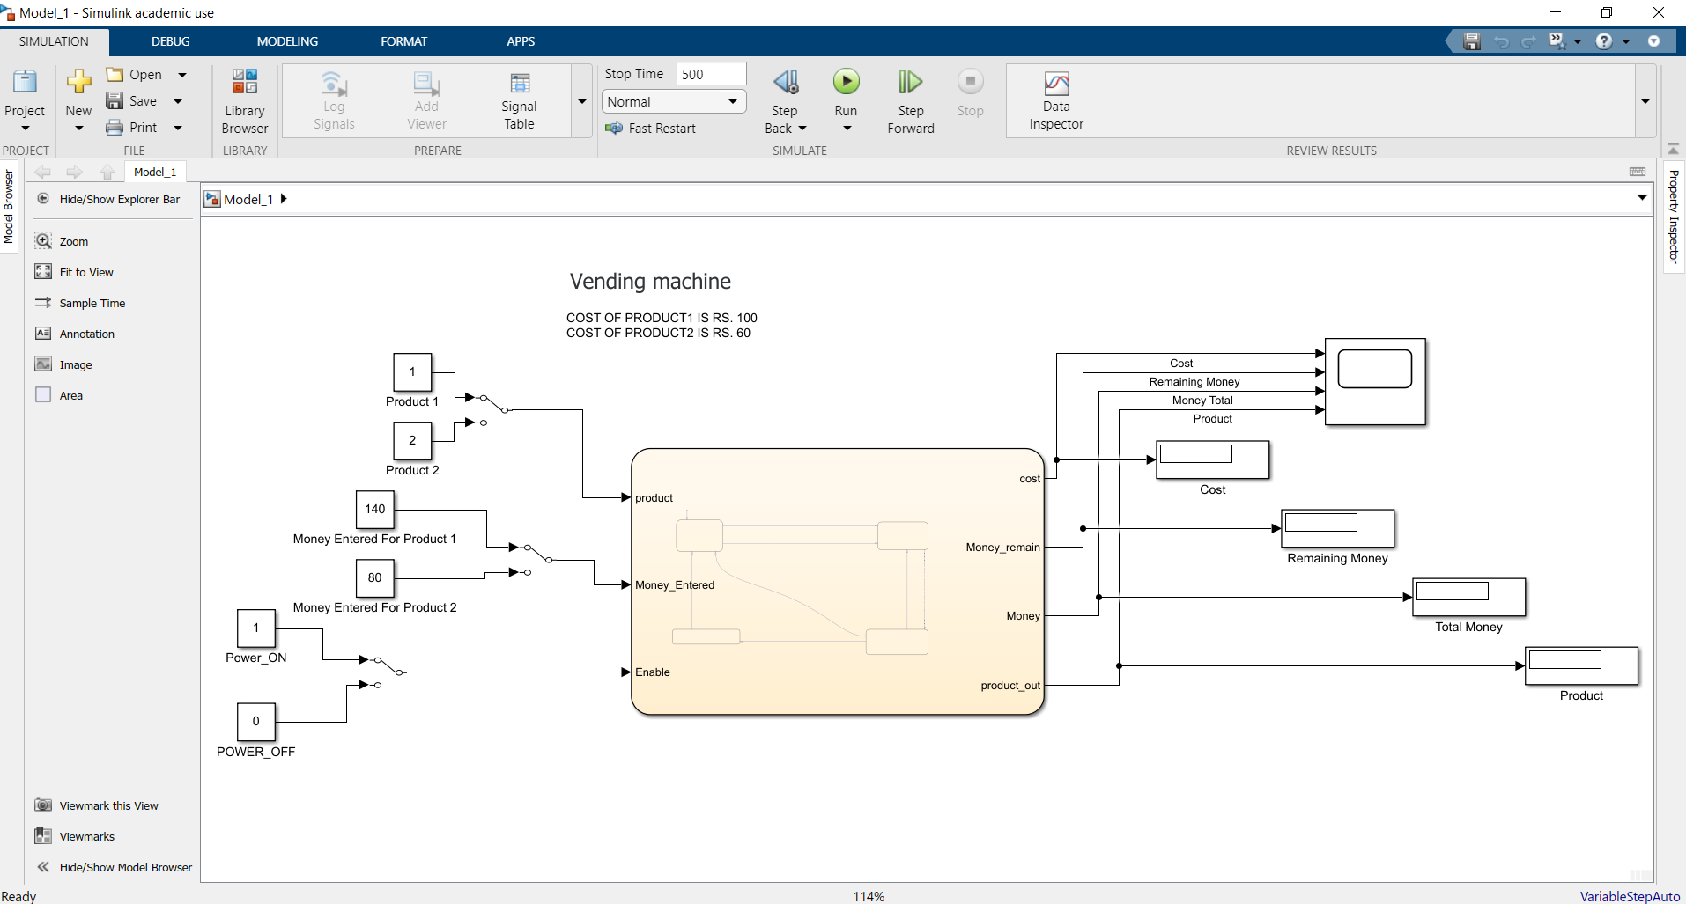

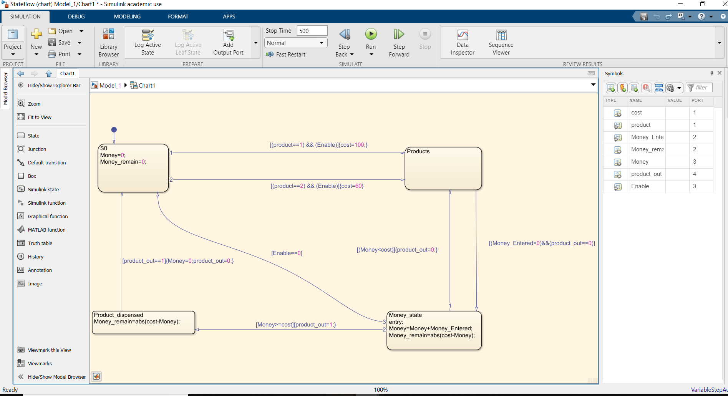

Output:  
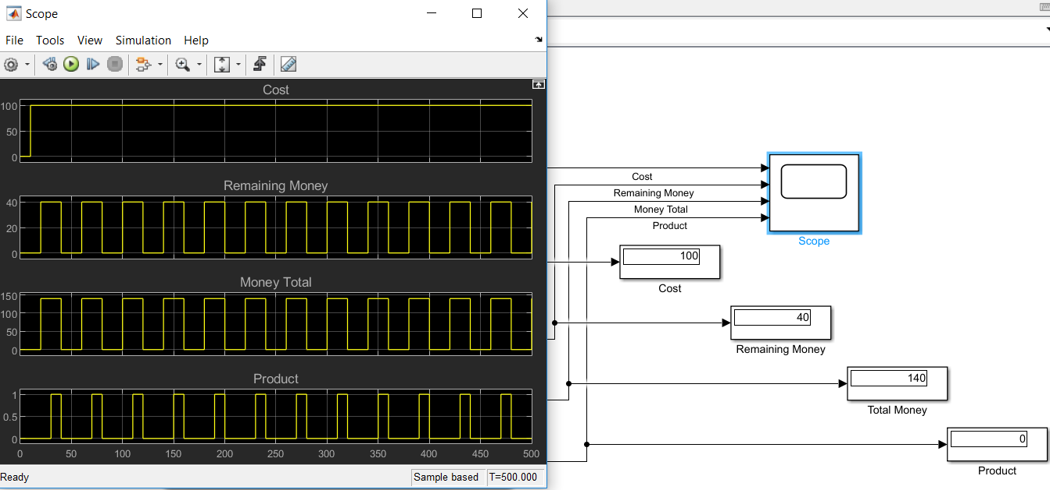

This is a vending machine model, in which 2 products are stored. The price of 1st product is set as Rs.100 and the other product Price is Rs.60. You will get choice to select which product you want and the money will be entered. The machine will give you the cost of product you choose, the total money given to the machine and the difference between the money given to the machine and the price of the product selected.

An enable power is also present which will start or stop the machine.