**Name- Akarsh Jain**

**Unique Id: 2005685**

**Problem 2 (100 points)**

**In State flow design a traffic light system using Moore semantics**

**Model:**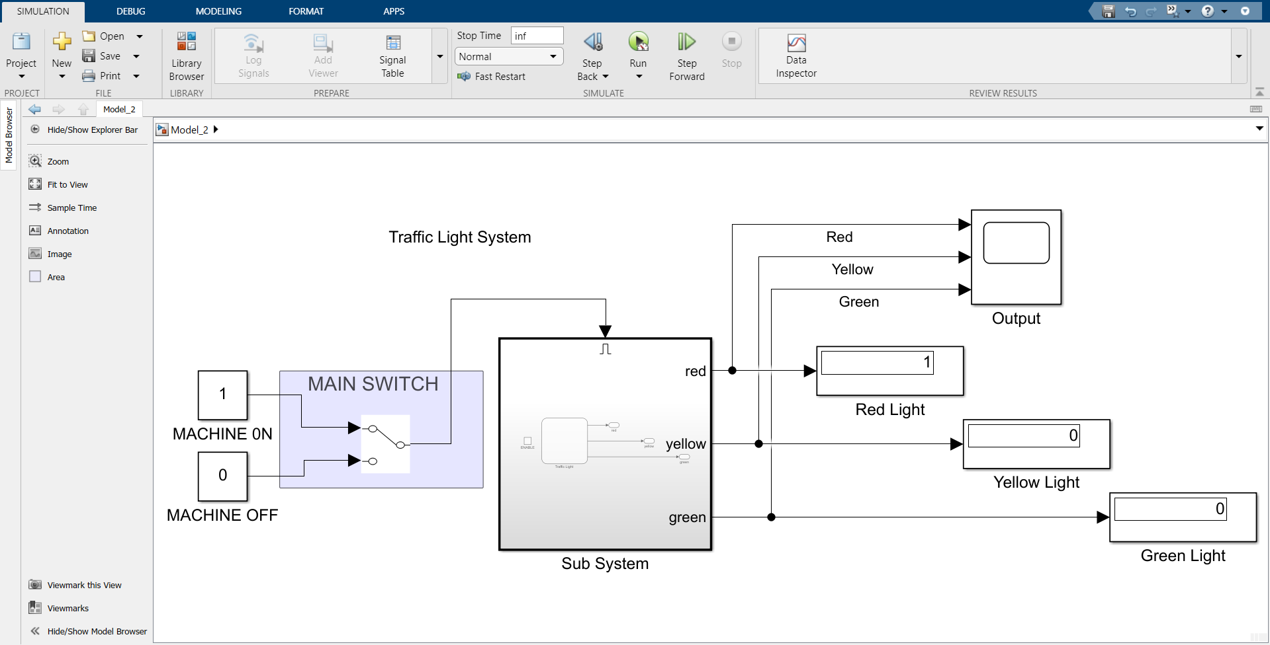

**Output:**

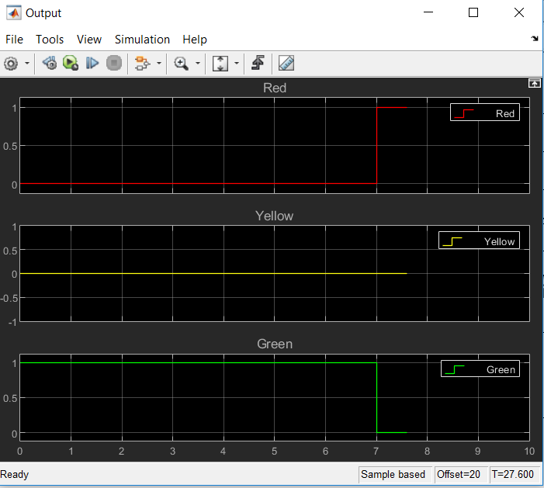

The model depicts traffic sign Simulation. When the power is off, the model output will not change their values i.e. the light will not glow. But when the power is turned on, the output values will change. The Red light will glow while others will be off, then yellow light will get a 1 value while others will have 0 and at last the green light will have the value 1 and thus denoting the vehicle can move. After few seconds the process will repeat itself till it receives power.