**Name- Akarsh Jain**

**Unique Id: 2005685**

**Model Based Design**

Design a complex automotive system of your choice. Create a small report of this project and demonstrate following skills in your model. Highlight these skills in your report

**Introduction**

I have designed a model for an Anti-Lock Braking System (ABS). The model simulates the dynamic behavior of a vehicle under hard braking conditions. The model represents a single wheel, which may be replicated a number of times to create a model for a multi-wheel vehicle.

**What is Anti-Lock Braking System(ABS)**

An anti-lock braking system (ABS) is a safety anti-skid braking system used on aircraft and on land vehicles, such as cars, motorcycles, trucks, and buses. ABS operates by preventing the wheels from locking up during braking, thereby maintaining tractive contact with the road surface and allowing the driver to maintain more control over the vehicle. ABS prevents wheel lock-up and consequent sliding under heavy braking or on slippery road surfaces. Wheel lock-up causes loss of steering and vehicle control, so ABS allows the driver to steer away from hazards, even on slippery surfaces, while applying maximum braking force.

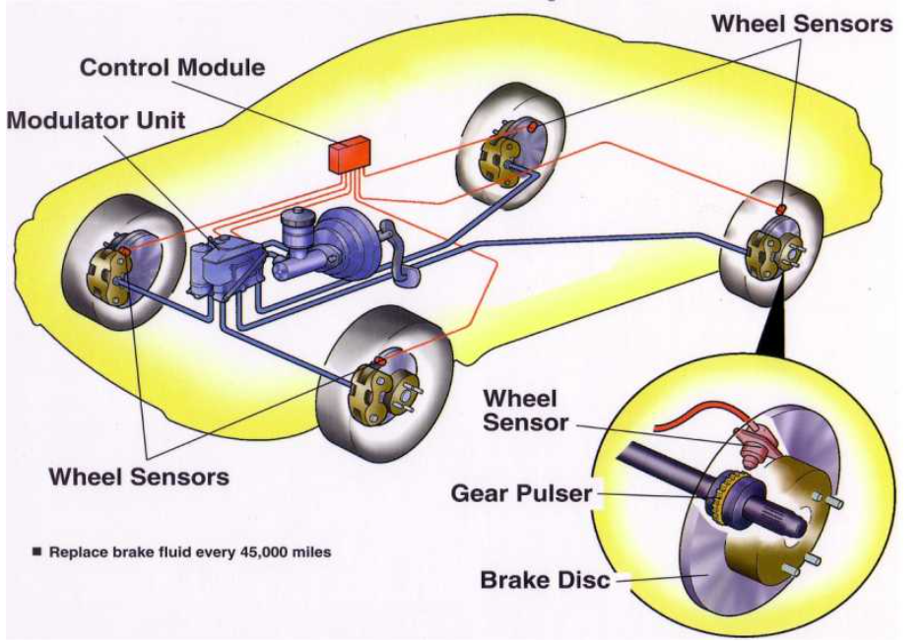

**Brief History Anti-Lock Braking System(ABS)**

The concept for ABS predates the modern systems that were introduced in the 1950s. In 1908, for example, J.E. Francis introduced his 'Slip Prevention Regulator for Rail Vehicles'.In 1920 the French automobile and aircraft pioneer Gabriel Voisin experimented with systems that modulated the hydraulic braking pressure on his aircraft brakes to reduce the risk of tire slippage. These systems used a flywheel and valve attached to a hydraulic line that feeds the brake cylinders. The flywheel is attached to a drum that runs at the same speed as the wheel. In normal braking, the drum and flywheel should spin at the same speed. However, when a wheel slows down, then the drum would do the same, leaving the flywheel spinning at a faster rate. This causes the valve to open, allowing a small amount of brake fluid to bypass the master cylinder into a local reservoir, lowering the pressure on the cylinder and releasing the brakes. The use of the drum and flywheel meant the valve only opened when the wheel was turning. In testing, a 30% improvement in braking performance was noted, because the pilots immediately applied full brakes instead of slowly increasing pressure in order to find the skid point. An additional benefit was the elimination of burned or burst tires.

The first proper recognition of the ABS system came later with the German engineer Karl Waessel, whose system for modulating braking power was officially patented in 1928. Wessel, however, never developed a working product and neither did Robert Bosch who produced a similar patent eight years later.

By the early 1950s, the Dunlop Maxaret anti-skid system was in widespread aviation use in the UK, with aircraft such as the Avro Vulcan and Handley Page Victor, Vickers Viscount, Vickers Valiant, English Electric Lightning, de Havilland Comet 2c, de Havilland Sea Vixen, and later aircraft, such as the Vickers VC10, Hawker Siddeley Trident, Hawker Siddeley 125, Hawker Siddeley HS 748 and derived British Aerospace ATP, and BAC One-Eleven, and the Dutch Fokker F27 Friendship (which unusually had a Dunlop high pressure (200 Bar) pneumatic system in lieu of hydraulics for braking, nose wheel steering and landing gear retraction), being fitted with Maxaret as standard.Maxaret, while reducing braking distances by up to 30% in icy or wet conditions, also increased tire life, and had the additional advantage of allowing take-offs and landings in conditions that would preclude flying at all in non-Maxaret equipped aircraft.

In 1958, a Royal Enfield Super Meteor motorcycle was used by the Road Research Laboratory to test the Maxaret anti-lock brake. The experiments demonstrated that anti-lock brakes can be of great value to motorcycles, for which skidding is involved in a high proportion of accidents. Stopping distances were reduced in most of the tests compared with locked wheel braking, particularly on slippery surfaces, in which the improvement could be as much as 30 percent. Enfield's technical director at the time, Tony Wilson-Jones, saw little future in the system, however, and it was not put into production by the company.

A fully-mechanical system saw limited automobile use in the 1960s in the Ferguson P99 racing car, the Jensen FF, and the experimental all-wheel drive Ford Zodiac, but saw no further use; the system proved expensive and unreliable. The first fully-electronic anti-lock braking system was developed in the late-1960s for the Concorde aircraft.

The modern ABS system was invented by Mario Palazzetti (known as 'Mister ABS') in the Fiat Research Center and is now standard in every car. The system was called Antiskid and the patent was sold to Bosch who named it ABS.

**How does it work?**

ABS is part of an overall stability system, commonly known as electronic stability control, which monitors wheels’ under heavy braking. Each wheel has a sensor attached to it. If the intelligent sensors detect that a wheel is about to lock up and stop moving, the system will release the brake. The release is only for a moment. ABS then continuously and repeatedly applies optimum braking pressure to each wheel, meaning the system will brake just enough to not lock the wheels. When ABS is active you may feel pulsation through the brake pedal as you’re pressing it. The anti-lock system helps the driver remain in control of the vehicle rather than bringing the car to a stop. It reduces the risk of skidding even when undertaking excessive evasive manoeuvres. This is why it’s important to remember that the car’s braking distance may increase. So, if you keep driving ahead straight into an obstacle, the car may not stop in time even if your instincts dictate otherwise. It’s a common misconception that ABS helps reducing stopping distance.

**Simulink Model Based Design**

**Main Block Diagram**

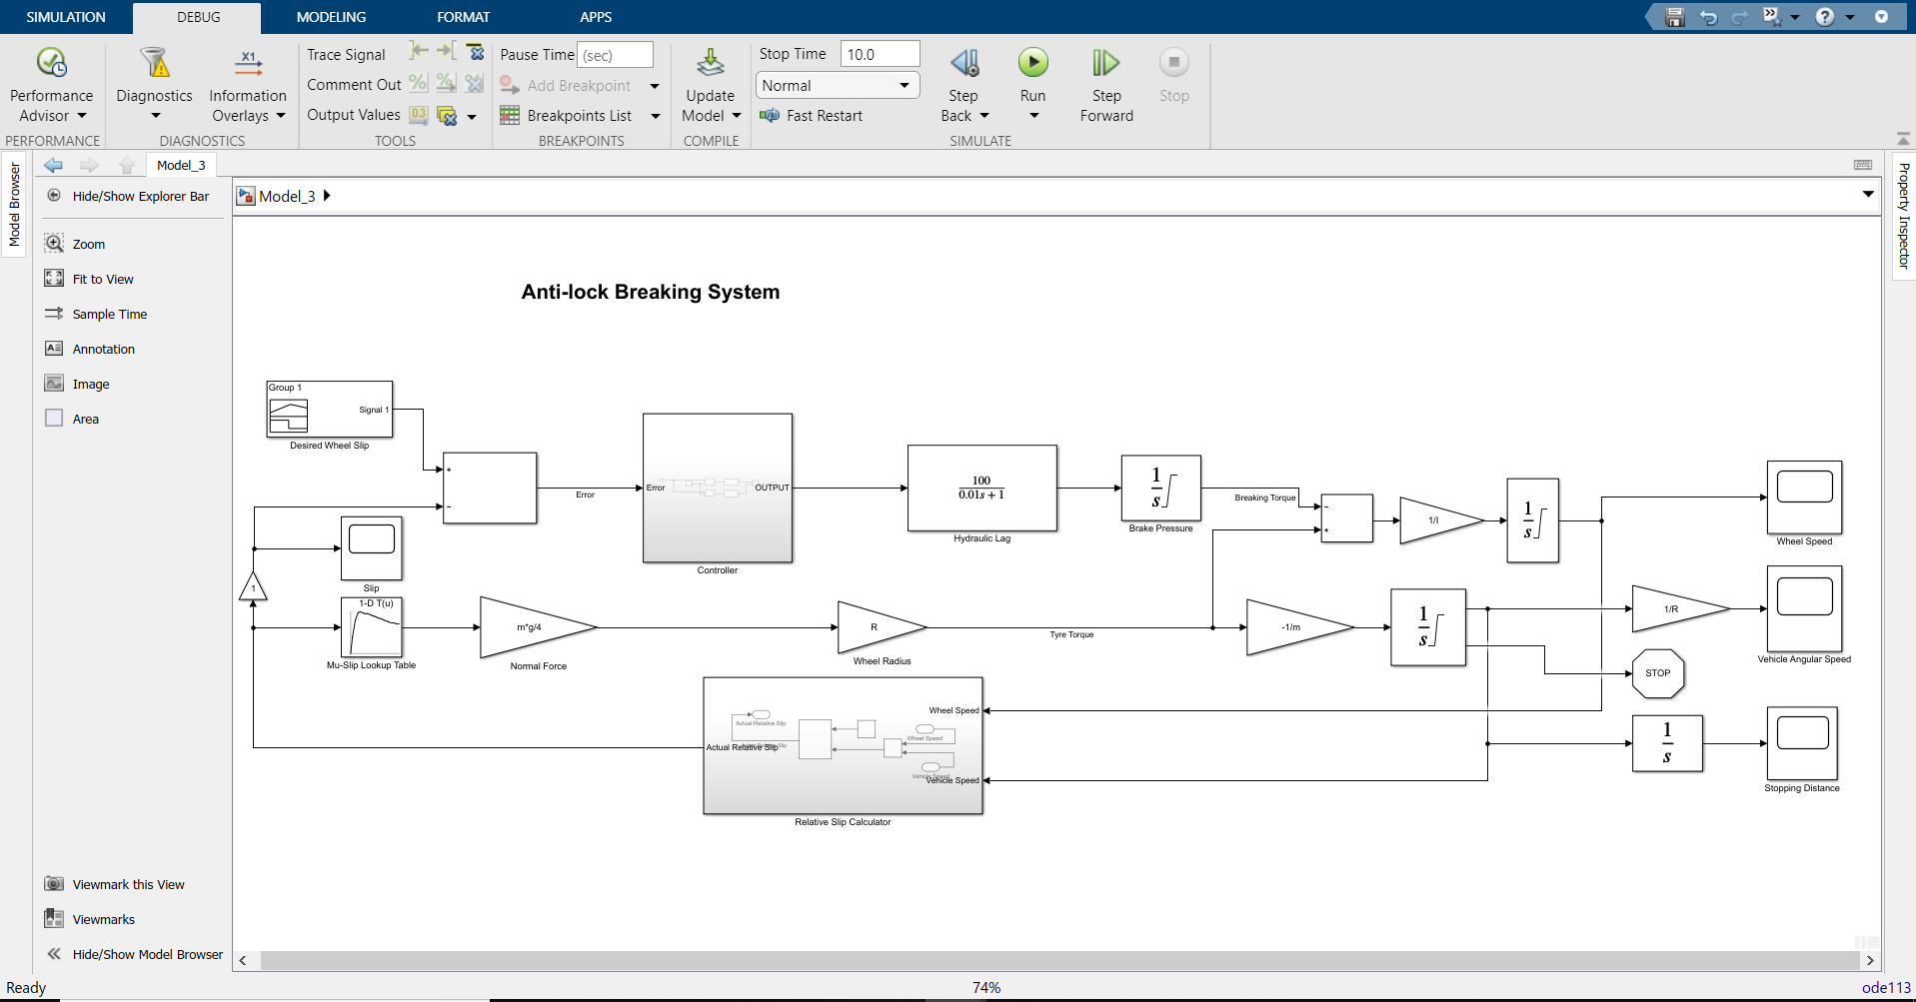

**Inside Controller Block**

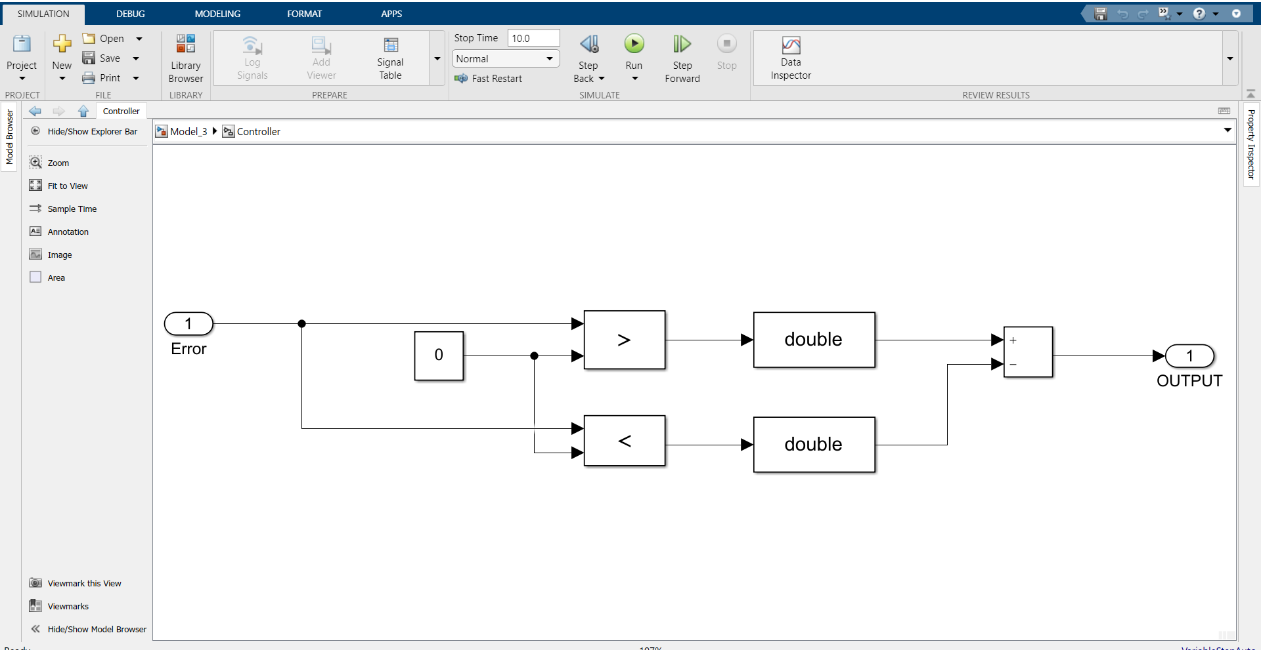

**Inside Relative Slip Calculator Block**

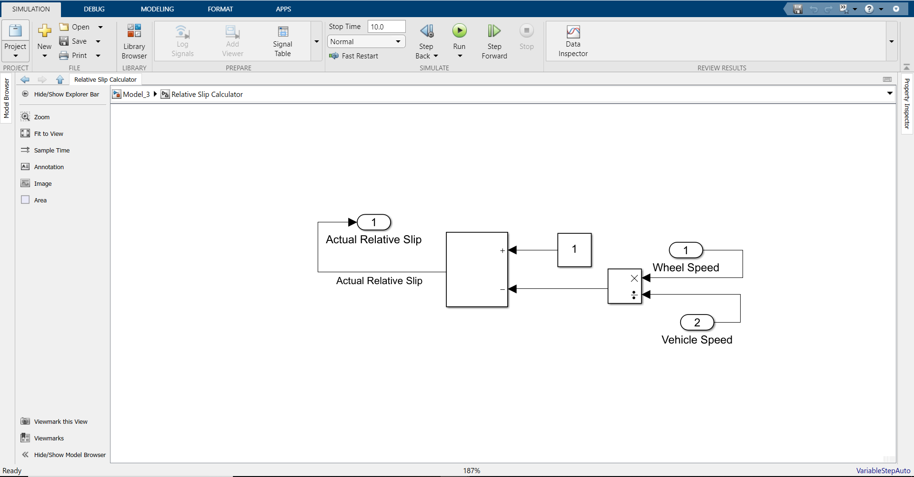

Output:

Wheel speed:

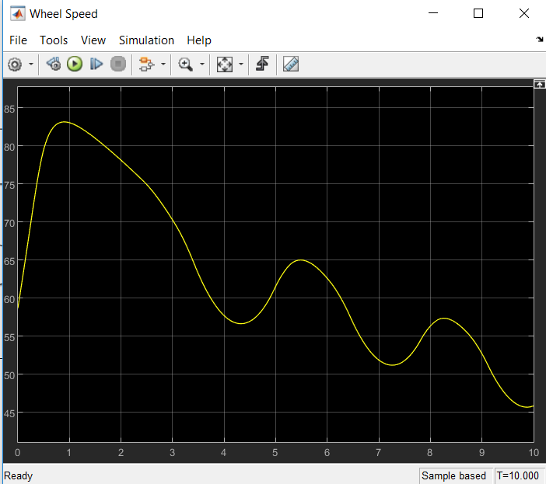

Vehicle Angular Speed

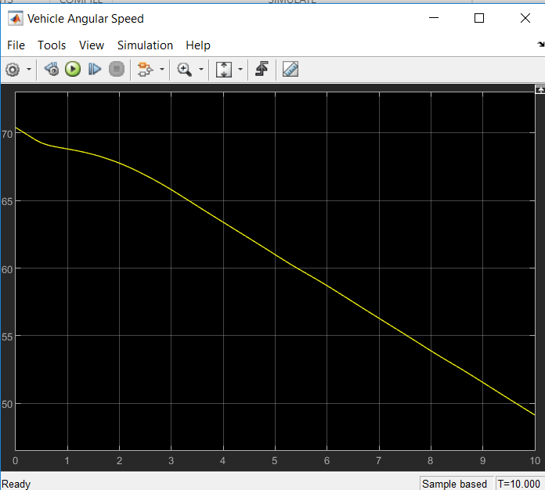

Stopping Distance

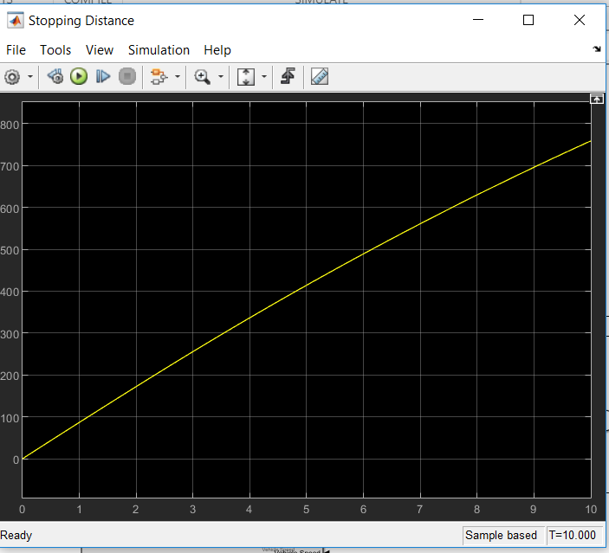

Slip:

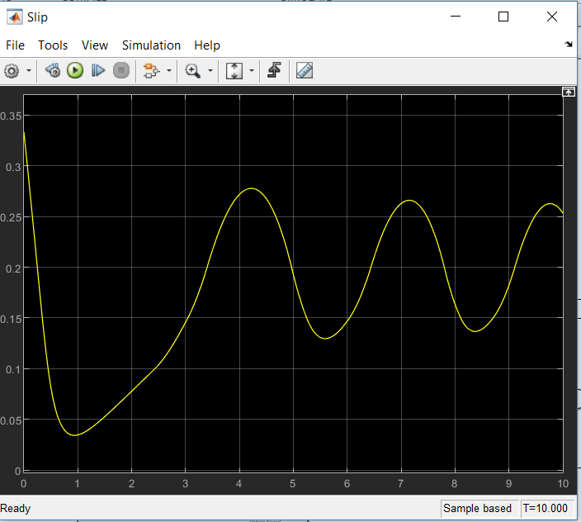

**Conclusion**

This model demonstrates how Simulink can be used to simulate a braking system under the action of an ABS controller. The controller in this example is idealized, but any proposed control algorithm can be used in its place to evaluate the system’s performance.