PE05: Programming Exercise
Clustering Methods and PCA
- In this programming exercise, you will analyze a dataset using the k-means clustering algorithm.
- Dataset: mtcars.csv is provided with this assignment. This original mtcars dataset holds specifications for different car models.
- Tools: Jupyter notebook.
- A very basic Jupyter notebook file is provided but you will have to fill it all in
Step 0: Install and load Python libraries.
- Import all the relevant Python libraries required to conduct K-Means clustering
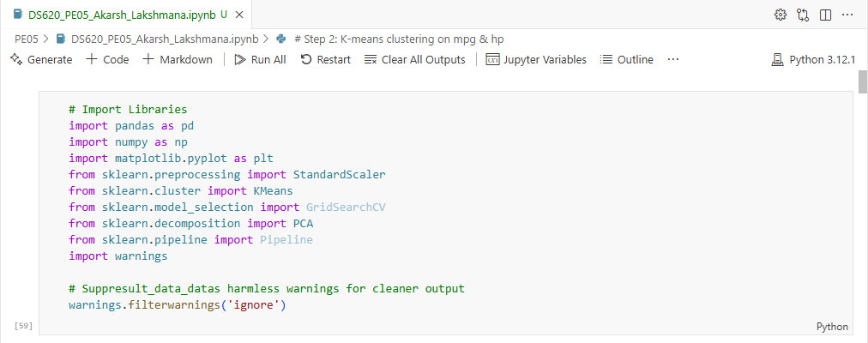
Step 1: Load the dataset and Explore the data.
- Load the mtcars.csv dataset into a dataframe df.
- Drop all columns except ['car_model' ,'mpg', 'hp']
- Study the dataset by using the usual Python/pandas functions for a dataset.
  - Describe what you see based on the functions used.
  - Note that one of the columns contains characters (non-numeric) data.
- Create a new dataframe called cars to hold numeric data only:
  - You want to drop the non-numeric column to prepare the data for K-means.
  - Confirm cars contains numeric values only.
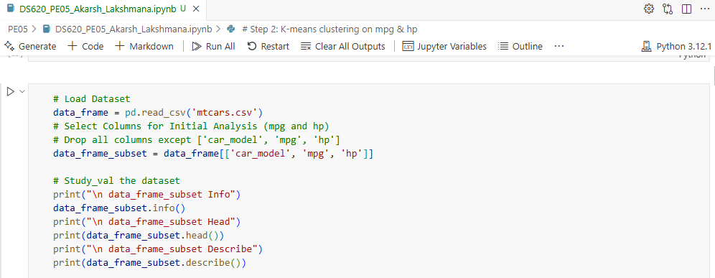

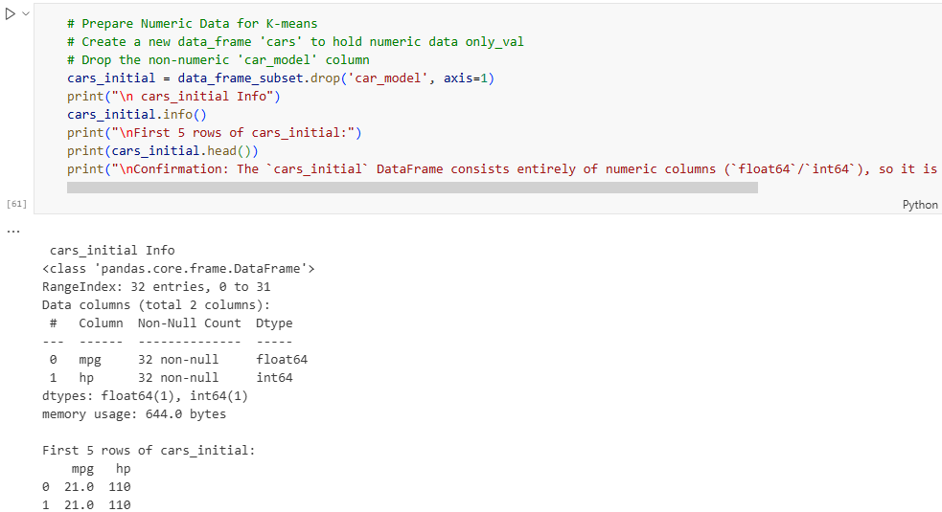
Step 2: Use k-means algorithm to find clusters in the data.
- First normalize the cars dataset to ensure attributes with large values do not skew the results.
  - confirm the normalization by showing the 10 top instances in the notebook.
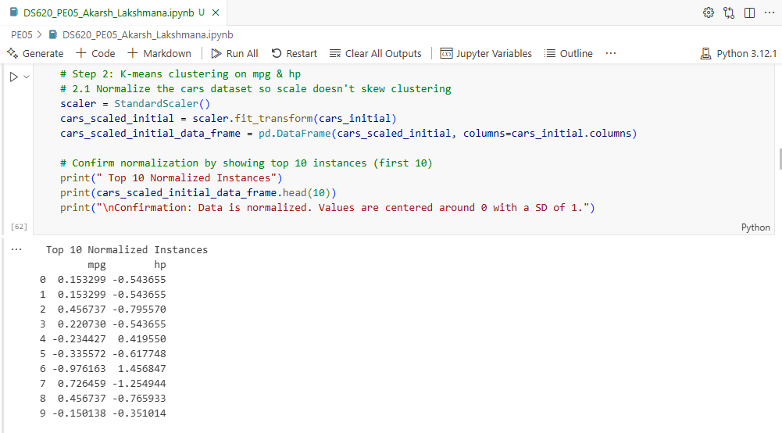
- Next, run the k-means for k=3, k=10, and k=20, store the models in km3, km10, and km20 respectively.
  - Set the random seed to 42.
  - For each of the three models, print
    - The predictions (y_pred) for data
    - The cluster centers.
- Use a scatter plot to visualize the clusters based on mpg and hp in the dataset.
  - For each of the three models (k=3, k=10, and k=20)
    - Show a different scatter plot including the centroids found above.
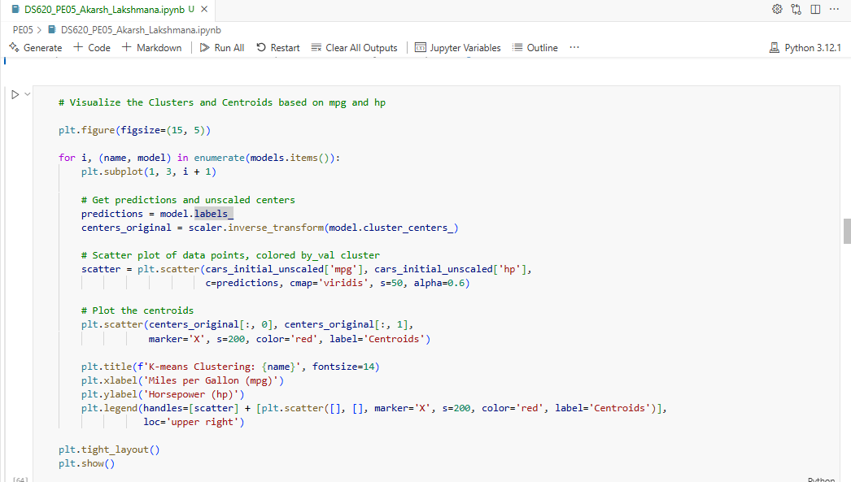
- Which of k=3, k=10, and k-20 provide the best clusters for this given pair of features? Explain.
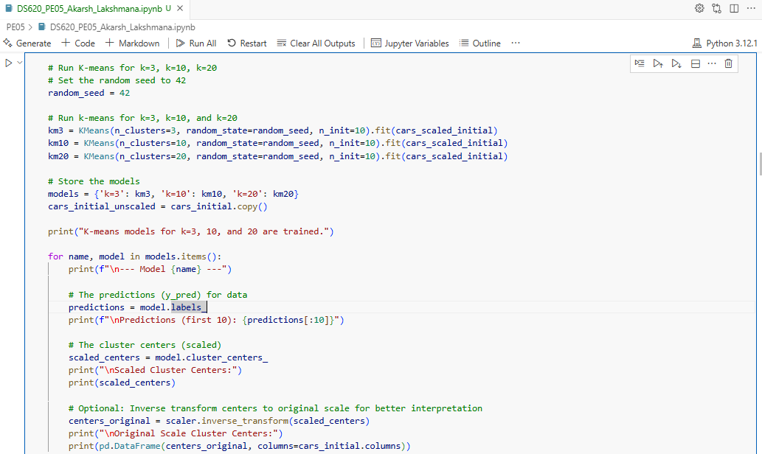
Which K looks best?
For the features mpg and hp, k=3 appears to produce the most meaningful clusters.
- k=3: The data is divided into three well-separated groups that are easy to interpret, such as "Low mpg / High hp," "Medium mpg / Medium hp," and "High mpg / Low hp." This level of clustering effectively captures the main structure in the dataset.
- k=10 & k=20: As the number of clusters increases, the groups become smaller and more fragmented. Over-clustering occurs, where clusters may contain only a few points or centroids lie very close to individual points. This makes the clusters less generalizable and reduces their usefulness for understanding broader patterns or car types.

The purpose of clustering is to identify meaningful groups, not just to assign every data point to its own cluster.
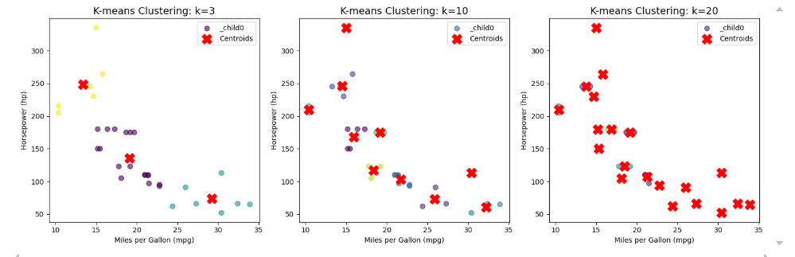
Step 3: Repeat steps 1 to 3 but with all the features and plot the new clusters (step 2.3) and their centers. You do not need to print or show any other information. Use this new data and clusters in the following steps.
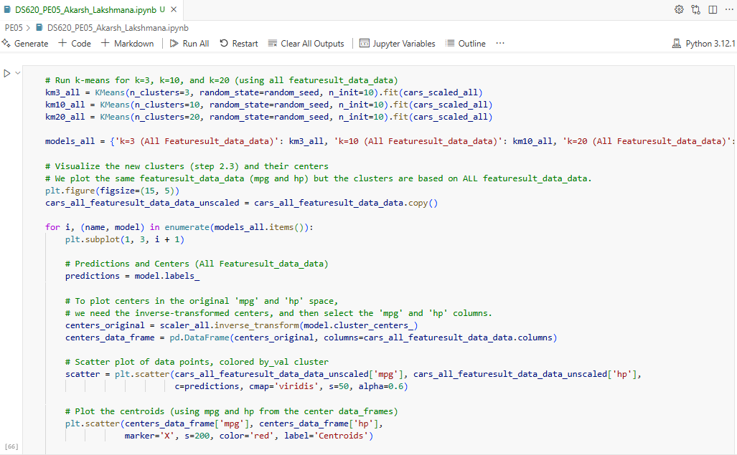
Step 4: Finding the optimal k for k-means:
- In the textbook, there is a discussion of the elbow method which makes it possible to pick an optimal value for k. an alternate method is to perform a grid search as demonstrated in the follow code snippet:
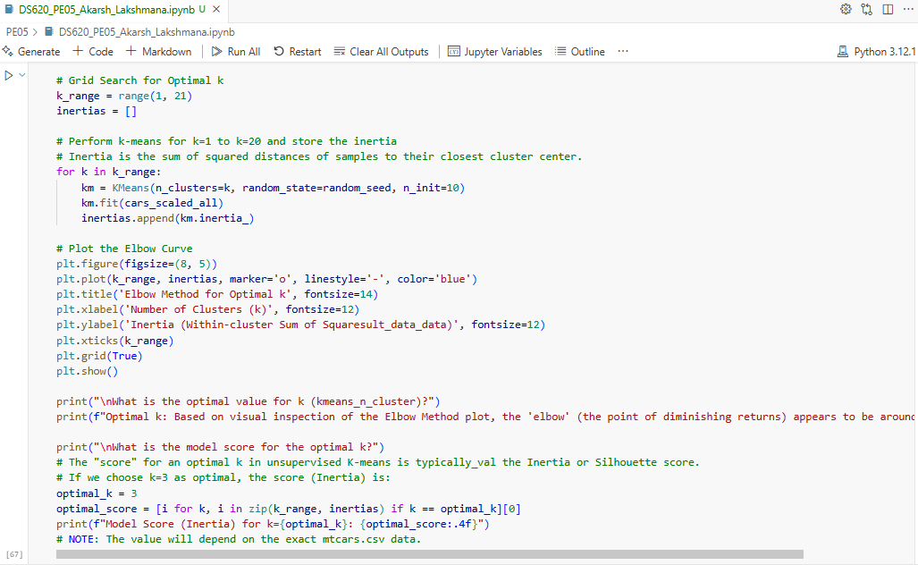
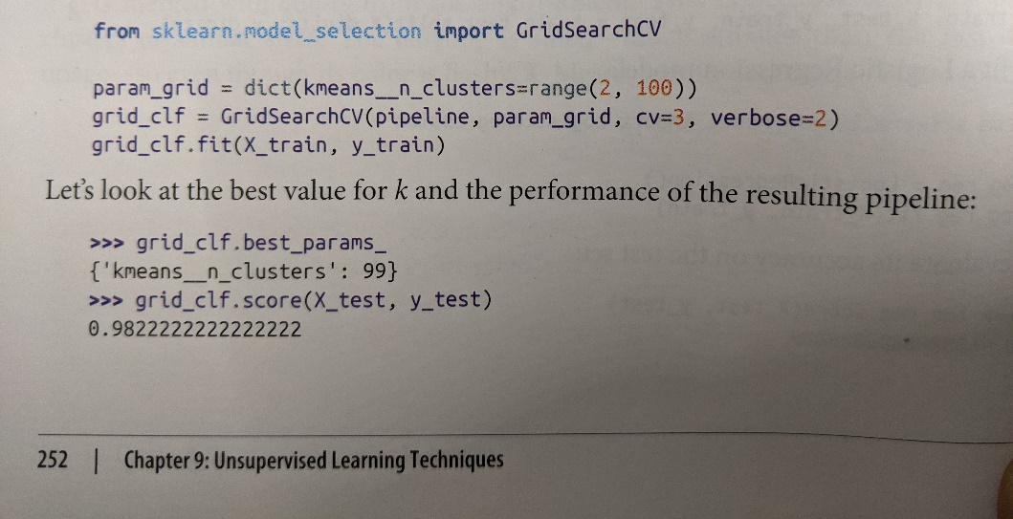

- Perform a grid search to produce k-means models for k=1 to k=20
  - What is the optimal value for k (kmeans_n_cluster)?
  - What is the model score for the optimal k?
What is the optimal value for k (kmeans_n_cluster)?
Optimal k: Based on visual inspection of the Elbow Method plot, the 'elbow' (the point of diminishing returns) appears to be around k=3 or k=4.

What is the model score for the optimal k?
Model Score (Inertia) for k=3: 132.5414
Step 5: Dimensionality Reduction – Principal Component Analysis:
- After determining the number of clusters in the cars dataframe, we are now going to determine the optimal number of features (dimensions) that describes the variance in the dataset using Principal component Analysis (PCA).
  - Refer to the section in the textbook Chapter 8 titled Choosing the Right Number of Dimensions
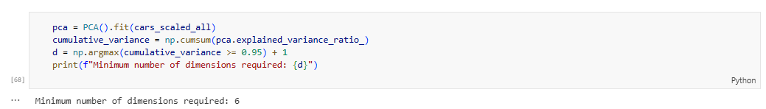

- Assuming we are selecting an explained variance of 95%, derive the minimum number of dimensions required to preserve 95%of the dataset variance. Hint: use the code example in the textbook.
- Using the additional code snippet in the textbook (same section), derive the X_reduced dataframe.
  - Print it in your notebook.
- Plot the Explained Variance vs Dimensions curve (see figure 8.8 in chapter 8)
  - Label the plot with “Dimensions” and “Explained Variance”.
  - Visualize the 0.95 point corresponding to the calculated reduced dimension d.
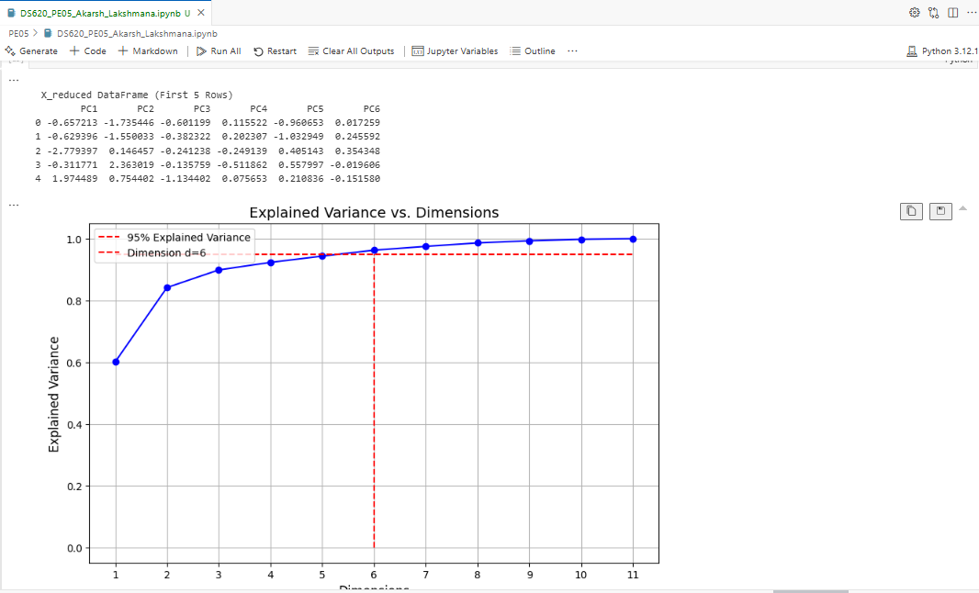
PCA-
1. Is d a significant dimensionality reduction?
The dataset originally has 11 dimensions. Reducing it to d (e.g., 5–6) represents a substantial reduction while still preserving around 95% of the total variance. This indicates a meaningful simplification of the data.
If d is equal to or greater than the original number of features, then the reduction is not significant, suggesting that most features contribute importantly to the variance, or the dataset is small.

2. Benefits of dimensionality reduction:
- Computational Efficiency: Algorithms like k-means or classification run faster with fewer features.
- Reduced Storage: Less memory is required to store the dataset.
- Improved Performance: Removing noise or redundant features can improve generalization and reduce the curse of dimensionality.
- Data Visualization: Easier to visualize in 2D or 3D plots.

3. Possible disadvantages of dimensionality reduction:
- Information Loss: Some information is inevitably lost (e.g., 5%), which might be important.
- Interpretability: PCA components are linear combinations of original features, making them harder to interpret.
- Scalability: PCA can be computationally intensive on very large datasets.

- Save all your answers, relevant function outputs and plots in a single notebook.
- Submit the notebook file to your instructor.

