**目 录**

1. 数据库设计

1.1 数据库名

1.2 开发环境(系统和版本)

2. 库表清单

3. 逻辑关系图

4. 系统表设计

# 数据库设计

## 数据库名

项目全称：大题小做在线教育网站

英文名：big problem small do

数据库缩写：dtxz

数据库地址：120.78.64.78

数据库连接帐号：dtxzdba

数据库连接密码：dtxz1314

## 开发环境(系统和版本)

系统第一版数据库环境：mysql 5.6以上

# 库表清单

|  |  |  |
| --- | --- | --- |
| **序号** | **库表名** | **说明** |
|  | dxtz_user | 用户信息表 |
|  | dxtz_bill | 资金流转表 |
|  | dxtz_teacher_auth | 教师认证表 |
|  | dxtz_class | 班级表 |
|  | dxtz_user_class | 班级用户关联表 |
|  | dxtz_exam | 考试表 |
|  | dxtz_exampaper | 试卷表 |
|  | dxtz_exercise | 题目表 |
|  | dxtz_paper_exe | 试卷题目关联表 |
|  | dxtz_submit | 考生提交表 |
|  | dxtz_message | 通知表 |
|  | dxtz_receive | 接收通知表 |
|  | dxtz_problem | 问题表 |
|  | dxtz_answer | 答案表 |
|  | dxtz_comment | 评论表 |
|  | dxtz_pv | pv流量表 |
|  | dxtz_admin | 管理员表 |
|  | dxtz_role | 角色表 |
|  | dxtz_power | 权限表 |

# 物理模型图 E-R 物理模型图(.pdm)

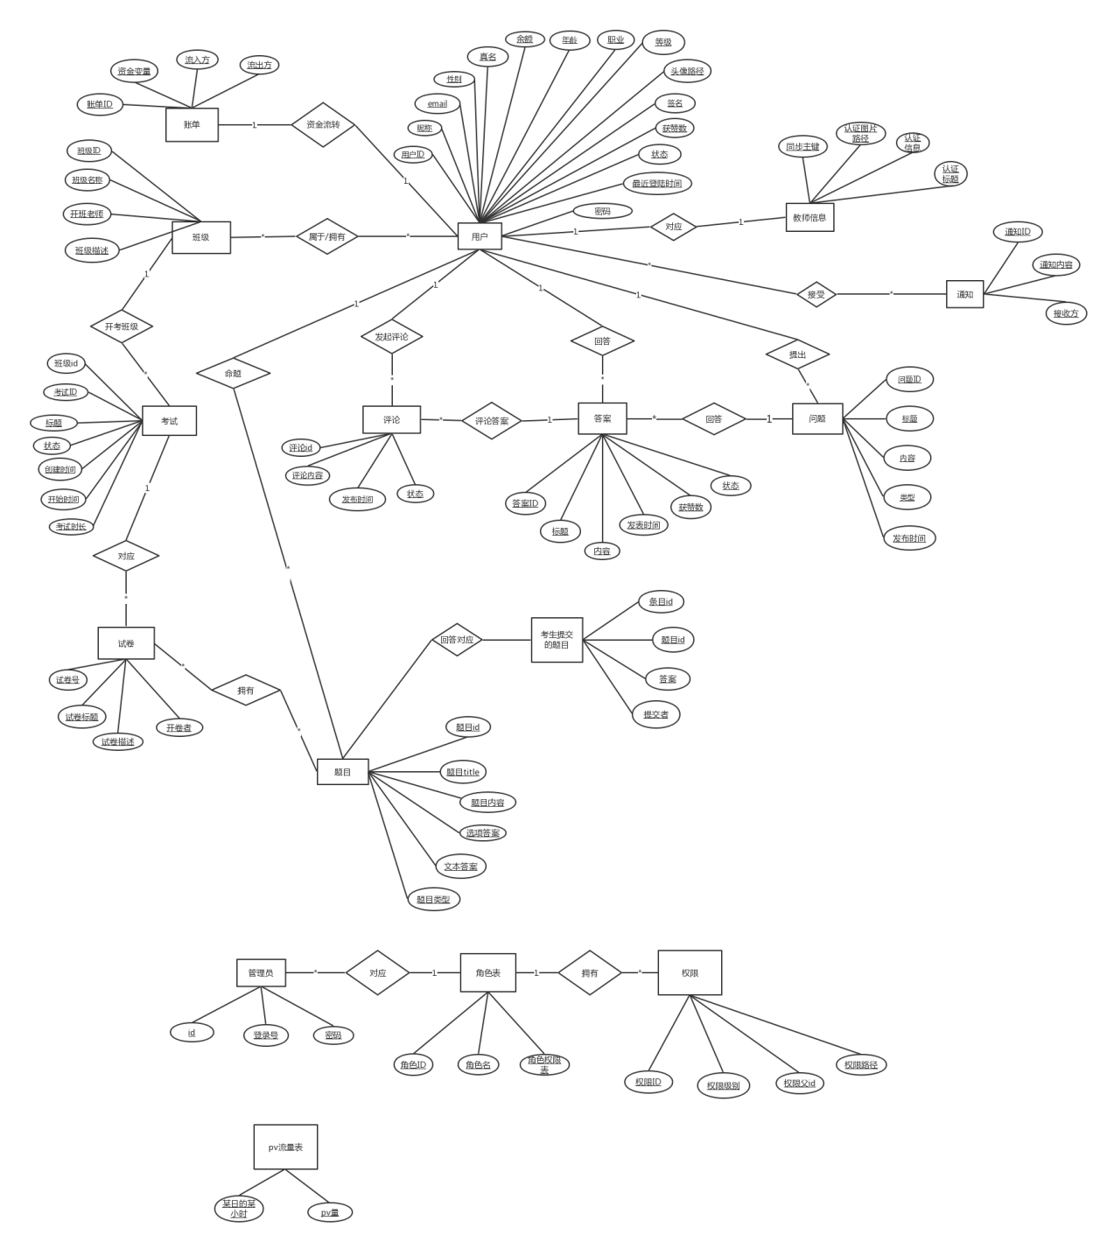

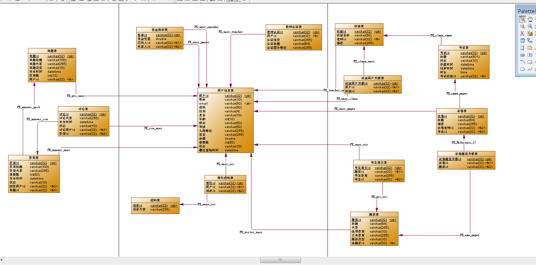

# 系统表设计

## dtxz_user表

|  |  |  |  |  |  |  |  |  |
| --- | --- | --- | --- | --- | --- | --- | --- | --- |
| **序号** | **列名** | **数据类型** | **长度** | **主键** | **外键** | **允许空** | **默认值** | **说明** |
|  | user_id | varchar | 32 | pk |  | N |  | 主键标识 |
|  | nickname | varchar | 10 |  |  | N |  | 昵称 |
|  | email | varchar | 50 |  |  | N |  | 唯一性 |
|  | pwd | varchar | 50 |  |  | N |  |  |
|  | sex | varchar | 50 |  |  | Y |  |  |
|  | name | varchar | 50 |  |  | Y |  | 真名 |
|  | age | int | 10 |  |  | Y |  |  |
|  | job | varchar | 50 |  |  | Y |  | 职业 |
|  | rank | varchar | 50 |  |  | Y |  | 等级 |
|  | img | varchar | 250 |  |  | Y |  | 头像路径 |
|  | [signature](http://www.baidu.com/link?url=8gK8tvWiQYfFmL7bTWXuupq8r-DFcZgmoti7sSCBMWz_8vSWH1XUJZftIzL-ib8qt5z1yj1pZ1NTQdLT93cOK82rY552fkyrLsysRFfq0apzq414ylSA4m3-Q7IMkSjd) | varchar | 50 |  |  | Y |  | 签名 |
|  | money | varchar | 50 |  |  | N | 0 |  |
|  | praise_count | int | 50 |  |  | N | 0 | 获赞数 |
|  | status | varchar | 16 |  |  | Y |  |  |
|  | recent_login_time | datetime |  |  |  | Y |  |  |

表说明：用户信息表。

字段说明：

|  |  |
| --- | --- |
| 字段名称 | 说明 |
|  |  |

## dtxz_bill表

|  |  |  |  |  |  |  |  |  |
| --- | --- | --- | --- | --- | --- | --- | --- | --- |
| **序号** | **列名** | **数据类型** | **长度** | **主键** | **外键** | **允许空** | **默认值** | **说明** |
|  | bill_id | varchar | 32 | pk |  | N |  | 主键标识 |
|  | cost | double | 8 |  |  | N |  | 资金变量 |
|  | spender_id | varchar | 32 |  | fk（user_id） | N |  | 花钱人 |
|  | payee_id | varchar | 32 |  | fk（user_id） | N |  | 收款人 |

表说明：资金流转表。

字段说明：

|  |  |
| --- | --- |
| 字段名称 | 说明 |
|  |  |

## dtxz_authen表

|  |  |  |  |  |  |  |  |  |
| --- | --- | --- | --- | --- | --- | --- | --- | --- |
| **序号** | **列名** | **数据类型** | **长度** | **主键** | **外键** | **允许空** | **默认值** | **说明** |
|  | authen_id | varchar | 32 | pk |  | N |  | 主键标识 |
|  | user_id | varchar | 32 |  | fk（user_id） | N |  |  |
|  | info | varchar | 255 |  |  | N |  | 认证信息 |
|  | title | varchar | 64 |  |  | N |  | 认证标题 |
|  | img | varchar | 255 |  |  | N |  | 认证图片路径 |

表说明：教师认证表

字段说明：

|  |  |
| --- | --- |
| 字段名称 | 说明 |
|  |  |

## dtxz_clazz表

|  |  |  |  |  |  |  |  |  |
| --- | --- | --- | --- | --- | --- | --- | --- | --- |
| **序号** | **列名** | **数据类型** | **长度** | **主键** | **外键** | **允许空** | **默认值** | **说明** |
|  | clazz_id | varchar | 32 | pk |  | N |  | 主键标识 |
|  | name | varchar | 50 |  |  | N |  | 班级名称 |
|  | teacher_id | varchar | 32 |  | fk（user_id） | N |  | 老师(用户)id |
|  | description | varchar | 255 |  |  | Y |  | 描述 |

表说明：班级表

字段说明：

|  |  |
| --- | --- |
| 字段名称 | 说明 |
|  |  |

## dtxz_user_class表

|  |  |  |  |  |  |  |  |  |
| --- | --- | --- | --- | --- | --- | --- | --- | --- |
| **序号** | **列名** | **数据类型** | **长度** | **主键** | **外键** | **允许空** | **默认值** | **说明** |
|  | uc_id | varchar | 32 | pk |  | N |  | 主键标识 |
|  | user_id | varchar | 32 |  | fk(user_id) | N |  |  |
|  | clazz_id | varchar | 32 |  | fk（clazz_id） | N |  |  |

表说明：班级用户关联表

字段说明：

|  |  |
| --- | --- |
| 字段名称 | 说明 |
|  |  |

## dtxz_exam表

|  |  |  |  |  |  |  |  |  |
| --- | --- | --- | --- | --- | --- | --- | --- | --- |
| **序号** | **列名** | **数据类型** | **长度** | **主键** | **外键** | **允许空** | **默认值** | **说明** |
|  | exam_id | varchar | 32 | pk |  | N |  | 主键标识 |
|  | title | varchar | 100 |  |  | N |  |  |
|  | status | varchar | 16 |  |  | Y |  |  |
|  | createtime | datetime |  |  |  | N |  |  |
|  | begintime | datetime |  |  |  | N |  |  |
|  | duration | time |  |  |  | N |  | 时长 |
|  | clazz_id | varchar | 32 |  | fk(clazz_id) | N |  |  |
|  | ep_id | varchar | 32 |  | fk(ep_id) | N |  |  |

表说明：考试表

字段说明：

|  |  |
| --- | --- |
| 字段名称 | 说明 |
|  |  |

## dtxz_exampaper表

|  |  |  |  |  |  |  |  |  |
| --- | --- | --- | --- | --- | --- | --- | --- | --- |
| **序号** | **列名** | **数据类型** | **长度** | **主键** | **外键** | **允许空** | **默认值** | **说明** |
|  | ep_id | varchar | 32 | pk |  | N |  | 主键标识 |
|  | title | varchar | 64 |  |  | N |  |  |
|  | description | varchar | 255 |  |  | Y |  |  |
|  | teacher_id | varchar | 32 |  | fk(user_id) | N |  | 命题老师 |

表说明：试卷表

字段说明：

|  |  |
| --- | --- |
| 字段名称 | 说明 |
|  |  |

## dtxz_exercise表

|  |  |  |  |  |  |  |  |  |
| --- | --- | --- | --- | --- | --- | --- | --- | --- |
| **序号** | **列名** | **数据类型** | **长度** | **主键** | **外键** | **允许空** | **默认值** | **说明** |
|  | exercise_id | varchar | 32 | pk |  | N |  | 主键标识 |
|  | title | varchar | 64 |  |  | N |  |  |
|  | description | varchar | 255 |  |  | N |  | 题目内容 |
|  | answer | text |  |  |  | N |  | 正确答案 |
|  | type | varchar | 10 |  |  | N |  | 题目类型 |
|  | writer_id | varchar | 32 |  | fk（user_id） | N |  | 命题者 |

表说明：题目表

字段说明：

|  |  |
| --- | --- |
| 字段名称 | 说明 |
|  |  |

## dtxz_paper_exe表

|  |  |  |  |  |  |  |  |  |
| --- | --- | --- | --- | --- | --- | --- | --- | --- |
| **序号** | **列名** | **数据类型** | **长度** | **主键** | **外键** | **允许空** | **默认值** | **说明** |
|  | pe_id | varchar | 32 | pk |  | N |  | 主键标识 |
|  | ep_id | varchar | 32 |  | fk(ep_id) | N |  |  |
|  | exercise_id | varchar | 32 |  | fk(exercise_id) | N |  |  |

表说明：试卷题目关联表

字段说明：

|  |  |
| --- | --- |
| 字段名称 | 说明 |
|  |  |

## dtxz_submit表

|  |  |  |  |  |  |  |  |  |
| --- | --- | --- | --- | --- | --- | --- | --- | --- |
| **序号** | **列名** | **数据类型** | **长度** | **主键** | **外键** | **允许空** | **默认值** | **说明** |
|  | submit_id | varchar | 32 | pk |  | N |  | 主键标识 |
|  | execrise_id | varchar | 32 |  | fk(exercise_id) | N |  |  |
|  | answer | text |  |  |  | Y |  | 答案 |
|  | examinee_id | varchar | 32 |  | fk（user_id） | N |  | 考生 |

表说明：考生提交表

字段说明：

|  |  |
| --- | --- |
| 字段名称 | 说明 |
|  |  |

## dtxz_message表

|  |  |  |  |  |  |  |  |  |
| --- | --- | --- | --- | --- | --- | --- | --- | --- |
| **序号** | **列名** | **数据类型** | **长度** | **主键** | **外键** | **允许空** | **默认值** | **说明** |
|  | mes_id | varchar | 32 | pk |  | N |  | 主键标识 |
|  | content | varchar | 255 |  |  | N |  | 内容 |

表说明：通知表

字段说明：

|  |  |
| --- | --- |
| 字段名称 | 说明 |
|  |  |

## dtxz_receive表

|  |  |  |  |  |  |  |  |  |
| --- | --- | --- | --- | --- | --- | --- | --- | --- |
| **序号** | **列名** | **数据类型** | **长度** | **主键** | **外键** | **允许空** | **默认值** | **说明** |
|  | rec_id | varchar | 32 | pk |  | N |  | 主键标识 |
|  | user_id | varchar | 32 |  | fk(user_id） | N |  |  |
|  | mes_id | varchar | 32 |  | fk(mes_id) | N |  |  |

表说明：接收通知表

字段说明：

|  |  |
| --- | --- |
| 字段名称 | 说明 |
|  |  |

## dtxz_problem表

|  |  |  |  |  |  |  |  |  |
| --- | --- | --- | --- | --- | --- | --- | --- | --- |
| **序号** | **列名** | **数据类型** | **长度** | **主键** | **外键** | **允许空** | **默认值** | **说明** |
|  | prob_id | varchar | 32 | pk |  | N |  | 主键标识 |
|  | title | varchar | 100 |  |  | N |  |  |
|  | content | varchar | 255 |  |  | N |  | 内容 |
|  | type | varchar | 16 |  |  | Y |  | 题目类型 |
|  | pub_time | datetime | 8 |  |  | N |  | 发布时间 |
|  | user_id | varchar | 32 |  | fk(user_id） | N |  |  |
|  | count | int | 4 |  |  | N |  | 答案数 |

表说明：问题表

字段说明：

|  |  |
| --- | --- |
| 字段名称 | 说明 |
|  |  |

## dtxz_answer表

|  |  |  |  |  |  |  |  |  |
| --- | --- | --- | --- | --- | --- | --- | --- | --- |
| **序号** | **列名** | **数据类型** | **长度** | **主键** | **外键** | **允许空** | **默认值** | **说明** |
|  | answer_id | varchar | 32 | pk |  | N |  | 主键标识 |
|  | title | varchar | 100 |  |  | Y |  |  |
|  | content | varchar | 255 |  |  | N |  | 内容 |
|  | praise_count | int | 50 |  |  | N | 0 |  |
|  | pub_time | datetime | 8 |  |  | N |  | 发布时间 |
|  | status | varchar | 16 |  |  | Y |  |  |
|  | user_id | varchar | 32 |  | fk(user_id） | N |  |  |
|  | prob_id | varchar | 32 |  | fk(prob_id) | N |  |  |

表说明：答案表

字段说明：

|  |  |
| --- | --- |
| 字段名称 | 说明 |
|  |  |

## dtxz_comment表

|  |  |  |  |  |  |  |  |  |
| --- | --- | --- | --- | --- | --- | --- | --- | --- |
| **序号** | **列名** | **数据类型** | **长度** | **主键** | **外键** | **允许空** | **默认值** | **说明** |
|  | comment_id | varchar | 32 | pk |  | N |  | 主键标识 |
|  | content | varchar | 255 |  |  | N |  | 内容 |
|  | pub_time | datetime | 8 |  |  | N |  | 发布时间 |
|  | status | varchar | 16 |  |  | Y |  |  |
|  | user_id | varchar | 32 |  | fk(user_id） | N |  |  |
|  | answer_id | varchar | 32 |  | fk(answer_id) | N |  |  |

表说明：评论表

字段说明：

|  |  |
| --- | --- |
| 字段名称 | 说明 |
|  |  |

## dtxz_pv表

|  |  |  |  |  |  |  |  |  |
| --- | --- | --- | --- | --- | --- | --- | --- | --- |
| **序号** | **列名** | **数据类型** | **长度** | **主键** | **外键** | **允许空** | **默认值** | **说明** |
|  | pv_id | varchar | 32 | pk |  | N |  | 主键标识 |
|  | hour | datetime |  |  |  | N |  |  |
|  | pv | varchar | 255 |  |  | N |  |  |

表说明：pv流量表

字段说明：

|  |  |
| --- | --- |
| 字段名称 | 说明 |
|  |  |

## dtxz_admin表

|  |  |  |  |  |  |  |  |  |
| --- | --- | --- | --- | --- | --- | --- | --- | --- |
| **序号** | **列名** | **数据类型** | **长度** | **主键** | **外键** | **允许空** | **默认值** | **说明** |
|  | admin_id | varchar | 32 | pk |  | N |  | 主键标识 |
|  | account | varchar | 32 |  |  | N |  |  |
|  | pwd | varchar | 32 |  |  | N |  | Md5加密 |
|  | role_id | varchar | 32 |  | fk(role_id) | N |  |  |

表说明：管理员表

字段说明：

|  |  |
| --- | --- |
| 字段名称 | 说明 |
|  |  |

## dtxz_role表

|  |  |  |  |  |  |  |  |  |
| --- | --- | --- | --- | --- | --- | --- | --- | --- |
| **序号** | **列名** | **数据类型** | **长度** | **主键** | **外键** | **允许空** | **默认值** | **说明** |
|  | role_id | varchar | 32 | pk |  | N |  | 主键标识 |
|  | name | varchar | 32 |  |  | N |  |  |
|  | power | varchar | 255 |  |  | N |  | 角色权限表 |

表说明：角色表

字段说明：

|  |  |
| --- | --- |
| 字段名称 | 说明 |
|  |  |

## dtxz_power表

|  |  |  |  |  |  |  |  |  |
| --- | --- | --- | --- | --- | --- | --- | --- | --- |
| **序号** | **列名** | **数据类型** | **长度** | **主键** | **外键** | **允许空** | **默认值** | **说明** |
|  | power_id | varchar | 32 | pk |  | N |  | 主键标识 |
|  | rank | varchar | 50 |  |  | N |  |  |
|  | src | varchar | 255 |  |  | N |  |  |
|  | parent_id | varchar | 32 |  |  | Y |  |  |

表说明：权限表

字段说明：

|  |  |
| --- | --- |
| 字段名称 | 说明 |
|  |  |

## dtxz_exam_submit视图

|  |  |  |  |  |  |  |  |  |
| --- | --- | --- | --- | --- | --- | --- | --- | --- |
| **序号** | **列名** | **数据类型** | **长度** | **主键** | **外键** | **允许空** | **默认值** | **说明** |
|  | examId | varchar | 32 | pk |  | N |  | 主键标识 |
|  | title | varchar | 50 |  |  | N |  | 考试标题 |
|  | status | varchar | 255 |  |  | N |  | 考试状态 |
|  | createtime | varchar | 32 |  |  | Y |  | 考试创建时间 |
|  | begintime | datetime |  |  |  |  |  | 考试结束时间 |
|  | duration | datetime |  |  |  |  |  | 考试时长 |
|  | clazzId |  |  |  |  |  |  | 班级id |
|  | epId |  |  |  |  |  |  | 试卷id |
|  | epTitle |  |  |  |  |  |  | 试卷标题 |
|  | epDescription |  |  |  |  |  |  | 试卷描述 |
|  | teacherId |  |  |  |  |  |  | 试卷命题老师id |
|  | peId |  |  |  |  |  |  | 标识，没啥用 |
|  | exerciseId |  |  |  |  |  |  | 题目id |
|  | ecTitle |  |  |  |  |  |  | 题目标题 |
|  | ecDescription |  |  |  |  |  |  | 题目描述 |
|  | type |  |  |  |  |  |  | 题目类型 |
|  | ecWriter |  |  |  |  |  |  | 命题者id |
|  | submitId |  |  |  |  |  |  | 题目回答的id |
|  | examineeId |  |  |  |  |  |  | 答题者id |

表说明：权限表

字段说明：

|  |  |
| --- | --- |
| 字段名称 | 说明 |
|  |  |