mysql> create database mydb;

Query OK, 1 row affected (1.06 sec)

mysql> use mydb;

Database changed

mysql> create table Student(Reg_No int,Name char(20),Age int);

Query OK, 0 rows affected (1.20 sec)

mysql> insert into Student Values(192211055,'Akash B',17);

Query OK, 1 row affected (0.05 sec)

mysql> select * from student;



mysql> alter table student add (Dept char(10));

Query OK, 0 rows affected (0.64 sec)

Records: 0 Duplicates: 0 Warnings: 0

mysql> select * from student;

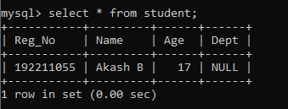

mysql> update student set dept ='CSE';

Query OK, 1 row affected (0.61 sec)

Rows matched: 1 Changed: 1 Warnings: 0

mysql> select * from student;

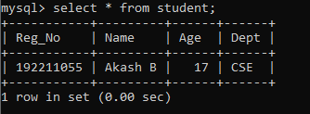

mysql> insert into student values(192211045,'Hsaka B',17,'ECE');

Query OK, 1 row affected (0.12 sec)

mysql> select * from student;

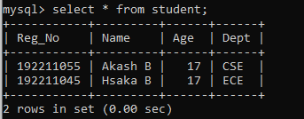

mysql> delete from student where dept='ECE';

Query OK, 1 row affected (1.93 sec)

mysql> select * from student;

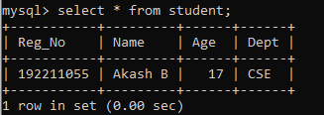

mysql> truncate student;

Query OK, 0 rows affected (0.57 sec)

mysql> select * from student;

Empty set (0.00 sec)