Assignment_5

#include <WiFi.h>

#include <HTTPClient.h>

#include <ArduinoJson.h>

WiFiServer server(80);

String header;

const char* ssid = "dlink";

const char* password = "geetha5588";

// Current time

unsigned long currentTime = millis();

// Previous time

unsigned long previousTime = 0;

// Define timeout time in milliseconds (example: 2000ms = 2s)

const long timeoutTime = 2000;

void setup() {

Serial.begin(115200);

delay(4000);

pinMode(2, OUTPUT);

digitalWrite(2, HIGH);

WiFi.begin(ssid, password);

while (WiFi.status() != WL_CONNECTED) {

delay(1000);

Serial.println("Connecting to WiFi..");

}

Serial.println("Connected to the WiFi network");

Serial.println("");

Serial.println("WiFi connected.");

Serial.println("IP address: ");

Serial.println(WiFi.localIP());

server.begin();

}

void loop() {

//client connection

WiFiClient client = server.available();

//data collector

if ((WiFi.status() == WL_CONNECTED)) {

//Check the current connection status

HTTPClient http;

http.begin("http://api.openweathermap.org/data/2.5/weather?q=Hyderabad,IN&appid=759b0b87bcfd9ca950be4beec21b527c"); //Specify the URL

int httpCode = http.GET(); //Make the request

if (httpCode > 0) { //Check for the returning code

String payload = http.getString();

DynamicJsonBuffer jsonBuffer(512);

//parse Json object

JsonObject&root =jsonBuffer.parseObject(payload);

if(!root.success())

{

Serial.println(F("parsing failed"));

return;

}

float temp=(float)(root["main"]["temp"])-273.15;

int humidity=(float)(root["main"]["humidity"]);

Serial.println("Temperature");

Serial.println(temp);

Serial.println("Humidity");

Serial.println(humidity);

// Display the HTML web page

client.println("<!DOCTYPE html><html>");

client.println("<head><meta name=\"viewport\" content=\"width=device-width, initial-scale=1\">");

client.println("<link rel=\"icon\" href=\"data:,\">");

// CSS to style the on/off buttons

// Feel free to change the background-color and font-size attributes to fit your preferences

client.println("<style>html { font-family: Helvetica; display: inline-block; margin: 0px auto; text-align: center;}");

client.println(".button { background-color: #4CAF50; border: none; color: white; padding: 16px 40px;");

client.println("text-decoration: none; font-size: 30px; margin: 2px; cursor: pointer;}");

client.println(".button2 {background-color: #555555;}</style></head>");

// Web Page Heading

client.println("<body><h1>Temperature and Humidity Display</h1>");

//temperature display

client.println("<p>Teperature</p>");

client.println(temp);

//humidity display

client.println("<p>Humidity</p>");

client.println(humidity);

}

else {

Serial.println("Error on HTTP request");

}

http.end(); //Free the resources

}

delay(10000);

}

Hyderabad Temperature and Humdity:

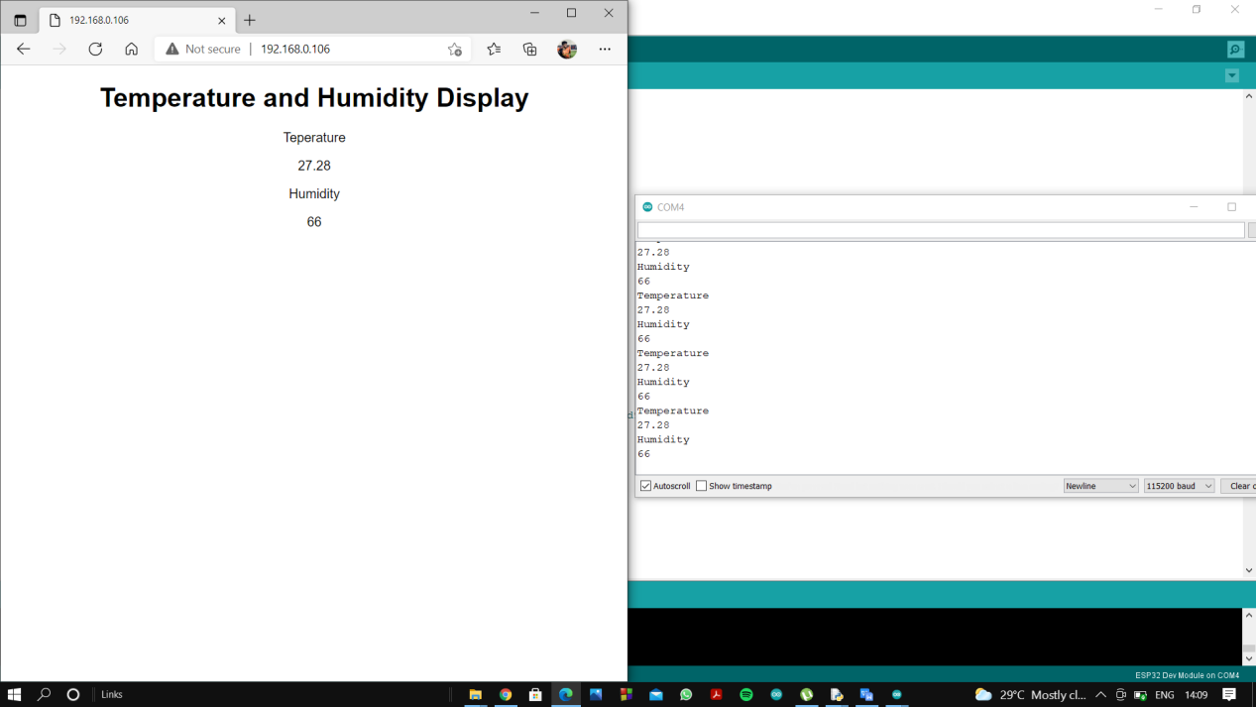

Delhi Temperature and Humdity:

