//1.printing water level in app

#include "BluetoothSerial.h"

#if !defined(CONFIG_BT_ENABLED) || !defined(CONFIG_BLUEDROID_ENABLED)

#error Bluetooth is not enabled! Please run `make menuconfig` to and enable it

#endif

int trigpin =33;

int echopin=4;

BluetoothSerial SerialBT;

void setup() {

Serial.begin(115200);

SerialBT.begin("ESP32test"); //Bluetooth device name

Serial.println("The device started, now you can pair it with bluetooth!");

pinMode(echopin,INPUT);

pinMode(trigpin,OUTPUT);

}

void loop() {

if (Serial.available()) {

SerialBT.write(Serial.read());

}

if (SerialBT.available()) {

Serial.write(SerialBT.read());

}

digitalWrite(trigpin,HIGH);

delay(1000);

digitalWrite(trigpin,LOW);

int duration=pulseIn(echopin,HIGH);

int distance=duration*0.0343/2;

Serial.println("the distance is");

Serial.println(distance);

SerialBT.print("the water level is :");

SerialBT.print(distance);

delay(2000);

}

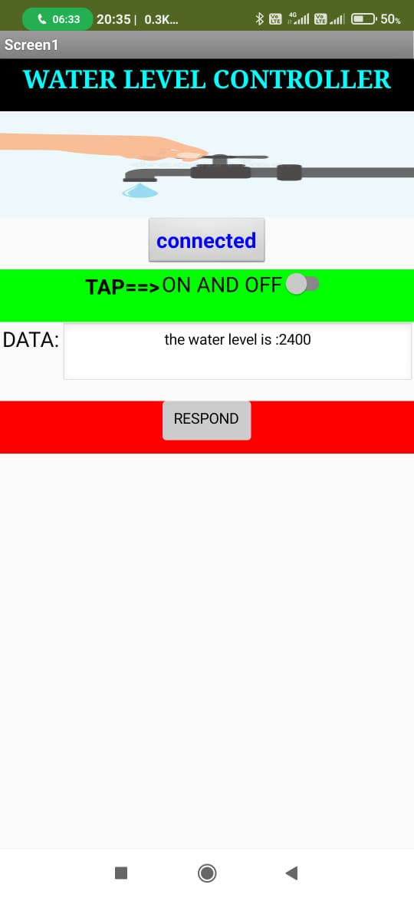

//2.integrate buttos and revice data on click of button

#include "BluetoothSerial.h"

#if !defined(CONFIG_BT_ENABLED) || !defined(CONFIG_BLUEDROID_ENABLED)

#error Bluetooth is not enabled! Please run `make menuconfig` to and enable it

#endif

BluetoothSerial SerialBT;

int received;// received value will be stored in this variable

char receivedChar;// received value will be stored as CHAR in this variable

const char turnON ='a';

const char turnOFF ='b';

const int LEDpin = 2;

void setup() {

Serial.begin(115200);

SerialBT.begin("ESP32_test"); //Bluetooth device name

Serial.println("The device started, now you can pair it with bluetooth!");

Serial.println("To turn ON send: a");//print on serial monitor

Serial.println("To turn OFF send: b"); //print on serial monitor

pinMode(LEDpin, OUTPUT);

}

void loop() {

receivedChar =(char)SerialBT.read();

if (Serial.available()) {

SerialBT.write(Serial.read());

}

if (SerialBT.available()) {

SerialBT.print("Received:");// write on BT app

SerialBT.println(receivedChar);// write on BT app

Serial.print ("Received:");//print on serial monitor

Serial.println(receivedChar);//print on serial monitor

//SerialBT.println(receivedChar);//print on the app

//SerialBT.write(receivedChar); //print on serial monitor

if(receivedChar == turnON)

{

SerialBT.println("TAP ON:");// write on BT app

Serial.println("TAP ON:");//write on serial monitor

digitalWrite(LEDpin, HIGH);// turn the LED ON

}

if(receivedChar == turnOFF)

{

SerialBT.println("TAP OFF:");// write on BT app

Serial.println("TAP OFF:");//write on serial monitor

digitalWrite(LEDpin, LOW);// turn the LED off

}

}

delay(20);

}

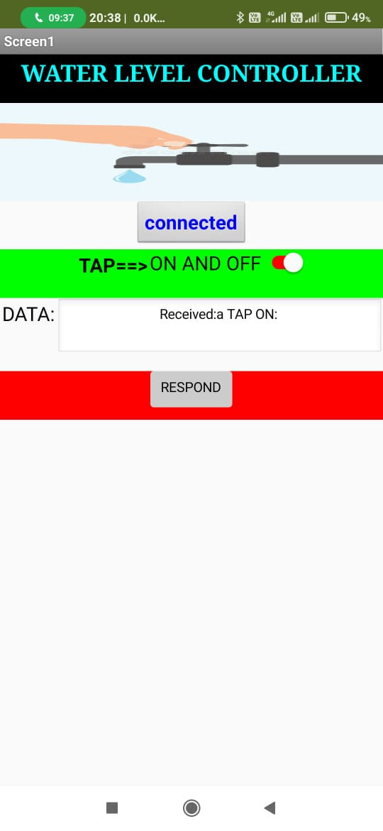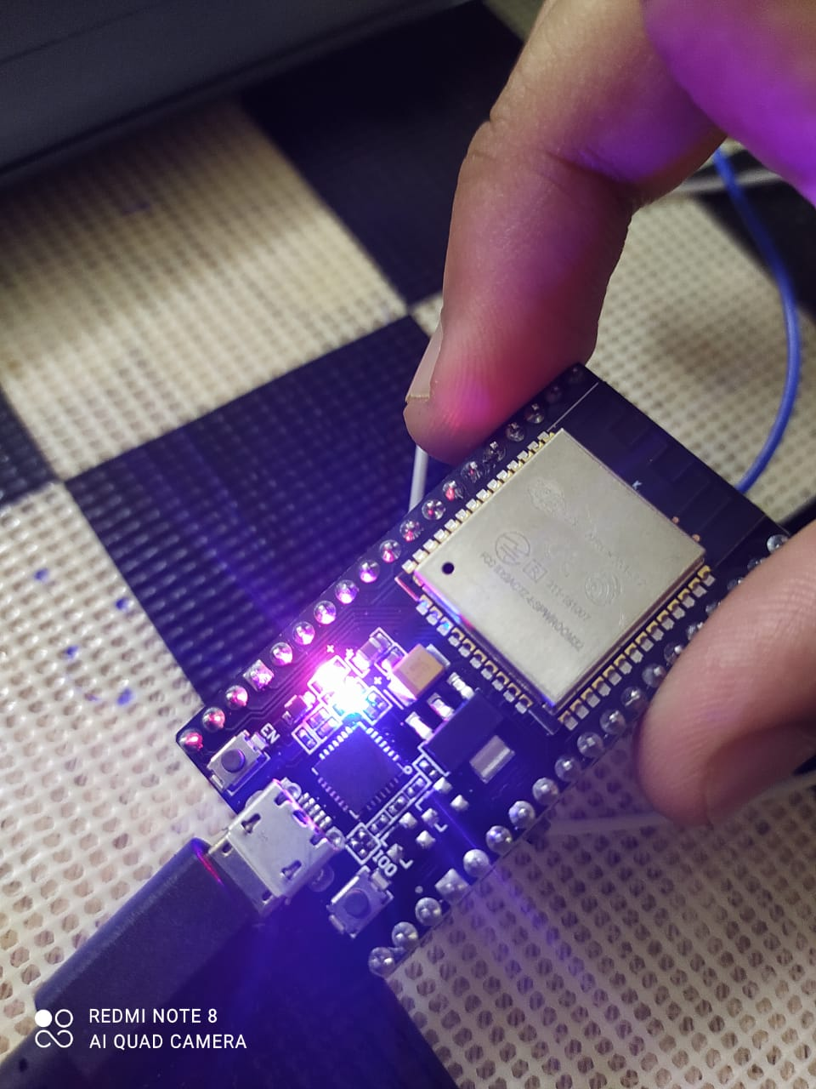

//3.recieve the data from the esp32 and control tap based on that.

#include "BluetoothSerial.h"

#if !defined(CONFIG_BT_ENABLED) || !defined(CONFIG_BLUEDROID_ENABLED)

#error Bluetooth is not enabled! Please run `make menuconfig` to and enable it

#endif

BluetoothSerial SerialBT;

int received;// received value will be stored in this variable

char receivedChar;// received value will be stored as CHAR in this variable

const char turnON ='a';

const char turnOFF ='b';

const int LEDpin = 2;

int trigpin =33;

int echopin=4;

void setup() {

Serial.begin(115200);

SerialBT.begin("ESP32_test"); //Bluetooth device name

Serial.println("The device started, now you can pair it with bluetooth!");

Serial.println("To turn ON send: a");//print on serial monitor

Serial.println("To turn OFF send: b"); //print on serial monitor

pinMode(LEDpin, OUTPUT);

pinMode(echopin,INPUT);

pinMode(trigpin,OUTPUT);

}

void loop() {

digitalWrite(trigpin,HIGH);

delay(1000);

digitalWrite(trigpin,LOW);

int duration=pulseIn(echopin,HIGH);

int distance=duration*0.0343/2;

Serial.println("the distance is");

Serial.println(distance);

SerialBT.println(distance);

if(distance>=2000)

{

SerialBT.println("if it is greater than 2000 ON tap ");

}

if(distance<2000)

{

SerialBT.println("if it is less than 2000 OFF tap ");

}

receivedChar =(char)SerialBT.read();

if (Serial.available()) {

SerialBT.write(Serial.read());

}

if (SerialBT.available()) {

SerialBT.print("Received:");// write on BT app

SerialBT.println(receivedChar);// write on BT app

Serial.print ("Received:");//print on serial monitor

Serial.println(receivedChar);//print on serial monitor

//SerialBT.println(receivedChar);//print on the app

//SerialBT.write(receivedChar); //print on serial monitor

if(distance>=2000)

{

if(receivedChar == turnON)

{

SerialBT.println("TAP ON:");// write on BT app

Serial.println("TAP ON:");//write on serial monitor

digitalWrite(LEDpin, HIGH);// turn the LED ON

}

}

if(distance<2000)

{

if(receivedChar == turnOFF)

{

SerialBT.println("TAP OFF:");// write on BT app

Serial.println("TAP OFF:");//write on serial monitor

digitalWrite(LEDpin, LOW);// turn the LED off

}

}

delay(20);

}

}

