Web Development Application Lab
Assignment - 2C

Name : Akash Kulkarni
Roll No : 33241
Class : TE-10

Problem Statement :
Create an Angular application which will do following actions: Register User, Login User, Show User Data on Profile Component

Screenshots :
Login Form :
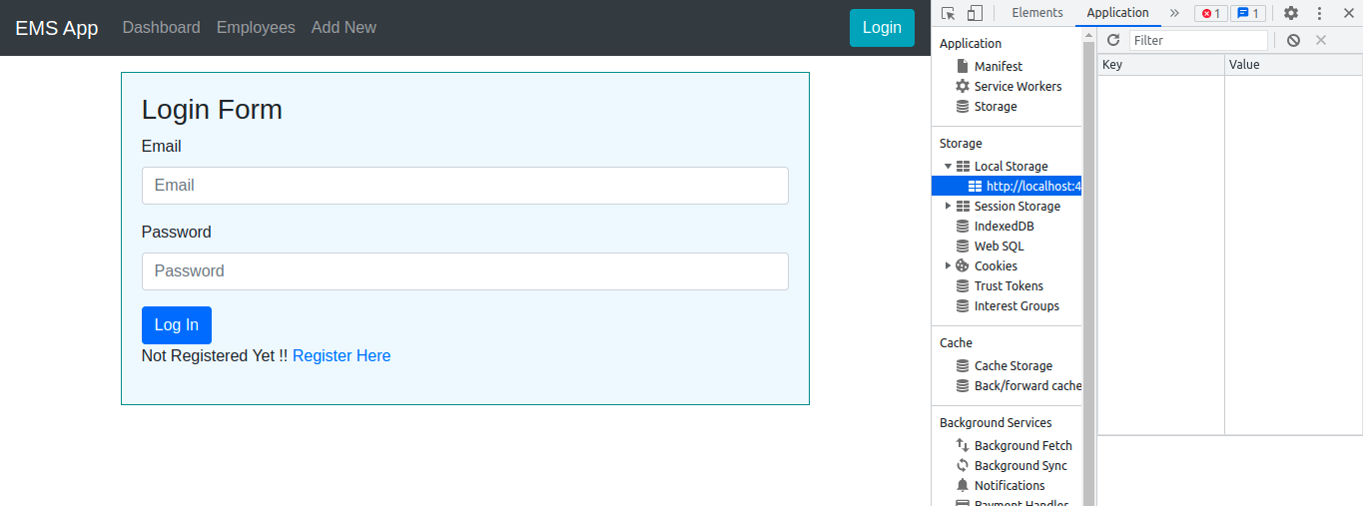
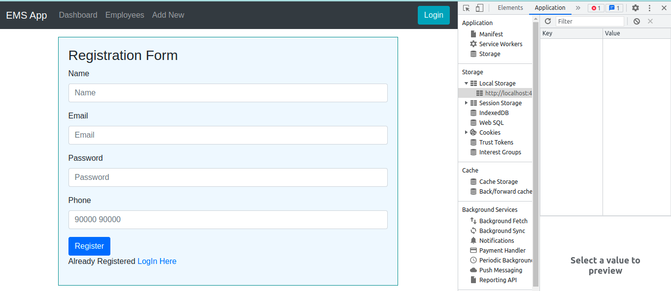
Registration Form :

After Registration :

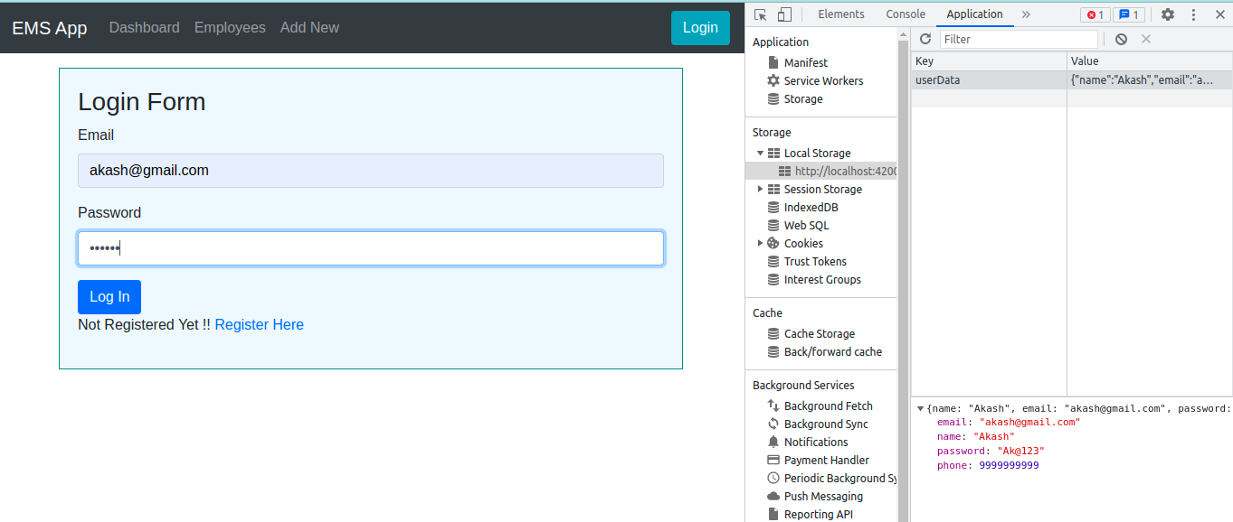
Dashboard :

