VYRON — Sample Output Screenshots
Hackathon submission · dashboard outputs from a live local-video run
Date captured: 7–8 Nov 2026
Sources shown: Local MP4 (record_… / video_sample1.mp4) · Postgres · dashboard
How to read: Each figure has a short title and explanation. Counts vary by capture time as the session continued.

Run snapshot (from Configuration audit + Live Monitor)
- Count audit (Fig. 12): DB gallery = log gallery = 54; entries = exits = 114; verdict Consistent.
- Later Live Monitor (Fig. 3): unique 58, entries = exits = 149 (same visit rule continuing on more footage).
- Crowd sample (Fig. 4): unique 59 with many simultaneous tracks on video_sample1.mp4.
- Unique visitors always = rows in faces; returning people keep the same face_id.

Figure index
- Fig. 1 — Overview — idle / before Start (01_overview_idle.png)
- Fig. 2 — Overview — live run with KPIs (02_overview_live_kpis.png)
- Fig. 3 — Live Monitor — face IDs + away / no-face (03_live_monitor_ids_noface.png)
- Fig. 4 — Live Monitor — dense crowd on sample video (04_live_monitor_crowd.png)
- Fig. 5 — Registered Faces — gallery (05_registered_faces_gallery.png)
- Fig. 6 — Visitor detail — visits + appearance (06_visitor_appearance.png)
- Fig. 7 — Visitor detail — Face & Embedding (07_visitor_embedding.png)
- Fig. 8 — Visitor detail — closest identities (08_visitor_closest_identities.png)
- Fig. 9 — ARIA assistant — natural-language query (09_aria_assistant.png)
- Fig. 10 — Event Logs — ENTRY / EXIT table (10_event_logs.png)
- Fig. 11 — Analytics — no-face / away walkers (11_analytics_noface.png)
- Fig. 12 — Configuration — invariants + count audit (12_configuration_audit.png)
- Fig. 13 — System Log — events.log tail (13_system_log.png)

Fig. 1 — Overview — idle / before Start
What this shows. Dashboard Overview with KPIs at zero and an empty Live Monitor. Shows the clean starting state before a video, webcam, or RTSP stream is started.
File: docs/assets/output/01_overview_idle.png
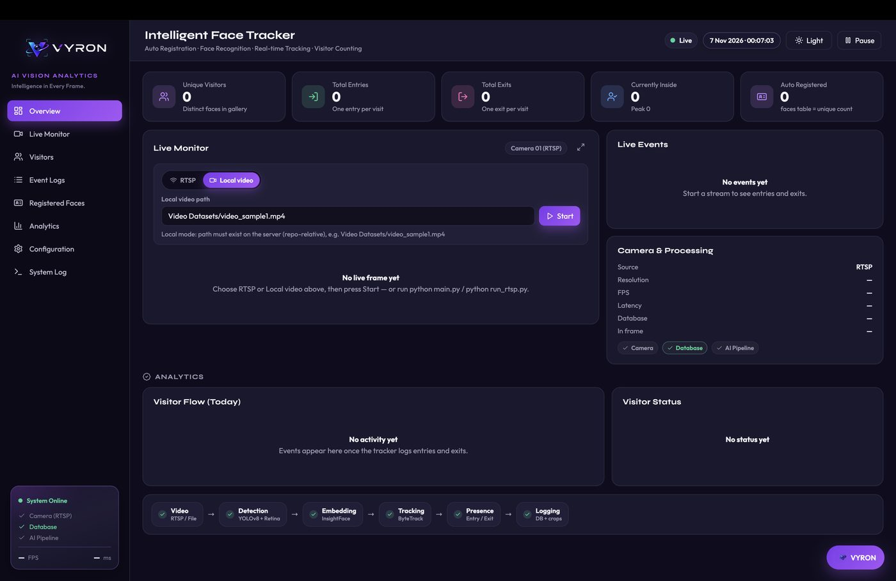

Fig. 2 — Overview — live run with KPIs
What this shows. Overview during an active local-video session. Unique visitors 56, entries 117, exits 114, currently inside 3. Live feed shows recognized IDs with confidence, Visitor Flow / Status charts, Live Events, and the AI pipeline strip.
File: docs/assets/output/02_overview_live_kpis.png
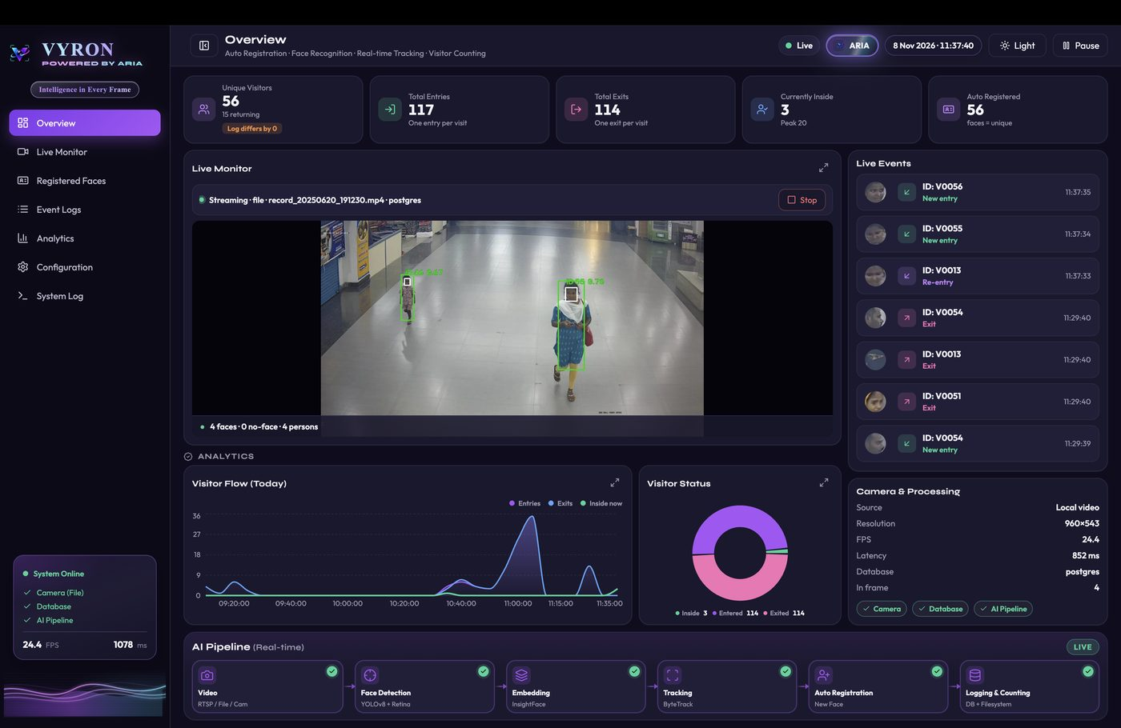

Fig. 3 — Live Monitor — face IDs + away / no-face
What this shows. Full Live Monitor on a local MP4. Face tracks show green ID labels; turned-away people are labeled NO-FACE (excluded from unique face count). Side KPIs: unique 58, entries = exits = 149.
File: docs/assets/output/03_live_monitor_ids_noface.png
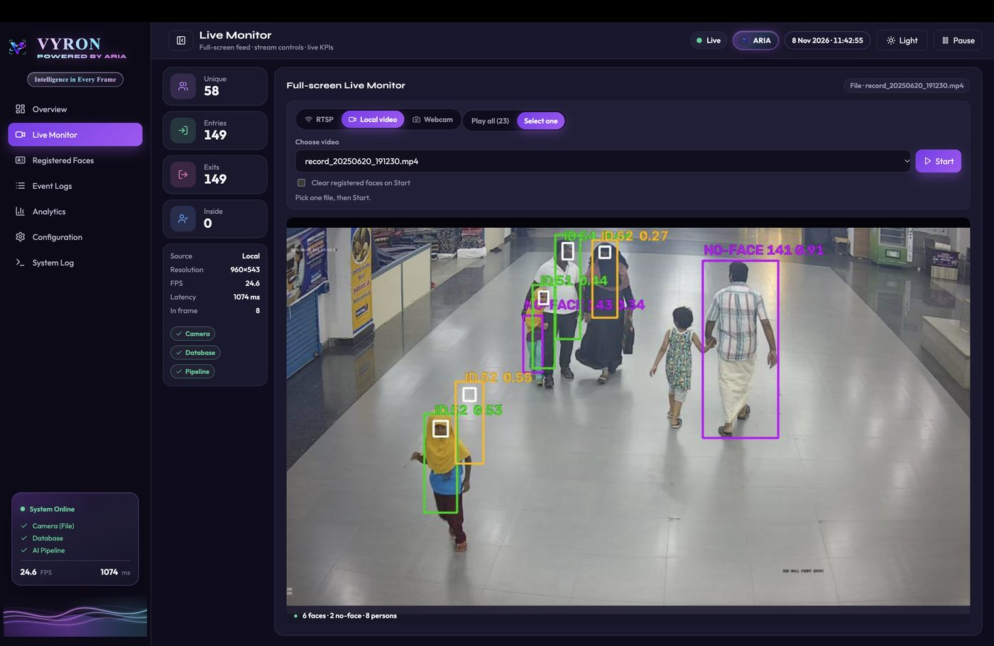

Fig. 4 — Live Monitor — dense crowd on sample video
What this shows. Live Monitor on video_sample1.mp4 with many simultaneous tracks (48 faces / 48 persons). Live Events shows New entry / Re-entry in sync with the feed. Demonstrates crowd-scale detection and counting.
File: docs/assets/output/04_live_monitor_crowd.png
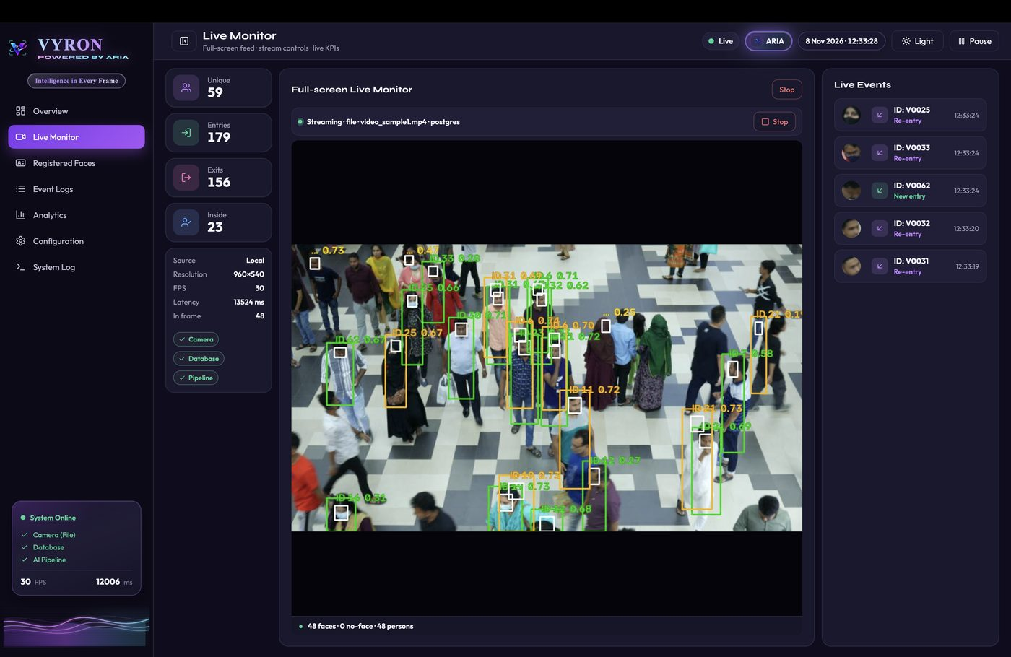

Fig. 5 — Registered Faces — gallery
What this shows. Unique identities in the faces gallery (54 at capture). Each card shows thumbnail, visit count, time in frame / visible, OpenCLIP appearance tags, and first/last seen. Unique count = rows in faces.
File: docs/assets/output/05_registered_faces_gallery.png
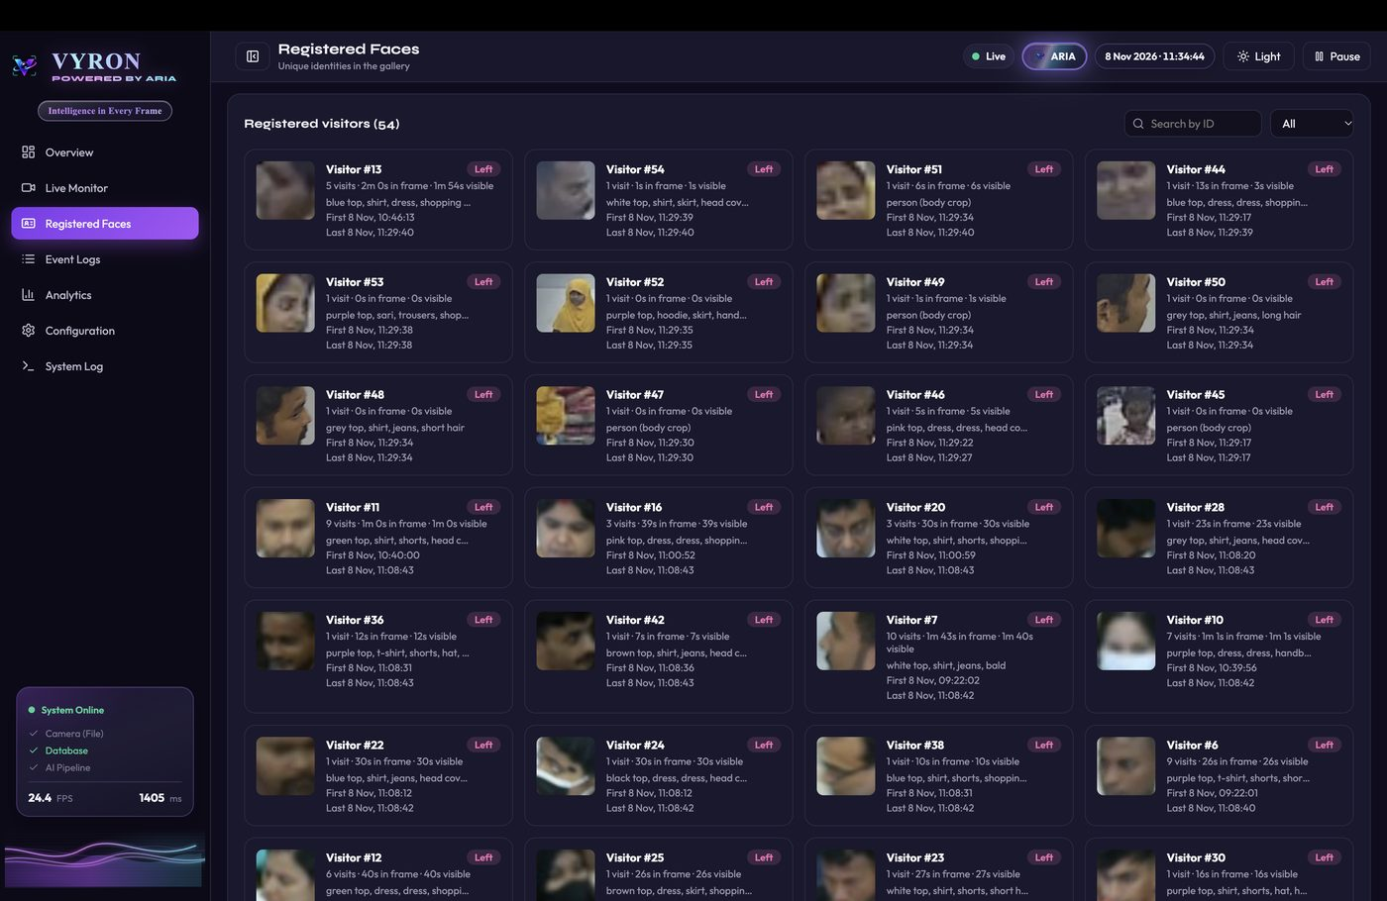

Fig. 6 — Visitor detail — visits + appearance
What this shows. Visitor #11 drawer: visit history with resume/stream_end notes, full-body appearance crop, clothing tags (open_clip ViT-B-32), and ArcFace 512-d face model summary.
File: docs/assets/output/06_visitor_appearance.png
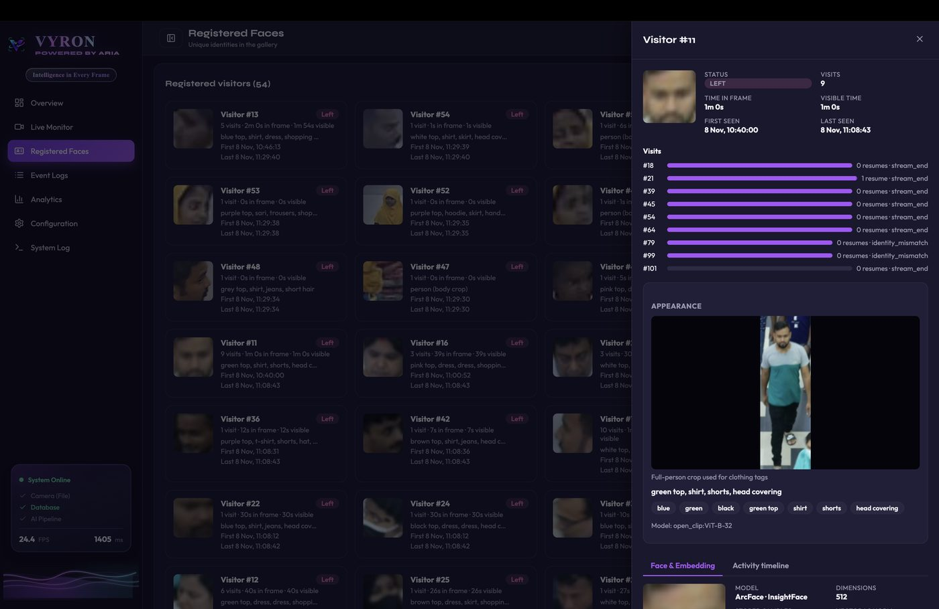

Fig. 7 — Visitor detail — Face & Embedding
What this shows. Embedding panel for Visitor #11: 5 stored samples, mean vector, 512-d heatmap, value distribution, raw floats, match threshold 0.52, and closest other identities by cosine similarity.
File: docs/assets/output/07_visitor_embedding.png
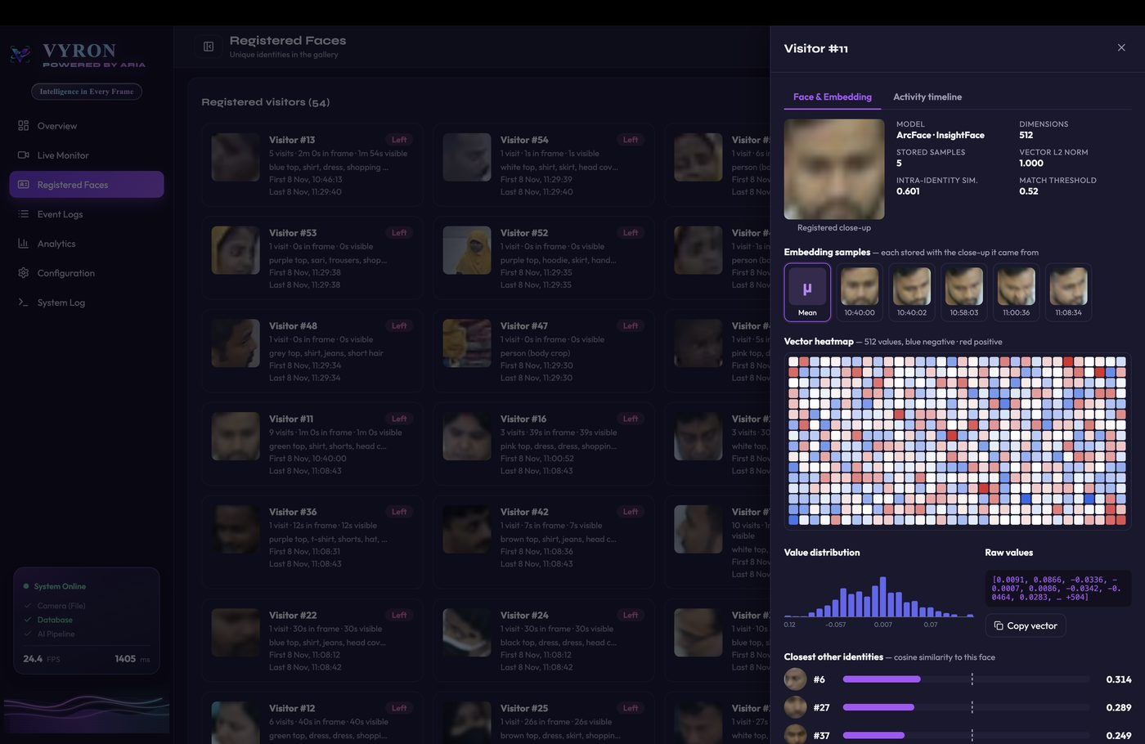

Fig. 8 — Visitor detail — closest identities
What this shows. Same embedding view scrolled to Closest other identities. Scores (~0.21–0.31) sit well below the match threshold, showing the gallery does not wrongly merge distinct people.
File: docs/assets/output/08_visitor_closest_identities.png
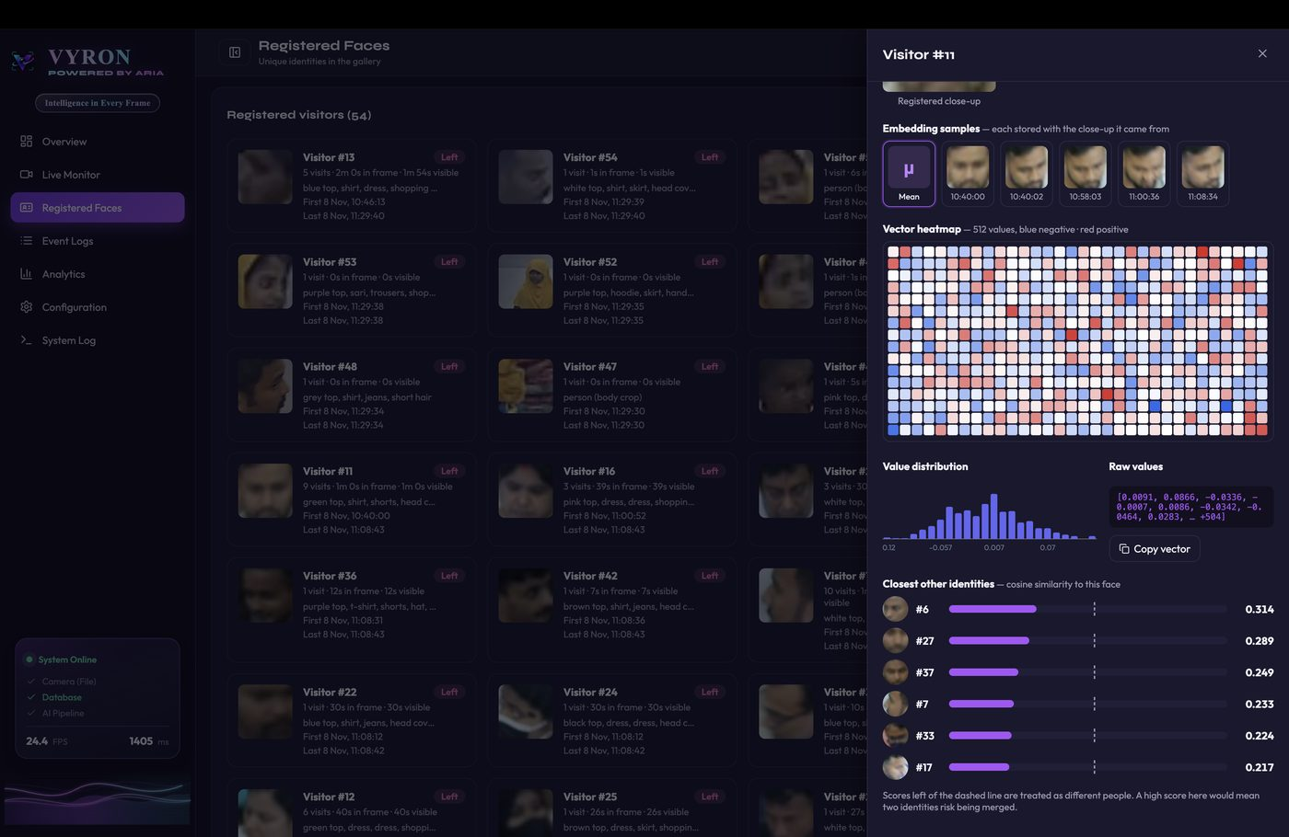

Fig. 9 — ARIA assistant — natural-language query
What this shows. ARIA (Groq) answers “Who stayed longest?” with Visitor #2 (~4m 4s) while the visitor card (visits, appearance, embeddings) is open. Read-only assistant over live gallery stats.
File: docs/assets/output/09_aria_assistant.png
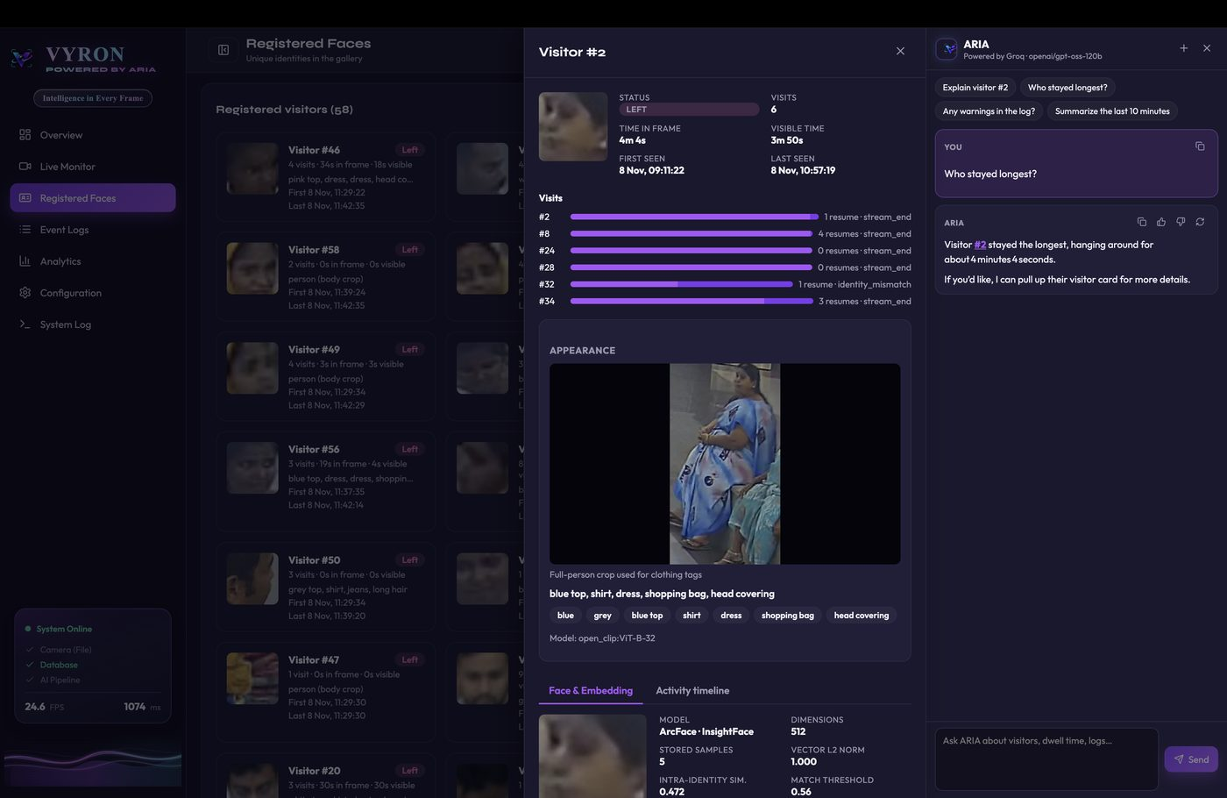

Fig. 10 — Event Logs — ENTRY / EXIT table
What this shows. Entry/exit log (228 events) with face crops, visitor id, New entry / Exit badges, timestamps, track id, frame index, and notes (e.g. stream_end). Evidence crops for each visit event.
File: docs/assets/output/10_event_logs.png
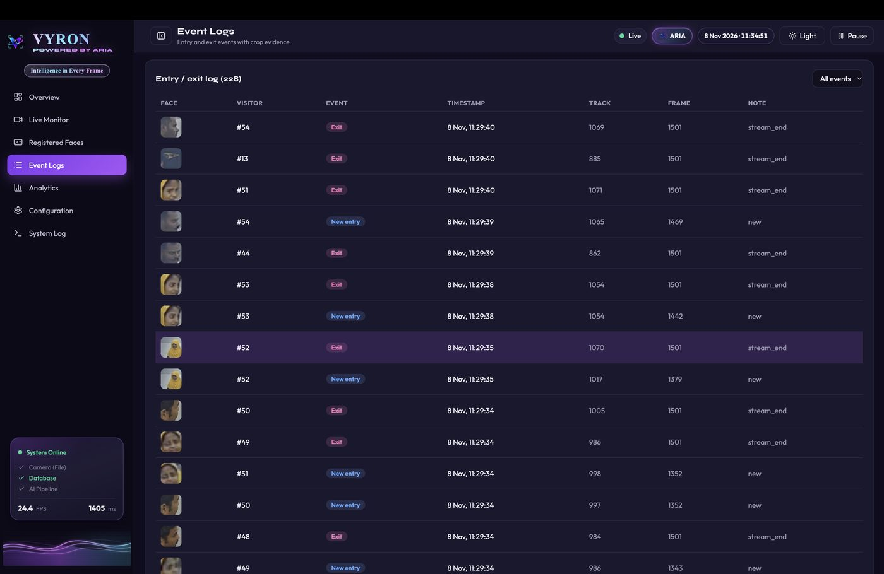

Fig. 11 — Analytics — no-face / away walkers
What this shows. Analytics KPIs plus No-face people grid (excluded from unique face count). Cards can show Turned → face #N when a later face ID links to a prior away track.
File: docs/assets/output/11_analytics_noface.png
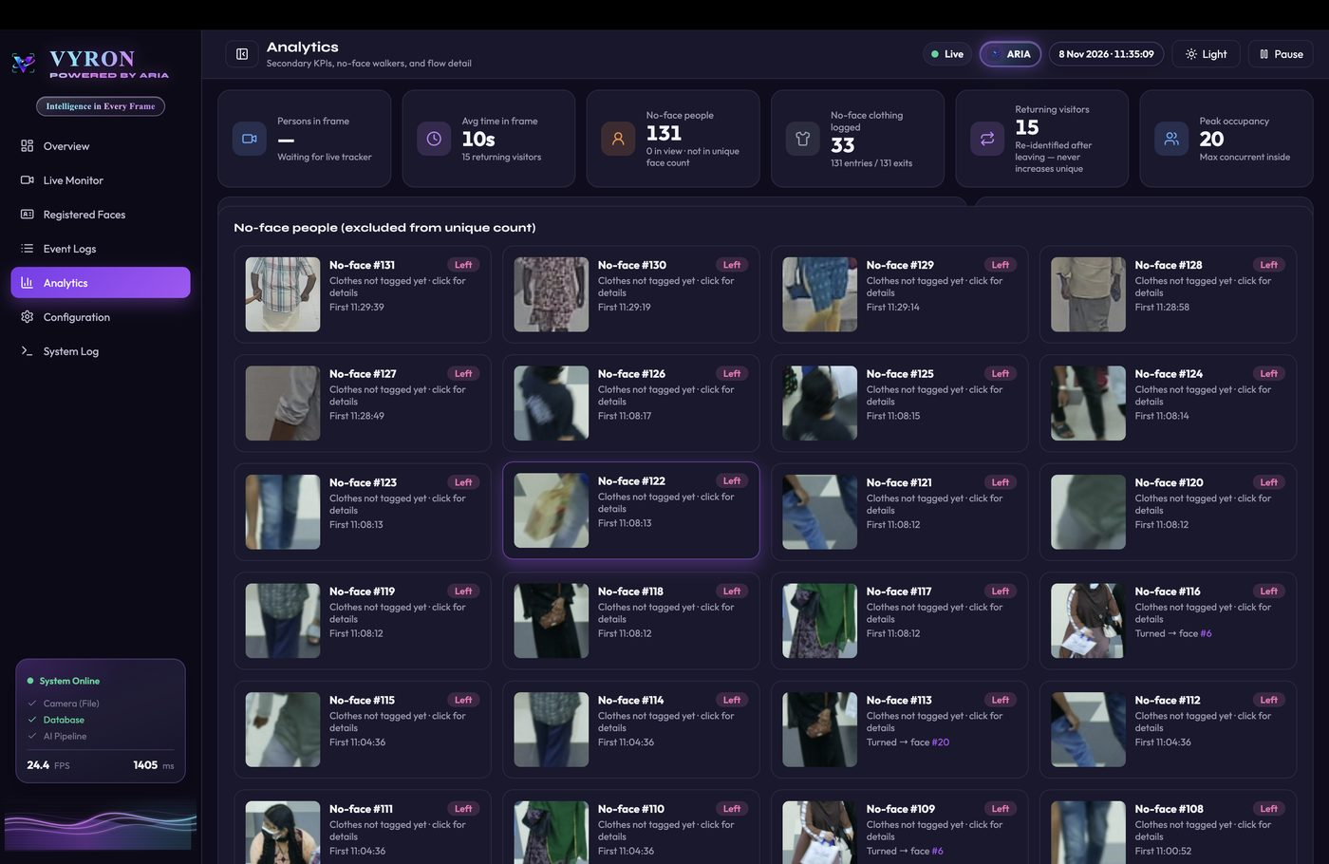

Fig. 12 — Configuration — invariants + count audit
What this shows. Theme / stream sources / invariants, plus Count Audit: DB gallery 54 = Log gallery 54, entries = exits = 114, verdict Consistent. Optional preprocess panel (off in this run).
File: docs/assets/output/12_configuration_audit.png
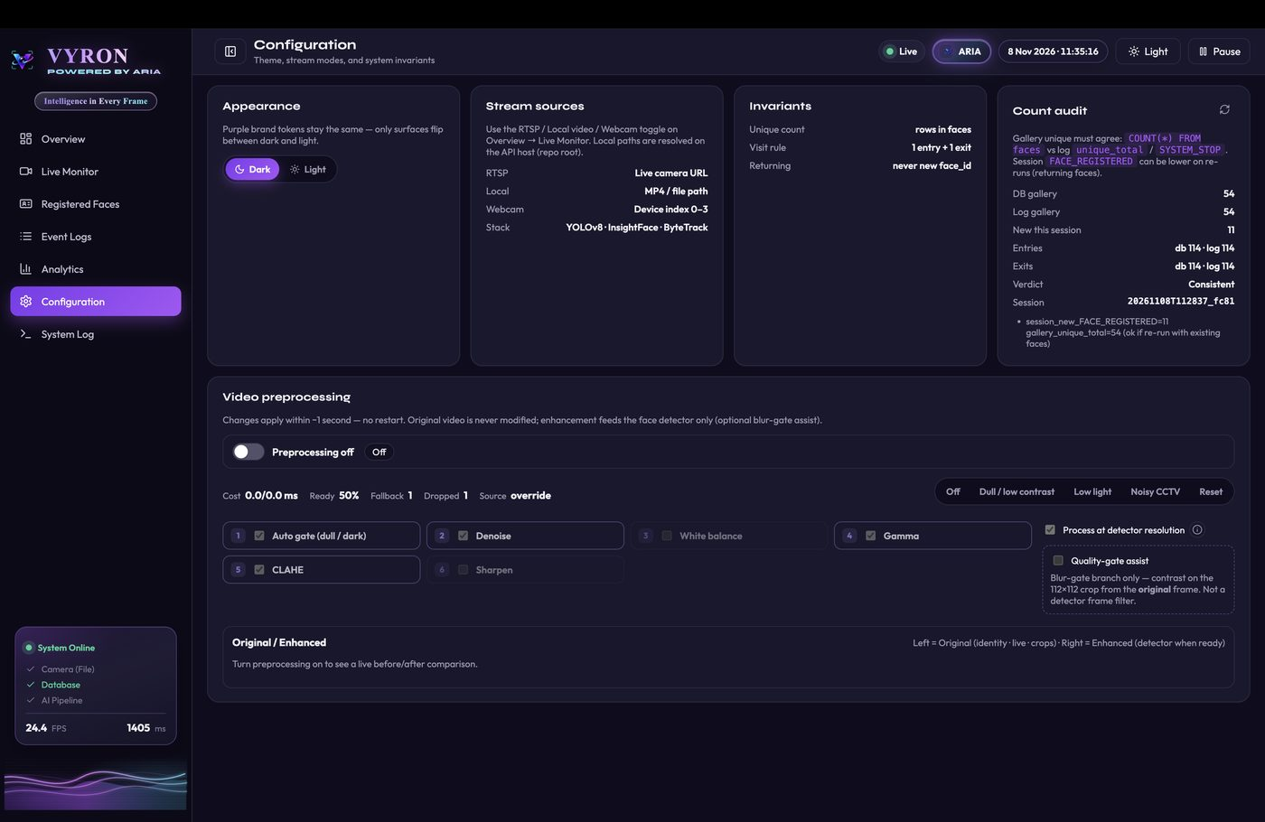

Fig. 13 — System Log — events.log tail
What this shows. Parsed events.log with chips for TRACK_STARTED, FACE_RECOGNIZED, EXIT, etc. Lines include sid, face_id, similarity, and crop paths — same source of truth used by make count.
File: docs/assets/output/13_system_log.png
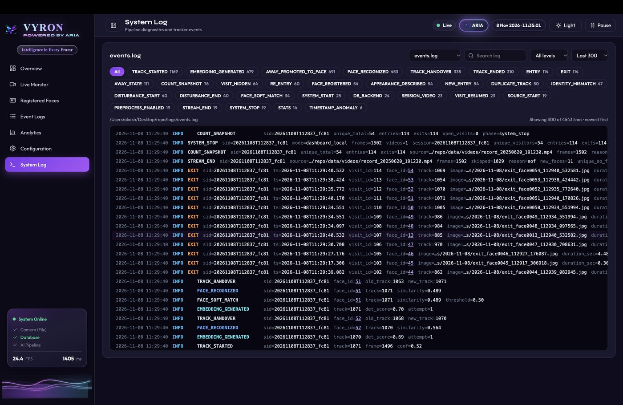
This project is a part of a hackathon run by https://katomaran.com

