Lab 3: Component Modelling & Architectural Pattern Selection
Architectural Style Analysis
Pros: Clear separation of concerns, easy to understand
Cons: Performance overhead, tight coupling between layers, difficult to scale individual components
Suitability for Dropshipping Inventory & Order Orchestrator: Good, but scaling individual services can be difficult

Microservices
Pros: Independent scaling, fault isolation, independent deployment
Cons: Operational complexity, network latency, data consistency challenges
Suitability for Dropshipping Inventory & Order Orchestrator: Highly suitable

Client-Server
Pros: Centralized control, simple deployment, easy data consistency
Cons: Single point of failure, scalability bottleneck, limited fault tolerance
Suitability for Dropshipping Inventory & Order Orchestrator: Less suitable

Architecture Selection & Component Identification
Selected Architecture: Microservices Architecture
Components: 1. Order Manager Component
2. Payment Service Component
3. Inventory Management Component
4. Supplier Management Component
5. Notification Component

UML Diagram
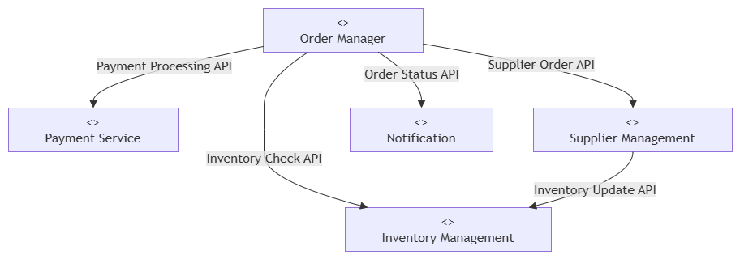

Architecture Selection
We chose Microservices Architecture for the Dropshipping Inventory & Order Orchestrator System.
Architectural Choice:
Microservices Architecture was selected because the system contains multiple independent functions such as order management, payment processing, inventory management, supplier management, and notifications.
Reason 1:
Each service can be developed, deployed, and scaled independently according to its workload.
Reason 2:
Microservices provide fault isolation, so a failure in one supplier or service does not necessarily affect the entire system.
Security Advantage:
Each service can have its own access controls and authentication, reducing unnecessary access between system components.
Performance Benefit:
Individual services can be scaled independently, allowing high-load services such as order and inventory processing to handle more requests efficiently.

