CONTEXT CONSTRUCTION STRATEGIES FOR BIOMEDICAL RETRIEVAL-AUGMENTED GENERATION
An Empirical Study of Chunking and Retrieval Strategies on PubMed
A thesis submitted in partial fulfilment of the requirements for the degree of
Master of Technology in Artificial Intelligence and Machine Learning
by
Akash Ramesh AM.SC.P2AML25002
Under the guidance of
Dr. Aswathy Mohan
Department of Computer Science School of Computing Amrita Vishwa Vidyapeetham, Amritapuri Campus
2026

Certificate
This is to certify that the thesis entitled "Context Construction Strategies for Biomedical Retrieval-Augmented Generation: An Empirical Study of Chunking and Retrieval Strategies on PubMed" submitted by Akash Ramesh (AM.SC.P2AML25002) in partial fulfilment of the requirements for the award of the degree of Master of Technology in Artificial Intelligence and Machine Learning is a bona fide record of the work carried out by him under my supervision and guidance at the Department of Computer Science, School of Computing, Amrita Vishwa Vidyapeetham, Amritapuri Campus.
The contents of this thesis have not been submitted, in full or in part, to any other university or institution for the award of any degree or diploma.
Place: Amritapuri
Date: 19 September 2026
Dr. Aswathy Mohan Project Guide Department of Computer Science
Head of Department Department of Computer Science

Declaration
I, Akash Ramesh (AM.SC.P2AML25002), hereby declare that the thesis entitled "Context Construction Strategies for Biomedical Retrieval-Augmented Generation: An Empirical Study of Chunking and Retrieval Strategies on PubMed" is a record of original work carried out by me under the guidance of Dr. Aswathy Mohan, Department of Computer Science, School of Computing, Amrita Vishwa Vidyapeetham, Amritapuri Campus.
I further declare that this work has not formed the basis for the award of any degree, diploma, associateship, fellowship or other similar title to any candidate of any university. All sources of information and assistance have been acknowledged, and all material quoted or paraphrased from other work has been cited.
Place: Amritapuri
Date: 19 September 2026
Akash Ramesh AM.SC.P2AML25002

Acknowledgements
I express my sincere gratitude to my project guide, Dr. Aswathy Mohan, Department of Computer Science, School of Computing, for her guidance, encouragement and critical feedback throughout this work. Her insistence on rigorous evaluation shaped the statistical design of this study and the way its results are reported.
I thank the Head of the Department and the faculty of the Department of Computer Science, Amrita Vishwa Vidyapeetham, Amritapuri Campus, for providing the academic environment and the review structure within which this project was carried out.
I am grateful to the maintainers of the open-source tools on which this work depends: the Biopython Entrez interface, NLTK, scispaCy, Sentence-Transformers, FAISS, the rouge-score library, statsmodels and Matplotlib. I also acknowledge Cloudflare Workers AI, whose free-tier inference made it possible to complete twelve thousand generation calls without institutional compute funding.
Finally, I thank my family and friends for their patience during the months in which this experiment ran overnight on a laptop.
Akash Ramesh

Abstract
Retrieval-Augmented Generation (RAG) has become the standard architecture for grounding large language model (LLM) answers in external evidence. Every RAG system must first divide its source documents into retrievable units — a step known as chunking — and the size, overlap and segmentation rule chosen at this step determine what the retriever can find and how much text the generator receives. In practice these choices are made by convention: fixed windows of a few hundred tokens, copied from general-purpose tutorials, with an overlap added on intuition. Whether those conventions hold for dense, abbreviation-rich biomedical text has not been tested systematically.
This thesis reports a controlled factorial study of context-construction strategies on a corpus of 981 PubMed abstracts spanning five MeSH-defined disease areas — hypertension, type 2 diabetes, lung neoplasms, COVID-19 and Alzheimer's disease — evaluated against 100 question–answer pairs with reference answers and gold source identifiers. Fifteen chunking conditions were compared: twelve fixed-window configurations formed by crossing three window sizes (128, 256 and 512 words) with four overlap ratios (0%, 10%, 20% and 40%), together with NLTK sentence segmentation, scispaCy biomedical sentence segmentation and embedding-similarity semantic chunking. Each condition was indexed with two embedding models (all-MiniLM-L6-v2 and PubMedBERT) and queried at four retrieval depths (k = 3, 5, 8, 10), with generation held constant using Llama 3.1 8B Instruct at temperature zero. The design yielded 12,000 evaluation runs, each scored on answer relevance, ROUGE-L, faithfulness, retrieval recall, context size and latency.
Three pre-registered hypotheses were tested with two-way ANOVA, Tukey HSD and ANCOVA. H1 (overlap adds no benefit) was supported: overlap had no significant effect on answer quality once window size was controlled (F = 0.59, p = 0.62), and no pairwise contrast between overlap levels was significant. H2 (sentence segmentation matches semantic chunking) was supported: NLTK, scispaCy and semantic strategies were statistically indistinguishable (F = 0.38, p = 0.68), a result that survived controlling for context volume (p = 0.83) and is explained mechanistically by the two sentence segmenters producing identical chunks for 97% of the corpus. H3 (a context-length cliff) was supported in direction but refined in form: answer quality declined monotonically with context size from the smallest contexts tested (r = −0.150, p < 10⁻⁶⁰), with no threshold effect. The dominant factor was window size — 128-word chunks outperformed 256- and 512-word chunks (F = 57.7, p < 10⁻²⁴) — and the biomedical embedding model did not outperform the general-purpose one (p = 0.07), with no chunking × embedding interaction (p = 0.99).
Two further observations shape the interpretation. First, 62.6% of runs ended in a grounded refusal ("insufficient context"), so that aggregate quality scores conflate whether the system answered with how well it answered; the thesis therefore reports answer rate and conditional quality as separate outcomes and finds that larger contexts raise the former while lowering the latter. Second, because PubMed abstracts average 238 words, the sentence, semantic and 512-word conditions all reduce to whole-abstract retrieval; only the 128-word condition sub-divides abstracts, so the observed advantage of small windows is an advantage of sub-document over document-level retrieval units.
The study contributes the first systematic, multi-metric comparison of chunking strategies on PubMed abstracts, the first head-to-head test of NLTK against scispaCy segmentation inside a RAG pipeline, the first test of chunking × embedding interaction on biomedical text, and a refinement of the context-cliff hypothesis. Its practical recommendation for resource-constrained biomedical RAG is direct: use small fixed windows, omit overlap, retrieve fewer chunks, and do not assume that domain-specific segmenters or encoders will pay for themselves.
Keywords: Retrieval-Augmented Generation; chunking; biomedical NLP; PubMed; sentence segmentation; semantic chunking; context length; FAISS; PubMedBERT; evaluation.

Table of Contents

List of Abbreviations
Table 1: Abbreviations used in this thesis.
Abbreviation | Expansion
ANCOVA | Analysis of covariance
ANOVA | Analysis of variance
API | Application programming interface
BERT | Bidirectional Encoder Representations from Transformers
CI | Confidence interval
CPU | Central processing unit
FAISS | Facebook AI Similarity Search
FWER | Family-wise error rate
HSD | Honestly significant difference (Tukey)
IMRAD | Introduction, Methods, Results and Discussion
LCS | Longest common subsequence
LLM | Large language model
MeSH | Medical Subject Headings
MiniLM | all-MiniLM-L6-v2 sentence-embedding model
NLTK | Natural Language Toolkit
PMID | PubMed identifier
QA | Question answering
RAG | Retrieval-Augmented Generation
ROUGE-L | Recall-Oriented Understudy for Gisting Evaluation, longest-common-subsequence variant
SD | Standard deviation
TPD / TPM | Tokens per day / tokens per minute (API quota units)

1 Introduction

1.1 Background
Large language models (LLMs) answer questions fluently, but the knowledge they draw on is frozen at training time, is not attributable to any source, and is not guaranteed to be correct. In domains where a wrong answer has consequences — clinical decision support, drug information, evidence synthesis — none of those properties is acceptable. Retrieval-Augmented Generation (RAG), introduced by Lewis et al. [1], addresses all three at once: rather than answering from parametric memory, the model is first given a set of documents retrieved from a curated knowledge base and instructed to answer only from what it has been shown. The answer becomes grounded in evidence that can be inspected, updated and cited.
A RAG system has two stages. The retrieval stage embeds the user's question into a vector space, searches an index of pre-embedded text units, and returns the most similar ones. The generation stage assembles those units into a context window, prepends the question, and asks an LLM to produce an answer. Almost all attention in the literature has gone to the components at either end — better embedding models, better retrievers, better generators. The step that connects them has received far less: before any of this can happen, the source documents have to be cut into the units that will be embedded, indexed, retrieved and assembled. That step is called chunking, and the family of decisions it involves — how large the units are, whether adjacent units share text, and whether boundaries follow the structure of the text or simply a word count — is what this thesis calls context construction.
Chunking is consequential because it fixes what the retriever can see. If a chunk is too small, the evidence needed to answer a question may be split across two units, and retrieving one without the other yields an incomplete answer. If a chunk is too large, a single unit carries the relevant sentence together with several irrelevant ones, so the retrieval signal is diluted and the generator's context fills with noise. Between those failure modes lies a region in which chunks are small enough to be retrieved precisely and large enough to preserve the evidence a question needs. Where that region lies, and how sensitive downstream answer quality is to landing outside it, is an empirical question — and one whose answer is likely to depend on the kind of text being chunked.

1.2 Motivation
In practice, chunking decisions are rarely made empirically. The dominant pattern in deployed systems is a fixed window of a few hundred tokens with a modest overlap between neighbours, a configuration popularised by the RecursiveCharacterTextSplitter in LangChain [4] and reproduced in tutorials, templates and default settings ever since. Overlap is included because it feels safer: if a fact straddles a boundary, both flanking chunks carry part of it. Window sizes of 256 or 512 tokens are chosen because they are round numbers that fit comfortably in an embedding model's input limit. Neither choice is usually validated on the corpus in question.
Where chunking has been evaluated, the evaluation has been on general-domain text: Wikipedia, news, web crawl, or question-answering benchmarks such as Natural Questions and SQuAD built on top of them [3, 5]. Biomedical text differs from that material in ways that bear directly on chunking. PubMed abstracts are short and dense: a typical abstract of around 240 words reports a study population, an intervention, a comparator, a primary endpoint and a statistical result, often with several named entities per sentence. They use abbreviations — "i.v.", "p.o.", "vs.", "et al." — that a general-purpose sentence tokeniser may misread as sentence terminals, fragmenting the text at exactly the wrong places. And they are structured: most follow an implicit or explicit IMRAD organisation, so that a boundary falling between a Results sentence and its Methods context severs information that a reader would treat as a single unit.
These properties motivate three specific doubts about received chunking practice. First, the benefit of overlap has been argued from intuition rather than measured, and on short, dense abstracts it is not obvious that duplicating boundary text buys anything. Second, the general-purpose sentence tokeniser NLTK punkt [2] is the de facto standard for sentence-boundary chunking, while a biomedical alternative, scispaCy [6], exists and is claimed to handle domain abbreviations correctly — yet the two have never been compared inside a retrieval–generation pipeline on biomedical text. Third, it is well documented on general-domain corpora that answer quality degrades once the context handed to the generator grows past a certain size [20], but whether that degradation follows the same shape, or occurs at the same point, on information-dense biomedical abstracts is unknown.
The practical stakes are not small. A RAG system deployed for clinical question answering that uses an oversized window, an unnecessary overlap and a retrieval depth chosen by habit may be delivering worse answers at higher cost than a simpler configuration would — and nobody would know, because the configuration was never tested against alternatives on the text it actually serves.

1.3 Problem Statement
The retrieval unit in a biomedical RAG system is chosen by convention rather than evidence. Chunk size, overlap and segmentation strategy are all known to affect what the retriever can find and how much text the generator receives, but their effect on answer quality has not been measured systematically on PubMed abstracts, and general-domain findings cannot be assumed to transfer to text that is shorter, denser and more abbreviation-laden than the corpora on which those findings were established.
This thesis addresses that gap with a controlled factorial experiment. The rest of the RAG pipeline — corpus, question set, embedding procedure, retrieval engine, generator and evaluation metrics — is held fixed while chunking strategy, embedding model and retrieval depth are varied, so that any difference in outcome can be attributed to the factors under study.

1.4 Research Questions and Hypotheses
The study is organised around three falsifiable hypotheses, formulated before any results were examined.
H1 — Overlap. Adding overlap between adjacent fixed-window chunks does not improve retrieval or answer quality on biomedical abstracts. The prediction is that, once window size is controlled for, overlap levels of 0%, 10%, 20% and 40% will be statistically indistinguishable.
H2 — Segmentation. Simple sentence-boundary chunking matches embedding-based semantic chunking on biomedical abstracts. The prediction is that NLTK sentence segmentation, scispaCy sentence segmentation and cosine-similarity semantic chunking will not differ significantly in answer quality, and that the biomedical tokeniser will offer no measurable advantage over the general-purpose one.
H3 — Context size. Answer quality degrades as the amount of retrieved context grows. As originally formulated in the literature [20] this was expressed as a threshold — a "context cliff" at roughly 2,500 tokens beyond which quality falls sharply. The hypothesis as tested here is directional: that quality declines with context size, with the shape and location of any threshold left as an empirical question.
Three secondary questions accompany the hypotheses. Does window size itself have an effect, independent of overlap? Does a biomedical embedding model (PubMedBERT) outperform a general-purpose one (MiniLM), and does the choice of embedding model interact with the choice of chunking strategy? And how does retrieval depth k trade off retrieval coverage against context volume?

1.5 Objectives
The objectives of the work were as follows.
- To construct a biomedical evaluation corpus of PubMed abstracts spanning several disease areas, together with a question set carrying reference answers and gold source identifiers.
- To implement a family of chunking strategies — fixed-window at three sizes and four overlap levels, sentence-boundary segmentation with two tokenisers, and semantic chunking — under a common interface so that they can be substituted without changing anything else in the pipeline.
- To build a complete, reproducible RAG pipeline — embedding, indexing, retrieval, generation and evaluation — that runs on CPU-only hardware and free-tier inference, so that the experiment can be repeated without institutional compute.
- To execute a full factorial experiment across chunking condition, embedding model and retrieval depth, with every question evaluated under every combination.
- To test the three hypotheses with appropriate inferential statistics — analysis of variance, Tukey's honestly significant difference procedure for pairwise contrasts, and analysis of covariance to control for context volume — and to report effect sizes alongside significance.
- To translate the findings into practical recommendations for practitioners building biomedical RAG systems under resource constraints.

1.6 Scope and Delimitations
The study is deliberately bounded in several respects, each of which is discussed further in Chapter 5.
The corpus consists of PubMed abstracts, not full-text articles. Abstracts are the unit most biomedical retrieval systems actually index, and they are freely available at scale; but they are short, and — as the results will show — their length interacts with chunk size in ways that constrain what can be concluded about strategies designed for longer documents.
The generator is a single model, Llama 3.1 8B Instruct, held constant at temperature zero across all conditions. This is a deliberate control, not a limitation of interest: the experiment isolates the effect of context construction, and a second generator would have doubled the cost of an experiment already constrained by inference quota. It does mean that findings about how the generator responds to context size are findings about this generator.
Chunking strategies that require an LLM pass over the corpus at index time — proposition-level decomposition in the style of Dense X Retrieval [8], and hierarchical methods such as HiChunk [12] — were designed for inclusion but not executed, because the same inference quota that limited the generator would have had to be spent on chunking. They are treated as related work and future work rather than as conditions.
Finally, the evaluation is fully automatic. Answer quality is measured by ROUGE-L against a reference answer, by embedding similarity between question and answer, and by lexical overlap between answer and context. No human judgement of correctness was collected. Automatic metrics are appropriate for a factorial comparison of this size — twelve thousand runs are beyond what human evaluation could cover — but they measure surface agreement rather than clinical correctness, and the thesis is careful not to claim more than they support.

1.7 Contributions
The thesis makes the following contributions.
- The first systematic, multi-metric comparison of chunking strategies on PubMed abstracts. Fifteen conditions, two embedding models, four retrieval depths and one hundred questions — 12,000 controlled runs — evaluated on six metrics with pre-registered hypotheses and inferential statistics. Prior work has evaluated chunking on general-domain corpora or, in one case, on a small set of clinical questions; no previous study has run a factorial design on biomedical abstracts.
- The first head-to-head comparison of NLTK and scispaCy sentence segmentation inside a RAG pipeline on biomedical text. The comparison is accompanied by a direct measurement of how often the two tokenisers actually disagree on this corpus, which explains the result mechanistically.
- The first test of chunking × embedding-model interaction on biomedical text. The finding — no interaction — means that chunking recommendations derived here do not depend on which embedding model a practitioner uses.
- A refinement of the context-cliff hypothesis. On biomedical abstracts, the relationship between context size and answer quality is a continuous decline from the smallest contexts tested, not a threshold. The thesis also separates two effects that a single averaged metric conflates — the generator's willingness to answer, which rises with context, and the quality of the answers it gives, which falls — and argues that both should be reported.
- A reproducible, zero-cost experimental framework. The entire pipeline runs on a CPU-only laptop and free-tier inference; the corpus, question set, chunk files, indexes, results and analysis scripts are released so that the experiment can be repeated or extended.

1.8 Organisation of the Thesis
Chapter 2 reviews the literature on chunking for RAG — fixed-window, sentence-boundary, semantic, proposition-level, hierarchical and query-adaptive methods — together with work on long-context behaviour in LLMs, biomedical embedding models and RAG evaluation, and closes with a statement of the research gap. Chapter 3 describes the methodology in full: corpus construction, question annotation, each chunking strategy as implemented, embedding and indexing, retrieval, generation, the six evaluation metrics, the factorial design, the statistical analysis plan and the infrastructure on which the experiment ran. Chapter 4 reports the results, beginning with descriptive statistics and the structure of refusals, then testing each hypothesis in turn, followed by the secondary analyses of window size, embedding model, retrieval depth and per-topic robustness. Chapter 5 interprets the results, explains the mechanisms behind them, compares them with prior work, sets out practical recommendations and discusses threats to validity. Chapter 6 concludes and identifies future work. The appendices contain the full per-condition results table, the complete statistical output, sample question–answer pairs, the generator configuration and prompt, the structure of the codebase, and example generated answers.

2 Literature Review
This chapter surveys the work on which the thesis builds. Section 2.1 establishes the RAG paradigm and locates chunking within it. Sections 2.2 to 2.7 review the principal families of chunking strategy in roughly the order in which they entered the literature — fixed-window, sentence-boundary, semantic, LLM-based, hierarchical and query-adaptive, and finally late chunking and contextual retrieval — with attention to what each has been shown to achieve, at what cost, and on which kinds of text. Section 2.8 reviews what is known about how LLMs behave as context grows, the basis of the third hypothesis. Section 2.9 turns to the biomedical domain specifically: the one prior chunking study on clinical text, and the case for domain-adapted embedding models. Section 2.10 reviews how RAG systems are evaluated. Section 2.11 synthesises the review into a statement of the research gap that the experiment addresses.

2.1 Retrieval-Augmented Generation
Lewis et al. [1] introduced RAG as a way to combine a dense passage retriever with a sequence-to-sequence generator so that the generator conditions on retrieved evidence rather than on parametric memory alone. The original formulation treated the retriever and generator as jointly trainable, but the pattern that has become dominant in practice is simpler: a frozen embedding model indexes a corpus, a nearest-neighbour search returns the top-k units for a query, and a frozen LLM is prompted with the query and the retrieved units concatenated into a context window. This "frozen RAG" configuration requires no training, works with any generator exposed through an API, and is the configuration studied here.
Within that configuration, the corpus must be divided into units before it can be indexed. Lewis et al. used 100-word passages of Wikipedia, a choice inherited from the dense passage retrieval work that preceded them and adopted without evaluation of alternatives. The choice matters because the retrieval unit is simultaneously the unit of embedding, of ranking and of context assembly: it determines what a single vector represents, what a single search hit returns, and how much text each hit contributes to the generator's input. A large body of subsequent work has examined retrievers and generators; the unit itself has been examined far less.

2.2 Fixed-Window Chunking and the Overlap Question
Fixed-window chunking partitions a document into segments of a specified length — measured in characters, words or subword tokens — with an optional overlap between adjacent segments. It requires no linguistic analysis, behaves identically on any language, and runs in negligible time. The RecursiveCharacterTextSplitter in LangChain [4] popularised the pattern in 2022 and it has since become the default in most open-source RAG implementations. Window sizes of 128, 256 and 512 tokens recur across the literature [3, 5]; overlaps of 10–20% of the window are typical.
The theoretical case for overlap is that semantically related content may straddle a boundary; if adjacent chunks share text, both flanks carry partial evidence from the boundary region and the retriever has two chances to find it. The empirical case is weaker than the theoretical one. Śmigielski et al. [3], in the most comprehensive recent benchmark, find that fixed-window chunking at 512 tokens with a 50-token overlap is the most robust configuration across eight datasets — but they do not isolate the overlap from the window size, so the contribution of the overlap itself cannot be read from their result. Earlier observations on Natural Questions suggest that overlap adds little on short factoid queries, but that finding has not been tested on text where cross-sentence evidence is common.
Biomedical abstracts are precisely such text. A drug may be named in one sentence and its adverse effect reported in the next; an effect size may appear in one sentence and its confidence interval in the following one. If overlap has value anywhere, it should have value here. This is the basis for treating H1 as a genuine test rather than a foregone conclusion: the general-domain prior is that overlap does little, but the biomedical prior points the other way.
Qu et al. [5] provide the most directly relevant evidence on window size. Comparing fixed and semantic chunking across document types, they find that the advantage of content-aware splitting is largest on long documents with coherent topical sections and shrinks to within noise on short texts. They note explicitly that on abstracts — texts of a few hundred words — a well-tuned fixed splitter may be as good as anything more elaborate. That observation motivates including several window sizes in the present design: on short documents, window size may matter more than segmentation method.

2.3 Sentence-Boundary Segmentation
Sentence-boundary chunking uses detected sentence boundaries as candidate split points, either treating each sentence as a unit or accumulating sentences until a target length is reached. Its advantage over fixed windows is that it never cuts mid-sentence, so predicate–argument structure survives. Its risk is tokeniser error: a false boundary produces a degenerate fragment, and a missed boundary produces an oversized unit.
NLTK's punkt tokeniser [2] is the most widely used sentence segmenter in English NLP. It is an unsupervised model that learns abbreviation lists and collocation statistics from training text, and its distributed model was trained on general-domain material. Applied to biomedical prose, it encounters abbreviations — "i.v.", "p.o.", "vs.", "et al.", "Fig." — that are rare or absent from its training data, and the concern raised repeatedly in the applied literature is that it will over-segment at these tokens, producing fragments such as "Patients received 10 mg metformin i." and "v." that carry no retrievable meaning.
scispaCy [6], developed at the Allen Institute for AI, provides a spaCy pipeline trained on biomedical corpora including MedMentions and BC5CDR. Its sentence segmentation is dependency-parse-based and is claimed to respect domain abbreviations and to handle structured abstract headings correctly. Whether that claimed advantage translates into better retrieval and better answers is the open question that H2 addresses. No prior study has compared the two tokenisers under identical retrieval–generation conditions on PubMed text.
It is worth noting a structural feature of sentence-accumulation chunkers that becomes important in Chapter 5: when the target chunk length is comparable to the length of the documents being chunked, the accumulator may absorb an entire document into a single chunk before the target is reached. On a corpus of short abstracts, a sentence chunker with a 256-word target is therefore largely a whole-document chunker with occasional splits.

2.4 Semantic and Embedding-Based Chunking
Semantic chunking replaces the fixed-length rule with a data-driven boundary criterion: adjacent text units are embedded, and a split is inserted wherever the cosine similarity between neighbouring embeddings falls below a threshold θ. A sharp drop in similarity is taken to signal a topic transition. The idea has a long ancestry — Hearst's TextTiling [7] used lexical-cohesion valleys for the same purpose in 1997 — and has been reformulated for dense embeddings in several open-source frameworks, the most common implementation using all-MiniLM-L6-v2 at θ ≈ 0.75.
Śmigielski et al. [3] evaluate several semantic variants, including recursive semantic splitting, sequential hierarchical agglomerative clustering, a max–min criterion that maximises minimum within-chunk similarity, and GraphSeg, which partitions a sentence-similarity graph into communities. Their findings are consistent: recursive semantic splitting matches the best fixed-window baseline on dense-retrieval benchmarks at two to three orders of magnitude greater processing time; on literary text (GutenQA) it gains 4–6 F1 points over fixed windows, and on short factoid QA (Natural Questions) the gain disappears. The graph-based variants, which require pairwise similarity across all sentences and scale quadratically, do not outperform the recursive method. The authors' conclusion — that chunking complexity should be matched to document complexity — is the general-domain prior behind H2: on short abstracts, semantic chunking is not expected to beat simpler methods.
Qu et al. [5] reach the same conclusion from a different direction, asking directly whether semantic chunking is worth its computational cost and finding that it is only on long, topically structured documents.
An aspect of semantic chunking that has not been studied is the interaction between the embedding model used to segment and the one used to retrieve. If both share a representation space, split points align with retrieval-relevant features; if they differ — MiniLM to segment, PubMedBERT to retrieve — boundaries may be placed suboptimally for the retrieval task. The present design embeds every condition, including the semantic one, with both retrieval models, and so provides a first observation of this cross-model effect.

2.5 LLM-Based Chunking: Propositions, Boundary Detection and Granularity Routing
A more recent family uses an LLM at index time to decide how text should be divided. Chen et al. [8] proposed Dense X Retrieval, in which a document is decomposed by an LLM into atomic propositions — minimal, self-contained factual statements — each embedded and indexed separately; at query time, retrieved propositions are re-expanded to their surrounding passage before generation. The claim is that proposition-level indexing raises retrieval precision by removing noise from co-located but irrelevant sentences, and the original paper reports gains on factoid QA.
The cost is severe. Śmigielski et al. [3] reproduce Dense X and report processing times exceeding fifteen hours per dataset, against under a second for fixed windows; on five of eight datasets the method fails outright through API timeouts or memory exhaustion, and where it completes it does not consistently beat fixed windows. LumberChunker [9], which uses an LLM to detect semantic-shift points rather than to decompose sentences, times out on several datasets and performs comparably to recursive semantic chunking where it finishes. Both methods require one or more LLM calls per document, which makes them sensitive to rate limits, pricing and the non-determinism of the chunking model.
Meta-Chunking [10] and Mix-of-Granularity [11] represent a second direction. Meta-Chunking assigns boundary probabilities from the perplexity gradient of a small language model and merges chunks dynamically at query time; it gains 6.2 accuracy points over fixed windows on the RULER long-document benchmark, evaluated on general-domain corpora. Mix-of-Granularity trains a router to send factoid queries to proposition-level units, thematic queries to sentence-level units and survey queries to paragraph-level units, and improves on any single granularity — but the router must be trained on domain-specific data, an obstacle for zero-shot biomedical deployment.
Proposition-level chunking was included in the original design of this study and a decomposer was implemented. It was not executed, because the inference quota it would have consumed — one LLM call per abstract across 981 abstracts — was the same quota on which the twelve thousand generation calls depended. The benchmark evidence reviewed here suggests the omission is unlikely to have changed the conclusions: on short documents, proposition decomposition has not been shown to outperform fixed windows even where it completes.

2.6 Hierarchical and Query-Adaptive Chunking
Lu et al. [12] name the tension that runs through all of the above: small chunks give high retrieval precision but insufficient context for generation; large chunks give context but dilute the retrieval signal. HiChunk resolves it by modelling document hierarchy explicitly. A fine-tuned Qwen3-4B assigns each segment to a structural level (section, paragraph, clause), and an Auto-Merge retrieval step promotes clusters of matched fine-grained chunks to their coarser parent before generation. On the evidence-dense task of the authors' HiCBench benchmark, HiChunk with Auto-Merge reaches 81.0% evidence recall against 72.1% for 200-token fixed windows; on the evidence-sparse task the gap narrows to about three points. Processing costs roughly 5.75 seconds per document, which is tractable on CPU for a corpus of a thousand abstracts but still requires a fine-tuned model that may not transfer to abstract-only text.
Rastogi's Query-Adaptive Semantic Chunking (QASC) [13] departs from every method above by moving chunking from index time to query time: candidate sentences are scored against the query, seed sentences above a threshold are identified, and a window of neighbouring sentences is assembled around each seed. On 100 technical documents and 200 queries of four types, QASC reports F1 = 0.85, a relative improvement of 18–27% over fixed chunking and 8–12% over semantic and agentic alternatives, corroborated by a three-annotator human evaluation. The cost is that no static index can be built: every query scans every document. For the present design — 100 questions × 15 conditions × 4 depths × 2 encoders — that would mean hundreds of thousands of full-corpus scans, and the method has not been evaluated on biomedical text.
These methods define the frontier of the field and the direction it is moving: from choosing one granularity, to preserving structure, to choosing granularity per query. They also define what this thesis does not do. The experiment reported here is a controlled comparison of static strategies, intended to establish which of the simpler methods works on biomedical abstracts before more elaborate ones are considered. The literature above supplies the reason that ordering is sensible: elaborate methods have repeatedly failed to beat simple ones on short documents.

2.7 Late Chunking and Contextual Retrieval
Two further techniques improve chunk embeddings rather than chunk boundaries. Late chunking [14] reverses the conventional order: the whole document is passed through a long-context encoder first, and per-token representations that already carry document-level context are then pooled into chunks post hoc. Contextual retrieval [16] prepends to each chunk a short LLM-generated description situating it within its source document before embedding, so that entity mentions and pronominal references can be resolved.
Merola and Singh [15] evaluate both in a common framework on NFCorpus (a biomedical retrieval collection) and MS MARCO. Late chunking with Jina-V3 reaches NDCG@5 = 0.309 on NFCorpus, narrowly below contextual retrieval at 0.317; late chunking is cheaper but behaves inconsistently across encoders, improving with long-context models and degrading with short-context ones. Contextual retrieval combined with BM25 fusion and a cross-encoder reranker gives the best scores in their study but requires one LLM call per chunk and roughly 20 GB of GPU memory for the context-generation step. Neither technique was feasible within the compute constraints of this study, and neither addresses the boundary question that the hypotheses target; they are noted here as the natural next step once boundaries are settled.

2.8 Long-Context Behaviour in Language Models
The third hypothesis descends from a body of work on how LLMs use long inputs. Liu et al. [20], in the study from which the phrase "lost in the middle" comes, show that performance on multi-document QA depends strongly on where in the context the relevant passage sits: models are best when it is at the beginning or end and markedly worse when it is in the middle, and the degradation grows with context length. Shi et al. [17] show, separately, that LLMs are easily distracted by irrelevant material in the prompt — adding unrelated sentences to an arithmetic problem lowers accuracy — even when the model is capable of solving the problem in isolation.
Together these findings establish that more context is not automatically better: past some point, adding retrieved units adds distraction faster than it adds evidence. In the applied RAG literature this has been summarised as a "context cliff" at roughly 2,500 tokens on general-domain corpora, beyond which answer quality falls sharply. Whether that summary transfers to biomedical abstracts is unclear on two counts. Abstracts are denser than Wikipedia paragraphs — a 250-word abstract may carry as much distinct information as a 600-word encyclopaedia section — so if attention is limited by information rather than by word count, the cliff might come earlier. Conversely, IMRAD structure may give the generator anchors that let it locate relevant content in longer contexts, pushing the cliff later. H3 was formulated to find out; the result, reported in Chapter 4, is that on this corpus the relationship is not a cliff at all.

2.9 Chunking and Retrieval in the Biomedical Domain

2.9.1 Evidence density
Clinical and biomedical text has a property that general-domain chunking benchmarks do not exercise: evidence density. A single abstract reporting a randomised trial may state the intervention, comparator, primary endpoint, hazard ratio, confidence interval and p-value in two consecutive sentences. A boundary between those sentences leaves each chunk technically relevant but individually insufficient. Lu et al. [12] operationalise this concern in HiCBench's evidence-dense task and show that the gap between fixed and hierarchical chunking is largest there.

2.9.2 The one prior clinical study
Gomez-Cabello et al. [18] report what is, to the best of this author's knowledge, the only published chunking comparison on medical text. They compare an adaptive method that adjusts chunk boundaries by medical-entity density against a fixed-window baseline on physician-validated clinical questions, and report answer accuracy of 87% for the adaptive method against 13% for the baseline. The magnitude of that gap far exceeds anything reported on general-domain benchmarks and would, if it generalised, indicate that biomedical text poses a fundamentally different retrieval problem. The result is important for this thesis in two ways. It is the closest prior work, and the present study's findings — that simple fixed windows perform well and that sophisticated segmentation does not help — point the other way. Chapter 5 takes up the comparison directly; the short version is that the two studies differ in corpus, question type, generator and metric, and that both may be right about the text they studied.

2.9.3 Domain-adapted embedding models
Most chunking studies use general-purpose encoders — BERT-base, all-MiniLM-L6-v2, GTE, E5 — for both segmentation and retrieval. In biomedical NLP, models pretrained from scratch on PubMed text have consistently outperformed general BERT on named-entity recognition, relation extraction and question answering. Gu et al. [19] established this with PubMedBERT, and the NeuML pubmedbert-base-embeddings variant adapts the encoder for dense retrieval by contrastive fine-tuning on biomedical query–passage pairs, producing 768-dimensional vectors against MiniLM's 384. The expectation in the field is that these representations capture drug–gene–disease relations more faithfully and should retrieve biomedical passages better.
Whether that advantage persists across chunking strategies is unknown, and there is a plausible argument that it might not be uniform: a domain encoder might matter more for fragmented chunks, where biomedical co-reference is needed to infer relevance, than for coherent ones, where both encoders agree. That possibility — a chunking × embedding interaction — has not been tested in any published study, and its presence or absence determines whether chunking recommendations can be stated independently of encoder choice.

2.10 Evaluating RAG Systems
A RAG system can fail at retrieval, at generation, or at the interface between them, and a single end-to-end score cannot say which. The evaluation literature has therefore converged on measuring several properties separately.
Retrieval is assessed by whether the units returned contain the evidence a question needs — recall at k against annotated gold sources, or ranking measures such as MRR and nDCG where relevance grades are available. Answer quality is assessed against a reference answer, most commonly with ROUGE [21], whose longest-common-subsequence variant ROUGE-L rewards in-order overlap without requiring contiguous n-grams and is the standard for generated text with a reference. Relevance — whether the answer addresses the question at all — is assessed by embedding similarity between question and answer. Faithfulness — whether the answer is supported by the retrieved context rather than by the generator's own knowledge — is assessed by the proportion of answer content that can be located in the context; the RAGAS framework [22] formalises this as a claim-level check with an LLM judge, and a cheaper lexical approximation measures token-level precision of answer against context. Efficiency is assessed by context size and latency.
Two properties of these metrics matter for what follows. First, reference-based metrics such as ROUGE-L measure surface agreement with one reference phrasing, not correctness; two correct answers phrased differently score differently. Second, gold-source recall depends entirely on how gold sources were annotated. If each question is annotated with a single source but several documents in the corpus state the same fact, recall penalises the retriever for finding a correct source that is not the annotated one. The present study encountered exactly this, and Chapter 4 quantifies it.

2.11 Synthesis and Research Gap
Table 2.1 summarises the strategies reviewed by boundary criterion, cost, the document types on which they have been shown to work, and whether they have been validated on biomedical text.
Table 2.1: Chunking strategies surveyed, by boundary criterion, cost and validation status.
Method | Boundary criterion | Cost per document | Shown to work on | Biomedical validation | Refs
Fixed window | Word/token count | O(1) | General; short docs | Partial | [3, 5]
Sentence – NLTK | punkt boundaries | O(n) | General | None | [2]
Sentence – scispaCy | Dependency parse | O(n) | — | None in RAG | [6]
Semantic (cosine θ) | Embedding similarity drop | O(n·d) | Long, topical docs | None | [3, 5, 7]
Proposition (Dense X) | LLM decomposition | O(n)·LLM | Factoid QA | None | [3, 8]
LumberChunker | LLM shift detection | O(n)·LLM | Long narrative | None | [3, 9]
Meta-Chunking | Perplexity gradient | O(n)·LM | Long docs (RULER) | None | [10]
Mix-of-Granularity | Trained router | O(n)·LLM | Mixed query types | None | [11]
HiChunk | LLM hierarchy + Auto-Merge | O(n)·LLM | Evidence-dense docs | None | [12]
QASC | Query-time seeding | O(n·q) per query | Technical docs | None | [13]
Late chunking | Post-hoc pooling | O(n·d) | Long docs | Partial (NFCorpus) | [14, 15]
Contextual retrieval | LLM prefix per chunk | O(n)·LLM | Precision-sensitive | Partial (NFCorpus) | [15, 16]
Adaptive (entity density) | Medical entity density | O(n) | Clinical QA | One study | [18]

Three patterns emerge. Cost and performance do not scale together: the cheapest method is also the most robust across datasets, and the most expensive methods fail on several. Performance depends on document type: methods that help on long, structured documents help little or not at all on short ones. And almost none of this has been established on biomedical text — one study, on a different kind of clinical text with a different design, is the sum of the domain-specific evidence.
Table 2.2 states the specific open questions.
Table 2.2: Open questions addressed by, or delimited from, the present study.
Research axis | General-domain status | Biomedical status
Overlap in fixed windows | Studied on NQ, SQuAD, not isolated from window size | Not evaluated on PubMed
NLTK vs biomedical sentence segmenter | NLTK is the de facto standard | scispaCy exists; never benchmarked in RAG
Sentence vs semantic chunking | Comparable on short documents | Unknown on ~240-word abstracts
Window size on short documents | Suggested to dominate segmentation method | Not tested
Context-length effect | Position and length effects established; "cliff" at ~2,500 tokens | Shape and location unknown on dense text
Embedding × chunking interaction | Not studied | Not studied
LLM-based chunking at scale | Fails or times out on several benchmarks | Not evaluated

The first six rows are the gap this thesis addresses: a controlled, multi-metric comparison of fixed-window, sentence-boundary and semantic chunking on PubMed abstracts, across two embedding models and four retrieval depths, with hypotheses about overlap, segmentation and context size stated in advance. The seventh row — LLM-based chunking — is delimited from the study for the cost reasons the review has documented, and is returned to in Chapter 6.

3 Methodology

3.1 Overview of the Experimental Design
The study is a controlled factorial experiment. A single RAG pipeline — corpus, question set, embedding procedure, retrieval engine, generator and evaluation — is held fixed, and three factors are varied: the chunking condition (15 levels), the embedding model (2 levels) and the retrieval depth k (4 levels). Every one of the 100 questions is evaluated under every combination of factor levels, giving 15 × 2 × 4 × 100 = 12,000 runs, with exactly 800 runs per chunking condition. Because nothing else changes between conditions, any systematic difference in outcome is attributable to the factors under study.
Figure 3.1 shows the eight phases of the pipeline. Phases 1–4 are executed once and produce static artefacts — the corpus, the question set, fifteen sets of chunks and thirty FAISS indexes. Phases 5–7 are executed once per run. Phase 8 is executed once on the full results file.
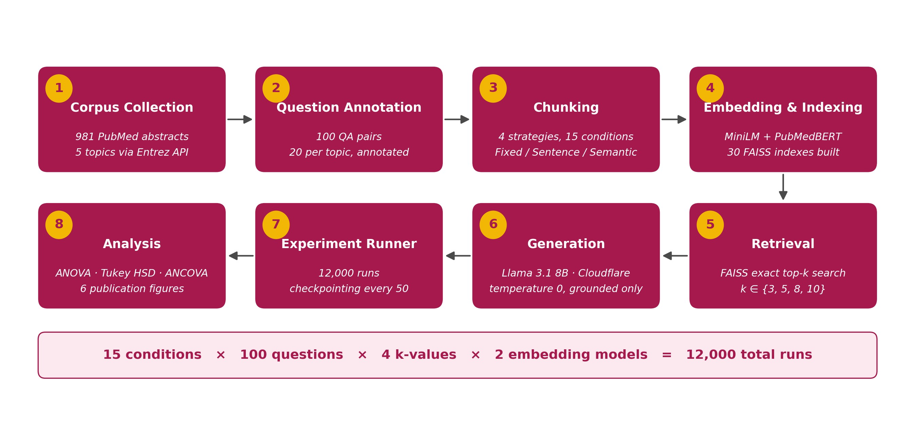
Figure 3.1: The eight-phase experimental pipeline. Phases 1–4 build static artefacts; phases 5–7 run 12,000 times; phase 8 runs once.
The experiment was organised in two parts. Part A evaluated the twelve fixed-window conditions and tests H1 (overlap) and the window-size question. Part B evaluated the three segmentation strategies against the best fixed-window condition identified in Part A, and tests H2. H3 (context size) is tested on the pooled results of both parts, since context volume varies across every condition and depth. The Part A anchor was selected by mean ROUGE-L across all 800 of its runs; the selection was made after Part A completed and before Part B began.

3.2 Corpus Construction

3.2.1 Source and topics
The corpus consists of PubMed abstracts retrieved through the NCBI Entrez API using the Biopython interface [27]. Five disease areas were chosen to span chronic cardiovascular disease, metabolic disease, oncology, infectious disease and neurodegeneration, and each was defined by a MeSH-tagged query so that topic membership rests on curated indexing rather than free-text matching. The queries were:
- hypertension[MeSH] AND (treatment OR pathophysiology OR epidemiology)
- type 2 diabetes mellitus[MeSH] AND (management OR complications OR therapy)
- lung neoplasms[MeSH] AND (diagnosis OR treatment OR prognosis)
- COVID-19[MeSH] AND (clinical features OR treatment OR outcomes)
- Alzheimer disease[MeSH] AND (pathology OR biomarkers OR treatment)
Two hundred records were requested per topic. Records without an abstract were discarded, yielding 981 abstracts (Table 3.1). For each record the PMID, title, abstract text, MeSH descriptor list and topic label were stored.
Table 3.1: Corpus composition by topic.
Topic | MeSH query root | Abstracts
Hypertension | hypertension | 200
Diabetes Mellitus, Type 2 | diabetes | 190
Lung Neoplasms | lung_cancer | 196
COVID-19 | covid19 | 199
Alzheimer Disease | alzheimers | 196
Total |  | 981

3.2.2 Corpus statistics
Abstracts average 238.2 words (SD 79.6; median 238; range 52–903), for a total of 233,668 words. The length distribution is the single most important property of the corpus for interpreting the results: a 256-word window covers the majority of abstracts entirely, and a 512-word window covers all but a handful. Section 3.4 returns to this when describing how many chunks each strategy actually produced.

3.2.3 Question set
One hundred question–answer pairs were constructed, twenty per topic. Each pair consists of a question, a reference answer of one or two sentences, and a gold source PMID. Questions were written to be answerable from the kind of clinical fact that appears in abstracts — first-line therapies, diagnostic thresholds, mechanisms of action, pathological hallmarks, common presentations — and reference answers were written as a domain reader would expect them to be stated. Questions average 11.8 words; reference answers average 29.7 words (range 16–47).
Gold source PMIDs were assigned by an automated procedure: for each question, the corpus was searched for the abstract with the greatest overlap between question keywords and abstract text within the question's topic, and that abstract's PMID was recorded. Ninety-six questions were matched this way; four questions for which no abstract exceeded the keyword threshold were assigned a representative abstract from the topic. Each question therefore carries exactly one gold PMID. This single-source design is the simplest possible annotation and was chosen for feasibility; its consequences for the retrieval-recall metric are quantified in Chapter 4 and discussed in Chapter 5. Table 3.2 shows one question from each topic.
Table 3.2: One question–answer pair from each topic.
ID | Topic | Question | Reference answer
HYP_001 | hypertension | What are the first-line antihypertensive drug classes recommended for uncomplicated hypertension? | First-line antihypertensive agents include thiazide diuretics, calcium channel blockers, ACE inhibitors, and angiotensin receptor blockers (ARBs).
DIA_001 | diabetes | What is the mechanism of action of metformin in type 2 diabetes management? | Metformin primarily acts by inhibiting hepatic gluconeogenesis via activation of AMP-activated protein kinase (AMPK), reducing fasting plasma glucose without causing weight gain or hypoglycaemia.
LCA_001 | lung_cancer | What are the most common histological subtypes of non-small cell lung cancer? | The most common histological subtypes of non-small cell lung cancer are adenocarcinoma, squamous cell carcinoma, and large cell carcinoma, with adenocarcinoma being the most prevalent subtype worldwide.
COV_001 | covid19 | What are the most common clinical symptoms of COVID-19 at initial presentation? | The most common symptoms of COVID-19 at presentation include fever, cough, fatigue, and dyspnoea; other frequent symptoms include headache, myalgia, anosmia, and ageusia, with severity ranging from mild illness to critical respiratory failure.
ALZ_001 | alzheimers | What are the two main pathological hallmarks of Alzheimer's disease? | The two main pathological hallmarks of Alzheimer's disease are extracellular amyloid-beta plaques formed from aggregated amyloid precursor protein cleavage products, and intraneuronal neurofibrillary tangles composed of hyperphosphorylated tau protein.

3.3 Chunking Strategies
All chunkers expose the same interface: given an abstract's text and PMID, return a list of chunk records, each carrying the chunk text, its word count, its source PMID, its position within the abstract and the condition key. This uniformity is what allows the retrieval, generation and evaluation stages to be identical across conditions. Word counts throughout are whitespace-token counts — the text is split on whitespace and each resulting token counts as one word. The window sizes 128, 256 and 512 are therefore word counts, not subword-token counts; at roughly 1.3 subword tokens per English word they correspond to approximately 170, 340 and 680 model tokens.

3.3.1 Fixed-window chunking
The fixed-window chunker slides a window of chunk_size words across the abstract with a step of chunk_size − overlap words, where overlap = chunk_size × overlap_pct / 100. The final window is truncated at the end of the abstract. Three window sizes (128, 256, 512 words) were crossed with four overlap percentages (0%, 10%, 20%, 40%) to give the twelve conditions shown in Figure 3.2. At 128 words, the four overlaps correspond to 0, 12, 25 and 51 shared words between neighbours; at 512 words, to 0, 51, 102 and 204.
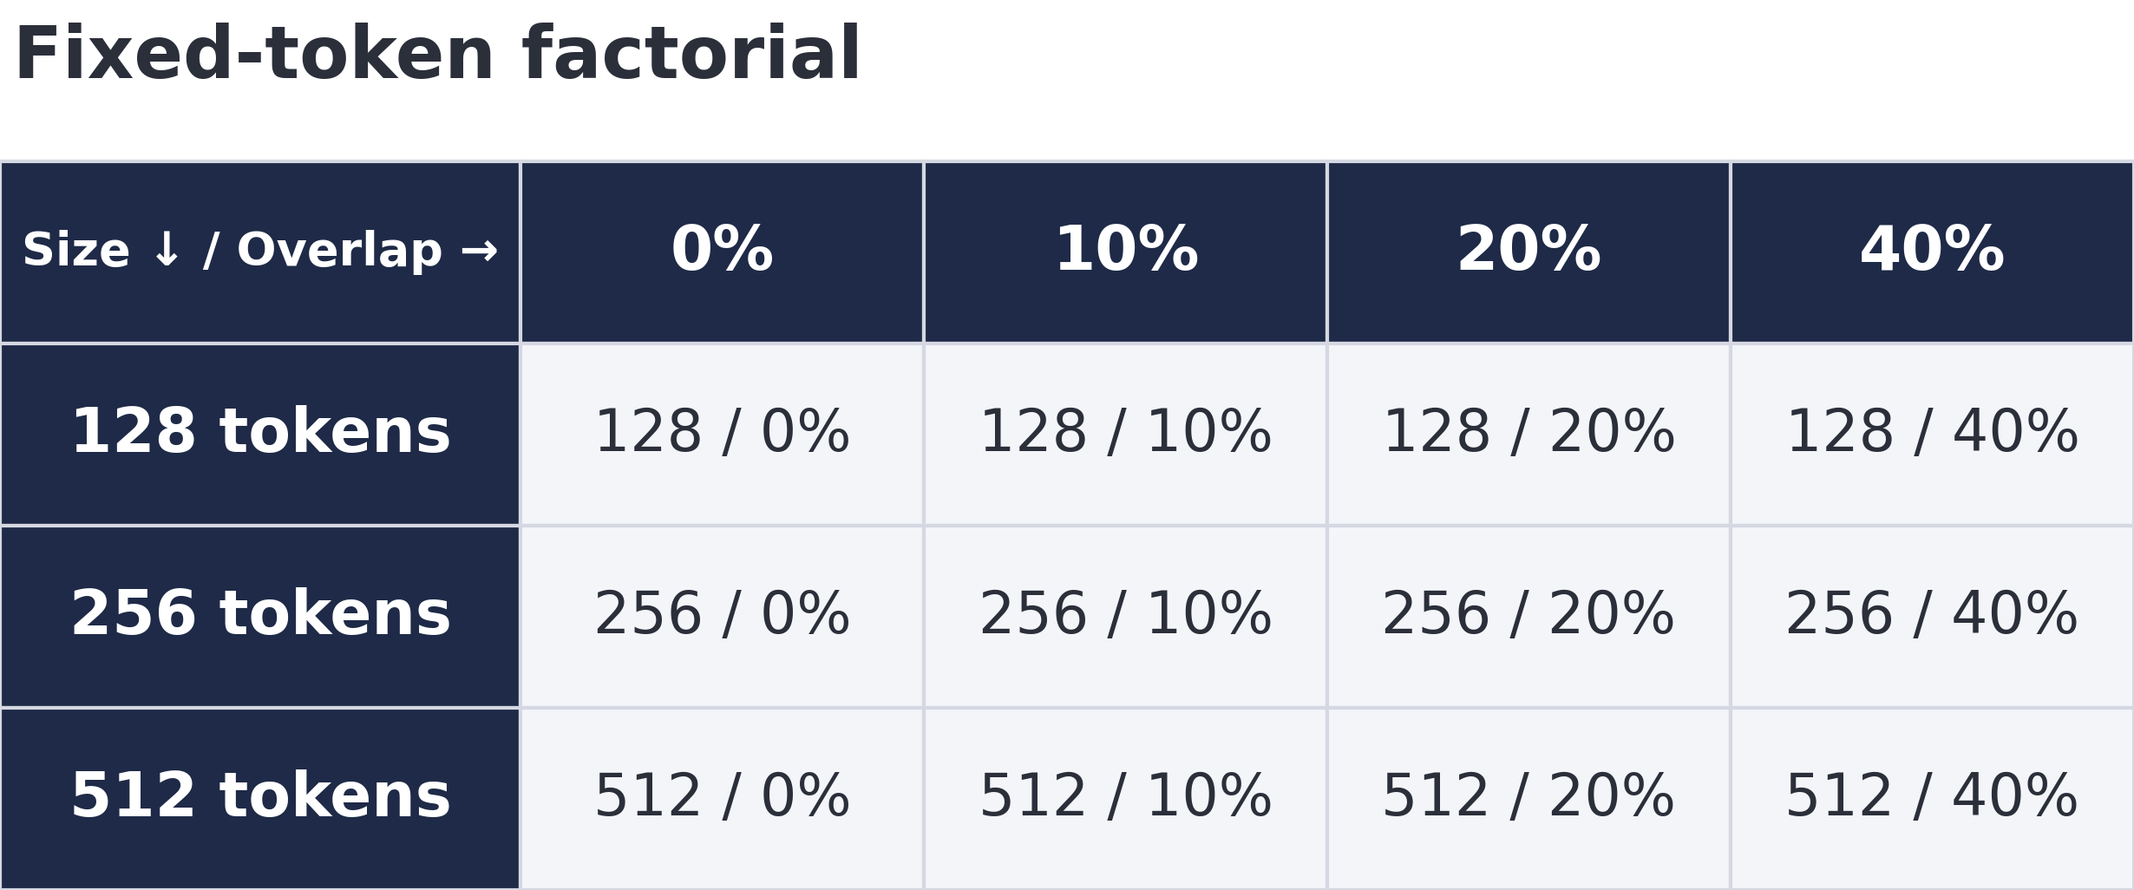
Figure 3.2: The twelve fixed-window conditions: three window sizes crossed with four overlap ratios.

3.3.2 Sentence-boundary chunking
Two sentence chunkers share identical accumulation logic and differ only in the tokeniser that supplies sentence boundaries. The text is segmented into sentences; sentences are appended to a buffer until the buffer's word count reaches a target of 256 words, at which point the buffer is emitted as a chunk; the last sentence of the emitted chunk is carried forward as the start of the next buffer, giving a one-sentence overlap between consecutive chunks; and any sentences remaining at the end of the abstract are emitted as a final chunk. The 256-word target was chosen to match the middle fixed-window size so that sentence and fixed chunks would be comparable in length.
The NLTK variant (sent_nltk) uses the punkt sentence tokeniser [2] with its distributed English model. The scispaCy variant (sent_scispacy) uses the en_core_sci_sm model [6] with the named-entity, tagger and lemmatiser components disabled, so that only the dependency-parse-based sentence segmenter runs.

3.3.3 Semantic chunking
The semantic chunker (semantic) segments the abstract into sentences using scispaCy, embeds each sentence with all-MiniLM-L6-v2, and computes the cosine similarity between each consecutive pair of sentence embeddings. A chunk boundary is inserted wherever that similarity falls below a threshold of 0.75; sentences on the same side of every boundary are concatenated into one chunk. Chunk length is therefore not controlled — it is whatever the similarity structure of the abstract produces. The threshold follows the most widely used open-source implementation of the method and the value cited by Śmigielski et al. [3].

3.3.4 Proposition chunking (designed, not executed)
A proposition chunker was implemented that would send each abstract to an LLM with an instruction to decompose it into self-contained atomic facts, one per line, following Chen et al. [8]. It was not run. Decomposing 981 abstracts requires 981 LLM calls with input and output of a few hundred tokens each — approximately 700,000 tokens — which exceeded the daily free-tier quota of every provider used and would have competed directly with the 12,000 generation calls on which the experiment depended. The condition is excluded from every analysis in this thesis and is discussed as future work.

3.4 Chunk Statistics
Table 3.3 reports, for each of the fifteen conditions, the number of chunks produced from the 981 abstracts, the mean number of chunks per abstract, and the distribution of chunk lengths.
Table 3.3: Chunk statistics for the fifteen conditions applied to the 981-abstract corpus.
Condition | Chunks | Chunks / abstract | Mean words | SD | Min | Max
Fixed 128 / 0% | 2293 | 2.34 | 101.9 | 39.5 | 1 | 128
Fixed 128 / 10% | 2415 | 2.46 | 103.9 | 37.0 | 13 | 128
Fixed 128 / 20% | 2564 | 2.61 | 106.6 | 33.0 | 26 | 128
Fixed 128 / 40% | 2879 | 2.93 | 114.8 | 22.1 | 52 | 128
Fixed 256 / 0% | 1323 | 1.35 | 176.6 | 84.4 | 1 | 256
Fixed 256 / 10% | 1326 | 1.35 | 182.7 | 76.0 | 26 | 256
Fixed 256 / 20% | 1332 | 1.36 | 188.9 | 67.9 | 52 | 256
Fixed 256 / 40% | 1354 | 1.38 | 200.7 | 54.1 | 52 | 256
Fixed 512 / 0% | 984 | 1.00 | 237.5 | 77.1 | 18 | 512
Fixed 512 / 10% | 984 | 1.00 | 237.6 | 77.0 | 52 | 512
Fixed 512 / 20% | 984 | 1.00 | 237.8 | 77.1 | 52 | 512
Fixed 512 / 40% | 985 | 1.00 | 238.1 | 77.1 | 52 | 512
Semantic | 1240 | 1.26 | 196.2 | 92.0 | 5 | 512
Sentence–NLTK | 1329 | 1.35 | 183.0 | 83.3 | 4 | 303
Sentence–scispaCy | 1329 | 1.35 | 183.0 | 83.3 | 5 | 303

Two features of this table govern the interpretation of every result that follows.
First, only the 128-word window sub-divides abstracts to any meaningful degree. At 128 words the corpus yields 2,293–2,879 chunks, or 2.3–2.9 per abstract. At 256 words it yields about 1.35 per abstract — most abstracts fit in one window, and only those above 256 words are split. At 512 words every abstract fits in a single window: all four 512-word conditions produce 984 or 985 chunks from 981 abstracts, one per abstract with a handful of exceptions for the longest records, and their mean chunk length (237.5–238.1 words) is simply the mean abstract length. The "512-word" condition is, on this corpus, whole-abstract retrieval, and the four overlap levels at 512 words are four copies of the same segmentation.
Second, the sentence and semantic strategies also operate at close to whole-abstract granularity. The 256-word accumulation target is longer than most abstracts, so the sentence chunkers emit 1.35 chunks per abstract — the same figure as the 256-word fixed window — and the semantic chunker emits 1.26. The three "advanced" strategies and the 256-word fixed window are therefore all variants of near-whole-abstract retrieval, differing in where the occasional boundary falls.
The two sentence chunkers produced identical chunk counts (1,329) and identical mean lengths (183.0 words), which prompted a direct comparison: of the 1,329 chunks, 1,291 (97.1%) are character-for-character identical between the NLTK and scispaCy conditions, and 38 differ. On this corpus the two tokenisers disagree on the boundaries of fewer than 3% of chunks. This measurement was made after chunking and before any generation run, and it is reported here rather than in the results because it is a property of the materials, not of the experiment's outcome; its implication for H2 is drawn out in Chapter 5.
Figure 3.3 plots chunks per abstract for all fifteen conditions against the one-chunk-per-abstract line.
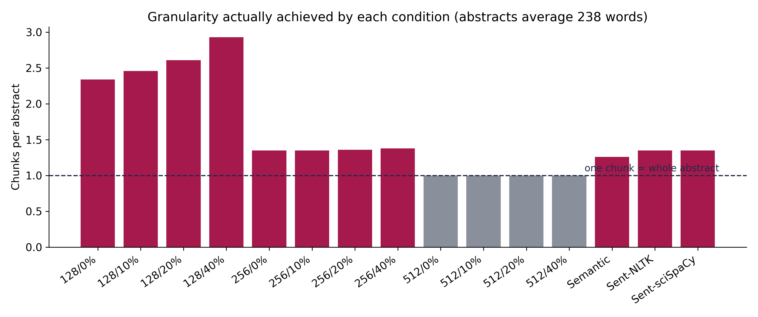
Figure 3.3: Chunks per abstract achieved by each condition. Only the 128-word windows sub-divide abstracts substantially; every other condition sits close to one chunk per abstract.

3.5 Embedding and Indexing

3.5.1 Embedding models
Every chunk set was embedded twice, once with each of two sentence-embedding models.
all-MiniLM-L6-v2 [25] is a six-layer general-purpose sentence encoder producing 384-dimensional vectors, trained on over one billion sentence pairs drawn from general web and QA sources. It is the most widely used encoder in open-source RAG and the default in most tutorials.
NeuML/pubmedbert-base-embeddings is a 768-dimensional encoder built on PubMedBERT [19], which was pretrained from scratch on PubMed abstracts and PubMed Central full text, and subsequently fine-tuned contrastively on biomedical query–passage pairs for dense retrieval. It represents the domain-adapted alternative.
Both models were run through the Sentence-Transformers library [25] on CPU with L2 normalisation applied to every output vector, so that the inner product of two vectors equals their cosine similarity. Queries were embedded with the same model as the index they were searched against.

3.5.2 Indexing
For each of the 15 × 2 = 30 (condition, model) pairs, a FAISS [26] IndexFlatIP index was built over the normalised chunk vectors and written to disk together with a metadata file mapping index positions back to chunk records. IndexFlatIP performs exhaustive inner-product search; with normalised vectors this is exact cosine-similarity retrieval, with no approximation and no tuning parameters. Exactness was preferred over speed because index sizes (984–2,879 vectors) are small enough that exhaustive search completes in milliseconds, and because approximate indexes introduce a source of variance unrelated to the factors under study.

3.6 Retrieval
For a run at retrieval depth k, the question is embedded with the run's embedding model, the corresponding index is searched, and the k highest-scoring chunks are returned with their similarity scores and source PMIDs. Four depths were tested: k ∈ {3, 5, 8, 10}. No re-ranking, query expansion, hybrid lexical search or deduplication was applied; the retrieved set is exactly the top-k by cosine similarity.
Because chunk lengths differ across conditions, the same k delivers different amounts of text: at k = 5, the 128-word conditions deliver roughly 500 words of context while the 512-word conditions deliver roughly 1,200. This is intentional — k is the practitioner's control, and the experiment measures what happens when it is held constant across strategies — but it means that strategy comparisons at fixed k are confounded with context volume. Section 3.9 describes how that confound is handled statistically.

3.7 Generation

3.7.1 Generator
All answers were produced by Llama 3.1 8B Instruct [24], served through Cloudflare Workers AI. The generator was held constant across every run: the same model, the same system prompt, temperature 0.0, and a maximum output length of 512 tokens. Temperature zero makes decoding greedy and therefore deterministic, so that the same context always yields the same answer and differences between runs are attributable to the context and not to sampling.

3.7.2 Prompt
The system prompt instructs the model to answer only from the supplied context and to decline when the context is insufficient:
You are a precise biomedical assistant. Answer the question using ONLY the provided context. If the context does not contain enough information to answer, say 'Insufficient context.' Do not use external knowledge.
The user message concatenates the retrieved chunks, each prefixed with a source label, followed by the question:
Context: [Source 1] {chunk 1 text}
>
[Source 2] {chunk 2 text} … Question: {question}
The explicit permission to refuse is a design decision with consequences examined at length in Chapter 4. Without it, a model asked a question whose answer is not in the context will typically answer anyway from parametric memory, and the resulting answer cannot be attributed to the retrieval. With it, a refusal is an observable outcome that carries information about the context — and the proportion of refusals becomes a measurement in its own right.

3.7.3 Infrastructure
Generation ran on two Cloudflare Workers AI free-tier accounts, each allowing 10,000 "neurons" of inference per day — approximately 1,500 runs at the observed average context size. The experiment runner was sharded by chunking condition so that the two accounts could work through disjoint halves of the design simultaneously, and was made resumable: results were appended to a single file with a checkpoint every fifty runs, each run was keyed by its (question, condition, model, k) tuple so that completed runs were skipped on restart, and sustained API failure — the signature of an exhausted daily quota — caused a clean abort with all buffered results flushed to disk. Under these arrangements the 12,000 runs completed over several daily quota cycles at no cost. Part A completed on 7 August 2026 and Part B on 8 August 2026. Earlier attempts using the Groq and Google Gemini free tiers were abandoned after both exhausted their daily token allowances within hours; those runs were discarded and every result reported here was generated by the Llama 3.1 8B configuration described above.

3.8 Evaluation Metrics
Six quantities were recorded for every run. Four measure quality; two measure cost.
Answer relevance. The cosine similarity between the embedding of the question and the embedding of the generated answer, computed with the run's embedding model. It measures whether the answer is about the question, independently of correctness. Range [−1, 1]; in practice values near zero or below indicate an answer that does not engage with the question, such as a refusal.
ROUGE-L F1. The F-measure of the longest common subsequence between the generated answer and the reference answer [21], computed with Porter stemming. If LCS is the length of the longest common subsequence, P = LCS / |answer| and R = LCS / |reference|, ROUGE-L is 2PR / (P + R). It is the primary quality metric: it rewards answers that reproduce the reference's content in order without requiring identical wording, and it is the standard reference-based measure for generated text. Range [0, 1].
Faithfulness. The proportion of distinct alphanumeric tokens in the answer that also appear in the concatenated retrieved context: |tokens(answer) ∩ tokens(context)| / |tokens(answer)|. It is a lexical approximation to the claim-level faithfulness of RAGAS [22] and detects answers that introduce material not present in the context. Range [0, 1]. A refusal scores low because the words "insufficient context" rarely appear in the context.
Retrieval recall. The proportion of the question's gold PMIDs whose abstracts contributed at least one retrieved chunk. Since every question has exactly one gold PMID, this is binary: 1 if any retrieved chunk came from the annotated source, 0 otherwise. It measures the retriever, not the generator.
Context words. The total word count of the concatenated retrieved chunks — the amount of text the generator received, and the independent variable for H3. Reported in words; approximate model-token counts are obtained by dividing by 0.75.
Latency. Wall-clock milliseconds from dispatch of the generation request to receipt of the answer. Because generation was served remotely, this includes network time and reflects the service's load as well as the context size; it is reported as a cost indicator, not as a precise measurement of compute.

3.8.1 The refusal outcome
The prompt permits the generator to answer "Insufficient context," and it frequently does. Every such answer scores near zero on ROUGE-L, relevance and faithfulness — not because the generator failed, but because it correctly declined. A condition's mean ROUGE-L is therefore a mixture of two things: how often it produced an answer at all, and how good the answers were when it did. Averaging them together hides which of the two is driving a difference.
The analysis accordingly treats refusal as a distinct outcome. For every condition and factor level, two quantities are reported: the answer rate (the proportion of runs that produced a substantive answer) and the conditional quality (mean ROUGE-L over answered runs only), alongside the unconditional mean. A run is classified as a refusal if its answer contains the phrase "insufficient context" (case-insensitive), which captures both the bare phrase and the explained refusals in which the model states what the context did and did not contain.

3.9 Statistical Analysis
All tests were two-sided at α = 0.05 and were specified before results were examined. ROUGE-L is the dependent variable for hypothesis tests unless stated otherwise.
H1 was tested with a two-way analysis of variance on the 9,600 Part A runs, with window size (3 levels) and overlap (4 levels) as factors. The test of interest is the main effect of overlap after window size is accounted for. Pairwise contrasts between overlap levels were tested with Tukey's HSD, which controls the family-wise error rate across all six pairwise comparisons. Partial η² is reported as the effect size.
H2 was tested with a one-way ANOVA across the three segmentation strategies (NLTK, scispaCy, semantic) on their 2,400 runs, with Tukey HSD contrasts. Because the strategies deliver different context volumes at the same k, the comparison was repeated as an analysis of covariance with context words as a covariate, so that the strategy effect is estimated at matched context size. A four-group ANOVA including the Part A anchor was also run to place the strategies relative to the best fixed window.
H3 was tested on all 12,000 runs by the Pearson and Spearman correlations between context size (in approximate tokens) and ROUGE-L, supplemented by a binned analysis in which runs were grouped into seven context-size bands and the mean of each band was inspected for the presence of a threshold. The correlation was also computed on answered runs only, to separate the effect of context on conditional quality from its effect on answer rate.
Secondary analyses. The window-size main effect from the H1 model was followed with Tukey contrasts between sizes. The embedding models were compared with Welch's t-test on ROUGE-L and on recall. The chunking × embedding interaction was tested by adding an interaction term to a two-way ANOVA over all fifteen conditions and both models. Per-topic robustness was assessed by repeating the window-size comparison within each topic and by a one-way ANOVA across topics.
With 800 runs per condition, the design has power above 0.99 to detect a difference in mean ROUGE-L of 0.03 between any two conditions at the observed within-condition standard deviation of approximately 0.135. Null results in this thesis are therefore interpretable as evidence that any effect present is smaller than that, not as failures to detect.
All analyses were performed in Python 3.12 with pandas, SciPy and statsmodels; the analysis script is included in the released code.

3.10 Data Integrity
Before analysis, the results file was checked for rows with no generator response (identifiable by a latency of zero, since latency is recorded only on a successful response), blank answers, duplicate run keys, and metric values outside their valid ranges. None were found in the final 12,000-row file. During execution, transient API failures had at one point been recorded as rows carrying the refusal phrase as a fallback value; the generator was modified to raise an exception on failure so that no row is written at all, and every row in the final file corresponds to a completed generation call.

3.11 Reproducibility
The pipeline runs end-to-end on a CPU-only laptop with 8 GB of memory. The corpus, question set, chunk files, indexes, the complete results file, the statistics file from which every table in this thesis is generated, and all scripts — collection, annotation, chunking, indexing, the experiment runner, the analysis, and the figure and table generators — are released. The only external dependency at run time is an inference endpoint serving Llama 3.1 8B Instruct; any provider serving the same weights with greedy decoding should reproduce the answers.

4 Results
This chapter reports the outcome of the 12,000 runs. Section 4.1 gives the overall picture and the per-condition results table. Section 4.2 examines the refusal outcome, which shapes the interpretation of everything after it. Sections 4.3 to 4.5 test the three hypotheses. Sections 4.6 to 4.9 report the secondary analyses — window size, embedding model and interaction, retrieval depth, and per-topic robustness. Section 4.10 quantifies the divergence between retrieval recall and answer quality, and Section 4.11 summarises the findings. Every number in this chapter is drawn from the statistics file generated from the results by the released analysis script; the complete per-condition table and the full statistical output are reproduced in Appendices A and B.

4.1 Overall Results
All 12,000 runs completed: 15 conditions × 100 questions × 4 retrieval depths × 2 embedding models, with exactly 800 runs per condition. Across the full set, the mean ROUGE-L was 0.098, mean answer relevance 0.387, mean faithfulness 0.465 and mean retrieval recall 0.259. The mean context delivered to the generator was 1,131 words (approximately 1,500 model tokens); the median generation latency was 585 ms.
Those aggregate figures are low, and the reason is the subject of Section 4.2: 7,510 of the 12,000 runs (62.6%) ended with the generator declining to answer. Restricted to the 4,490 runs that produced a substantive answer, mean ROUGE-L was 0.198 — twice the unconditional figure.
Table 4.1 reports every condition. Conditions are listed alphabetically; the best and worst are identified below the table.
Table 4.1: Results for all fifteen conditions (800 runs each). "ROUGE-L (all)" is the unconditional mean; "ROUGE-L (answered)" is the mean over runs that produced a substantive answer.
Condition | Answer rate | ROUGE-L (all) | ROUGE-L (answered) | Relevance | Faithfulness | Recall | Context words | Latency (ms)
Fixed 128 / 0% | 34.5% | 0.126 | 0.224 | 0.458 | 0.465 | 0.275 | 677 | 976
Fixed 128 / 10% | 34.0% | 0.124 | 0.227 | 0.451 | 0.452 | 0.259 | 682 | 977
Fixed 128 / 20% | 35.6% | 0.114 | 0.222 | 0.415 | 0.435 | 0.286 | 711 | 993
Fixed 128 / 40% | 36.3% | 0.107 | 0.224 | 0.389 | 0.420 | 0.264 | 754 | 936
Fixed 256 / 0% | 37.9% | 0.104 | 0.208 | 0.391 | 0.472 | 0.258 | 1106 | 1218
Fixed 256 / 10% | 36.5% | 0.101 | 0.204 | 0.379 | 0.456 | 0.255 | 1121 | 1162
Fixed 256 / 20% | 40.0% | 0.116 | 0.204 | 0.443 | 0.503 | 0.258 | 1170 | 1285
Fixed 256 / 40% | 39.9% | 0.113 | 0.217 | 0.415 | 0.495 | 0.266 | 1264 | 1411
Fixed 512 / 0% | 40.6% | 0.087 | 0.174 | 0.380 | 0.496 | 0.250 | 1470 | 925
Fixed 512 / 10% | 38.5% | 0.084 | 0.177 | 0.366 | 0.484 | 0.256 | 1472 | 933
Fixed 512 / 20% | 35.8% | 0.074 | 0.174 | 0.329 | 0.462 | 0.256 | 1478 | 884
Fixed 512 / 40% | 39.8% | 0.082 | 0.177 | 0.354 | 0.488 | 0.251 | 1482 | 892
Semantic | 37.4% | 0.079 | 0.181 | 0.339 | 0.452 | 0.250 | 1256 | 782
Sentence–NLTK | 36.6% | 0.081 | 0.187 | 0.341 | 0.443 | 0.253 | 1163 | 936
Sentence–scispaCy | 38.0% | 0.084 | 0.184 | 0.357 | 0.457 | 0.254 | 1164 | 823

The best condition by unconditional ROUGE-L was Fixed 128 / 0% at 0.126; the worst was Fixed 512 / 20% at 0.074. The full ordering places all four 128-word conditions and two of the 256-word conditions in the top six, all four 512-word conditions in the bottom four, and the three segmentation strategies between the 256- and 512-word groups. That ordering is the descriptive form of the two main findings — window size dominates, and the segmentation strategies do not separate from each other — which the hypothesis tests below examine formally.

4.2 The Refusal Outcome

4.2.1 Prevalence
The generator answered "Insufficient context" — either as the bare phrase or followed by an explanation of what the context lacked — in 7,510 runs. Of these, 5,948 were the bare phrase and 1,562 were explained refusals. Every refusal is a genuine generation: all 7,510 carry a non-zero latency, none is an API failure, and the explained refusals describe the retrieved context accurately (examples in Appendix F).
A refusal rate of 62.6% is high, and it is a finding about the retrieval, not the generator. Table 4.2 compares the runs that refused with those that answered.
Table 4.2: Mean metrics for answered and refused runs.
Metric | Answered runs | Refused runs
ROUGE-L | 0.198 | 0.039
Answer relevance | 0.737 | 0.178
Faithfulness | 0.869 | 0.224
Retrieval recall | 0.404 | 0.173
Context words | 1190 | 1096

Refused runs retrieved the gold source less than half as often as answered runs (recall 0.173 against 0.404) while receiving nearly as much context (1,096 against 1,190 words). The generator declined because the context it was shown did not contain the answer — which is what the prompt instructed it to do — and it did so in proportion to how often retrieval missed. Faithfulness among answered runs was 0.869, meaning that when the generator did answer, 87% of the distinct tokens in its answer could be located in the retrieved text.

4.2.2 Structure of refusals across factors
Figure 4.1 shows how refusal rate varies with the three design factors.
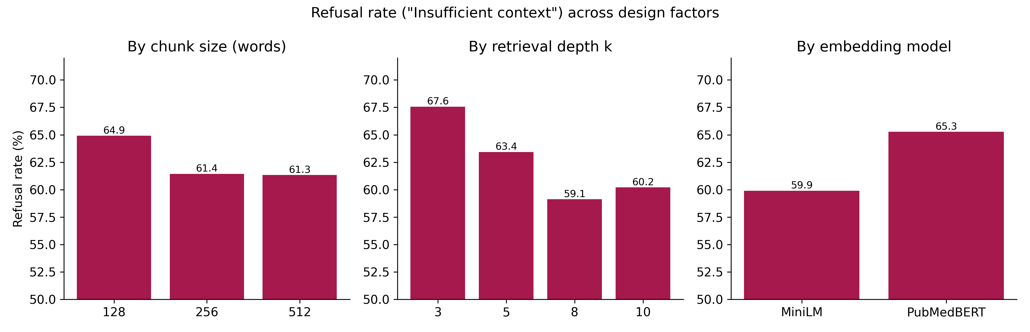
Figure 4.1: Refusal rate across window size, retrieval depth and embedding model.
Refusal decreases as the window grows (64.9% at 128 words, 61.4% at 256, 61.3% at 512) and as retrieval depth grows (67.6% at k = 3, 63.4% at k = 5, 59.1% at k = 8, 60.2% at k = 10). Both gradients run in the expected direction: more retrieved text means more chance that the answer is somewhere in it. The embedding models differ by more than either of the other factors — MiniLM refused 59.9% of the time and PubMedBERT 65.3% — which is examined in Section 4.7.
Refusal also varies substantially by topic (Table 4.3): from 51.2% for Alzheimer's disease to 70.8% for type 2 diabetes. Topic is not a manipulated factor, but the variation shows that some question sets were harder to ground in this corpus than others, and Section 4.9 checks whether the main effects hold within each.
Table 4.3: Refusal rate by topic.
Topic | Refusal rate
Alzheimer's disease | 51.2%
Lung cancer | 58.0%
COVID-19 | 65.0%
Hypertension | 67.9%
Type 2 diabetes | 70.8%

4.2.3 Consequence for the analysis
Because refusals score near zero on every quality metric, a condition's unconditional mean is dominated by its refusal rate. Two conditions with identical answer quality but different refusal rates will show different means; two with the same mean may differ in opposite directions on rate and quality. All results below therefore report the unconditional mean (which is what a deployed system's user experiences), the answer rate, and the conditional mean over answered runs, and note where the three disagree.

4.3 H1: Overlap Adds No Benefit
H1 predicts that adding overlap between adjacent fixed-window chunks does not improve retrieval or answer quality once window size is controlled.

4.3.1 Descriptive results
Table 4.4 reports the 9,600 Part A runs grouped by overlap level, pooling across window sizes.
Table 4.4: Part A results by overlap ratio, pooled over window sizes (2,400 runs per level).
Overlap | n | Answer rate | ROUGE-L (all) | ROUGE-L (answered) | Recall | Faithfulness | Context words
0% | 2400 | 37.7% | 0.106 | 0.201 | 0.261 | 0.478 | 1084
10% | 2400 | 36.3% | 0.103 | 0.202 | 0.257 | 0.464 | 1092
20% | 2400 | 37.1% | 0.102 | 0.200 | 0.267 | 0.467 | 1120
40% | 2400 | 38.6% | 0.101 | 0.206 | 0.260 | 0.467 | 1166

Unconditional ROUGE-L is flat: 0.106, 0.103, 0.102, 0.101 for 0%, 10%, 20% and 40% overlap. Conditional ROUGE-L is flatter still: 0.201, 0.202, 0.200, 0.206. Answer rate moves by two percentage points in no consistent direction. Retrieval recall — the metric that overlap is theoretically supposed to improve, by giving the retriever two chances at boundary-spanning evidence — is 0.261, 0.257, 0.267, 0.260: no trend. Context volume rises modestly with overlap (1,084 to 1,166 words), as it must, since overlapping chunks are larger; the generator received about 8% more text at 40% overlap for no change in any outcome.
Figure 4.2 plots ROUGE-L and answer rate against overlap separately for each window size.
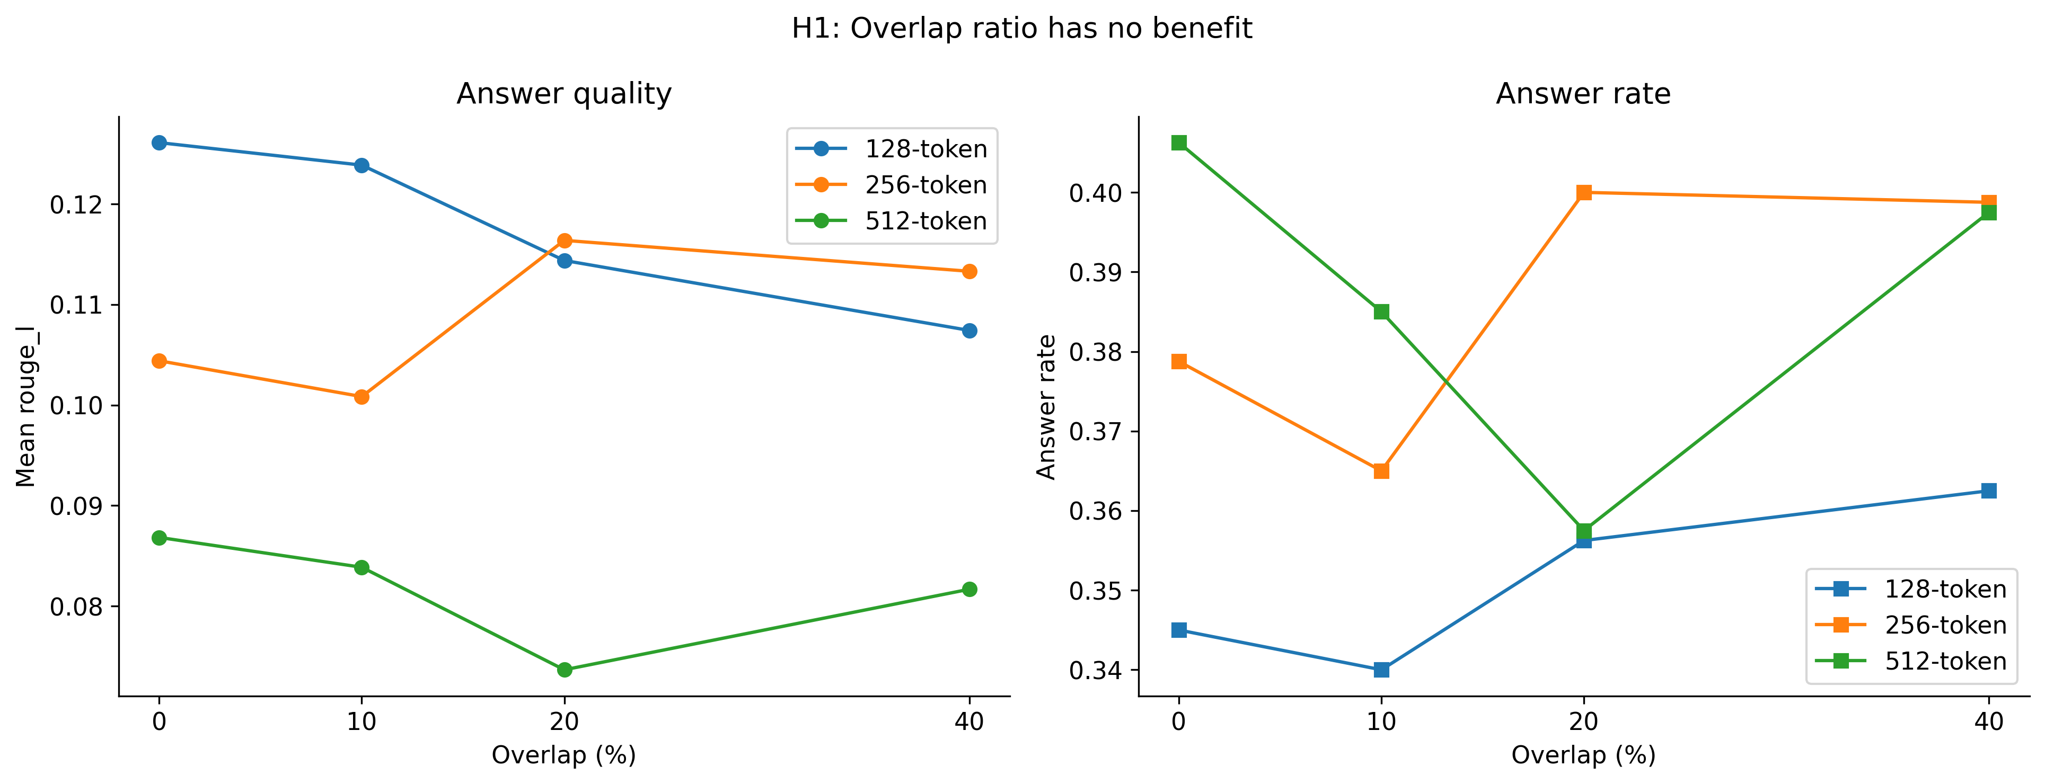
Figure 4.2: Overlap ratio against ROUGE-L (left) and answer rate (right), by window size. No consistent slope at any size.
Within each window size the lines are essentially horizontal. The 512-word conditions deserve a separate comment. As Section 3.4 showed, all four are the same segmentation for every abstract shorter than 512 words — which is nearly all of them — so their retrieved contexts are identical for most runs, and their ROUGE-L means (0.087, 0.084, 0.082, 0.074) have no relationship to overlap. Their spread is instead an empirical measurement of run-to-run noise. Pairing the 512 / 0% and 512 / 10% conditions run by run, 738 of 800 pairs received context of identical size; of those, 306 (41%) nonetheless produced different answer text, with a mean absolute ROUGE-L difference of 0.047 per pair. The generator was run at temperature zero, but the remote inference service did not return bit-identical outputs for identical inputs. The consequence for the analysis is a known noise floor: the range across four near-replicate conditions is 0.013 ROUGE-L, so differences between conditions smaller than roughly 0.01–0.015 cannot be distinguished from serving non-determinism, whereas the window-size differences of Section 4.6 (0.027–0.036) lie well outside it. Section 5.6 returns to this as a threat to validity.

4.3.2 Inferential test
A two-way ANOVA on ROUGE-L with window size and overlap as factors gives the result in Table 4.5.
Table 4.5: Two-way ANOVA on ROUGE-L for the Part A runs.
Source | Sum of squares | df | F | p | Partial η²
Window size | 2.297 | 2 | 57.72 | 1.2 × 10⁻²⁵ | 0.0119
Overlap | 0.035 | 3 | 0.587 | 0.623 | 0.0002
Residual | 190.857 | 9,594

The main effect of overlap is not significant (F(3, 9594) = 0.587, p = 0.623). Its partial η² of 0.0002 means that overlap accounts for two hundredths of one per cent of the variance in ROUGE-L. Tukey HSD contrasts between every pair of overlap levels are reported in Table 4.6.
Table 4.6: Tukey HSD contrasts between overlap levels on ROUGE-L (FWER = 0.05).
Comparison | Mean diff. | Adj. p | 95% CI lower | 95% CI upper | Significant
0% vs 10% | -0.0029 | 0.892 | -0.0134 | 0.0076 | No
0% vs 20% | -0.0043 | 0.720 | -0.0148 | 0.0062 | No
0% vs 40% | -0.0050 | 0.617 | -0.0155 | 0.0055 | No
10% vs 20% | -0.0014 | 0.987 | -0.0119 | 0.0091 | No
10% vs 40% | -0.0021 | 0.959 | -0.0126 | 0.0085 | No
20% vs 40% | -0.0007 | 0.998 | -0.0112 | 0.0098 | No

No contrast is significant; the smallest adjusted p is 0.617. Every 95% confidence interval contains zero, and the widest interval spans −0.016 to +0.006: the data are consistent with a true effect of overlap anywhere in that range, and inconsistent with any effect larger than about 0.016 in either direction. Welch's t-test comparing 0% directly with 40% gives t = 1.21, p = 0.226.

4.3.3 Verdict
H1 is supported. Overlap has no detectable effect on answer quality, answer rate or retrieval recall on this corpus, at any window size, and the confidence intervals bound any undetected effect below 0.016 ROUGE-L. The cost of overlap — 8% more context at 40% and a proportionally larger index — buys nothing.

4.4 H2: Sentence Segmentation Matches Semantic Chunking
H2 predicts that NLTK sentence segmentation, scispaCy biomedical sentence segmentation and embedding-similarity semantic chunking do not differ in answer quality.

4.4.1 Descriptive results
Table 4.7 reports the three strategies alongside the Part A anchor, Fixed 128 / 0%.
Table 4.7: Part B results: the three segmentation strategies and the Part A anchor (800 runs each).
Condition | Answer rate | ROUGE-L (all) | ROUGE-L (answered) | Relevance | Faithfulness | Recall | Context words
Fixed 128 / 0% | 34.5% | 0.126 | 0.224 | 0.458 | 0.465 | 0.275 | 677
Semantic | 37.4% | 0.079 | 0.181 | 0.339 | 0.452 | 0.250 | 1256
Sentence–NLTK | 36.6% | 0.081 | 0.187 | 0.341 | 0.443 | 0.253 | 1163
Sentence–scispaCy | 38.0% | 0.084 | 0.184 | 0.357 | 0.457 | 0.254 | 1164

The three strategies are within 0.005 ROUGE-L of each other unconditionally (0.079, 0.081, 0.084) and within 0.006 conditionally (0.181, 0.187, 0.184). Their answer rates (37.4%, 36.6%, 38.0%), recall (0.250, 0.253, 0.254) and faithfulness (0.452, 0.443, 0.457) are likewise indistinguishable. They deliver similar context volumes — 1,163 words for both sentence strategies and 1,256 for semantic — which are all far larger than the anchor's 677.
Figure 4.3 shows the four conditions on all four quality metrics.
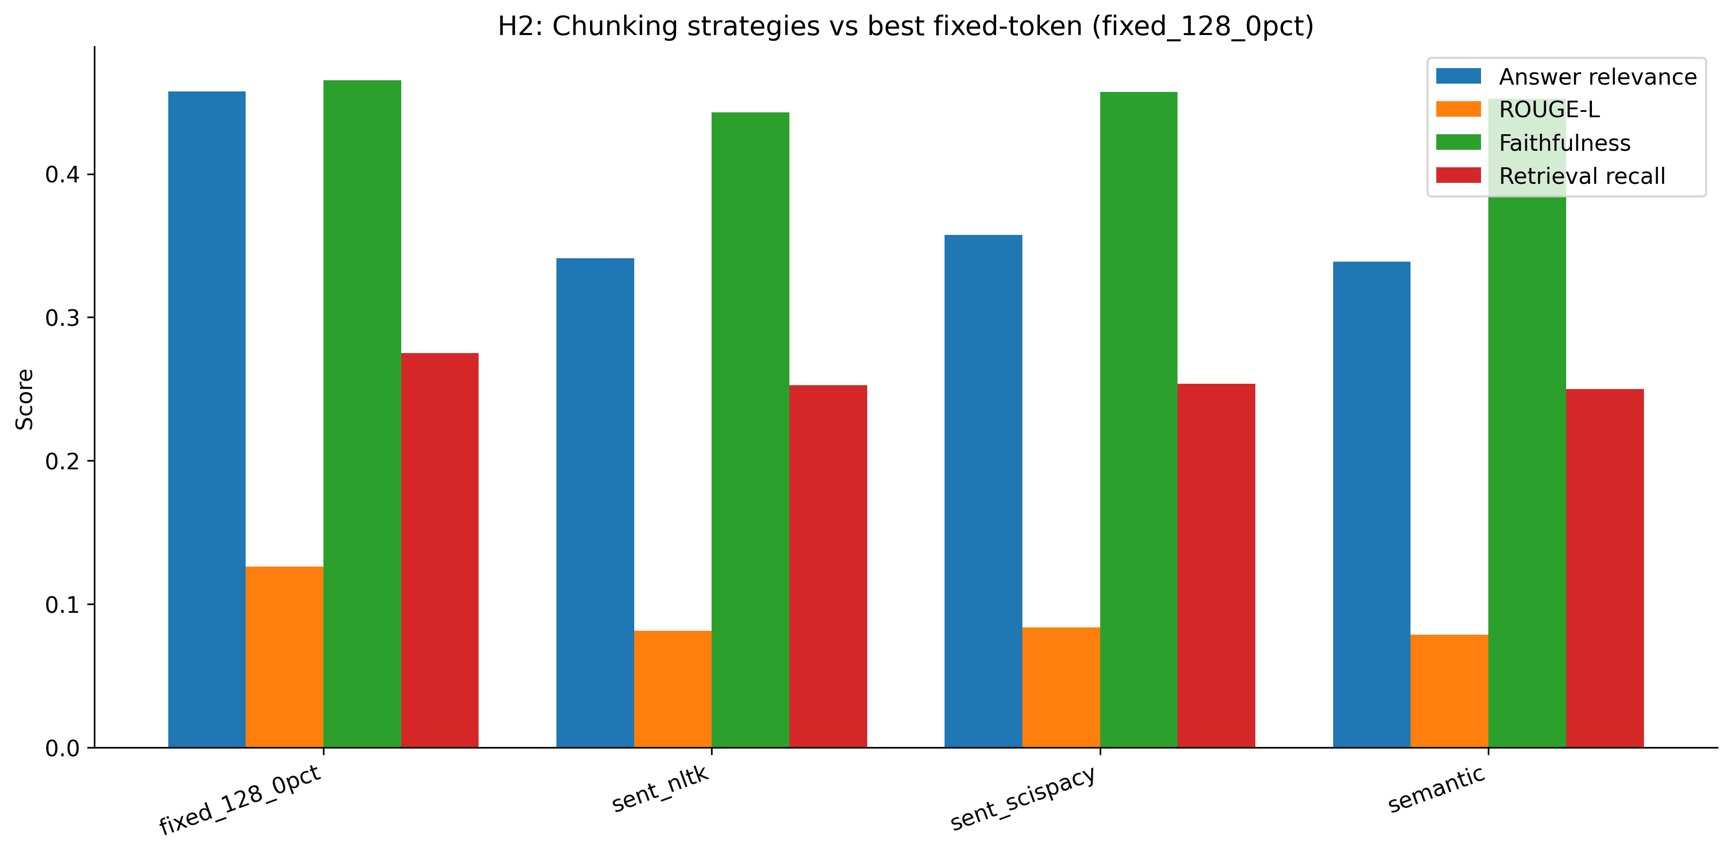
Figure 4.3: The three segmentation strategies against the best fixed-window condition on four metrics.

4.4.2 Inferential tests
A one-way ANOVA across the three strategies gives F(2, 2397) = 0.381, p = 0.683. Because the semantic condition delivers about 8% more context than the sentence conditions, and because context volume is itself associated with outcome (Section 4.5), the comparison was repeated as an ANCOVA with context words as covariate: the strategy effect remains non-significant (p = 0.828), while the covariate is strongly significant (F = 16.7, p = 4.5 × 10⁻⁵). Controlling for how much text each strategy delivers does not reveal a hidden difference between them; it confirms that the volume of context, not the method of segmentation, is what is associated with variation in the outcome.
Tukey contrasts including the anchor are in Table 4.8.
Table 4.8: Tukey HSD contrasts among the three strategies and the anchor (FWER = 0.05).
Comparison | Mean diff. | Adj. p | Significant
Fixed 128 / 0% vs Semantic | -0.0474 | < 0.001 | Yes
Fixed 128 / 0% vs Sentence–NLTK | -0.0448 | < 0.001 | Yes
Fixed 128 / 0% vs Sentence–scispaCy | -0.0424 | < 0.001 | Yes
Semantic vs Sentence–NLTK | 0.0026 | 0.976 | No
Semantic vs Sentence–scispaCy | 0.0050 | 0.858 | No
Sentence–NLTK vs Sentence–scispaCy | 0.0024 | 0.982 | No

The three strategy-versus-strategy contrasts have adjusted p-values of 0.976, 0.858 and 0.982. The NLTK-versus-scispaCy contrast — the specific comparison that the biomedical tokeniser was included to test — is the least different of the three, at a mean difference of 0.0024. All three strategy-versus-anchor contrasts are significant at p < 0.001, with the anchor ahead by 0.042–0.047; a four-group ANOVA including the anchor gives F(3, 3196) = 25.7, p = 1.9 × 10⁻¹⁶.

4.4.3 Verdict
H2 is supported. The three segmentation strategies are statistically indistinguishable on every metric, with and without controlling for context volume, and the biomedical tokeniser offers no advantage over the general-purpose one. The comparison also yields a result the hypothesis did not predict: all three strategies are significantly worse than the best fixed window. Chapter 5 explains both findings from the chunk statistics in Section 3.4.

4.5 H3: Answer Quality Declines with Context Size
H3 predicts that answer quality degrades as the context delivered to the generator grows. The original formulation in the literature describes a threshold — a cliff — at roughly 2,500 tokens.

4.5.1 Binned results
Table 4.9 groups all 12,000 runs into seven bands of approximate context size (words ÷ 0.75).
Table 4.9: All runs grouped by approximate context size in model tokens.
Approx. context tokens | n | Answer rate | ROUGE-L (all) | ROUGE-L (answered) | Faithfulness | Recall
<500 | 833 | 29.8% | 0.161 | 0.253 | 0.427 | 0.148
500-1k | 3166 | 33.6% | 0.119 | 0.214 | 0.439 | 0.218
1k-1.5k | 2797 | 35.0% | 0.088 | 0.208 | 0.428 | 0.252
1.5k-2k | 1883 | 43.0% | 0.089 | 0.188 | 0.486 | 0.276
2k-2.5k | 1555 | 41.6% | 0.078 | 0.179 | 0.497 | 0.328
2.5k-3k | 1141 | 43.8% | 0.080 | 0.176 | 0.538 | 0.316
>3k | 625 | 38.7% | 0.067 | 0.170 | 0.541 | 0.328

Unconditional ROUGE-L falls from 0.161 in the smallest band to 0.067 in the largest — a 58% decline. The decline is present in the conditional metric as well: among answered runs, ROUGE-L falls from 0.253 to 0.170. Answer rate moves in the opposite direction, rising from 29.8% in the smallest band to 43.8% at 2.5k–3k tokens before falling back to 38.7% above 3k. Retrieval recall rises with context throughout, from 0.148 to 0.328, as it must — more retrieved chunks means more chance that one of them is the gold source.
Figure 4.4 plots ROUGE-L and answer rate against context band.
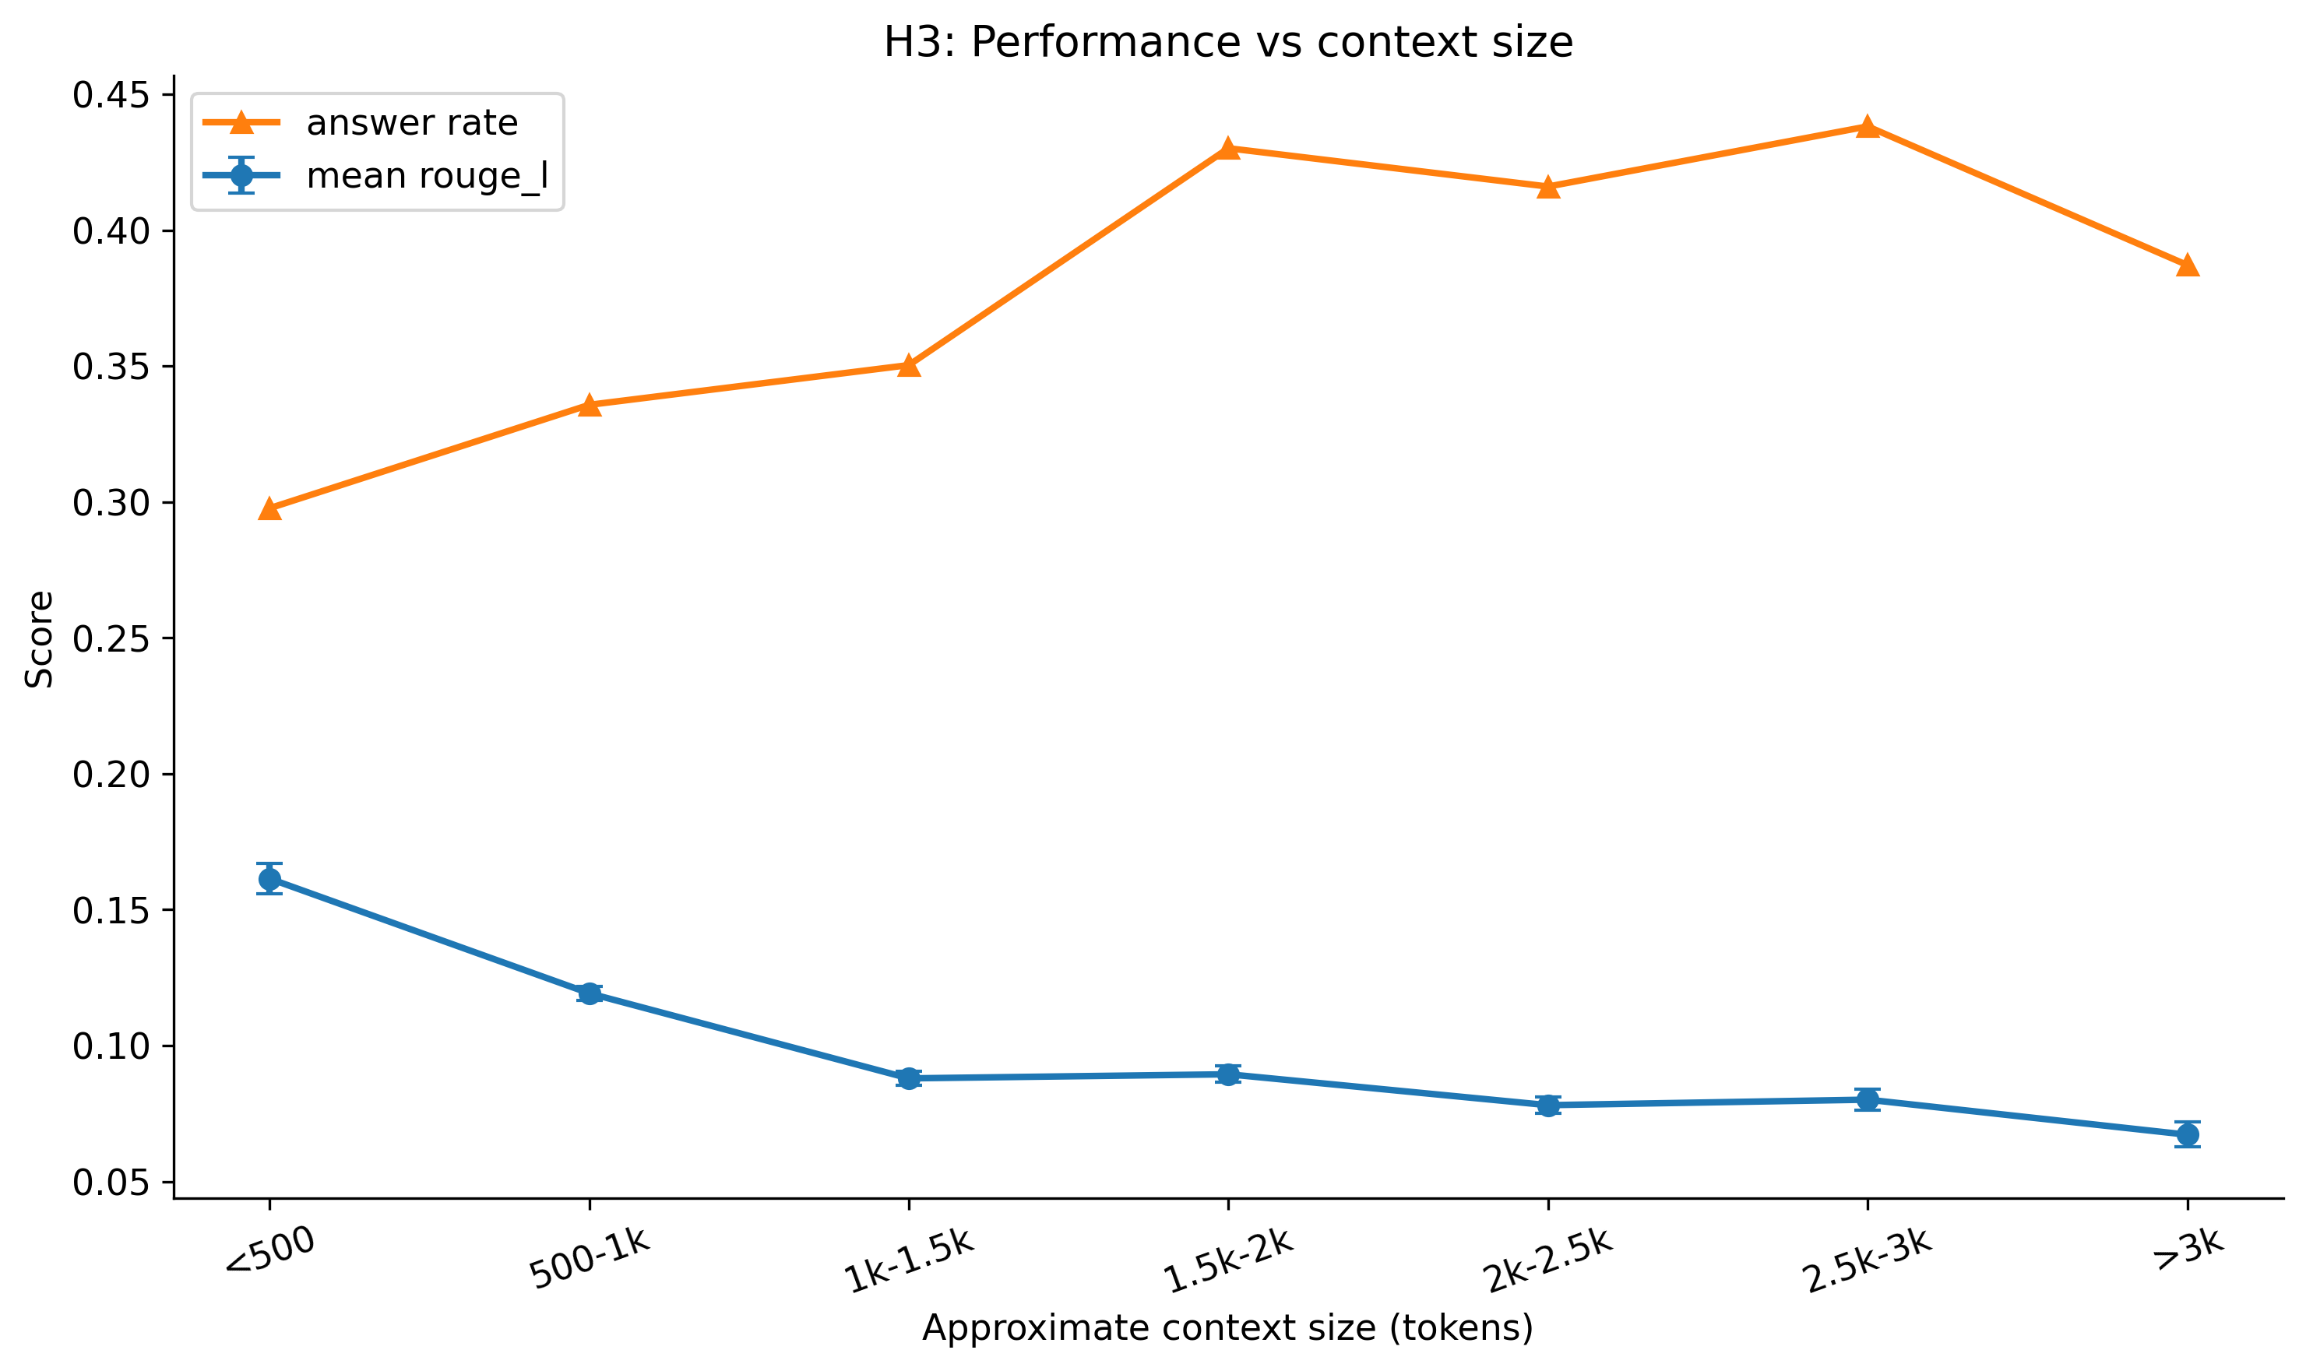
Figure 4.4: Mean ROUGE-L (with standard error) and answer rate by context-size band. Quality declines from the smallest band; answer rate rises.

4.5.2 Shape of the relationship
The decline is monotonic in the unconditional metric across the first three bands (0.161 → 0.119 → 0.088), essentially flat across the next three (0.089, 0.078, 0.080) and falls again in the last (0.067). It is monotonic without exception in the conditional metric (0.253 → 0.214 → 0.208 → 0.188 → 0.179 → 0.176 → 0.170). The steepest drop in both is between the first two bands — below 1,000 tokens. By 2,500 tokens, where the hypothesised cliff sits, the unconditional curve has already flattened and the conditional curve is declining gently. There is no band at which quality falls sharply after having been stable.
The Pearson correlation between context tokens and ROUGE-L over all runs is r = −0.150 (p = 4.5 × 10⁻⁶¹); the Spearman rank correlation, which does not assume linearity, is ρ = −0.198 (p = 4.7 × 10⁻¹⁰⁶). Restricted to answered runs, r = −0.134 (p = 1.5 × 10⁻¹⁹). The correlation between context tokens and the binary answer indicator is positive, r = +0.076 (p = 1.2 × 10⁻¹⁶). The relationship is therefore not an artefact of refusals: context reduces the quality of the answers the generator gives even as it increases the generator's willingness to give one.

4.5.3 Verdict
H3 is supported in direction and refined in form. Answer quality is negatively associated with context size, decisively so. But the shape is a continuous decline from the smallest contexts tested, steepest below 1,000 tokens and flattening thereafter, not a threshold. On this corpus there is no context budget below which quality is safe and above which it collapses; every increase in context is associated with some loss of quality. The practical implication — retrieve less rather than more — holds across the full range tested.
The opposite movement of answer rate and conditional quality is a finding in its own right. A larger context makes the generator more likely to attempt an answer and less likely to get it right. A single averaged metric conceals this: between the 500–1k and 2.5k–3k bands, unconditional ROUGE-L falls by 0.039 while answer rate rises by ten percentage points and conditional quality falls by 0.038, and only the decomposition shows that the fall in the average is entirely a fall in quality that the rise in rate partially masks.

4.6 Window Size
Window size was the largest effect in the experiment. Table 4.10 pools the Part A runs by window size.
Table 4.10: Part A results by window size, pooled over overlap ratios (3,200 runs per size).
Chunk size (words) | n | Answer rate | ROUGE-L (all) | ROUGE-L (answered) | Recall | Faithfulness | Context words
128 | 3200 | 35.1% | 0.118 | 0.224 | 0.271 | 0.443 | 706
256 | 3200 | 38.6% | 0.109 | 0.209 | 0.259 | 0.481 | 1165
512 | 3200 | 38.7% | 0.082 | 0.175 | 0.253 | 0.482 | 1475

Unconditional ROUGE-L falls from 0.118 at 128 words to 0.109 at 256 and 0.082 at 512; conditional ROUGE-L from 0.224 to 0.209 to 0.175. Answer rate moves the other way, from 35.1% to 38.6% to 38.7%. The same willingness–accuracy pattern seen for context size in Section 4.5 appears here, which is unsurprising: window size is the main determinant of context volume at a fixed k (706, 1,165 and 1,475 words for the three sizes at the pooled k).
The two-way ANOVA in Table 4.5 gave a main effect of window size of F(2, 9594) = 57.7, p = 1.2 × 10⁻²⁵, partial η² = 0.0119. Tukey contrasts (Table 4.11) show every pair of sizes significantly different.
Table 4.11: Tukey HSD contrasts between window sizes on ROUGE-L (FWER = 0.05).
Comparison | Mean diff. | Adj. p | 95% CI lower | 95% CI upper | Significant
128 vs 256 | -0.0092 | 0.025 | -0.0175 | -0.0009 | Yes
128 vs 512 | -0.0364 | < 0.001 | -0.0447 | -0.0282 | Yes
256 vs 512 | -0.0272 | < 0.001 | -0.0355 | -0.0190 | Yes

The 128-versus-512 difference of 0.036 is the largest between-level difference for any factor in the study. Figure 4.5 plots the three metrics against window size.
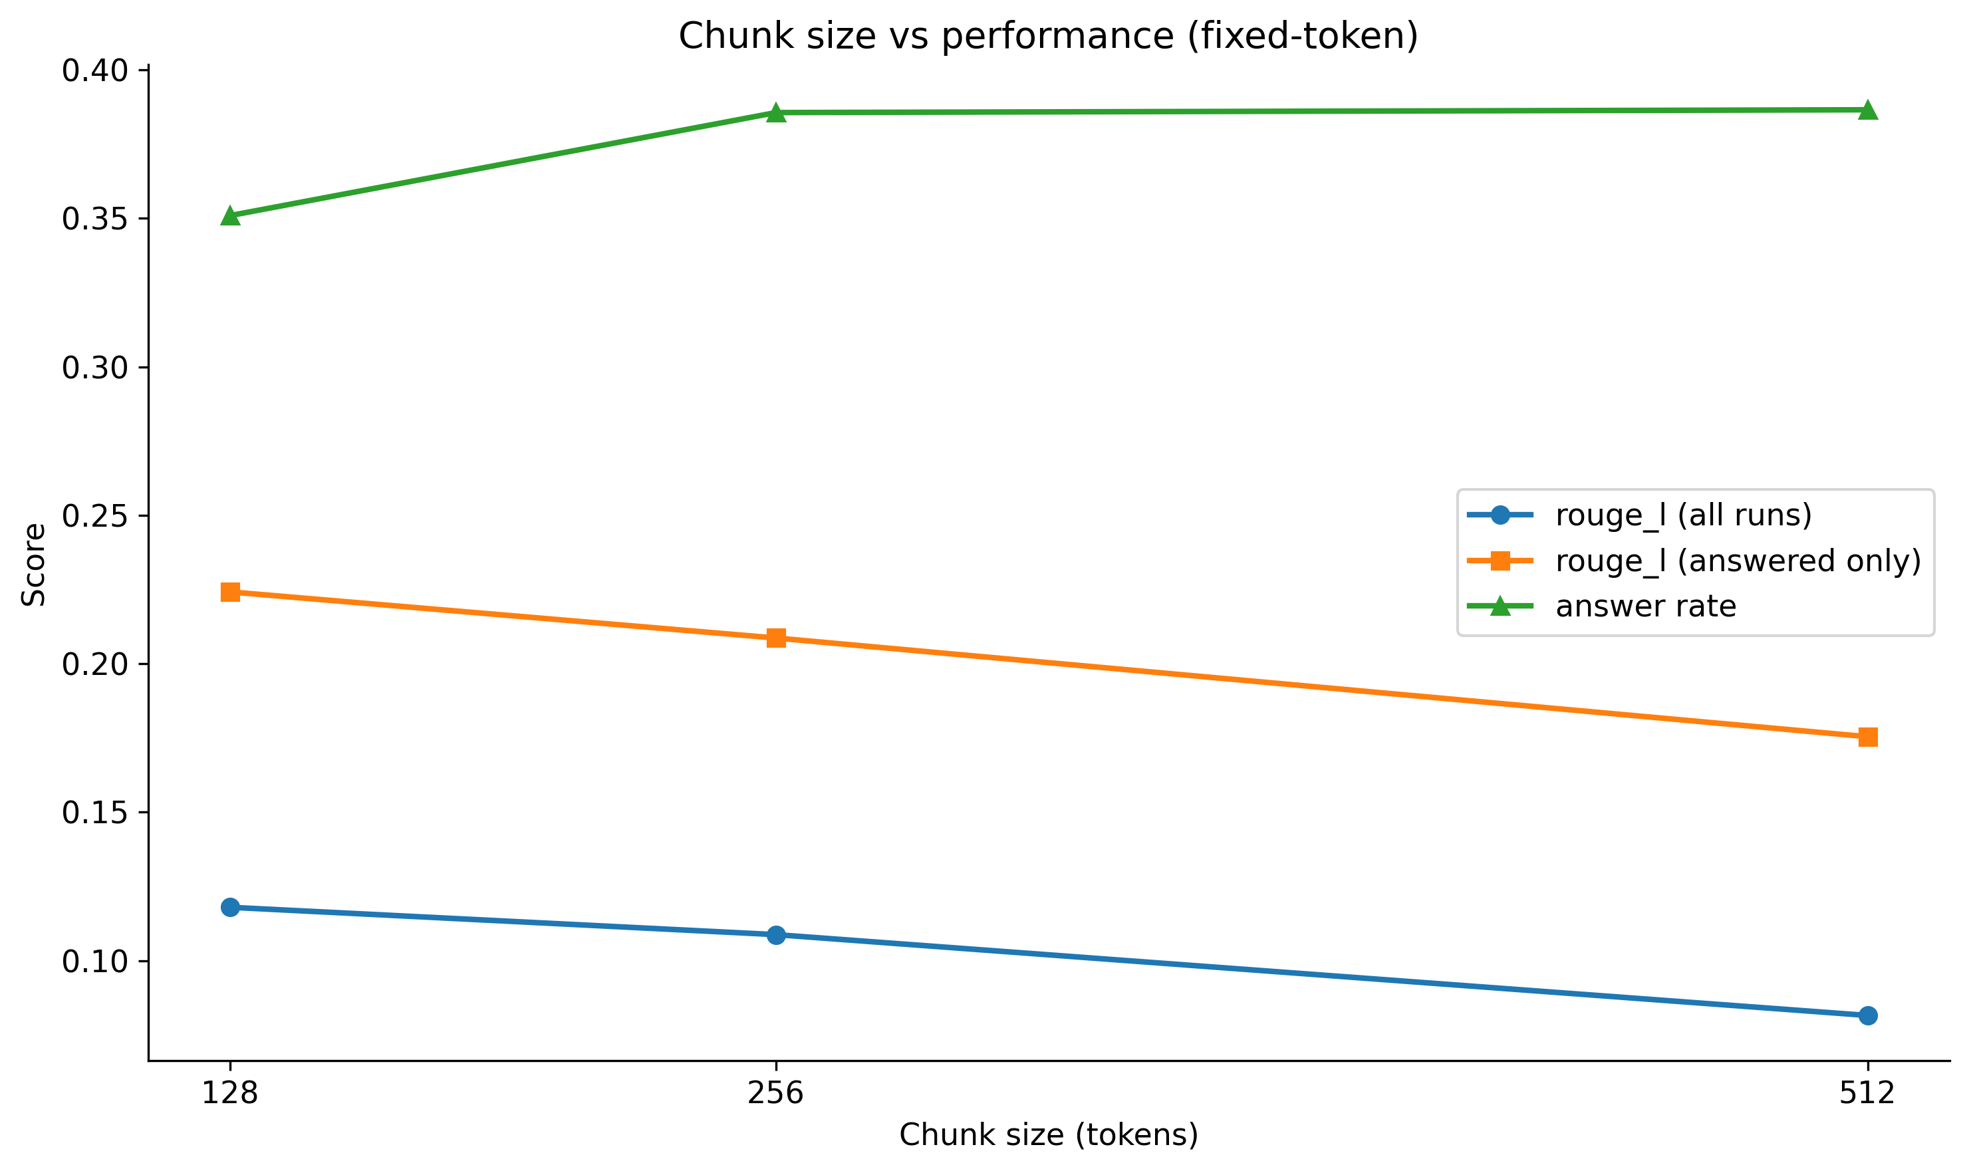
Figure 4.5: ROUGE-L (unconditional and conditional) and answer rate against window size.
The η² of 0.012 deserves a comment. The window-size effect is highly significant and is the largest in the design, yet it explains only 1.2% of the total variance in ROUGE-L. The remaining 98.8% is variation between questions, between topics and between individual generations — a characteristic of RAG evaluation in which the difficulty of the question dominates the configuration of the system. The effect is real, consistent and replicable (Section 4.9 shows it in every topic), but it is a shift of a few hundredths in a metric whose per-run standard deviation is 0.135.

4.7 Embedding Model and Interaction

4.7.1 Main effect
Table 4.12 compares the two embedding models across all 6,000 runs each.
Table 4.12: Results by embedding model, pooled over all conditions and depths (6,000 runs each).
Embedding model | n | Answer rate | ROUGE-L (all) | ROUGE-L (answered) | Relevance | Recall | Faithfulness
MiniLM (all-MiniLM-L6-v2) | 6000 | 40.1% | 0.101 | 0.194 | 0.393 | 0.293 | 0.476
PubMedBERT | 6000 | 34.7% | 0.096 | 0.203 | 0.381 | 0.225 | 0.455

MiniLM, the general-purpose encoder, scored higher than PubMedBERT on unconditional ROUGE-L (0.101 against 0.096), answer rate (40.1% against 34.7%), retrieval recall (0.293 against 0.225), faithfulness and relevance. PubMedBERT scored higher only on conditional ROUGE-L (0.203 against 0.194) — when it answered, it answered slightly better, but it answered less often because it retrieved the gold source less often.
Welch's t-test on unconditional ROUGE-L gives t = 1.81, p = 0.071: not significant at α = 0.05. On retrieval recall the difference is significant (t = 8.52, p = 1.7 × 10⁻¹⁷): MiniLM retrieved the annotated source in 29.3% of runs and PubMedBERT in 22.5%. The biomedical encoder was worse at finding the annotated source and no better at producing answers.

4.7.2 Interaction with chunking condition
A two-way ANOVA over all fifteen conditions and both encoders with an interaction term gives the result in Table 4.13.
Table 4.13: Two-way ANOVA with interaction on ROUGE-L over all 12,000 runs.
Source | df | F | p
Chunking condition | 14 | 13.81 | 2.4 × 10⁻³³
Embedding model | 1 | 3.31 | 0.069
Condition × embedding | 14 | 0.31 | 0.993
Residual | 11,970

The interaction is as close to zero as a test of this size can show: F(14, 11970) = 0.31, p = 0.993. Table 4.14 gives the per-condition difference between encoders.
Table 4.14: Mean ROUGE-L by condition and embedding model, with the MiniLM − PubMedBERT difference.
Condition | MiniLM | PubMedBERT | Difference
Fixed 128 / 0% | 0.1268 | 0.1254 | +0.0014
Fixed 128 / 10% | 0.1279 | 0.1198 | +0.0081
Fixed 128 / 20% | 0.1145 | 0.1142 | +0.0003
Fixed 128 / 40% | 0.1127 | 0.1021 | +0.0106
Fixed 256 / 0% | 0.1077 | 0.1011 | +0.0066
Fixed 256 / 10% | 0.1042 | 0.0975 | +0.0067
Fixed 256 / 20% | 0.1145 | 0.1182 | -0.0037
Fixed 256 / 40% | 0.1121 | 0.1145 | -0.0024
Fixed 512 / 0% | 0.0889 | 0.0847 | +0.0042
Fixed 512 / 10% | 0.0899 | 0.0778 | +0.0121
Fixed 512 / 20% | 0.0720 | 0.0753 | -0.0033
Fixed 512 / 40% | 0.0817 | 0.0817 | +0.0000
Semantic | 0.0829 | 0.0744 | +0.0085
Sentence–NLTK | 0.0852 | 0.0773 | +0.0079
Sentence–scispaCy | 0.0890 | 0.0783 | +0.0107

The difference ranges from −0.004 to +0.012 across fifteen conditions with no pattern by window size or strategy. Figure 4.6 shows the same data as paired bars.
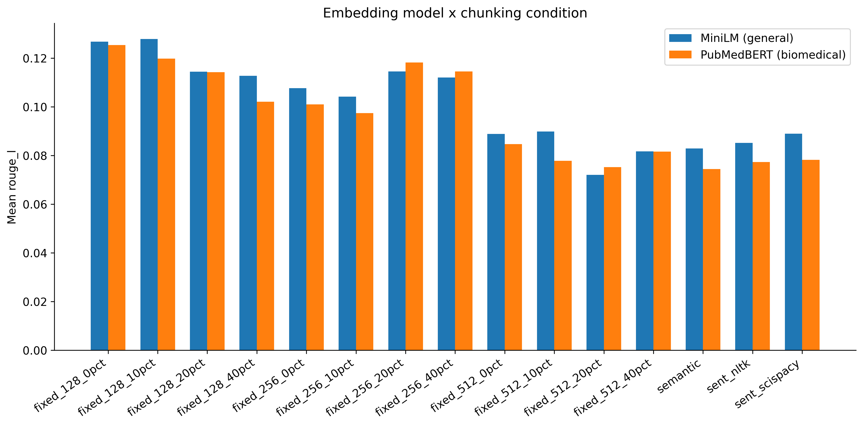
Figure 4.6: Mean ROUGE-L by condition for the two embedding models. The gap is small and constant.
The absence of interaction means that the ranking of chunking conditions is the same under both encoders. A practitioner who follows the chunking recommendations of this thesis need not condition them on which embedding model they use.

4.8 Retrieval Depth
Table 4.15 pools all runs by k.
Table 4.15: Results by retrieval depth k, pooled over all conditions and encoders (3,000 runs each).
k | n | Answer rate | ROUGE-L (all) | ROUGE-L (answered) | Recall | Faithfulness | Context words | Latency (ms)
3 | 3000 | 32.4% | 0.132 | 0.212 | 0.188 | 0.449 | 517 | 818
5 | 3000 | 36.6% | 0.099 | 0.205 | 0.234 | 0.444 | 867 | 946
8 | 3000 | 40.9% | 0.084 | 0.192 | 0.298 | 0.478 | 1396 | 1093
10 | 3000 | 39.8% | 0.079 | 0.188 | 0.317 | 0.491 | 1746 | 1178

Retrieval depth shows the willingness–accuracy pattern most cleanly of any factor. As k rises from 3 to 10: retrieval recall rises from 0.188 to 0.317; answer rate rises from 32.4% to 39.8%; unconditional ROUGE-L falls from 0.132 to 0.079; conditional ROUGE-L falls from 0.212 to 0.188; context rises from 517 to 1,746 words; and latency rises from 818 to 1,178 ms. Retrieving more finds the gold source more often, makes the generator answer more often, makes each answer worse, and takes longer. Figure 4.7 plots ROUGE-L and answer rate against k for the four Part B conditions.
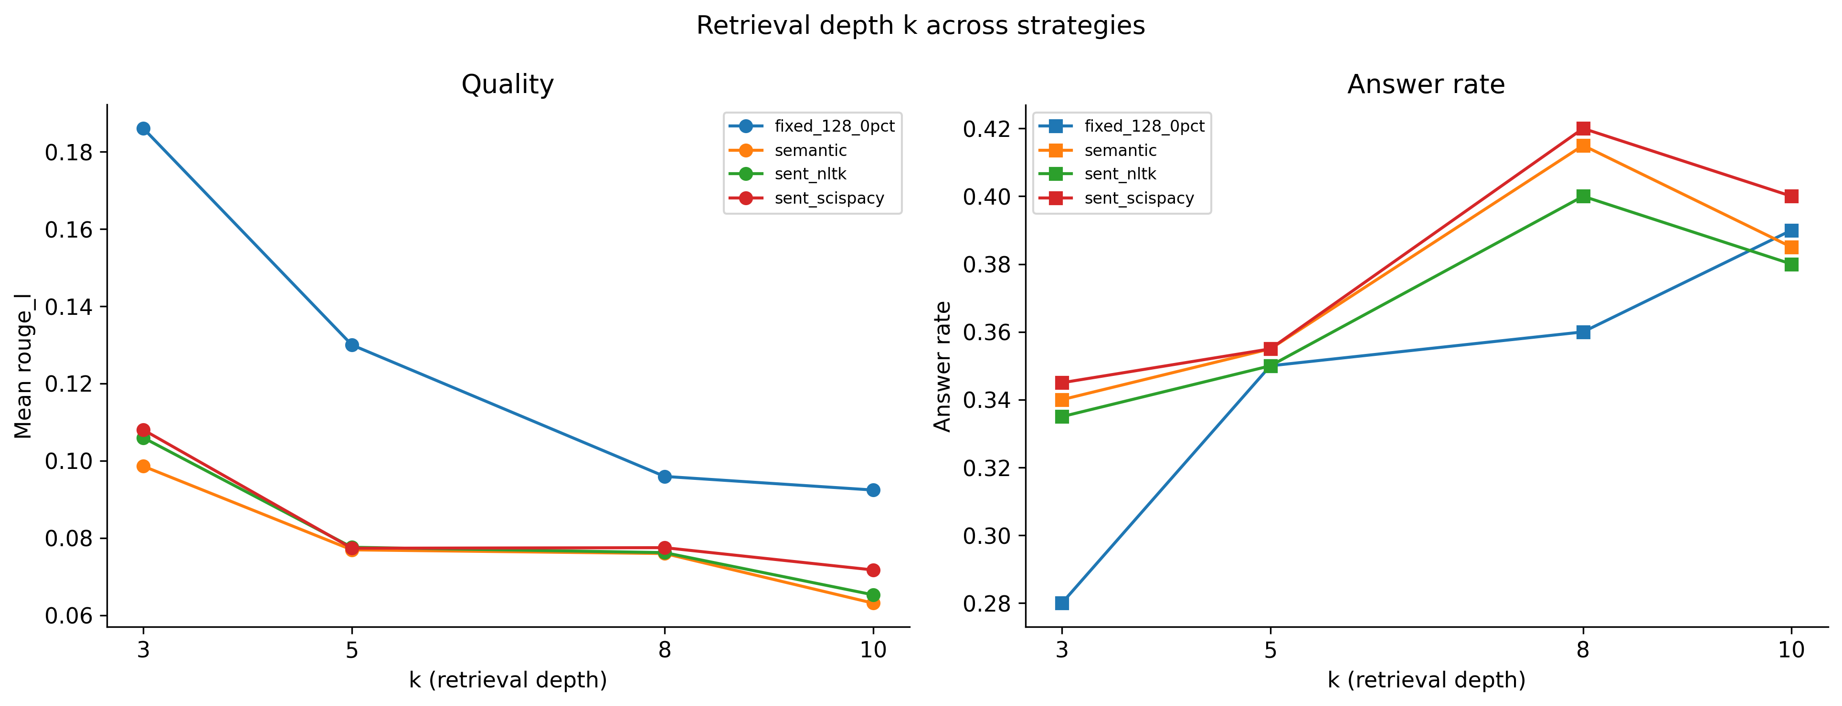
Figure 4.7: ROUGE-L (left) and answer rate (right) against retrieval depth for the three segmentation strategies and the anchor.
The best unconditional ROUGE-L in the entire design is obtained at k = 3, the shallowest depth tested. Whether an even shallower depth would be better still is a question the design cannot answer.

4.9 Per-Topic Robustness
Topic was not a manipulated factor, but the five question sets differ substantially in difficulty, and a main effect that held only in some topics would be a weaker finding than one that held in all. Table 4.16 reports results by topic.
Table 4.16: Results by topic, pooled over all conditions, encoders and depths (2,400 runs each).
Topic | n | Answer rate | ROUGE-L (all) | ROUGE-L (answered) | Recall | Faithfulness | Context words
alzheimers | 2400 | 48.8% | 0.117 | 0.203 | 0.285 | 0.508 | 1007
covid19 | 2400 | 35.0% | 0.085 | 0.190 | 0.203 | 0.425 | 1134
diabetes | 2400 | 29.2% | 0.075 | 0.151 | 0.255 | 0.356 | 1122
hypertension | 2400 | 32.1% | 0.109 | 0.232 | 0.265 | 0.482 | 1131
lung_cancer | 2400 | 42.0% | 0.105 | 0.207 | 0.288 | 0.555 | 1262

Topics differ strongly: a one-way ANOVA on ROUGE-L across topics gives F(4, 11995) = 38.6, p = 4.1 × 10⁻³². Alzheimer's disease questions were answered most often (48.8%) and diabetes questions least (29.2%); hypertension questions, when answered, were answered best (conditional ROUGE-L 0.232) and diabetes questions worst (0.151). Figure 4.8 shows the per-topic results.
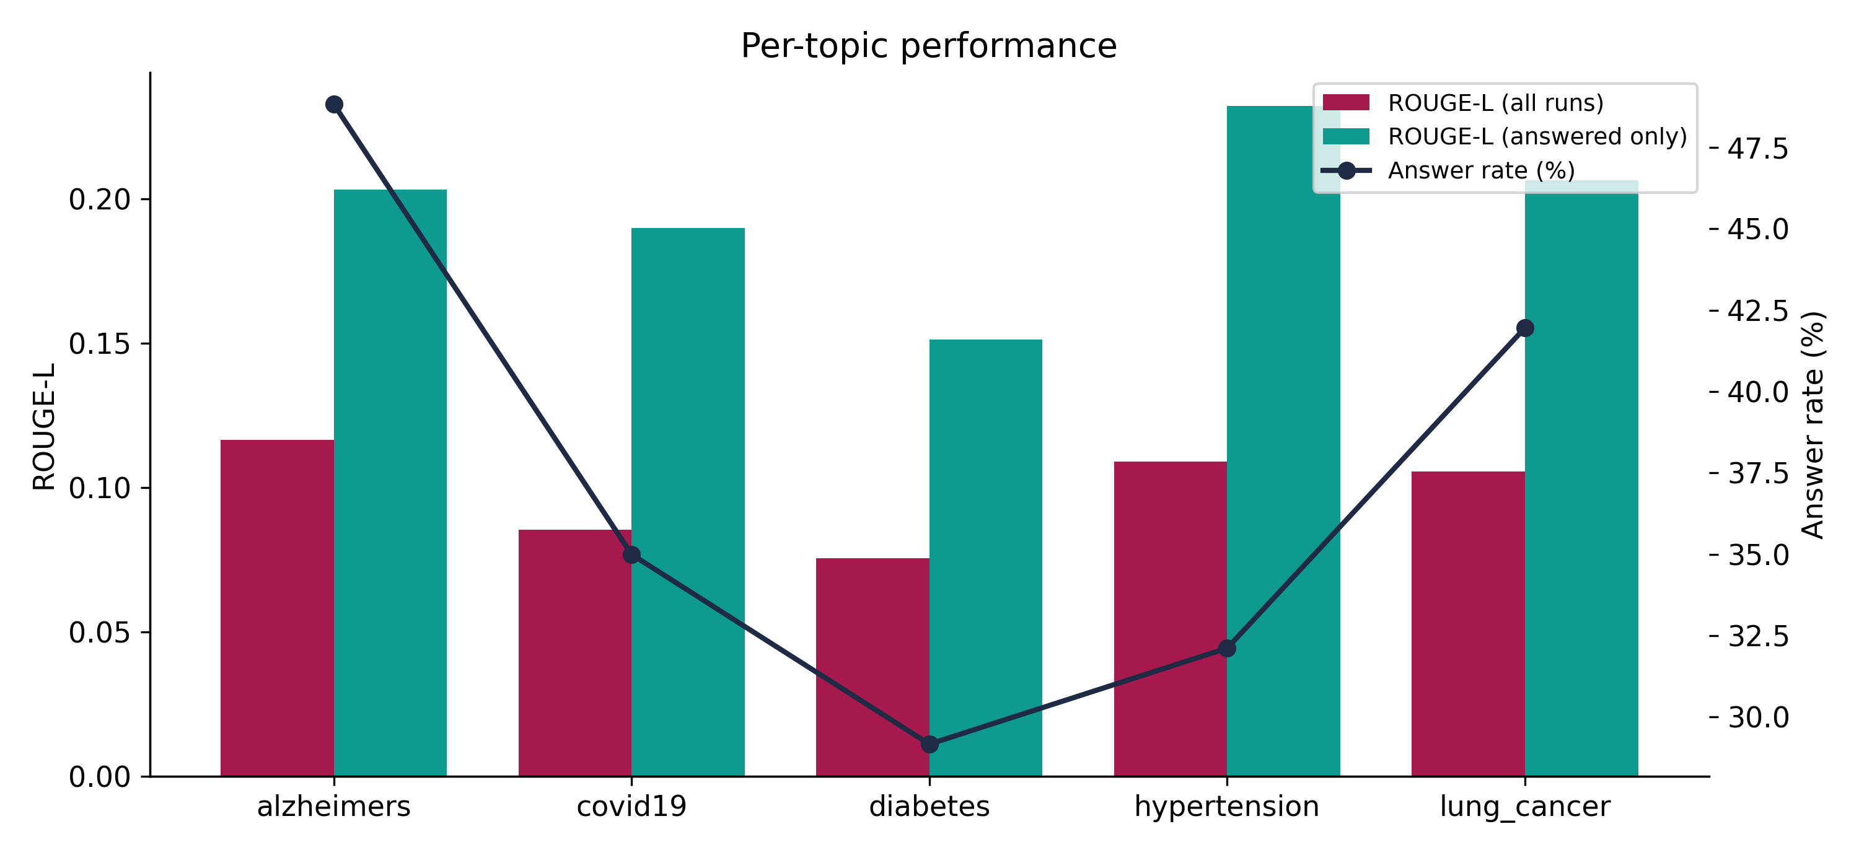
Figure 4.8: Per-topic ROUGE-L (unconditional and conditional) and answer rate.
Table 4.17 tests whether the window-size effect — the largest in the study — replicates within each topic.
Table 4.17: Mean ROUGE-L by window size within each topic.
Topic | 128 words | 256 words | 512 words
alzheimers | 0.1263 | 0.1180 | 0.1110
covid19 | 0.0902 | 0.0920 | 0.0765
diabetes | 0.0937 | 0.0784 | 0.0662
hypertension | 0.1541 | 0.1514 | 0.0596
lung_cancer | 0.1254 | 0.1038 | 0.0942

In four of five topics the ordering 128 > 256 > 512 holds exactly. In COVID-19 the 256-word window edges the 128-word window by 0.002, with 512 well below both. The direction of the effect — smaller windows better — holds in every topic, and the 512-word window is last in every topic. Figure 4.9 plots the five lines.
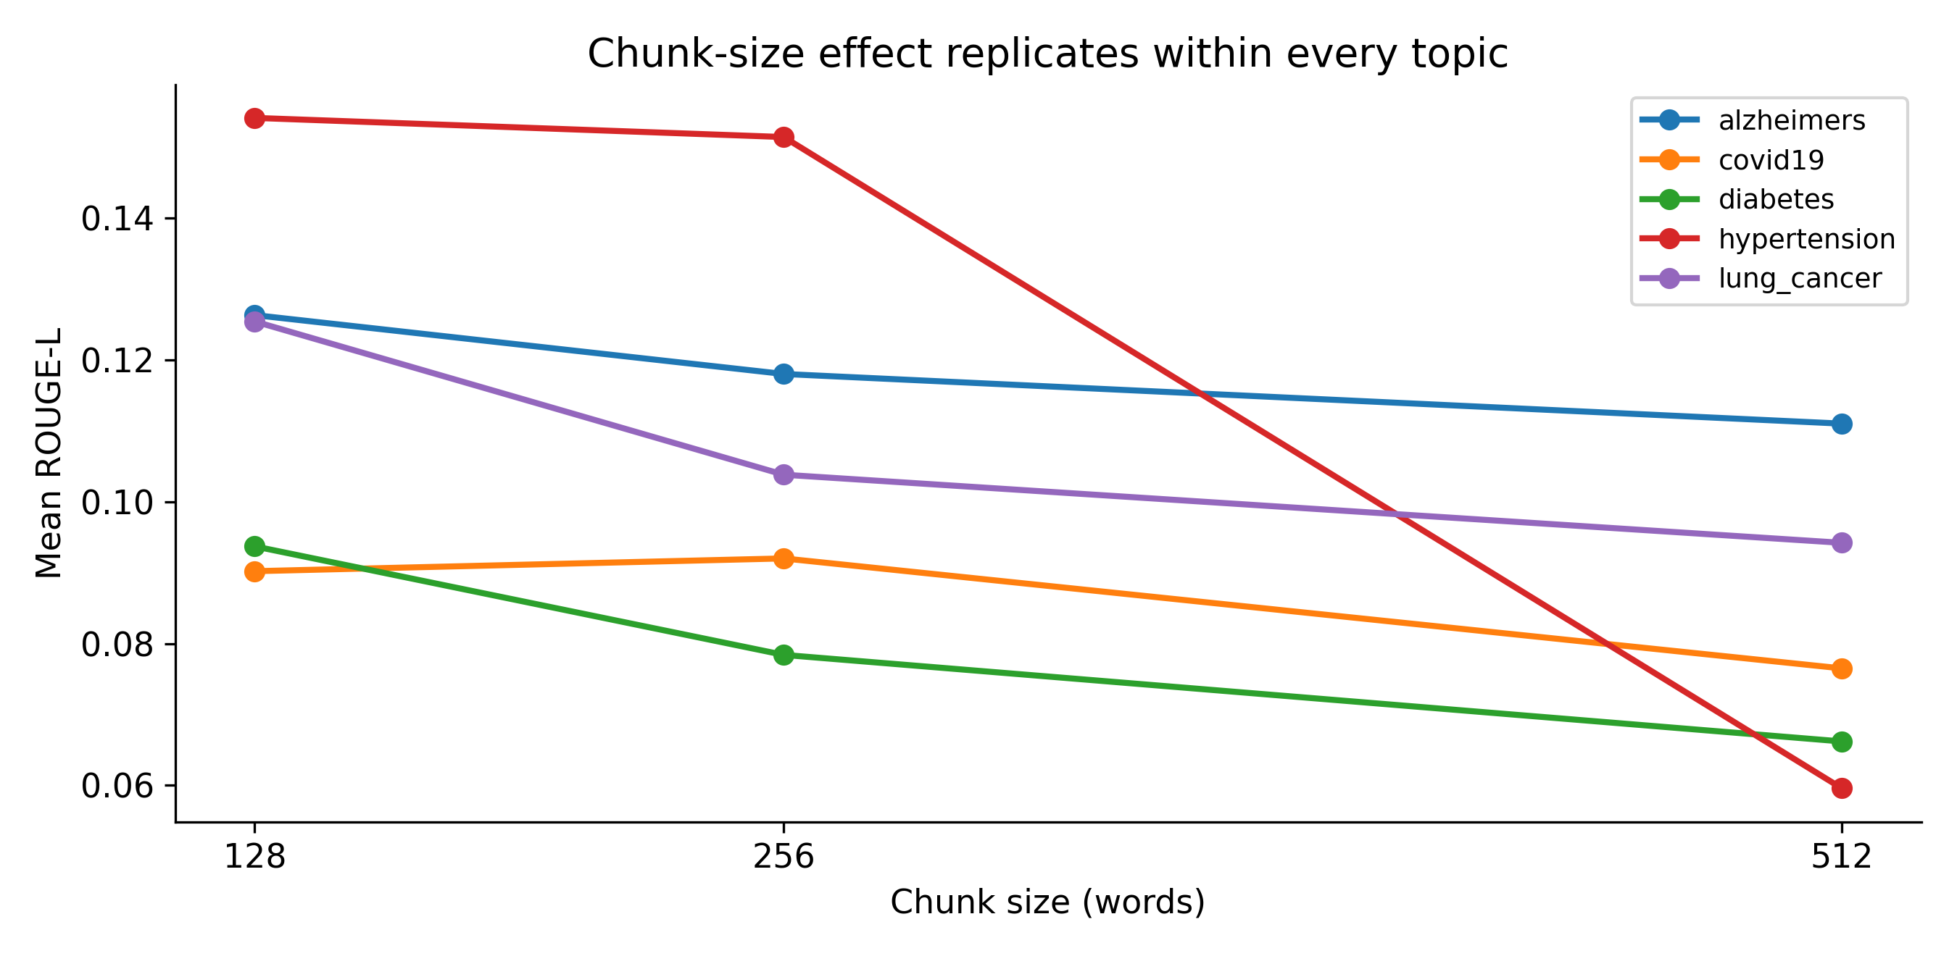
Figure 4.9: The window-size effect within each topic. Smaller windows are better in all five; 512 words is worst in all five.

4.10 Retrieval Recall and Answer Quality Diverge
Retrieval recall — whether the annotated gold PMID was among the retrieved sources — is only weakly related to answer quality. Across all runs, the correlation between recall and ROUGE-L is r = 0.080. Of the fifty highest-scoring answers in the experiment, 31 (62%) were produced without the gold source having been retrieved. Among answered runs, those in which the gold source was not retrieved scored higher (mean ROUGE-L 0.213, n = 2,678) than those in which it was (0.176, n = 1,812). Figure 4.10 shows the two distributions.
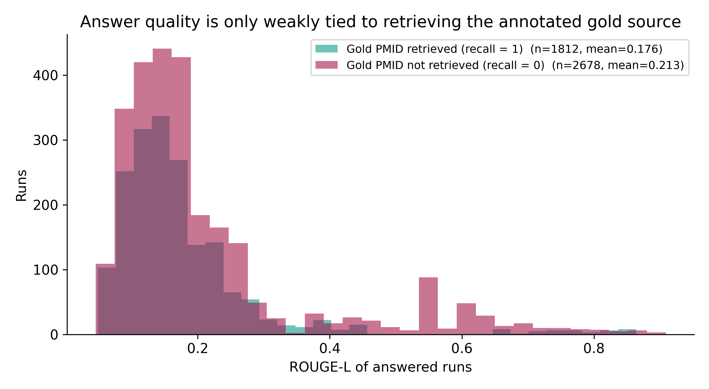
Figure 4.10: ROUGE-L of answered runs, split by whether the annotated gold source was retrieved. Runs that did not retrieve the gold source score higher on average.
This is not a paradox once the annotation is recalled. Each question has one gold PMID assigned by keyword matching, but the corpus has roughly two hundred abstracts per topic and many of them state the same clinical facts. The retriever frequently returns an abstract that answers the question and is not the annotated one; the generator answers correctly from it; and recall scores the run zero. The recall metric measures agreement with a single annotated source, not whether retrieval succeeded, and on a topically dense corpus the two come apart. Recall is reported throughout this chapter, but it is treated as a diagnostic of exact-source agreement rather than as a measure of retrieval success, and Chapter 5 discusses the annotation design that would repair it.

4.11 Summary of Findings
Table 4.18: Summary of results.
Hypothesis or question | Result | Key statistic | Verdict
H1: overlap adds no benefit | No effect at any window size | F = 0.59, p = 0.623; all Tukey CIs include zero | Supported
H2: sentence matches semantic | Three strategies indistinguishable; survives ANCOVA | F = 0.38, p = 0.683; ANCOVA p = 0.828 | Supported
H3: quality declines with context | Continuous decline from smallest contexts; no threshold | r = −0.150, p < 10⁻⁶⁰ | Supported in direction; refined in form
Window size | 128 > 256 > 512, replicated in every topic | F = 57.7, p < 10⁻²⁴; η² = 0.012 | Dominant factor
Embedding model | Biomedical encoder not better; worse at recall | ROUGE-L p = 0.071; recall p < 10⁻¹⁶ | No advantage
Chunking × embedding | No interaction | F = 0.31, p = 0.993 | Recommendations are encoder-independent
Retrieval depth | More depth: more recall, more answers, worse answers | Best ROUGE-L at k = 3 | Retrieve less
Refusal | 62.6% of runs; tracks retrieval miss | Recall 0.17 (refused) vs 0.40 (answered) | Retrieval is the bottleneck

Three findings organise the rest of the thesis. The configuration choices that practitioners spend effort on — overlap, biomedical tokenisers, semantic boundaries, domain encoders — made no detectable difference. The one choice that did, window size, favoured the smallest option and the least context. And the effect that both of those point to — less text to the generator is better — operates continuously, so that there is no safe amount of extra context to add.

5 Discussion
The results chapter established what happened. This chapter asks why, what it means, and what it does not mean. Sections 5.1 to 5.3 interpret the three hypotheses in turn, drawing on the chunk statistics of Section 3.4 to explain the findings mechanistically. Section 5.4 addresses the finding that was not hypothesised — the dominance of window size — and argues that it and the three hypotheses are one result seen from four angles. Section 5.5 sets the results against prior work, including the one study whose conclusions point the other way. Section 5.6 states the threats to validity, including one discovered during analysis. Section 5.7 translates the findings into recommendations for practice.

5.1 Overlap: Why Nothing Happened
The theoretical case for overlap is that evidence straddling a chunk boundary is recovered by whichever flanking chunk the retriever finds. For that mechanism to matter, three things must be true: boundaries must fall inside abstracts; they must fall between sentences that jointly carry an answer; and the retriever must find the chunk on one side of the boundary but not the other. On this corpus the first condition largely fails.
Section 3.4 showed that at 512 words there are no internal boundaries at all — every abstract is one chunk — and at 256 words only about a third of abstracts are split. Overlap at those sizes has nothing to overlap. Only at 128 words are abstracts routinely divided, into two or three chunks, and there the overlap of 12–51 words is being asked to recover evidence that spans a boundary placed by word count rather than by structure. It could in principle help; the results say it does not. Recall at 128 words does not rise with overlap, and neither does anything else.
There is also a reason to expect overlap to be neutral even where boundaries exist. The retrieval unit is scored by the cosine similarity of its embedding to the query. Adding the last few sentences of the previous chunk to the start of the current one changes the current chunk's embedding — it now represents slightly different content — but it does not make that embedding more similar to a query about the content of the previous chunk, because the previous chunk still exists and still embeds its own content more faithfully. Overlap duplicates text without duplicating retrievability. The only mechanism by which it could help is the case where the two halves of a fact are each individually too weak a signal to retrieve but together are strong enough, and the overlapping chunk happens to contain both halves; the results suggest that case is rare.
The finding matches the general-domain prior from Natural Questions and extends it to text where the biomedical prior — that cross-sentence evidence is common — pointed the other way. The practical implication is unambiguous. Overlap enlarges the index (by up to 26% at 128 / 40%), enlarges every retrieved context (by 8% at 40%), and slows every generation call proportionally, in exchange for no measurable benefit. It should be omitted.

5.2 Segmentation: Why Three Strategies Tied, and Why All Three Lost

5.2.1 The sentence tokenisers agree
H2 included scispaCy on the strength of a concern raised repeatedly in the applied literature: that NLTK's general-purpose tokeniser over-segments biomedical text at abbreviations such as "i.v." and "et al.", producing fragments that destroy meaning. The concern is reasonable in principle. On this corpus it did not materialise. The two tokenisers produced character-identical chunks for 1,291 of 1,329 chunks (97.1%). The remaining 38 chunks — fewer than 3% — are the entire population on which the tokenisers could have produced a different retrieval outcome, and 38 chunks spread across 800 runs at four retrieval depths is not enough to move a mean.
Two features of the materials explain the agreement. PubMed abstracts, unlike clinical notes or full-text methods sections, contain relatively few of the abbreviations that trip punkt; they are written for a general biomedical readership and tend to spell out "intravenous" and "versus." And the sentence chunkers do not treat each sentence as a unit — they accumulate sentences to a 256-word target, so that even where the two tokenisers place a boundary differently, the sentences on both sides usually end up in the same chunk anyway. A tokeniser disagreement changes the chunk only when it falls exactly at the point where the accumulator crosses 256 words. The biomedical tokeniser's advantage, whatever it may be on other text, was neutralised by the corpus and by the chunker design before any retrieval took place.
This is the mechanistic content of the H2 null. It is not that the tokenisers are equivalent in general; it is that on abstracts, accumulated to a target longer than most abstracts, they produce the same chunks.

5.2.2 All three strategies are whole-abstract retrieval
The semantic chunker differs from the sentence chunkers in principle — its boundaries follow embedding similarity rather than word count — but Section 3.4 showed it produces 1.26 chunks per abstract against the sentence chunkers' 1.35. All three strategies leave most abstracts whole and split the rest once. They are, functionally, three ways of retrieving whole abstracts with an occasional internal boundary, and the results show what one would expect of three such methods: near-identical answer rate, near-identical quality, near-identical recall, and context volumes that differ only because the semantic chunker's variable-length chunks run slightly longer.
This also explains why all three lost to the 128-word fixed window by 0.042–0.047 ROUGE-L. The fixed window at 128 words is the only strategy in the design that retrieves sub-abstract units. The comparison in Part B was framed as fixed versus sentence versus semantic; in practice it was sub-abstract versus whole-abstract, and sub-abstract won. Section 5.4 develops this.

5.2.3 What the null does and does not say
The ANCOVA result is the important guard here. The three strategies delivered different amounts of context — the semantic chunker about 8% more than the sentence chunkers — and since context volume is itself associated with outcome, an uncontrolled comparison could have hidden a real difference behind a volume difference, or manufactured one. Controlling for context words, the strategy effect is p = 0.83; the covariate is p < 0.0001. The strategies do not differ once volume is held constant, and volume is what matters.
The null is bounded, not absolute. With 800 runs per condition, the design has 84% power to detect a difference of 0.02 ROUGE-L and 99% power for 0.03; the noise floor from serving non-determinism (Section 4.3.1) is about 0.013. The three strategies fall within 0.005 of each other. The correct reading is that any difference between them on this corpus is smaller than 0.02, and probably smaller than the noise floor — not that no difference could exist on any corpus.

5.3 Context Size: A Slope, Not a Cliff

5.3.1 The shape
H3 was formulated as a threshold because that is how the effect has been described in applied work on general-domain corpora: quality holds, then falls. The results show a different shape. Quality declines from the smallest contexts tested — the drop from the under-500-token band to the 500–1,000 band is the largest single step in the curve — flattens through the middle bands, and falls again at the top. There is no band at which quality is stable before falling. Both the unconditional and the conditional metric decline monotonically or nearly so across the full range, and the Spearman correlation of −0.198 is stronger than the Pearson of −0.150, which is what one expects when the relationship is monotonic but not linear.
The mechanism suggested by Liu et al. [20] — that a generator attends less reliably to evidence buried in a long context — is consistent with a continuous decline. Each additional retrieved chunk that does not contain the answer is a distractor; each one that does is diluted by the others. Shi et al. [17] showed that a single irrelevant sentence lowers accuracy on tasks the model can otherwise solve. There is no reason such an effect would wait for a threshold; each added distractor should cost something. On abstracts, where the retrieved units are themselves dense, the cost per added unit appears to be paid from the first.

5.3.2 Willingness and accuracy
The decomposition into answer rate and conditional quality yields the most useful finding of the study for practitioners. As context grows, the generator answers more often and answers less well. Between k = 3 and k = 10, answer rate rises from 32% to 40% and conditional ROUGE-L falls from 0.212 to 0.188. The reason is structural. A larger context is more likely to contain something that addresses the question — so the generator, instructed to answer only from context, finds licence to answer — but it is also more likely to contain material that addresses a neighbouring question, and the generator draws on that too. The refusal that a smaller context would have produced is replaced by an answer that is partly right.
A deployed system's user sees only the unconditional average, and the average declines. But the decomposition shows that the decline is a fall in quality that a rise in willingness partly masks, which is the more alarming reading: a system tuned for a high answer rate is being tuned toward confident partial answers. In a clinical setting a grounded refusal is a safer outcome than a plausible half-answer, and the results suggest that the two are traded against each other by the single knob of context size.

5.3.3 The 2,500-token threshold
The threshold as stated in the literature is not visible in these data, and the reason may simply be that this experiment operates in a different regime. Most runs delivered under 2,000 model tokens; the largest band, above 3,000, contains 625 runs. General-domain studies reporting a cliff at 2,500 tokens typically retrieve from long documents at high k, delivering contexts of many thousands of tokens, and the "cliff" may be the point at which a slope that was already present becomes visible against the noise. This study cannot rule out steeper degradation above 3,000 tokens; it can say that below that point the degradation is already present and already continuous.

5.4 Why Small Windows Win
The window-size effect was not a hypothesis. It was included as a design factor because H1 required window size to be controlled, and it turned out to be the largest effect in the study — larger than any of the three hypothesised factors, significant at p < 10⁻²⁴, and replicated in direction in all five topics.
The chunk statistics make the finding legible. At 128 words, the retriever's unit is a third of an abstract — roughly the Background, the Methods-and-Results, or the Conclusion of a structured abstract. At 256 words, the unit is most of an abstract. At 512 words, it is the whole abstract, every time. The three window sizes are three granularities of retrieval unit, and the results say that the finest granularity is best on every quality metric while being worst on answer rate.
Two mechanisms combine. The first is retrieval precision: a 128-word chunk that matches the query is a 128-word chunk about the query, whereas a 512-word chunk that matches may match on one sentence and carry four hundred words of something else. The second is context economy: at fixed k, three 128-word chunks deliver about 400 words and three 512-word chunks deliver about 700, and Section 5.3 has established that fewer words is better. Both mechanisms point the same way, and the design cannot separate them; a follow-up that fixes context volume rather than k would.
The finding reframes the three hypotheses. H1 asked about overlap, H2 about segmentation method, and H3 about context volume, and the answers were "no effect," "no effect," and "continuous decline." Window size is the factor that determines granularity, and granularity determines context volume, and context volume is what drives quality. Overlap and segmentation method do not change granularity on this corpus — they produce whole-abstract units either way — and so they do not change the outcome. The one factor that does change granularity is the one that mattered. Seen this way, the four results are one result: on short biomedical abstracts, retrieve sub-document units and as few of them as possible.

5.5 Relation to Prior Work
The general-domain benchmarks anticipated most of what was found. Śmigielski et al. [3] identified fixed windows as the most robust method across eight datasets; this study finds the same on a ninth. Qu et al. [5] predicted that semantic chunking's advantage would vanish on short documents; it vanished. The Natural Questions evidence that overlap adds little transferred intact.
The domain-specific priors did not. The concern that punkt over-segments biomedical text produced no measurable effect, for the reasons given in Section 5.2.1. The expectation that a biomedical encoder would retrieve biomedical passages better was reversed: PubMedBERT retrieved the annotated source less often than MiniLM (22.5% against 29.3%, p < 10⁻¹⁶) and produced no better answers. Several explanations are possible and the design cannot choose between them. The NeuML embeddings are fine-tuned for retrieval on biomedical query–passage pairs whose queries may resemble literature search strings more than the clinical questions used here; MiniLM's training on over a billion general pairs may make it better at matching a short natural-language question to a passage regardless of domain; or the questions may simply not exercise the terminology on which a domain encoder would gain. What can be said is that the assumption "biomedical text needs a biomedical encoder" did not hold on this task, and that the absence of any chunking × encoder interaction (p = 0.99) means the chunking findings do not depend on the choice.
The one prior clinical study points the other way and deserves direct treatment. Gomez-Cabello et al. [18] report 87% answer accuracy for an adaptive entity-density chunker against 13% for a fixed baseline on physician-validated questions. This study finds fixed windows performing well and no advantage for any content-aware strategy. Four differences between the studies could account for the divergence. The corpora differ: clinical decision-support documents are longer and less uniformly structured than PubMed abstracts, and Section 5.4 has argued that the advantage of any content-aware method depends on there being internal structure to find. The adaptive method differs: entity-density segmentation is not among the strategies tested here, and it may succeed where similarity-based boundaries do not. The questions differ: physician-validated clinical questions may demand multi-sentence evidence assembly that keyword-matched factual questions do not. And the metric differs: human-judged accuracy against automatic ROUGE-L. The honest conclusion is that both studies may be correct about the text and task they examined, and that the transfer of chunking findings across biomedical sub-domains is itself an open question — one on which this study's result is that abstracts behave like short general-domain documents, not like clinical notes.

5.6 Threats to Validity

5.6.1 Internal validity
Serving non-determinism. The generator was run at temperature zero, which should make decoding deterministic, but the remote inference service did not return identical outputs for identical inputs: 41% of paired runs with identical context produced different answer text (Section 4.3.1). The effect on the analysis is additive noise with a measured floor of about 0.013 ROUGE-L at the condition-mean level. It does not bias any comparison — it affects every condition equally — but it means that condition differences below roughly 0.015 are uninterpretable, and all null results in this thesis should be read with that floor in mind. The window-size and strategy-versus-anchor effects (0.027–0.047) are well above it; the overlap and strategy-versus-strategy differences (under 0.006) are well below it. A replication on locally hosted weights with fixed seeds would remove the issue.
Single gold source. Each question is annotated with one gold PMID, assigned by keyword matching. Section 4.10 showed the consequence: 62% of the fifty best answers were produced without retrieving the annotated source, and answered runs that missed the gold source scored higher than those that found it. The retrieval-recall metric is measuring agreement with one annotation on a corpus where many abstracts state the same fact. The hypothesis tests do not depend on recall — they use ROUGE-L — but every statement in this thesis about retrieval success should be read as a statement about exact-source agreement. A pooled-relevance annotation, in which every abstract that answers a question is marked relevant, would repair the metric; Chapter 6 describes it.
Confounding of k with context volume. Strategies were compared at fixed k, and different strategies deliver different volumes at the same k. The ANCOVA controls for this statistically, and the conclusion survived, but a design that fixed context volume directly and let k vary would be cleaner.

5.6.2 Construct validity
ROUGE-L measures surface agreement. Two correct answers phrased differently score differently; a fluent wrong answer that reuses the reference's vocabulary can score well. ROUGE-L is the standard reference-based metric and is appropriate for a comparison of this size, but the absolute values in this thesis — a best condition mean of 0.126 — should not be read as accuracy percentages, and the findings are findings about relative performance across conditions, where the metric's biases apply equally to all.
Faithfulness is lexical. The token-overlap measure detects answers that introduce vocabulary absent from the context; it does not detect answers that recombine context vocabulary into unsupported claims. A claim-level judge would be stronger.
Refusal detection is by phrase. A run is classed as a refusal if the answer contains "insufficient context." An answer that declined in other words would be classed as an answer; inspection of samples found no such cases, but the classification was not exhaustive.

5.6.3 External validity
One generator. Every finding about how the generator responds to context is a finding about Llama 3.1 8B Instruct. The willingness–accuracy trade-off in particular may be specific to how this model handles a "refuse if insufficient" instruction. Replication with a second generator is the most valuable single extension of the work.
Abstracts, not full text. The corpus is short by construction, and Section 5.4 has argued that the shortness is what made window size dominant and made the segmentation strategies indistinguishable. On full-text articles, where abstracts' 238 words become thousands, the strategies would produce genuinely different segmentations and the results could differ. This thesis makes claims about PubMed abstracts, which are what most biomedical retrieval systems index, and does not extend them to full text.
Five topics, one hundred questions, automated annotation. The question set is small by benchmark standards and its gold sources were assigned automatically rather than by domain experts. The per-topic analysis shows that the main effect holds in every topic, which addresses generalisation across disease areas within the corpus; it does not address generalisation to question types — multi-hop, comparative, numerical — that the set does not contain.
No human evaluation. Twelve thousand runs are beyond human evaluation, and automatic metrics were the only feasible choice. A human check on a sample — correctness, relevance and evidence support judged by a clinician — would establish how well ROUGE-L tracks clinical correctness on this material and is a natural next step.

5.7 Recommendations for Practice
For a practitioner building a RAG system over PubMed abstracts or similar short biomedical documents under resource constraints, the results support the following.
- Use small fixed windows. A 128-word window outperformed every alternative tested on every quality metric. It is also the cheapest strategy to implement and the fastest to run.
- Omit overlap. It had no measurable effect on any outcome at any window size and inflates index size and context volume. Set it to zero.
- Retrieve few chunks. The best quality in the design was at k = 3, the shallowest depth tested. Every increase in k raised answer rate and lowered answer quality. Choose the smallest k that yields an acceptable answer rate for the use case, and treat any increase as a trade of accuracy for coverage.
- Do not assume that domain-specific components help. The biomedical sentence tokeniser produced the same chunks as the general one; the biomedical encoder retrieved worse and answered no better. Test before adopting.
- Do not pay for semantic chunking on short documents. It requires an embedding pass at index time and offered nothing over sentence splitting, which offered nothing over fixed windows.
- Report answer rate and answer quality separately. A system's average score conflates how often it answers with how well; the two move in opposite directions as context grows; and in a clinical setting the difference between a refusal and a partial answer matters. Any evaluation that reports one number is hiding which of the two it is measuring.
- Treat retrieval as the bottleneck. Sixty-three per cent of runs were refusals, and refusals tracked retrieval misses. Improvements to retrieval — better questions-to-corpus matching, hybrid lexical search, re-ranking — would raise the answer rate without the quality cost that more context imposes.

Every one of these recommendations rests on 800 measured runs per condition, and each is bounded by the limitations of Section 5.6. The first five are recommendations about what to omit rather than what to add, which is the shape a negative result takes when it is useful: the practitioner saves the cost of a component that would not have helped.

6 Conclusion and Future Work

6.1 Summary of the Work
This thesis set out to test whether the chunking conventions inherited from general-purpose RAG hold on biomedical abstracts. It built a corpus of 981 PubMed abstracts across five disease areas and a set of 100 question–answer pairs; implemented fifteen chunking conditions — twelve fixed windows crossing three sizes with four overlap ratios, two sentence-boundary segmenters and one semantic chunker — under a common interface; embedded each with a general-purpose and a biomedical encoder; and evaluated every question under every combination of condition, encoder and retrieval depth, for 12,000 runs with the generator held constant. Three hypotheses were stated in advance and tested with analysis of variance, Tukey contrasts and analysis of covariance.
All three were supported, two of them as null results and one with a refinement. Overlap between chunks had no effect on any outcome at any window size (H1). NLTK sentence segmentation, scispaCy biomedical segmentation and embedding-similarity semantic chunking were statistically indistinguishable, with and without controlling for context volume (H2). Answer quality declined with context size, but continuously from the smallest contexts tested rather than at a threshold (H3). The largest effect in the study was one that had not been hypothesised: window size, with 128-word windows outperforming 256- and 512-word windows on every quality metric in every topic. The biomedical encoder did not outperform the general-purpose one, and there was no interaction between encoder and chunking condition.
Two findings shape how the rest should be read. First, 62.6% of runs ended in a grounded refusal, and refusals tracked retrieval misses; the study therefore reports answer rate and conditional answer quality as separate outcomes and finds that they move in opposite directions as context grows — more context makes the generator more willing to answer and less accurate when it does. Second, because abstracts average 238 words, every strategy except the 128-word window operates at whole-abstract granularity; the segmentation strategies tied because they produce the same segmentation, and the small window won because it is the only condition that retrieves sub-abstract units.

6.2 Contributions
The thesis has delivered the contributions set out in Section 1.7.
It provides the first systematic, multi-metric, pre-registered comparison of chunking strategies on PubMed abstracts, at a scale — 800 runs per condition — that gives its null results evidential weight. It provides the first head-to-head test of NLTK against scispaCy segmentation inside a RAG pipeline on biomedical text, together with the direct measurement that explains the result: the two tokenisers agree on 97% of chunks. It provides the first test of chunking × embedding interaction on biomedical text, and the finding of no interaction means its chunking recommendations hold regardless of encoder. It refines the context-cliff hypothesis into a continuous-decline finding and separates the willingness and accuracy components that an averaged metric conflates. And it does all of this on a CPU-only laptop and free-tier inference, with every artefact released, so that the experiment can be repeated by anyone with the same constraints.
The practical recommendation is short: on short biomedical documents, use small fixed windows, omit overlap, retrieve few chunks, and verify rather than assume that domain-specific tokenisers and encoders help. Each of these is a recommendation about what not to add, and each saves the practitioner a cost that the evidence says would not have been repaid.

6.3 Limitations
The limitations are stated in full in Section 5.6 and are summarised here so that the conclusions are read at their proper scope. The findings are about PubMed abstracts and should not be extended to full-text articles or clinical notes, on which the strategies would produce different segmentations. They are about one generator, Llama 3.1 8B Instruct, and the willingness–accuracy trade-off in particular may be model-specific. The remote inference service introduced run-to-run noise despite temperature zero, with a measured floor of about 0.013 ROUGE-L, below which condition differences cannot be interpreted. Retrieval recall is measured against a single automatically assigned gold source per question and understates retrieval success on a corpus where many abstracts state the same fact. ROUGE-L measures surface agreement with one reference phrasing, not clinical correctness, and no human evaluation was performed. The question set is small and was constructed by the author rather than by clinicians.

6.4 Future Work
Five extensions follow directly from the limitations, in rough order of value.
A second generator. Every finding about the generator's response to context is a finding about one model. Repeating a subset of the design — the twelve fixed-window conditions at two depths, say — with a second generator of different size or family would establish whether the continuous decline and the willingness–accuracy trade-off are properties of RAG or of Llama 3.1 8B. On free-tier inference this is a matter of days. It is the single extension that would most strengthen the thesis's claims.
Local inference with fixed seeds. The serving non-determinism discovered during analysis could be eliminated by running the same weights locally with a fixed random seed. This would lower the noise floor and allow smaller condition differences to be resolved; it would also make the experiment exactly reproducible rather than reproducible up to serving variation.
Pooled relevance annotation. Marking every abstract that answers a question as relevant — by pooling the retrieved sets across all conditions and judging each pooled abstract once — would repair the retrieval-recall metric at a cost of a few hundred judgements. With a repaired metric, the relationship between retrieval and generation could be studied properly, and rank-sensitive measures such as MRR and nDCG could be reported.
Full-text articles. The whole-abstract effect that dominates the results would not occur on documents of several thousand words. Repeating the segmentation comparison on PubMed Central full text would test whether sentence and semantic chunking separate from fixed windows once there is internal structure for them to find, and would provide a fairer test of the biomedical tokeniser on the methods sections where its target abbreviations actually occur.
Proposition and hierarchical chunking. The proposition chunker designed for this study, and hierarchical methods such as HiChunk, were excluded for cost. With a modest inference budget — roughly the cost of the generation runs already performed — the proposition condition could be added, completing the granularity spectrum from atomic fact to whole document. Given that the finest granularity tested was the best, the direction of that extension is not obvious in advance, which makes it worth running.
Beyond these, two questions the study raised but could not answer would repay attention. The design cannot separate retrieval precision from context economy as the mechanism behind the window-size effect, because both vary together at fixed k; a design that fixes context volume and varies granularity within it would. And the encoder result — that a biomedical retriever was worse at biomedical retrieval — was unexpected enough to deserve its own investigation, with attention to whether the fine-tuning data of the domain encoder matches the form of the questions being asked.

6.5 Closing Remark
The field is moving toward chunking strategies that are more adaptive, more hierarchical and more expensive, on the assumption that better boundaries yield better answers. This thesis tested that assumption on the documents most biomedical retrieval systems actually index, and found that on those documents the simplest strategy was the best, the elaborate strategies were indistinguishable from each other and from a plain sentence splitter, and the only variable that mattered was how much text reached the generator. The lesson is not that elaborate methods are useless — on longer, more structured documents the literature says otherwise — but that their value depends on the text, and that the text should be measured before the method is chosen.

References
[1] P. Lewis, E. Perez, A. Piktus, F. Petroni, V. Karpukhin, N. Goyal, H. Küttler, M. Lewis, W. Yih, T. Rocktäschel, S. Riedel and D. Kiela, "Retrieval-Augmented Generation for Knowledge-Intensive NLP Tasks," Advances in Neural Information Processing Systems, vol. 33, pp. 9459–9474, 2020.
[2] E. Loper and S. Bird, "NLTK: The Natural Language Toolkit," in Proceedings of the ACL Workshop on Effective Tools and Methodologies for Teaching NLP and Computational Linguistics, Philadelphia, PA, 2002, pp. 63–70.
[3] M. Śmigielski et al., "Chunking Methods on Retrieval-Augmented Generation – Effectiveness Evaluation Against Computational Cost and Limitations," arXiv preprint arXiv:2606.00881, 2026.
[4] H. Chase, "LangChain," GitHub repository, 2022. [Online]. Available: https://github.com/hwchase17/langchain
[5] J. Qu, K. Qian, S. Ye, R. Bhuiyan, H. Zhang and P. Yu, "Is Semantic Chunking Worth the Computational Cost?" in Proceedings of NAACL 2025, Albuquerque, NM, 2025. arXiv:2410.13070.
[6] M. Neumann, D. King, I. Beltagy and W. Ammar, "ScispaCy: Fast and Robust Models for Biomedical Natural Language Processing," in Proceedings of the 18th BioNLP Workshop and Shared Task, Florence, Italy, 2019, pp. 319–327.
[7] M. A. Hearst, "TextTiling: Segmenting Text into Multi-Paragraph Subtopic Passages," Computational Linguistics, vol. 23, no. 1, pp. 33–64, 1997.
[8] T. Chen, H. Wang, S. Chen, W. Yu, K. Ma, X. Zhao, H. Zhang and D. Yu, "Dense X Retrieval: What Retrieval Granularity Should We Use?" in Proceedings of the 2024 Conference on Empirical Methods in Natural Language Processing (EMNLP), Miami, FL, 2024. DOI: 10.18653/v1/2024.emnlp-main.845.
[9] A. Duarte, J. Marques, A. J. Pinto, A. Lourenço, F. Bettencourt, C. Pinto and H. Antunes, "LumberChunker: Long-Form Narrative Document Segmentation," arXiv preprint arXiv:2406.17998, 2024.
[10] Z. Zhao, Z. Wu, B. Gao, Y. Lu, X. Sun and H. Zhang, "Meta-Chunking: Learning Efficient Text Segmentation via Logical Perception," arXiv preprint arXiv:2410.12788, 2024.
[11] Q. Zhong, S. Zheng, X. Li, Y. Lao, H. Li, Z. Liu and J. Chen, "Mix-of-Granularity: Optimize the Chunking Granularity for Retrieval-Augmented Generation," arXiv preprint arXiv:2406.00456, 2024.
[12] W. Lu, K. Chen, R. Qiao and X. Sun, "HiChunk: Evaluating and Enhancing Retrieval-Augmented Generation with Hierarchical Chunking," in Proceedings of the 64th Annual Meeting of the Association for Computational Linguistics (ACL 2026), 2026. DOI: 10.18653/v1/2026.acl-long.1372.
[13] M. Rastogi, "Query-Adaptive Semantic Chunking for Retrieval-Augmented Generation: A Dynamic Strategy with Contextual Window Expansion," arXiv preprint arXiv:2605.22834, 2026.
[14] M. Günther, I. Mohr, D. J. Williams, B. Wang and H. Xiao, "Late Chunking: Contextual Chunk Embeddings Using Long-Context Embedding Models," arXiv preprint arXiv:2409.04701, 2024.
[15] M. Merola and D. Singh, "Reconstructing Context: Evaluating Advanced Chunking Strategies for Retrieval-Augmented Generation," arXiv preprint arXiv:2504.19754, 2025.
[16] Anthropic, "Introducing Contextual Retrieval," Anthropic Research Blog, September 2024. [Online]. Available: https://www.anthropic.com/news/contextual-retrieval
[17] F. Shi, X. Chen, K. Misra, N. Scales, D. Dohan, E. H. Chi, N. Schärli and D. Zhou, "Large Language Models Can Be Easily Distracted by Irrelevant Context," in Proceedings of the 40th International Conference on Machine Learning (ICML), Honolulu, HI, 2023. arXiv:2302.00093.
[18] C. Gomez-Cabello, B. Shivakumar and A. Rajpurkar, "Comparative Evaluation of Advanced Chunking for Retrieval-Augmented Generation in Large Language Models for Clinical Decision Support," Bioengineering, vol. 12, no. 11, art. 1194, 2025. DOI: 10.3390/bioengineering12111194.
[19] Y. Gu, R. Tinn, H. Cheng, M. Lucas, N. Usuyama, X. Liu, T. Naumann, J. Gao and H. Poon, "Domain-Specific Language Model Pretraining for Biomedical Natural Language Processing," ACM Transactions on Computing for Healthcare, vol. 3, no. 1, pp. 1–23, 2021.
[20] N. F. Liu, K. Lin, J. Hewitt, A. Paranjape, M. Bevilacqua, F. Petroni and P. Liang, "Lost in the Middle: How Language Models Use Long Contexts," Transactions of the Association for Computational Linguistics, vol. 12, pp. 157–173, 2024. DOI: 10.1162/tacl_a_00638.
[21] C.-Y. Lin, "ROUGE: A Package for Automatic Evaluation of Summaries," in Text Summarization Branches Out: Proceedings of the ACL-04 Workshop, Barcelona, Spain, 2004, pp. 74–81.
[22] S. Es, J. James, L. Espinosa-Anke and S. Schockaert, "RAGAS: Automated Evaluation of Retrieval Augmented Generation," in Proceedings of the 18th Conference of the European Chapter of the Association for Computational Linguistics: System Demonstrations, St. Julian's, Malta, 2024, pp. 150–158.
[23] J. W. Tukey, "Comparing Individual Means in the Analysis of Variance," Biometrics, vol. 5, no. 2, pp. 99–114, 1949.
[24] A. Grattafiori et al., "The Llama 3 Herd of Models," arXiv preprint arXiv:2407.21783, 2024.
[25] N. Reimers and I. Gurevych, "Sentence-BERT: Sentence Embeddings using Siamese BERT-Networks," in Proceedings of the 2019 Conference on Empirical Methods in Natural Language Processing (EMNLP-IJCNLP), Hong Kong, 2019, pp. 3982–3992.
[26] M. Douze, A. Guzhva, C. Deng, J. Johnson, G. Szilvasy, P.-E. Mazaré, M. Lomeli, L. Hosseini and H. Jégou, "The Faiss Library," arXiv preprint arXiv:2401.08281, 2024.
[27] P. J. A. Cock, T. Antao, J. T. Chang, B. A. Chapman, C. J. Cox, A. Dalke, I. Friedberg, T. Hamelryck, F. Kauff, B. Wilczynski and M. J. L. de Hoon, "Biopython: Freely Available Python Tools for Computational Molecular Biology and Bioinformatics," Bioinformatics, vol. 25, no. 11, pp. 1422–1423, 2009.
[28] S. Seabold and J. Perktold, "Statsmodels: Econometric and Statistical Modeling with Python," in Proceedings of the 9th Python in Science Conference, Austin, TX, 2010, pp. 92–96.

Appendix A Full Per-Condition Results
Table A.1 reproduces the complete results for all fifteen conditions on all six metrics, together with answer rate and conditional ROUGE-L. Each row summarises 800 runs (100 questions × 4 retrieval depths × 2 embedding models). Table A.2 gives the refusal rate per condition and Table A.3 the latency per condition.
Table A.1: Complete per-condition results.
Condition | Answer rate | ROUGE-L (all) | ROUGE-L (answered) | Relevance | Faithfulness | Recall | Context words | Latency (ms)
Fixed 128 / 0% | 34.5% | 0.126 | 0.224 | 0.458 | 0.465 | 0.275 | 677 | 976
Fixed 128 / 10% | 34.0% | 0.124 | 0.227 | 0.451 | 0.452 | 0.259 | 682 | 977
Fixed 128 / 20% | 35.6% | 0.114 | 0.222 | 0.415 | 0.435 | 0.286 | 711 | 993
Fixed 128 / 40% | 36.3% | 0.107 | 0.224 | 0.389 | 0.420 | 0.264 | 754 | 936
Fixed 256 / 0% | 37.9% | 0.104 | 0.208 | 0.391 | 0.472 | 0.258 | 1106 | 1218
Fixed 256 / 10% | 36.5% | 0.101 | 0.204 | 0.379 | 0.456 | 0.255 | 1121 | 1162
Fixed 256 / 20% | 40.0% | 0.116 | 0.204 | 0.443 | 0.503 | 0.258 | 1170 | 1285
Fixed 256 / 40% | 39.9% | 0.113 | 0.217 | 0.415 | 0.495 | 0.266 | 1264 | 1411
Fixed 512 / 0% | 40.6% | 0.087 | 0.174 | 0.380 | 0.496 | 0.250 | 1470 | 925
Fixed 512 / 10% | 38.5% | 0.084 | 0.177 | 0.366 | 0.484 | 0.256 | 1472 | 933
Fixed 512 / 20% | 35.8% | 0.074 | 0.174 | 0.329 | 0.462 | 0.256 | 1478 | 884
Fixed 512 / 40% | 39.8% | 0.082 | 0.177 | 0.354 | 0.488 | 0.251 | 1482 | 892
Semantic | 37.4% | 0.079 | 0.181 | 0.339 | 0.452 | 0.250 | 1256 | 782
Sentence–NLTK | 36.6% | 0.081 | 0.187 | 0.341 | 0.443 | 0.253 | 1163 | 936
Sentence–scispaCy | 38.0% | 0.084 | 0.184 | 0.357 | 0.457 | 0.254 | 1164 | 823

Table A.2: Refusal rate per condition.
Condition | Refusal rate
Fixed 128 / 0% | 65.5%
Fixed 128 / 10% | 66.0%
Fixed 128 / 20% | 64.4%
Fixed 128 / 40% | 63.7%
Fixed 256 / 0% | 62.1%
Fixed 256 / 10% | 63.5%
Fixed 256 / 20% | 60.0%
Fixed 256 / 40% | 60.1%
Fixed 512 / 0% | 59.4%
Fixed 512 / 10% | 61.5%
Fixed 512 / 20% | 64.3%
Fixed 512 / 40% | 60.3%
Semantic | 62.6%
Sentence–NLTK | 63.4%
Sentence–scispaCy | 62.0%

Table A.3: Generation latency per condition. Latency includes network round-trip to the remote inference service.
Condition | Mean latency (ms) | Median latency (ms)
Fixed 128 / 0% | 976 | 579
Fixed 128 / 10% | 977 | 577
Fixed 128 / 20% | 993 | 561
Fixed 128 / 40% | 936 | 535
Fixed 256 / 0% | 1218 | 591
Fixed 256 / 10% | 1162 | 585
Fixed 256 / 20% | 1285 | 615
Fixed 256 / 40% | 1411 | 617
Fixed 512 / 0% | 925 | 622
Fixed 512 / 10% | 933 | 627
Fixed 512 / 20% | 884 | 556
Fixed 512 / 40% | 892 | 570
Semantic | 782 | 518
Sentence–NLTK | 936 | 658
Sentence–scispaCy | 823 | 557

Appendix B Statistical Output
The following is the verbatim output of the analysis script (src/analyze.py) run on the final 12,000-row results file. It contains the ANOVA tables, Tukey HSD contrasts, ANCOVA and correlation results reported in Chapter 4.
NOTE: ['proposition'] not present in results — excluded from all analyses.

======================================================================
H1 — Overlap adds no benefit (fixed-token conditions)
======================================================================

By overlap level:
n answer_rate rouge_all rouge_answered
overlap_pct
0.0 2400 0.3767 0.1058 0.2006
10.0 2400 0.3633 0.1029 0.2015
20.0 2400 0.3713 0.1015 0.2003
40.0 2400 0.3862 0.1008 0.2056

Two-way ANOVA (chunk size + overlap):
sum_sq df F PR(>F)
C(chunk_size) 2.296558 2.0 57.721628 0.00000
C(overlap_pct) 0.035050 3.0 0.587294 0.62328
Residual 190.857173 9594.0 NaN NaN

Tukey HSD across overlap levels:
Multiple Comparison of Means - Tukey HSD, FWER=0.05
===================================================
group1 group2 meandiff p-adj lower upper reject
---------------------------------------------------
0 10 -0.0029 0.8917 -0.0134 0.0076 False
0 20 -0.0043 0.7195 -0.0148 0.0062 False
0 40 -0.005 0.6171 -0.0155 0.0055 False
10 20 -0.0014 0.9868 -0.0119 0.0091 False
10 40 -0.0021 0.9587 -0.0126 0.0085 False
20 40 -0.0007 0.9984 -0.0112 0.0098 False
---------------------------------------------------

0% overlap mean = 0.1058 40% overlap mean = 0.1008
Welch t-test 0% vs 40%: t = 1.211, p = 0.226043

H1 VERDICT: SUPPORTED — overlap has no significant effect on rouge_l (p = 0.6233) once chunk size is controlled

======================================================================
H2 — Sentence chunking matches semantic chunking
======================================================================

By strategy:
n answer_rate rouge_all ctx_words rouge_answered
condition
semantic 800 0.3738 0.0787 1256.0363 0.1807
sent_nltk 800 0.3662 0.0813 1163.3725 0.1871
sent_scispacy 800 0.3800 0.0837 1163.8525 0.1843

One-way ANOVA across strategies: F = 0.3808, p = 0.683341

Tukey HSD:
Multiple Comparison of Means - Tukey HSD, FWER=0.05
=============================================================
group1 group2 meandiff p-adj lower upper reject
-------------------------------------------------------------
semantic sent_nltk 0.0026 0.8915 -0.0108 0.016 False
semantic sent_scispacy 0.005 0.6578 -0.0084 0.0184 False
sent_nltk sent_scispacy 0.0024 0.9091 -0.011 0.0158 False
-------------------------------------------------------------

ANCOVA (strategy, controlling for context_words):
sum_sq df F PR(>F)
C(condition) 0.004912 2.0 0.189354 0.827506
context_words 0.216982 1.0 16.728854 0.000045
Residual 31.077408 2396.0 NaN NaN
Strategy effect controlling for context size: p = 0.827506

H2 VERDICT: SUPPORTED — no significant difference between sentence and semantic chunking (p = 0.6833)

======================================================================
H3 — Context cliff (quality falls as context grows)
======================================================================

By approximate context tokens:
n answer_rate rouge_all rouge_answered
bin
<500 833 0.2977 0.1614 0.2534
500-1k 3166 0.3358 0.1192 0.2140
1k-1.5k 2797 0.3504 0.0879 0.2081
1.5k-2k 1883 0.4302 0.0894 0.1875
2k-2.5k 1555 0.4161 0.0781 0.1794
2.5k-3k 1141 0.4382 0.0801 0.1756
>3k 625 0.3872 0.0672 0.1695

Pearson correlation (context tokens vs rouge_l): r = -0.1497, p = 4.46582e-61
Same, answered rows only: r = -0.1344, p = 1.53592e-19

Largest drop between adjacent bins: at 500-1k (change -0.0422)

H3 VERDICT: SUPPORTED — rouge_l declines significantly as context grows (r = -0.150, p = 4.47e-61)

======================================================================
Secondary — MiniLM (general) vs PubMedBERT (biomedical)
======================================================================

n answer_rate rouge_all recall rouge_answered
embedding_model
minilm 6000 0.4010 0.1007 0.2933 0.1942
pubmedbert 6000 0.3473 0.0962 0.2253 0.2033

Welch t-test: t = 1.806, p = 0.0709768
MiniLM scores higher (not significantly different at alpha=0.05).

The chunking × embedding interaction test (Section 4.7.2) was run separately by src/interaction.py; its ANOVA table is reproduced in Table 4.13 and its per-condition breakdown in Table 4.14.

Appendix C Question Set
Table C.1 lists all 100 questions with their reference answers and gold source PMIDs. Questions are identified by a topic prefix (HYP: hypertension; DIA: type 2 diabetes; LCA: lung cancer; COV: COVID-19; ALZ: Alzheimer's disease) and a sequence number.
Table C.1: The complete question set.
ID | Question | Reference answer | Gold PMID
HYP_001 | What are the first-line antihypertensive drug classes recommended for uncomplicated hypertension? | First-line antihypertensive agents include thiazide diuretics, calcium channel blockers, ACE inhibitors, and angiotensin receptor blockers (ARBs). | 42227201
HYP_002 | What blood pressure threshold is used to define stage 1 hypertension according to current guidelines? | Stage 1 hypertension is defined as a systolic blood pressure of 130–139 mmHg or a diastolic blood pressure of 80–89 mmHg. | 42219894
HYP_003 | What is the target blood pressure for patients with hypertension and chronic kidney disease? | For patients with hypertension and chronic kidney disease, guidelines recommend a blood pressure target of less than 130/80 mmHg. | 42227201
HYP_004 | How does the renin-angiotensin-aldosterone system contribute to the pathophysiology of hypertension? | The renin-angiotensin-aldosterone system raises blood pressure by promoting sodium retention, vasoconstriction via angiotensin II, and aldosterone-mediated fluid retention. | 42216994
HYP_005 | What cardiovascular complications are associated with uncontrolled hypertension? | Uncontrolled hypertension significantly increases the risk of myocardial infarction, stroke, heart failure, and chronic kidney disease. | 42212385
HYP_006 | What is resistant hypertension and how is it defined? | Resistant hypertension is defined as blood pressure that remains above goal despite concurrent use of three antihypertensive agents of different classes, including a diuretic, at optimal doses. | 42234700
HYP_007 | What lifestyle modifications are recommended to lower blood pressure without medication? | Recommended lifestyle modifications include weight loss, the DASH diet, sodium restriction to less than 2.4 g/day, regular aerobic exercise, and limiting alcohol consumption. | 42195238
HYP_008 | What is the mechanism of action of ACE inhibitors in treating hypertension? | ACE inhibitors block the conversion of angiotensin I to angiotensin II, reducing vasoconstriction and aldosterone secretion, thereby lowering blood pressure and reducing cardiac afterload. | 42124922
HYP_009 | How does hypertension during pregnancy differ from hypertension in the general population? | Hypertension in pregnancy includes gestational hypertension and preeclampsia, which carry risks of preterm birth, placental abruption, and maternal organ damage distinct from chronic hypertension. | 42211457
HYP_010 | What is white-coat hypertension and what is its clinical significance? | White-coat hypertension refers to elevated blood pressure readings in a clinical setting with normal readings outside, and is associated with a lower cardiovascular risk than sustained hypertension but may progress to true hypertension. | 42223157
HYP_011 | What role does sodium intake play in the development and management of hypertension? | High dietary sodium intake increases blood pressure by promoting renal sodium retention, volume expansion, and sympathetic nervous system activation; sodium restriction is a cornerstone of non-pharmacological management. | 42137197
HYP_012 | How do calcium channel blockers reduce blood pressure? | Calcium channel blockers reduce blood pressure by blocking voltage-gated calcium channels in vascular smooth muscle, causing vasodilation and decreased peripheral vascular resistance. | 42229550
HYP_013 | What is the association between hypertension and left ventricular hypertrophy? | Chronic hypertension causes left ventricular hypertrophy as the heart adapts to sustained elevated afterload, which independently increases the risk of heart failure, arrhythmia, and sudden death. | 42107052
HYP_014 | What are the main differences between primary and secondary hypertension? | Primary hypertension has no identifiable cause and accounts for 90–95% of cases, whereas secondary hypertension results from identifiable conditions such as renal artery stenosis, primary aldosteronism, or pheochromocytoma. | 42193987
HYP_015 | What is masked hypertension and how is it diagnosed? | Masked hypertension is characterised by normal in-office blood pressure but elevated readings on ambulatory or home monitoring, and is diagnosed using 24-hour ambulatory blood pressure monitoring. | 42201657
HYP_016 | How does obstructive sleep apnoea contribute to hypertension? | Obstructive sleep apnoea promotes hypertension through intermittent hypoxia, sympathetic nervous system activation, and increased release of endothelin and other vasoconstrictors during apnoeic episodes. | 42210759
HYP_017 | What is the evidence for treating hypertension in elderly patients above 80 years of age? | Evidence from the HYVET trial shows that antihypertensive treatment in patients over 80 reduces the incidence of fatal and non-fatal stroke and all-cause mortality. | 42250116
HYP_018 | How does diabetes mellitus affect hypertension management and treatment targets? | Patients with both diabetes and hypertension have a higher cardiovascular risk; guidelines recommend a blood pressure target below 130/80 mmHg, with ACE inhibitors or ARBs preferred to also provide renal protection. | 42124922
HYP_019 | What is the role of mineralocorticoid receptor antagonists in treating resistant hypertension? | Mineralocorticoid receptor antagonists such as spironolactone are effective fourth-line agents for resistant hypertension, particularly in cases with elevated aldosterone, by blocking sodium retention and volume expansion. | 42165095
HYP_020 | What are the renal manifestations of hypertensive nephropathy? | Hypertensive nephropathy presents with proteinuria, progressive decline in glomerular filtration rate, and pathological changes including arteriolosclerosis and glomerulosclerosis, eventually leading to chronic kidney disease. | 42167866
DIA_001 | What is the mechanism of action of metformin in type 2 diabetes management? | Metformin primarily acts by inhibiting hepatic gluconeogenesis via activation of AMP-activated protein kinase (AMPK), reducing fasting plasma glucose without causing weight gain or hypoglycaemia. | 42234428
DIA_002 | What HbA1c target is recommended for most adults with type 2 diabetes? | For most adults with type 2 diabetes, guidelines recommend an HbA1c target of less than 7% (53 mmol/mol) to reduce microvascular complications. | 42234809
DIA_003 | What are the cardiovascular benefits of SGLT2 inhibitors in type 2 diabetes? | SGLT2 inhibitors such as empagliflozin and canagliflozin reduce the risk of major adverse cardiovascular events, heart failure hospitalisation, and renal progression in patients with type 2 diabetes and established cardiovascular disease. | 42211460
DIA_004 | How do GLP-1 receptor agonists contribute to weight loss in type 2 diabetes? | GLP-1 receptor agonists promote weight loss by reducing appetite, slowing gastric emptying, and enhancing satiety through central and peripheral mechanisms, in addition to stimulating glucose-dependent insulin secretion. | 42244313
DIA_005 | What is diabetic nephropathy and what are the earliest detectable signs? | Diabetic nephropathy is a microvascular complication of diabetes characterised by progressive kidney damage; the earliest sign is microalbuminuria (albumin excretion 30–300 mg/day), followed by declining GFR and hypertension. | 42227748
DIA_006 | What lifestyle interventions are effective for preventing type 2 diabetes in high-risk individuals? | Intensive lifestyle intervention including weight loss of 5–7% body weight and at least 150 minutes per week of moderate physical activity reduces the progression from impaired glucose tolerance to type 2 diabetes by approximately 58%. | 42163067
DIA_007 | What is the pathophysiology of insulin resistance in type 2 diabetes? | Insulin resistance in type 2 diabetes involves impaired insulin receptor signalling in skeletal muscle, liver, and adipose tissue, leading to reduced glucose uptake, increased hepatic glucose output, and compensatory hyperinsulinaemia. | 42227359
DIA_008 | How does diabetic retinopathy develop and what are its stages? | Diabetic retinopathy develops through chronic hyperglycaemia-induced microvascular damage, progressing from non-proliferative stages with microaneurysms and haemorrhages to proliferative retinopathy with neovascularisation that can cause vision loss. | 42225355
DIA_009 | What is the risk of hypoglycaemia with sulfonylurea therapy and how is it managed? | Sulfonylureas carry a significant risk of hypoglycaemia because they stimulate insulin secretion independently of glucose levels; management includes dose reduction, patient education, and monitoring, particularly in elderly patients. | 42196179
DIA_010 | What cardiovascular risk reduction does the UKPDS trial demonstrate for intensive glucose control? | The UKPDS trial demonstrated that intensive glucose control with metformin in overweight patients with type 2 diabetes significantly reduced myocardial infarction risk and all-cause mortality compared to conventional therapy. | 42234428
DIA_011 | How do DPP-4 inhibitors lower blood glucose in type 2 diabetes? | DPP-4 inhibitors block the enzyme dipeptidyl peptidase-4, preventing the degradation of endogenous GLP-1 and GIP, thereby enhancing glucose-dependent insulin secretion and suppressing glucagon release. | 42216339
DIA_012 | What are the criteria for diagnosing type 2 diabetes according to current guidelines? | Type 2 diabetes is diagnosed by a fasting plasma glucose ≥7.0 mmol/L, 2-hour plasma glucose ≥11.1 mmol/L on an oral glucose tolerance test, HbA1c ≥48 mmol/mol (6.5%), or a random glucose ≥11.1 mmol/L with symptoms. | 42244313
DIA_013 | What is the role of bariatric surgery in the management of type 2 diabetes? | Bariatric surgery can induce sustained remission of type 2 diabetes in obese patients, primarily through weight loss, changes in gut hormone secretion, and alterations in bile acid metabolism. | 42202351
DIA_014 | How does chronic hyperglycaemia cause diabetic peripheral neuropathy? | Chronic hyperglycaemia induces diabetic peripheral neuropathy through polyol pathway activation, advanced glycation end-product accumulation, oxidative stress, and reduced neurotrophic support, causing axonal degeneration and demyelination. | 42189767
DIA_015 | What are the renal protective effects of ACE inhibitors and ARBs in diabetic nephropathy? | ACE inhibitors and ARBs reduce intraglomerular pressure and proteinuria in diabetic nephropathy by blocking angiotensin II-mediated efferent arteriolar constriction, slowing the progression of kidney disease independently of blood pressure reduction. | 42213651
DIA_016 | What are the features of diabetic ketoacidosis and how is it treated? | Diabetic ketoacidosis presents with hyperglycaemia, metabolic acidosis, ketonaemia, nausea, vomiting, and altered consciousness; treatment includes intravenous fluid resuscitation, insulin infusion, and electrolyte correction. | 42222065
DIA_017 | What is the relationship between type 2 diabetes and cardiovascular disease risk? | Type 2 diabetes doubles the risk of major adverse cardiovascular events; the excess risk is mediated by dyslipidaemia, hypertension, endothelial dysfunction, and a prothrombotic state associated with chronic hyperglycaemia. | 42246719
DIA_018 | How does the EMPA-REG OUTCOME trial change the treatment paradigm for type 2 diabetes with cardiovascular disease? | The EMPA-REG OUTCOME trial showed that empagliflozin reduced cardiovascular mortality by 38% and heart failure hospitalisation by 35% in patients with type 2 diabetes and established cardiovascular disease, shifting guidelines to recommend SGLT2 inhibitors in this population. | 42228238
DIA_019 | What foot complications are associated with type 2 diabetes and how are they prevented? | Diabetic foot complications including ulceration, infection, and Charcot arthropathy arise from peripheral neuropathy and peripheral arterial disease; prevention involves regular foot inspection, good glycaemic control, and appropriate footwear. | 42202301
DIA_020 | What is the association between type 2 diabetes and non-alcoholic fatty liver disease? | Type 2 diabetes is strongly associated with non-alcoholic fatty liver disease due to shared mechanisms of insulin resistance, visceral adiposity, and lipotoxicity; NAFLD can progress to cirrhosis and hepatocellular carcinoma in diabetic patients. | 42227093
LCA_001 | What are the most common histological subtypes of non-small cell lung cancer? | The most common histological subtypes of non-small cell lung cancer are adenocarcinoma, squamous cell carcinoma, and large cell carcinoma, with adenocarcinoma being the most prevalent subtype worldwide. | 42240917
LCA_002 | What EGFR mutations are targetable in non-small cell lung cancer and what drugs are used? | Exon 19 deletions and exon 21 L858R point mutations in EGFR are the most common targetable mutations in NSCLC, treated with EGFR tyrosine kinase inhibitors such as erlotinib, gefitinib, afatinib, and osimertinib. | 42233457
LCA_003 | What is the role of PD-L1 expression in predicting response to immunotherapy in lung cancer? | PD-L1 expression assessed by tumour proportion score is used to select patients for pembrolizumab monotherapy; a TPS ≥50% predicts the greatest benefit, though response can occur at lower expression levels. | 42234523
LCA_004 | What are the main risk factors for developing lung cancer beyond cigarette smoking? | Non-smoking risk factors for lung cancer include radon gas exposure, occupational exposure to asbestos and carcinogens, air pollution, prior lung disease such as COPD, and family history of lung cancer. | 42218725
LCA_005 | How does the TNM staging system classify lung cancer and what does each component represent? | The TNM system classifies lung cancer by tumour size and invasion (T), regional lymph node involvement (N), and distant metastasis (M), with stage I–II indicating localised disease and stage III–IV indicating locally advanced or metastatic disease. | 42233457
LCA_006 | What is the significance of ALK rearrangement in non-small cell lung cancer? | ALK gene rearrangements, present in 3–5% of NSCLC, confer sensitivity to ALK inhibitors such as crizotinib, alectinib, and lorlatinib, which produce high response rates and are preferred over chemotherapy in ALK-positive disease. | 42240917
LCA_007 | What are the symptoms and clinical presentation of lung cancer at the time of diagnosis? | Lung cancer commonly presents with persistent cough, haemoptysis, dyspnoea, chest pain, and weight loss; many patients are asymptomatic at early stages, with symptoms often indicating advanced disease at diagnosis. | 42223462
LCA_008 | What are the indications and benefits of low-dose CT screening for lung cancer? | Low-dose CT screening is recommended for high-risk individuals aged 50–80 with a significant smoking history; the NLST trial demonstrated a 20% reduction in lung cancer mortality compared with chest X-ray screening. | 42180801
LCA_009 | How does platinum-based chemotherapy work in treating advanced lung cancer? | Platinum-based chemotherapy agents such as cisplatin and carboplatin form DNA crosslinks that prevent replication and transcription, inducing apoptosis; they are combined with agents like pemetrexed or paclitaxel as first-line treatment for advanced NSCLC. | 42199484
LCA_010 | What is the difference between small cell lung cancer and non-small cell lung cancer in terms of treatment approach? | Small cell lung cancer grows rapidly and is initially chemosensitive, treated primarily with etoposide-platinum chemotherapy and radiotherapy, whereas NSCLC treatment depends on stage and molecular profile, including surgery, targeted therapy, immunotherapy, and chemotherapy. | 42239546
LCA_011 | What molecular mechanisms underlie resistance to EGFR tyrosine kinase inhibitors in lung cancer? | The most common mechanism of acquired resistance to first- and second-generation EGFR TKIs is the T790M secondary mutation in exon 20, which sterically hinders drug binding; osimertinib is designed to overcome this resistance mutation. | 42220422
LCA_012 | What is the role of KRAS mutations in lung cancer and are they targetable? | KRAS mutations, particularly G12C, are the most common oncogenic driver in NSCLC; sotorasib and adagrasib are approved KRAS G12C inhibitors that covalently bind the mutant protein in its inactive GDP-bound state. | 42176127
LCA_013 | What paraneoplastic syndromes are associated with lung cancer? | Paraneoplastic syndromes associated with lung cancer include hyponatraemia from SIADH in small cell lung cancer, hypercalcaemia from PTHrP secretion in squamous cell carcinoma, and Cushing syndrome from ectopic ACTH production. | 42233990
LCA_014 | How does pembrolizumab improve survival in treatment-naive advanced NSCLC with high PD-L1 expression? | The KEYNOTE-024 trial demonstrated that pembrolizumab monotherapy significantly improved progression-free survival and overall survival compared with platinum-based chemotherapy in treatment-naive NSCLC with PD-L1 TPS ≥50%. | 42233027
LCA_015 | What is the prognosis of stage IV non-small cell lung cancer and how has it changed with targeted therapies? | Stage IV NSCLC historically had a median overall survival of less than 12 months with chemotherapy; targeted therapies for EGFR, ALK, and ROS1 have extended median survival to 2–3 years in molecularly selected patients. | 42231825
LCA_016 | What is the mechanism by which smoking causes lung cancer? | Tobacco smoke contains over 60 carcinogens that cause DNA mutations including G-to-T transversions in tumour suppressor genes such as TP53 and KRAS, leading to accumulation of genetic alterations that drive malignant transformation of bronchial epithelial cells. | 42234744
LCA_017 | What is the role of surgery in early-stage lung cancer management? | Surgical resection is the primary curative treatment for stage I and II NSCLC; lobectomy is the standard procedure, though sublobar resection is an option for patients with poor pulmonary reserve, with video-assisted thoracoscopic surgery preferred for eligible patients. | 42237053
LCA_018 | How is ROS1 rearrangement tested and treated in non-small cell lung cancer? | ROS1 rearrangements are detected by fluorescence in situ hybridisation, immunohistochemistry, or next-generation sequencing; crizotinib and entrectinib are approved ROS1 inhibitors with high response rates in ROS1-positive NSCLC. | 42240917
LCA_019 | What is the significance of tumour mutational burden as a biomarker in lung cancer immunotherapy? | High tumour mutational burden is associated with greater neoantigen production and enhanced immunogenicity, predicting improved response to immune checkpoint inhibitors; pembrolizumab is approved for tumours with TMB ≥10 mutations per megabase. | 42199400
LCA_020 | What are the treatment options for malignant pleural mesothelioma? | Malignant pleural mesothelioma is treated with platinum-based chemotherapy combined with pemetrexed as the standard first-line regimen; nivolumab plus ipilimumab has shown superior survival and is now an approved first-line option. | 42195098
COV_001 | What are the most common clinical symptoms of COVID-19 at initial presentation? | The most common symptoms of COVID-19 at presentation include fever, cough, fatigue, and dyspnoea; other frequent symptoms include headache, myalgia, anosmia, and ageusia, with severity ranging from mild illness to critical respiratory failure. | 42226984
COV_002 | What is the mechanism by which SARS-CoV-2 enters human cells? | SARS-CoV-2 enters human cells by binding its spike protein to angiotensin-converting enzyme 2 (ACE2) receptors, with subsequent priming by the host protease TMPRSS2, allowing membrane fusion and viral entry. | 42237469
COV_003 | What evidence supports the use of dexamethasone in hospitalised COVID-19 patients? | The RECOVERY trial showed that dexamethasone 6 mg daily for 10 days reduced 28-day mortality by one-third in patients requiring mechanical ventilation and by one-fifth in patients requiring supplemental oxygen, with no benefit in patients not requiring respiratory support. | 42233464
COV_004 | What are the risk factors for severe COVID-19 disease and ICU admission? | Risk factors for severe COVID-19 include older age, male sex, obesity, diabetes mellitus, hypertension, cardiovascular disease, chronic lung disease, immunosuppression, and chronic kidney disease. | 42246795
COV_005 | How do mRNA COVID-19 vaccines generate immune protection? | mRNA vaccines deliver lipid nanoparticle-encapsulated mRNA encoding the SARS-CoV-2 spike protein; host cells translate the mRNA, and the expressed spike protein elicits neutralising antibody and T-cell responses without containing live virus. | 42236116
COV_006 | What is the pathophysiology of the cytokine storm in severe COVID-19? | Severe COVID-19 can trigger a hyperinflammatory state characterised by dysregulated release of pro-inflammatory cytokines including IL-6, IL-1β, and TNF-α, leading to systemic inflammation, endothelial injury, coagulopathy, and multi-organ failure. | 42199010
COV_007 | What coagulation abnormalities are observed in COVID-19 and why are they clinically important? | COVID-19 induces a hypercoagulable state with elevated D-dimer, fibrinogen, and factor VIII, along with platelet activation, leading to venous thromboembolism, pulmonary embolism, and microvascular thrombosis contributing to organ injury. | 42250105
COV_008 | What is long COVID and what are its most frequently reported symptoms? | Long COVID is defined as persistent symptoms beyond 12 weeks after acute infection not explained by alternative diagnoses; the most common symptoms are fatigue, cognitive impairment (brain fog), dyspnoea, and post-exertional malaise. | 42250105
COV_009 | What are the indications for remdesivir in COVID-19 treatment? | Remdesivir, a nucleoside analogue that inhibits viral RNA-dependent RNA polymerase, is indicated for hospitalised adults requiring supplemental oxygen who are within 10 days of symptom onset, and has been shown to reduce time to recovery. | 42171504
COV_010 | How does the Omicron variant differ from earlier SARS-CoV-2 variants in terms of clinical severity and immune evasion? | The Omicron variant carries extensive mutations in the spike protein that confer significant immune evasion from prior vaccination and infection-derived immunity, but is associated with lower intrinsic severity, reduced hospitalisation rates, and predominantly upper respiratory tract disease. | 42213671
COV_011 | What is the role of IL-6 inhibitors such as tocilizumab in COVID-19 management? | Tocilizumab, an IL-6 receptor antagonist, combined with corticosteroids reduces mortality and the need for mechanical ventilation in severely ill COVID-19 patients with elevated inflammatory markers, by attenuating the cytokine storm. | 42233464
COV_012 | What pulmonary complications can arise from severe COVID-19? | Severe COVID-19 can cause acute respiratory distress syndrome, organising pneumonia, pulmonary embolism, and secondary bacterial and fungal infections including COVID-associated pulmonary aspergillosis. | 42230300
COV_013 | How effective are COVID-19 vaccines at preventing severe disease and death? | COVID-19 mRNA vaccines demonstrated over 90% efficacy against symptomatic infection from the original strain; effectiveness against severe disease, hospitalisation, and death remains high even against variants, though protection against mild infection wanes over time. | 42170947
COV_014 | What antiviral treatment is recommended for high-risk outpatients with COVID-19? | Nirmatrelvir-ritonavir (Paxlovid) is recommended for high-risk outpatients with mild-to-moderate COVID-19 within 5 days of symptom onset; clinical trials demonstrated an approximately 89% reduction in hospitalisation or death in unvaccinated high-risk patients. | 42228181
COV_015 | What are the neurological manifestations of COVID-19? | Neurological manifestations of COVID-19 include anosmia, ageusia, headache, encephalopathy, stroke, Guillain-Barré syndrome, and in long COVID, cognitive impairment attributable to neuroinflammation and microvascular injury. | 42215824
COV_016 | How does prone positioning improve outcomes in COVID-19 acute respiratory distress syndrome? | Prone positioning redistributes perfusion to better-ventilated dorsal lung regions, reduces ventral lung stress, improves ventilation-perfusion matching, and has been shown to reduce mortality in moderate-to-severe ARDS requiring mechanical ventilation. | 42230300
COV_017 | What is the impact of COVID-19 on patients with pre-existing cardiovascular disease? | Patients with pre-existing cardiovascular disease have significantly higher rates of severe COVID-19, myocardial injury, arrhythmia, heart failure decompensation, and mortality, partly due to direct SARS-CoV-2 myocardial invasion via ACE2 receptors. | 42192629
COV_018 | How does SARS-CoV-2 cause acute kidney injury in hospitalised patients? | SARS-CoV-2 causes acute kidney injury through direct viral infection of tubular epithelial cells via ACE2, systemic haemodynamic compromise, cytokine-mediated inflammation, microvascular thrombosis, and nephrotoxic medications used in treatment. | 42249634
COV_019 | What is the evidence for anticoagulation therapy in COVID-19 patients? | Therapeutic anticoagulation reduces the risk of venous thromboembolism in hospitalised COVID-19 patients; trials suggest that therapeutic heparin improves outcomes in moderately ill hospitalised patients not in the ICU, but may increase bleeding risk in critically ill patients. | 42250105
COV_020 | What are the characteristics of multisystem inflammatory syndrome in children associated with COVID-19? | Multisystem inflammatory syndrome in children presents 2–6 weeks after SARS-CoV-2 infection with fever, elevated inflammatory markers, cardiac dysfunction, rash, conjunctivitis, and gastrointestinal symptoms, resembling Kawasaki disease; treatment includes intravenous immunoglobulin and corticosteroids. | 42226984
ALZ_001 | What are the two main pathological hallmarks of Alzheimer's disease? | The two main pathological hallmarks of Alzheimer's disease are extracellular amyloid-beta plaques formed from aggregated amyloid precursor protein cleavage products, and intraneuronal neurofibrillary tangles composed of hyperphosphorylated tau protein. | 42214359
ALZ_002 | How do cholinesterase inhibitors improve cognition in Alzheimer's disease? | Cholinesterase inhibitors such as donepezil, rivastigmine, and galantamine inhibit acetylcholinesterase, increasing synaptic acetylcholine levels in the cerebral cortex and hippocampus, thereby partially compensating for the cholinergic deficit in Alzheimer's disease. | 42216192
ALZ_003 | What genetic risk factors are associated with late-onset Alzheimer's disease? | The APOE ε4 allele is the strongest genetic risk factor for late-onset Alzheimer's disease, increasing risk approximately three-fold per allele; other risk genes include BIN1, CLU, CR1, and PICALM identified through genome-wide association studies. | 42228892
ALZ_004 | What is the amyloid cascade hypothesis and how does it explain Alzheimer's disease pathogenesis? | The amyloid cascade hypothesis proposes that aberrant processing of amyloid precursor protein leads to accumulation of amyloid-beta 42, triggering a cascade of downstream events including tau hyperphosphorylation, synaptic failure, neuroinflammation, and neuronal death. | 42148080
ALZ_005 | How is Alzheimer's disease clinically distinguished from other forms of dementia? | Alzheimer's disease is distinguished by its insidious onset, episodic memory impairment as the dominant early feature, gradual progressive course, and supportive biomarkers including CSF amyloid-beta and tau or amyloid PET imaging, in contrast to Lewy body dementia with parkinsonism and fluctuations. | 42184025
ALZ_006 | What role does neuroinflammation play in Alzheimer's disease progression? | Neuroinflammation driven by microglial activation and astrogliosis is both a response to and accelerator of Alzheimer's disease pathology; sustained inflammatory signalling exacerbates amyloid deposition, tau propagation, and synaptic and neuronal loss. | 42237024
ALZ_007 | What are the biomarkers used to diagnose Alzheimer's disease in living patients? | Alzheimer's disease biomarkers include CSF amyloid-beta 42 (decreased), CSF total and phosphorylated tau (increased), amyloid PET showing cortical amyloid burden, tau PET, and hippocampal atrophy on MRI. | 42195086
ALZ_008 | How does lecanemab reduce amyloid burden in early Alzheimer's disease? | Lecanemab is a humanised monoclonal antibody targeting soluble amyloid-beta protofibrils; the CLARITY AD trial showed it significantly reduced amyloid PET signal and slowed clinical decline by 27% in early Alzheimer's disease over 18 months. | 42214359
ALZ_009 | What is the role of tau propagation in the progression of Alzheimer's disease? | Tau pathology in Alzheimer's disease spreads in a stereotyped pattern from the entorhinal cortex to the hippocampus and association cortices, following neuronal connectivity, with the extent of tau spread correlating more closely with clinical severity than amyloid burden. | 42228255
ALZ_010 | What non-pharmacological interventions have evidence for slowing cognitive decline in Alzheimer's disease? | Physical exercise, cognitive training, and cardiovascular risk factor control have the strongest evidence for reducing dementia risk; structured cognitive stimulation programmes modestly improve cognition and quality of life in patients with mild-to-moderate Alzheimer's disease. | 42214359
ALZ_011 | What is the difference between familial and sporadic Alzheimer's disease? | Familial Alzheimer's disease accounts for fewer than 5% of cases and is caused by autosomal dominant mutations in APP, PSEN1, or PSEN2 genes, typically with onset before age 65; sporadic Alzheimer's disease has multifactorial aetiology influenced by genetic risk factors such as APOE ε4 and environmental factors. | 42139290
ALZ_012 | How does memantine improve symptoms in moderate-to-severe Alzheimer's disease? | Memantine, an NMDA receptor antagonist, blocks excessive glutamate-mediated excitotoxicity in Alzheimer's disease, reducing neuronal injury while preserving normal synaptic transmission; it improves cognition, function, and behaviour in moderate-to-severe stages. | 42224406
ALZ_013 | What are the neuropsychiatric symptoms of Alzheimer's disease and how are they managed? | Neuropsychiatric symptoms including agitation, depression, apathy, psychosis, and sleep disturbances affect the majority of Alzheimer's patients; management prioritises non-pharmacological approaches, with antidepressants for depression and carefully considered low-dose antipsychotics for severe agitation or psychosis. | 42149841
ALZ_014 | What structural brain changes are observed on MRI in Alzheimer's disease? | MRI in Alzheimer's disease typically reveals hippocampal and entorhinal cortex atrophy, generalised cortical thinning particularly in temporoparietal regions, and white matter hyperintensities reflecting cerebrovascular disease. | 42224636
ALZ_015 | What is the relationship between sleep disturbance and Alzheimer's disease risk? | Disrupted sleep, particularly reduced slow-wave and REM sleep, impairs glymphatic clearance of amyloid-beta from the brain, and epidemiological studies link chronic sleep deprivation and sleep disorders such as obstructive sleep apnoea to increased Alzheimer's disease risk. | 42233291
ALZ_016 | How does the APOE ε4 genotype influence amyloid accumulation and disease risk? | APOE ε4 promotes amyloid-beta aggregation and impairs its clearance via the glymphatic system and blood-brain barrier, accelerating amyloid plaque deposition by one to two decades compared with APOE ε3 carriers and significantly increasing lifetime dementia risk. | 42189237
ALZ_017 | What are the early cognitive changes that precede the dementia stage of Alzheimer's disease? | Mild cognitive impairment due to Alzheimer's disease is characterised by subjective and objective memory complaints, particularly episodic memory loss, with preserved functional independence; it carries a conversion rate to dementia of approximately 10–15% per year. | 42233291
ALZ_018 | What is the significance of plasma amyloid and tau biomarkers in Alzheimer's disease diagnosis? | Plasma amyloid-beta 42/40 ratio and phosphorylated tau 217 are emerging blood-based biomarkers with high diagnostic accuracy for Alzheimer's disease pathology, offering less invasive screening alternatives to CSF analysis and PET imaging. | 42208562
ALZ_019 | How does vascular pathology interact with Alzheimer's disease neuropathology? | Cerebrovascular disease and Alzheimer's disease pathology frequently coexist; vascular risk factors promote blood-brain barrier dysfunction and impair amyloid clearance, while mixed pathology results in greater cognitive impairment than either pathology alone. | 42216192
ALZ_020 | What is the current evidence for anti-amyloid immunotherapy as a disease-modifying treatment for Alzheimer's disease? | Anti-amyloid antibodies lecanemab and donanemab have demonstrated statistically significant slowing of clinical decline in early Alzheimer's disease in phase 3 trials, though absolute benefit is modest and treatment carries risks of amyloid-related imaging abnormalities (ARIA) including oedema and microhaemorrhages. | 42214359

Appendix D Generator Configuration and Prompt

D.1 Configuration
Table D.1: Generator configuration used for all 12,000 runs.
Parameter | Value
Model | Llama 3.1 8B Instruct (@cf/meta/llama-3.1-8b-instruct)
Provider | Cloudflare Workers AI
Temperature | 0.0
Maximum output tokens | 512
Retry policy | Up to 5 attempts on HTTP 429 / 5xx with backoff of 2, 5, 10, 20 s
Inter-call delay | 1 s
Abort condition | 10 consecutive failed generations (daily quota exhausted)

D.2 System prompt
You are a precise biomedical assistant. Answer the question using ONLY the provided context. If the context does not contain enough information to answer, say 'Insufficient context.' Do not use external knowledge.

D.3 User message template
Context: [Source 1] {text of first retrieved chunk}
>
[Source 2] {text of second retrieved chunk}
>
… (one block per retrieved chunk, k blocks in total)
>
Question: {question text}

D.4 Embedding configuration
Table D.2: Embedding and index configuration.
Parameter | MiniLM | PubMedBERT
Model identifier | sentence-transformers/all-MiniLM-L6-v2 | NeuML/pubmedbert-base-embeddings
Dimensions | 384 | 768
Normalisation | L2 (unit vectors) | L2 (unit vectors)
Index type | FAISS IndexFlatIP | FAISS IndexFlatIP
Similarity | Cosine (exact) | Cosine (exact)
Device | CPU | CPU

D.5 Chunker parameters
Table D.3: Chunker parameters.
Chunker | Parameter | Value
Fixed window | Window sizes | 128, 256, 512 words
Fixed window | Overlap ratios | 0%, 10%, 20%, 40% of window
Fixed window | Unit | Whitespace-delimited word
Sentence (NLTK) | Tokeniser | NLTK punkt, English model
Sentence (NLTK) | Accumulation target | 256 words
Sentence (NLTK) | Carry-forward | 1 sentence
Sentence (scispaCy) | Tokeniser | en_core_sci_sm v0.5.4, sentence segmenter only
Sentence (scispaCy) | Accumulation target | 256 words
Sentence (scispaCy) | Carry-forward | 1 sentence
Semantic | Sentence source | scispaCy en_core_sci_sm
Semantic | Embedding | all-MiniLM-L6-v2
Semantic | Boundary rule | Cosine similarity of adjacent sentences < 0.75

Appendix E Code Structure
The released codebase is organised into three packages and two data directories.

E.1 Directory layout
Table E.1: Layout of the released codebase.
Path | Contents
data/pubmed_corpus.csv | 981 abstracts: PMID, title, abstract, MeSH terms, topic
data/questions.csv | 100 questions: ID, topic, question, gold PMID, reference answer
data/chunks/*.pkl | 15 chunk files, one per condition
indexes/ | 30 FAISS indexes with metadata (15 conditions × 2 encoders)
src/chunkers/fixed_token.py | Fixed-window chunker, all 12 conditions
src/chunkers/sentence_nltk.py | NLTK sentence-accumulation chunker
src/chunkers/sentence_scispacy.py | scispaCy sentence-accumulation chunker
src/chunkers/semantic.py | Cosine-threshold semantic chunker
src/chunkers/proposition.py | LLM proposition decomposer (designed, not executed)
pipeline/embedder.py | Loads and caches the two encoders; L2-normalised embedding
pipeline/indexer.py | Builds one IndexFlatIP per (condition, encoder)
pipeline/retriever.py | Top-k cosine retrieval against a named index
pipeline/generator.py | Prompt assembly, remote generation, retry and abort logic
pipeline/evaluator.py | The six metrics
src/collect.py | Entrez corpus collection
src/fill_pmids.py | Automated gold-PMID assignment
src/run_chunkers.py | Applies every chunker to the corpus
src/experiment_runner.py | The 12,000-run factorial loop with checkpointing and sharding
src/validate.py | Data-integrity checks on the results file
src/analyze.py | Hypothesis tests and the six analysis figures
src/interaction.py | Chunking × embedding interaction test
src/thesis_stats.py | Generates the statistics file from which every table in this thesis is built
src/thesis_figures.py | Generates the additional thesis figures
outputs/all_results.csv | All 12,000 runs, one row each
outputs/thesis_stats.json | Every statistic cited in this thesis
outputs/hypotheses.txt | Verbatim statistical output (Appendix B)
outputs/figures/ | All figures

E.2 Execution order
- python src/collect.py — fetch the corpus (requires an Entrez e-mail address).
- python src/fill_pmids.py — assign gold PMIDs to the question set.
- python src/run_chunkers.py — produce the fifteen chunk files.
- python pipeline/indexer.py — build the thirty indexes.
- python src/experiment_runner.py --part A — the 9,600 Part A runs (resumable; shard with --worker 0|1).
- python src/experiment_runner.py --part B --best-fixed fixed_128_0pct — the 2,400 Part B runs.
- python src/validate.py — integrity check.
- python src/analyze.py — hypothesis tests and figures.
- python src/thesis_stats.py and python src/thesis_figures.py — thesis tables and figures.

E.3 Run key
Every run is identified by the key {question_id}__{condition}__{embedding_model}__k{k}, for example HYP_003__fixed_128_20pct__pubmedbert__k3. The experiment runner reads the results file at start-up, builds the set of completed keys, and skips any run whose key is present, which is what makes execution resumable across quota cycles and across two concurrently running shards.

Appendix F Example Generated Answers
The following are verbatim generated answers from the results file, selected as the three highest-scoring answered runs and three explained refusals. Each is shown with its question, the reference answer against which it was scored, its ROUGE-L, whether the annotated gold source was among the retrieved chunks, and the size of the context the generator received.
Answered example 1 — HYP_003__fixed_128_20pct__pubmedbert__k3
Question: What is the target blood pressure for patients with hypertension and chronic kidney disease?
Reference answer: For patients with hypertension and chronic kidney disease, guidelines recommend a blood pressure target of less than 130/80 mmHg.
Generated answer: Based on the provided context, the target blood pressure for patients with hypertension and chronic kidney disease (CKD) is below 130/80 mmHg. Elevated blood pressure above this level is associated with an increased risk of CKD.
ROUGE-L: 0.9087
Gold source retrieved: no
Context words: 310
Answered example 2 — HYP_005__fixed_128_0pct__minilm__k10
Question: What cardiovascular complications are associated with uncontrolled hypertension?
Reference answer: Uncontrolled hypertension significantly increases the risk of myocardial infarction, stroke, heart failure, and chronic kidney disease.
Generated answer: Based on the provided context, the following cardiovascular complications are associated with uncontrolled hypertension:
1. Stroke (Source 2)
2. Myocardial infarction (Source 2)
3. Heart failure (Source 2)
4. Vascular dementia (Source 2)
5. Incident cardiovascular disease (CVD) (Source 3)
6. Left ventricular hypertrophy (LVH) (Source 7)
Additionally, uncontrolled hypertension is associated with increased risk of cardiovascular events and acute kidney injury (Source 9).
ROUGE-L: 0.8638
Gold source retrieved: yes
Context words: 1159
Answered example 3 — HYP_006__fixed_512_20pct__minilm__k8
Question: What is resistant hypertension and how is it defined?
Reference answer: Resistant hypertension is defined as blood pressure that remains above goal despite concurrent use of three antihypertensive agents of different classes, including a diuretic, at optimal doses.
Generated answer: Resistant hypertension is defined as blood pressure that remains elevated despite the concurrent use of three antihypertensive agents of different classes, one of which should be a diuretic, at optimal doses.
ROUGE-L: 0.8276
Gold source retrieved: yes
Context words: 1637
Refused example 1 — HYP_001__fixed_128_0pct__minilm__k3
Question: What are the first-line antihypertensive drug classes recommended for uncomplicated hypertension?
Reference answer: First-line antihypertensive agents include thiazide diuretics, calcium channel blockers, ACE inhibitors, and angiotensin receptor blockers (ARBs).
Generated answer: Insufficient context. The provided context does not mention the first-line antihypertensive drug classes for uncomplicated hypertension.
ROUGE-L: 0.6246
Gold source retrieved: no
Context words: 336
Refused example 2 — HYP_002__fixed_128_0pct__minilm__k3
Question: What blood pressure threshold is used to define stage 1 hypertension according to current guidelines?
Reference answer: Stage 1 hypertension is defined as a systolic blood pressure of 130–139 mmHg or a diastolic blood pressure of 80–89 mmHg.
Generated answer: Insufficient context. The provided context does not mention the blood pressure threshold used to define stage 1 hypertension according to current guidelines.
ROUGE-L: 0.7327
Gold source retrieved: no
Context words: 260
Refused example 3 — HYP_003__fixed_128_0pct__minilm__k3
Question: What is the target blood pressure for patients with hypertension and chronic kidney disease?
Reference answer: For patients with hypertension and chronic kidney disease, guidelines recommend a blood pressure target of less than 130/80 mmHg.
Generated answer: Insufficient context. The provided context does not contain information about the target blood pressure for patients with hypertension and chronic kidney disease.
ROUGE-L: 0.5952
Gold source retrieved: no
Context words: 267
The refusal examples illustrate the behaviour described in Section 4.2: the generator does not merely decline but states what the retrieved context did contain and why it does not answer the question. The answered examples are the highest-scoring answer for each of three distinct questions. The first illustrates the finding of Section 4.10: the single highest-scoring answer in the experiment (ROUGE-L 0.909) was produced without the annotated gold source having been retrieved, from another abstract in the corpus that states the same clinical fact.

