Week 1 Project Documentation
Personal Portfolio Website
Name | Bhasetti Akash
Course | B.Tech CSE (Cybersecurity)
College | GCET, Hyderabad
Year | 2nd Year
Submission | Week 1 Internship Project

1. Project Overview
This project is a personal portfolio website created using pure HTML5. It serves as a professional online presence showcasing academic background, technical skills, and projects. The website was built as part of the Week 1 internship assignment.

Project Summary
Project Name | Personal Portfolio Website
Technology Used | HTML5 (Pure, no CSS/JS)
Sections Included | About, Education, Skills, Projects, Contact
File Count | 1 HTML file, 1 README.md, 1 profile image
Submission Format | GitHub Repository

Sections in the Website
- About Me - Introduction and personal background
- Education - B.Tech details at GCET
- Skills - HTML, Java, Python, Cybersecurity, Git
- Projects - Portfolio Website, Java Calculator
- Contact Form - Name, Email, Message fields with Submit button
- Navigation Menu - Anchor tag links to each section

2. HTML Concepts Learned
The following HTML5 concepts were applied and learned during this project:

Concept | Description / Tags Used
HTML Document Structure | <!DOCTYPE html>, <html>, <head>, <body>, meta charset, viewport
Semantic HTML Tags | <header>, <main>, <footer>, <section>, <nav> for meaningful layout
Headings & Paragraphs | <h1> to <h2> for hierarchy; <p> for content paragraphs
Navigation & Anchor Tags | <nav>, <a href='#id'> for internal page navigation
Images | <img src=...> with alt text and width attribute
Lists | <ul> and <li> for unordered lists (skills, projects)
Forms & Input Fields | <form>, <input type='text/email'>, <textarea>, <button>, required attribute
Labels | <label> tag for accessibility in forms
Page Linking | href='#section-id' for smooth scroll navigation

3. Setup Instructions

Prerequisites
- A computer with Windows / Mac / Linux
- Visual Studio Code (VS Code) - Download from https://code.visualstudio.com
- Any modern web browser (Google Chrome recommended)
- GitHub account for submission

Step-by-Step Setup
- Create a folder named Week1-Portfolio on your desktop or preferred location
- Inside it, create a subfolder named images
- Place your profile photo in the images folder, renamed to profile.jpg
- Open VS Code and select File > Open Folder, then choose Week1-Portfolio
- Create a new file named index.html and paste the HTML code
- Create a new file named README.md and paste the documentation
- Open index.html in Chrome by right-clicking > Open with > Google Chrome
- Verify all sections load correctly in the browser

GitHub Upload Steps
- Sign in to github.com
- Click the '+' icon > New Repository
- Name the repository: week1-portfolio
- Set visibility to Public
- Upload index.html, README.md, and the images folder
- Click Commit Changes
- Copy the repository URL for submission

4. Project Structure
The project follows a clean, minimal folder structure:

File / Folder | Purpose
Week1-Portfolio/ | Root project folder
index.html | Main HTML file containing the entire portfolio website
README.md | Project documentation and description for GitHub
images/ | Folder containing all image assets
images/profile.jpg | Developer's profile photograph displayed in About section

5. Screenshots

Screenshot 1: Homepage - Portfolio Overview
The homepage displays the header, navigation menu, About Me section, Education, Skills, and Projects sections.

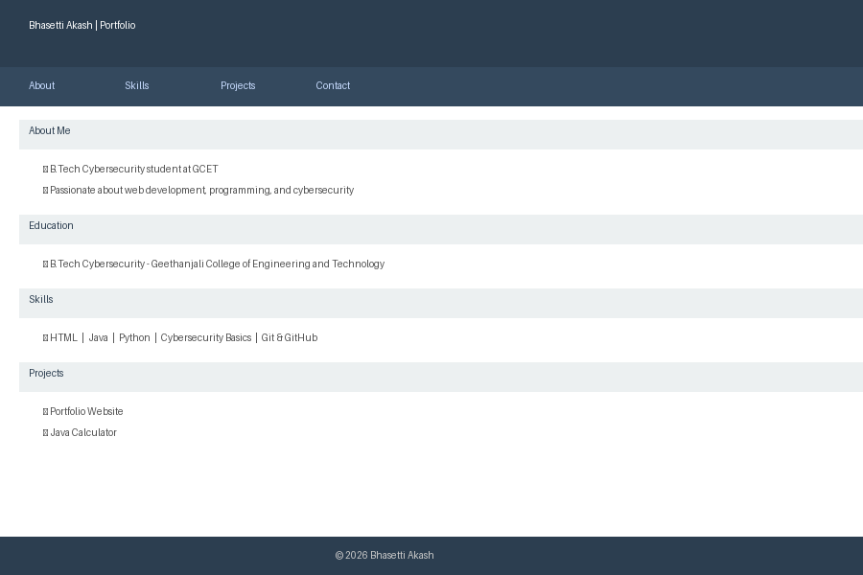

Screenshot 2: Contact Form Section
The contact form includes Name, Email, and Message input fields with a Submit button and HTML5 required field validation.

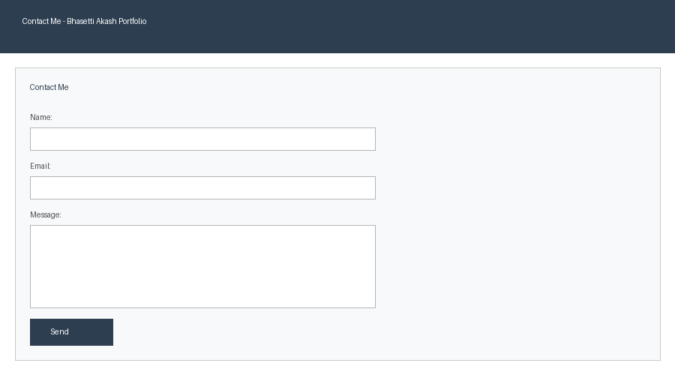

6. Testing Details
The following tests were performed to verify the website functions correctly before submission:

# | Test Case | Expected Result | Status
1 | Browser Launch | index.html opens in Chrome without errors | ✓ PASS
2 | Navigation Links | About / Skills / Projects / Contact links scroll to correct sections | ✓ PASS
3 | Profile Image | Profile image renders correctly in About section | ✓ PASS
4 | About Section | Name and description text displays properly | ✓ PASS
5 | Education Section | B.Tech details appear correctly | ✓ PASS
6 | Skills List | All 5 skills render as bullet list items | ✓ PASS
7 | Projects List | Both projects appear as bullet list items | ✓ PASS
8 | Contact Form | Form fields are visible and editable | ✓ PASS
9 | Form Validation | Required fields show browser warning when empty on submit | ✓ PASS
10 | Footer Text | Copyright text shows correctly in footer | ✓ PASS
11 | HTML Validation | No structural errors in HTML code | ✓ PASS
12 | GitHub Upload | All files accessible in GitHub repository | ✓ PASS

Testing Environment
- Browser: Google Chrome (latest version)
- Operating System: Windows 10/11
- Editor: Visual Studio Code
- HTML Validator: Browser DevTools (F12 > Console)

All 12 test cases passed successfully. The website is ready for submission.

