Application: Sensitive Analysis Dashboard
Version: 1.0
Developed By: Web Prism Dynamics
Date: 6th March, 2026

Abstract: Sensitive analysis dashboard is a web based chat service application, which is using to display customer message with sensitive analysis on each message. Below is the workflow diagram of backend processes. All the backend services are working as a AWS services(AWS Lambdas).

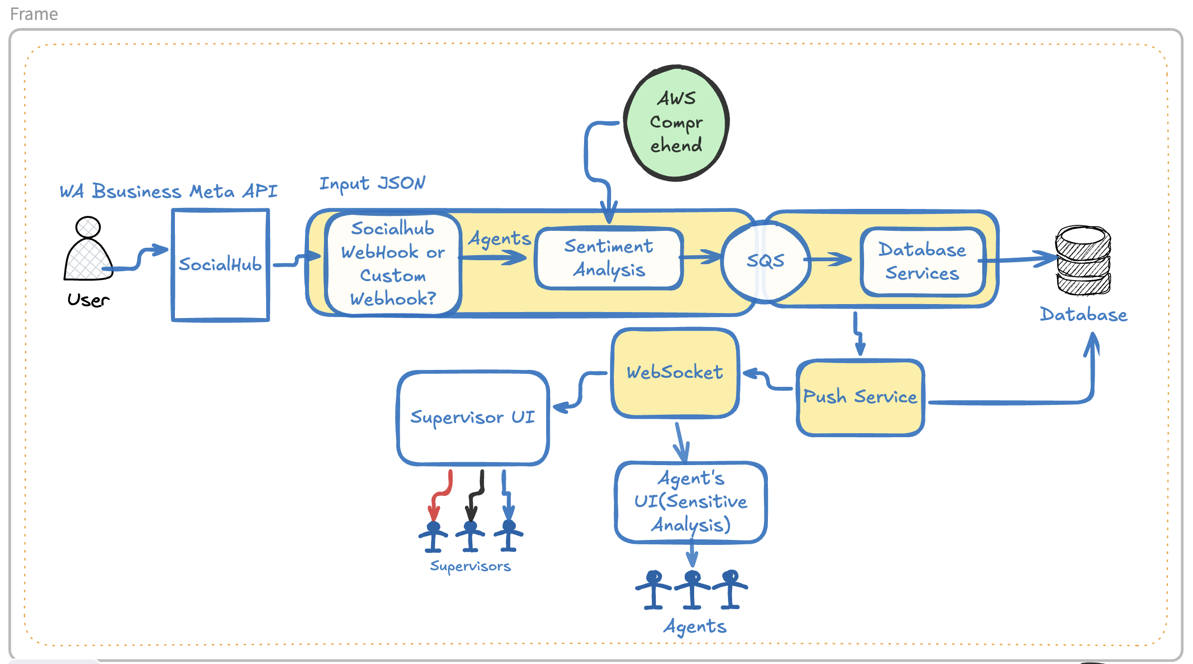

Below are the technologies using for displaying the services
a. Python as main programming languages
b. SAM & Chalice for maintaining framework.
c. AWS Comprehend for basic sensitive analysis
d. CrateDB database

Below is the workflow diagram where lambda names mentioned respective to its needs:

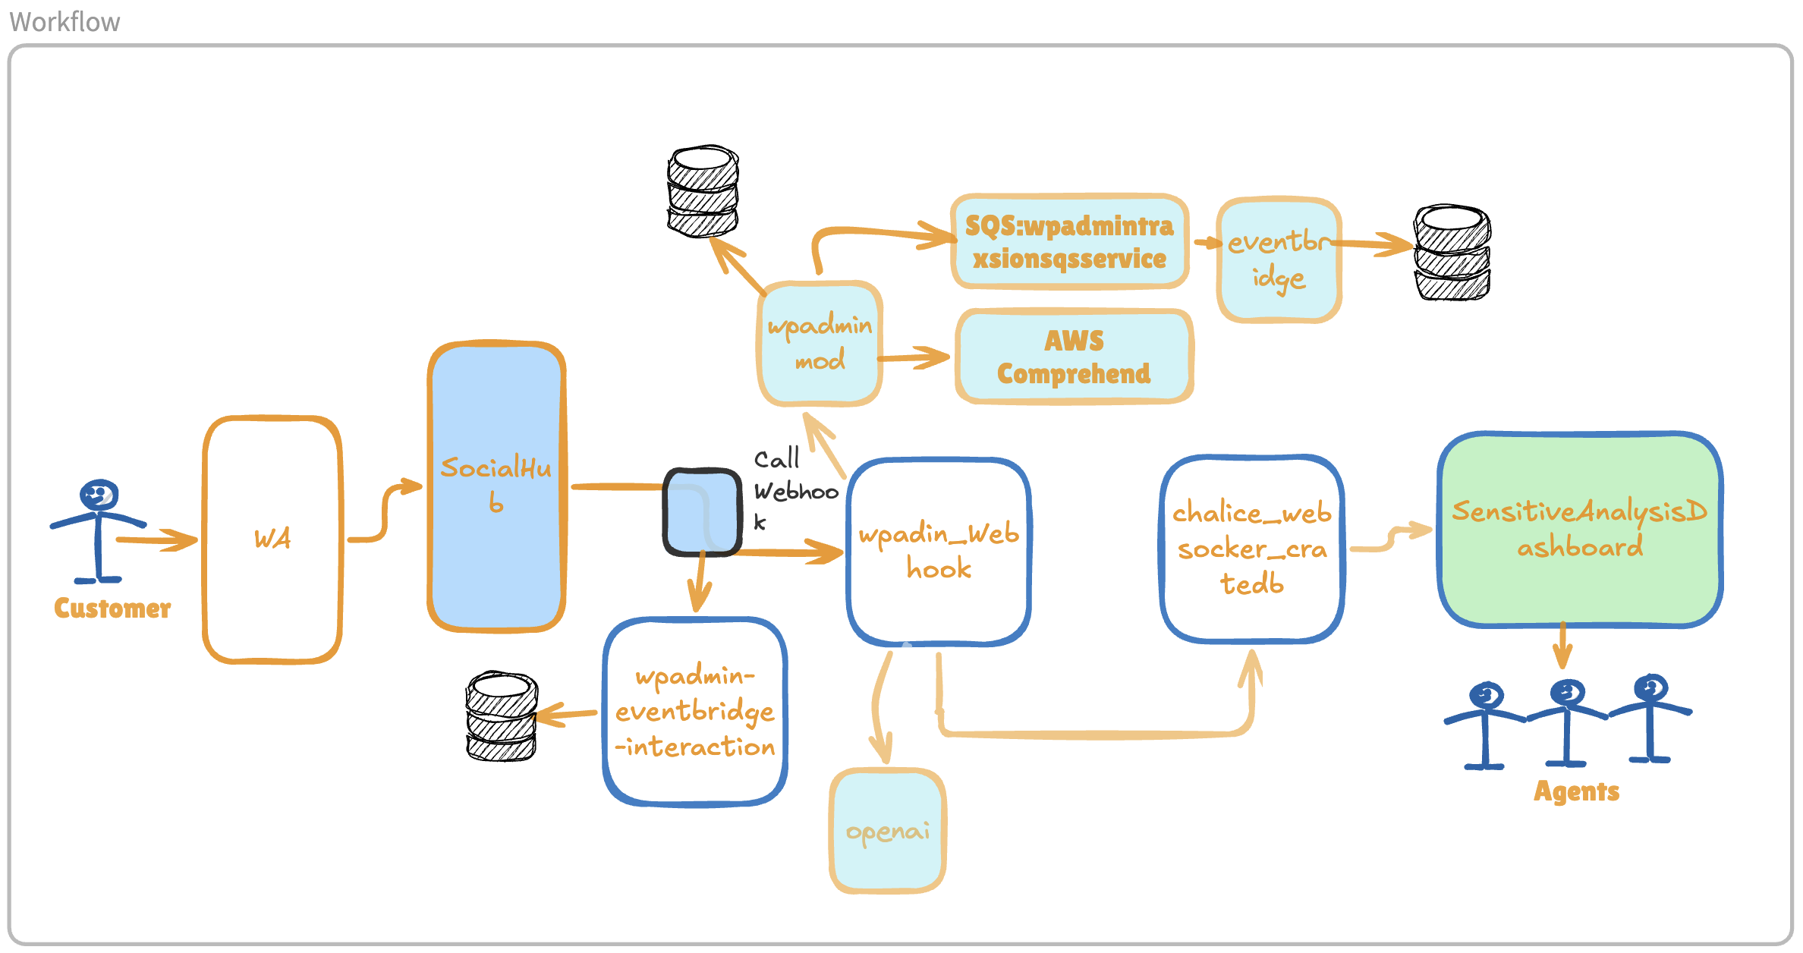
Lets’s explain each lambda in details:

wpadmin:
Developed in chalice based on Python and executed for AWS lambda. This service is using to expose some Restful APIs. The major APIs which is providing the sensitive analysis operation through endpoint /sentiment.
This endpoint is called internally from other lambda service. The /sentiment endpoint using using AWS Comprehend and perform sentiment analysis on user’s provided text message.

wpadmin-webhook:
Developed in SAM based on python and executed for AWS lambda. This is a webhook application directly receiving payload from SocialHub. Call multiple rest endpoints as defined below and push the output message to websocket application.
/sentiment: Perform sentiment analysis
/getagent: Get available agentID who can perform the operation.
/publish: Push the output message to the respective agent.

Chalice-websocket-cratedb:
Developed in chalice based on Python and executed for AWS lambda. This is a websocket application which helps to catch the result from webhook and respond to UI respective to agent.

wpadmin-eventbridge-interaction:
Developed to receive event payload from eventbridge and inserting record in database.

wpadmin-openai-service:
Developed in chalice based on Python executed for AWS lambda. This lambda is using to connect to openai and get the answer based on user’s input text. The endpoints is /getquestions is using for getting openai response.

wpadmin-sql-service:
Developed in SAM based Python for AWS Lambda. This lambda is using to get message from SQS(Queue) and insert data in database. The SQS create an event which invoke this lambda.

Superadmin-websocket:
Developed in Chalice based Python for AWS Lambda. This lambda should be used for making a tunnel from supervisor UI to agent UI through which tunnel, supervisor can transfer any message to selected agent.

